Reflections on baseline determination as included in Marrakech Accords and applied under the CDM: implications for JI

by Wytze van der Gaast, Foundation JIN

Contact: tel. 0031 50 3096815; e-mail: jin@jiqweb.org

Introduction
According to the Decision -/CMP.1 on Guidelines for the Implementation of Article 6 of the Kyoto Protocol taken at the first Conference of the Parties serving as the Meeting of the Parties to the Kyoto Protocol (COP/MOP-1), a baseline for an Article 6 project (hereafter: Joint Implementation, JI) shall be established
- on a project-specific basis and/or using a multi-project emission factor;
- in a transparent manner with regard to the choice of approaches, assumptions, methodologies, parameters, data sources and key factors;
- taking into account relevant national and/or sectoral policies and circumstances, such as sectoral reform initiatives, local fuel availability, power sector expansion plans, and the economic situation in the project sector;
- in such as way that ERUs cannot be earned for decreases in activity levels outside the project activity or due to force majeure;
- taking account of uncertainties and using conservative assumptions.
This paper discusses:
- How these criteria have been incorporated in the modalities and procedures of the Clean Development Mechanism (CDM) and the actual practise of CDM project development under the supervision of the CDM Executive Board (EB). An analysis of the CDM practice is relevant for the JI Supervisory Committee since Decision-/CMP.1 states that methodologies for baselines and monitoring approved by the EB may be applied by project participants under JI – Section 1.
- How under JI Track-2 additionality of greenhouse gas (GHG) emission reductions can satisfactorily be dealt with through baseline determination – Section 2.

1. CDM baseline determination in the Marrakech Accords and in practise
COP/MOP-1 has defined the baseline for JI and CDM projects as the scenario that reasonably represents the anthropogenic emissions by GHG sources (or anthropogenic removals by sinks, as specifically included in the Decision on JI modalities) that would occur in the absence of the JI or CDM project. In these decisions, the term ‘reasonably’ is of crucial importance. Because of its hypothetical character (i.e. the baseline scenario will never take place due to the project), the baseline is surrounded by uncertainties regarding the choice of the ‘right’ methodology, parameters, key factors, etc. As a consequence, more than one baseline could be considered reasonable. It should be noted that the modalities and procedures for setting CDM project baselines in the COP/MOP-1 text are much more detailed than for JI project baselines.
For the determination of CDM project baselines, further to the Marrakech Accords, COP/MOP-1 has listed three approaches from which project participants must select the one which they consider most appropriate for the project activity:
In the first approach, the baseline is derived from actual or historical emissions relevant for the project. It assumes that the (recent) historic and actual emissions of GHGs at the project site (i.e. within the project’s system boundary) form a good representation of what reasonably would have happened in absence of the project during its crediting lifetime.
The second approach determines a baseline by identifying a technology that represents ‘an economically attractive course of action, taking into account barriers to investment.’ This approach assumes that under business-as-usual circumstances an economically attractive course of action would have occurred, although it does not specify economic attractiveness as a concept, which could imply that several different economically attractive options would qualify as a baseline ranging from the economically most attractive course to less attractive ones. The choice of the baseline in this approach is to a certain extent narrowed down by the condition that under business-as-usual an economically attractive course of action would not have been hampered by investment barriers.
The third approach differs from the first two in that it actually describes a multi-project baseline application, whereas the first two approaches can both be applied to single-project and multi-project baselines. It specifies that the baseline or benchmark is to be derived from the “average emissions of similar projects undertaken in the previous five years, in similar … circumstances, and whose performance is among the top 20 percent of their category.”
Despite the statement in the text on the CDM that baselines shall be established on a project-specific basis, the CDM practice has shown that several project methodologies include baseline elements which can be applied to a multitude of projects. Also, the EB has taken the initiative to merge individual methodologies based on specific projects into consolidated baseline methodologies which could be applied on a multi-project scale. Multi-project (or standardised) baselines are generic baselines derived for application to multiple projects and which contain reasonable descriptions of the future development of a sector (e.g., electricity grid) or country.
The CDM expertise with baseline determination and assessments is very useful for dealing with JI project baselines. First, the distinction between ‘retrofit’ and ‘greenfield’ projects has had strong implications for baseline determination. Retrofit projects aim at modifying existing plants to operate in a different way (e.g., modify an old oil-fired boiler in order to produce the same output with a gas-fired boiler). No new sites are involved with this type of project. Greenfield projects always involve a new or greenfield site and have been planned to meet an increase in energy demand, to replace written off capacity, or to install new renewable energy capacity. The implication of this distinction for baseline determination is that the baseline for a retrofit project is based on a clearly identifiable plant or capacity, whereas for greenfield projects the baseline is often based on an abstract definition of the capacity to be replaced by the project, which in the practice of CDM greenfield electricity sector projects has often turned out to be an adjusted average GHG emission level of the electricity grid to which the project delivers the electricity.
Second, for large-scale projects 27 baseline and monitoring methodologies and eight consolidated methodologies have been approved (as per 23 February 2006). These methodologies could provide valuable input into JI project development. However, it should be noted that of the 15 sectors identified by the EB, only eight have been covered by approved methodologies. Of the latter sectors, electricity production and handling of waste and disposal are well covered with 12 and 11 methodologies, respectively. The other six sectors are only minimally covered by approved methodologies (see Table 1).
Table 1. overview of approved baseline & monitoring methodologies for CDM projects.
Sector | Approved methodologies | Approved small-scale methodologies | Approved consolidated methodologies
1. Energy production | 7 | 6 | 4
2. Energy distribution | - | 1 | -
3. Energy demand | 3 | 3 | -
4. Manufacturing industries | 4 | 1 | 2
5. Chemical industries | 2 | - | -
6. Construction | - | - | -
7. Transport | - | 1 | -
8. Mining/mineral production | - | - | 1
9. Metal production | - | - | -
10. Fugitive emissions from fuels | 2 | 1 | 1
11. Fugitive emissions: halocarbons/sulphur hexafluoride | 1 | - | -
12. Solvent use | - | - | -
13. Waste handling and disposal | 10 | 2 | 1
14. Afforestation and reforestation | 1 | - | -
15. Agriculture | 2 | 1 | -

The implication for JI is that for sectors not yet covered by approved CDM methodologies new baseline and monitoring methodologies will have to be approved by the JI Supervisory Committee. This could particularly apply to district heating JI projects, which, contrary to developing countries, might have a strong JI potential in Central and Eastern Europe, as far as not yet covered by the EU emissions trading scheme (ETS). Also for sectors such as transport and built environment, which are not covered by the ETS and which have been identified by a number of potential JI host country governments as priority sectors not many lessons can be learned from CDM baseline determination. Finally, energy efficiency projects (a.o. demand-side management) are only limitedly covered by the CDM.

2. The additionality debate under the CDM and lessons for JI
A general requirement of a JI project is that it must result in additional emission reductions. Basically, an investment in a JI/CDM project is a GHG-neutral activity. The investor country acquires GHG emission reduction credits from the country where the project takes place (the host country). These credits provide the investor country with flexibility to have higher emissions domestically than the amount of emissions assigned to it under the Kyoto Protocol. An important condition for the carbon neutrality is that the emission reductions are real and would not have taken place in the absence of the project.
Obviously, additionality of emission reductions achieved through JI and the CDM is key to the credibility of this type of international co-operation. The essence of the concept of additionality is as follows. In order to test whether the emission reductions are additional, the project’s GHG emissions are compared with the emissions corresponding with the baseline scenario. In case the project’s actual emissions are lower than the baseline emissions, the emission reductions can be considered additional. This rather straightforward case can for instance be applied to situations where it can be clearly identified what the project replaces, e.g., a coal-fired plant being replaced with a gas-fired boiler.
This picture changes if baselines are determined for ‘greenfield’ electricity sector projects (see above) aiming at creating new electricity capacity to deliver power to the grid. These projects, of which there are several in the present CDM pipeline, do not replace a particular, well-defined existing plant or system, but replace power production capacity connected to the power grid in the CDM host country. In order to determine which capacity will be replaced by the project, the baseline study must identify which grid-connected capacity would be dispatched first when new capacity becomes available and/or which capacity would have been added to the grid in the absence of the CDM project. As it is in most cases difficult to specify such a marginal capacity (after all, the decision which capacity to dispatch or to replace is beyond the control of the CDM project developers, which only sign a power purchase agreement with the power grid owner/operator), a baseline for a ‘greenfield’ project is in most cases determined with the help of a dispatch analysis to estimate which capacity connected or planned to be connected to the grid will be replaced by the CDM project, based on technology lifetime, operational costs, fuel availability, etc.
As these baseline are based on an analysis of the entire grid, they are not very project-specific and do not provide as much information about the additionality of the emission reductions as retrofit projects do. This brought the issue of additionality back in the spotlights. After all, similar to the theoretical case of multi-project baselines described above, each project with GHG emissions below the aggregate grid-based baseline could apply for CDM credits, irrespective of whether the project developers would have carried out the activity anyhow.
Based on the decision of COP-7 in the context of the Marrakech Accords the EB formally had to provide guidance to the interpretation of the additionality issue under the CDM. In August 2002, the EB decided on the format for a project design document (PDD), which was mostly a one-to-one reflection of the modalities and procedures for the CDM in the Marrakech Accords with the exception that the requirement for an additionality assessment was explicitly formulated as a separate test next to the baseline analysis (Question B.3 of the “Guidelines for Completing CDM-PDD, CDM-NMB and CDM-NMM”, CDM Executive Board). In its assessment of baseline methodologies, the EB generally has taken the position that project participants must also explain why the project itself is additional.
Baseline methodologies that have been proposed by project developers since June 2003 have dealt with additionality in basically two approaches. First, some project developers aimed at showing additionality by calculating the increase in a project’s internal rate of return if the CDM credits are taken into consideration. For some project types, e.g., landfill gas capture, these two rates could strongly differ, thereby showing that the carbon credits make a considerable difference. Second, other methodologies contained a more qualitative barrier test showing that without the CDM the investment would have faced prohibitive investment barriers. Examples of such investment barriers are: lack of technical expertise and adequate supply of equipment in the host country, poor utility infrastructure and lack of administrative infrastructure and legislative framework (incl. enforcement), shortage of capital, lack of financial incentives to carry out investments as envisaged under the project, risk of subsidised energy prices, low acceptance from the public, etc.
In order to streamline the operationalisation of the CDM additionality assessment, the EB, at its 16th and 17th meeting (2004), decided to adopt a ‘tool for the demonstration of additionality’. In order to provide more guidance on this aspect of the PDD, the EB consolidated the additionality methods used by project developers and approved by the EB into one general framework for additionality.
The consolidated additionality tool starts with the notion that the demonstration of additionality of the GHG emission reductions must be consistent with the project baseline determination. In other words, additionality and baseline determination are conceptually strongly related to each other and this must be reflected in their application in the overall project methodology. The tool contains a stepwise approach to assess whether a proposed CDM project activity would have been carried out in the absence of the CDM.
First, the project developer must explore whether alternatives to the project activity exist in the host country. For instance, in case laws and regulations in the country require the investment envisaged under the project to be carried out anyway, it can be concluded that alternatives to the project exist.
In the second and third step either a financial investment or a barrier analysis must be carried out. The project developer has the freedom to choose between both steps (either step two or three) or do both. In the financial investment analysis the project developer can choose either to show via a simple cost analysis that, without the CDM credits, the project will have insufficient benefits to go ahead, or, if that is not a viable option, to apply a investment comparison analysis or a benchmark analysis. The barrier analysis requires project developers to identify barriers that prevent the implementation of the proposed project activity, while not preventing alternatives. The EB has incorporated some safeguards to ensure the strictness of the barrier assessment by insisting on a conservative interpretation of documentation supplied in support of the identified barriers.
In the subsequent fourth step, project developers are asked to provide information on the dissemination of the technology envisaged under the project, or the proposed project activity itself in the country/region. If comparable technologies/project activities already widely exist elsewhere under comparable circumstances in the country, the project developers must answer the question why, despite the wide penetration of the technology, the project would not have been carried out without the CDM credits. As such, this common practice step is an extension of the investment/barrier analysis in steps 2 and 3 in the sense that it broadens the scope of the assessment to a national/regional level. Whereas in steps 2 and 3 an investment/barrier analysis must be carried out in the context of the project, in step 4 this analysis is broadened to the host country or regional context. A consequence of this step is that it requires a national or regional assessment of the recent and actual energy sector development in the host country. This may place a relatively large burden on project developers as it requires considerable data gathering and interpretation efforts, and could further raise the transaction costs related to project development.
In a final step the project developer must show how CDM registration will help the project to overcome the barriers identified in steps 2 and 3.
Figure 1 shows how project developers of the 100 registered CDM projects (as per 22 February 2006) have applied the additionality assessment required in Question B.3 of the “Guidelines for Completing CDM-PDD, CDM-NMB and CDM-NMM” of the CDM Executive Board. The assessments have been carried out as follows:
- Barrier analysis: The main mode for establishing additionality
- A financial investment analysis: A scarcely used mode for proving additionality, although it seems to be an easy method for small-scale projects which fulfil the additionality requirement by the use of a simplified cost calculation method.
- Hybrid analysis: in this analysis PDDs contain both barrier and investment tests are applied.
- Description of baseline: in this approach additionality is predominantly shown by explaining that the baseline does not apply for this project. In most cases additionality is proven by stating that the legal or institutional structure in the host country does not provide any incentive to invest in emission reductions that are not prohibited by national rules and/or regulations (which is close to the barrier analysis above).
- Scenario/barrier approach: with respect to additionality this category uses a number of possible baseline scenarios and then uses an elimination method based on certain identified barriers.

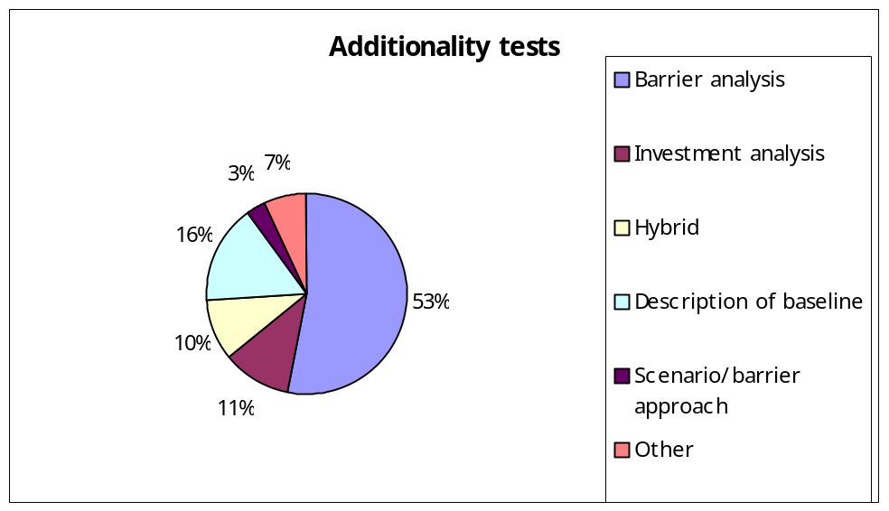
Figure 1. additionality assessment approaches used for registered CDM projects

For the design of projects under Track-2 of JI, it would be important that overlaps between the additionality tool and baseline determination are prevented, especially in cases of retrofit JI projects. In the latter type of projects, the baseline, in order to be a reasonable reflection of the emissions by sources in the absence of the project, should, and according to the required information in e.g. the CDM PDD would, contain the information that is requested by the additionality tool: an assessment of the expected legal and policy developments deemed relevant for the project (step 1 of the CDM additionality tool); an analysis of the emission sources within the project boundaries under business-as-usual circumstances, which implies that it is analysed that due to some barriers (which could be a financial analysis) they would not have developed as is envisaged by the project (step 2/3); and, as has been included in the key factor approach of the Dutch “Operational Guidelines for PDDs of JI Projects” used for the ERUPT programme, factors/developments from outside the project boundary that are considered relevant for the business-as-usual circumstances within the boundary should be taken into the baseline considerations (step 4).
For JI greenfield projects it is recommended, should the JI Supervisory Committee decide on an assessment of additionality next to the baseline scenario for JI Track-2 projects, that the consolidated additionality tool used for the CDM be applied in a simplified manner:
- Step 1 is generally covered by baselines derived from sector-level or energy grid-level analysis, as with many greenfield projects.
- Steps 2 and/or 3 could be applied next to the baseline of a greenfield project, similar to the CDM, since the baselines do not contain clearly identifiable plants or capacity and resemble multi-project baseline methodologies with risks of free riders.
- Step 4 is also generally covered by greenfield project baselines as these are derived from sector level and/or other aggregate level analyses.
- Step 5 could be combined with Steps 2 and/or 3.

Para. 1 Appendix B to the Decision -/CPM.1 (Article 6) and para. 44 of the Annex to Decision -/CPM.1 (Article 12).
Para. 48 of the Annex to Decision -/CPM.1 (Article 12).
Para. 48b of the Annex to Decision -/CPM.1 (Article 12).
Para. 48c of the Annex to Decision -/CPM.1 (Article 12).
Para. 45c of the Annex to Decision -/CPM.1 (Article 12).
Van der Gaast, W.P., 2005. Baseline standardisation for JI Track-I projects, presentation at JI Track I workshop, Prague, Czech Republic, 7-8 September 2005.
For example, of the 18 projects approved in the Dutch tender programme for the CDM (CERUPT) in 2003, 13 were ‘greenfield’ activities: renewable energy projects delivering electricity to an existing grid.
Ministry of Economic Affairs, 2003, Operational Guidelines for PDD’s of JI Projects, the Hague, the Netherlands.

