REFOREST THE TROPICS, Inc.

A non-profit organization developing economic farm forestry in the tropics to offset U. S. carbon emissions and to mitigate climate change.

________________________________________________________________________________________________________________________________

MANAGING U. S. CO2 EMISSIONS THROUGH CARBON SEQUESTRATION AND LONG-TERM
STORAGE IN TROPICAL FARM REFORESTATION PROJECTS
February 5, 2006

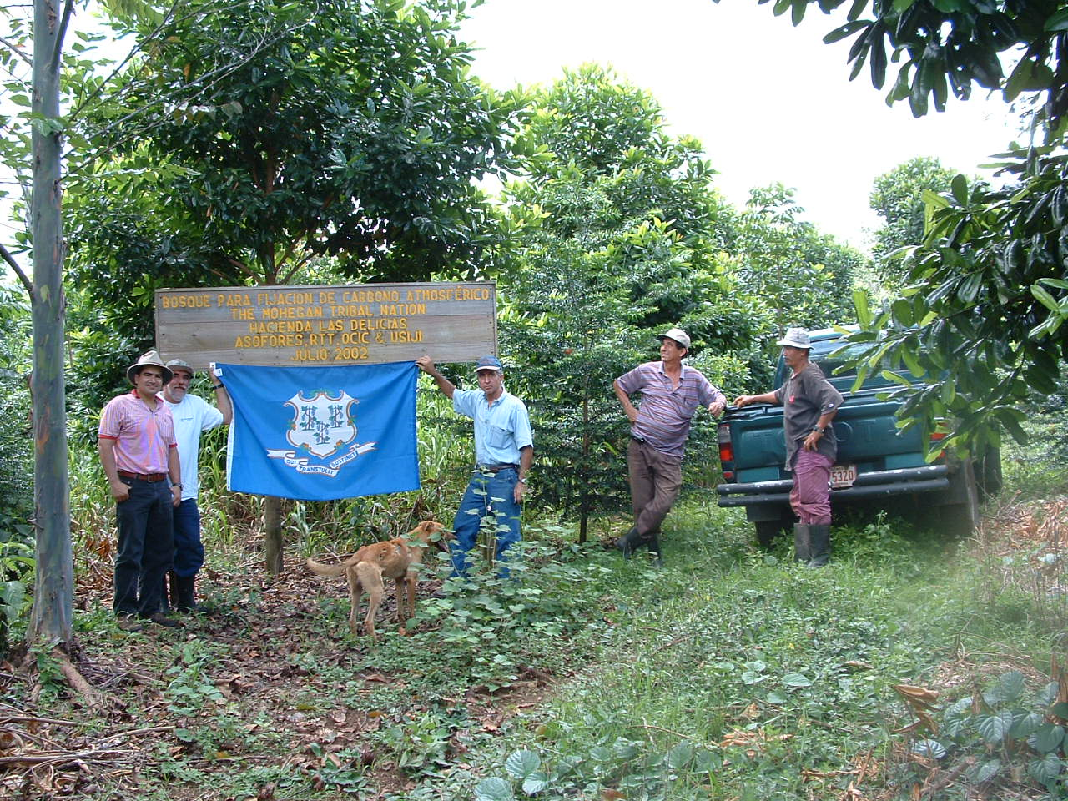

The Connecticut flag symbolizes the cooperation involved when Costa Rican farmers balance CO2 emissions in new forests for CT emitters using the RTT Program. The sign lists the name of the donor of funds, of the farmer participating and date of planting in this young carbon-offset forest. Less than 3 years old, this forest was planted to balance CO2 emissions for the Mohegan Tribal Nation in Uncasville, CT for a 25-year period. The RTT program was accepted by the State of Connecticut as a voluntary option for managing its citizens’ carbon emissions.
_____________________________________________________

A case can be made for reforesting pastures in the tropics to sequester and store U. S. carbon emissions.
Brazil converted 9,170 square miles of tropical forest to pastures for meat exports last year (April, 2004 issue of The Economist). The destruction of the world’s tropical forests reaches about 20-35 million acres per year. The burning of this biomass contributes 18% of the world’s annual carbon emissions (Intergovernmental Panel on Climate Change).

The reforestation of these same pastures for carbon sequestration can help us manage, balance or offset U. S. emissions from sources such as vehicles, buildings, factories and from the generation of electricity. RTT has developed a model in which U. S. emitters fund reforestation projects with participating farmers with long-term contracts for legal carbon sequestration. This model has the potential for inexpensive and long-term carbon sequestration while providing the participating farmer with an income stream as good as or better than he gets from cattle.

This is a program approved by the U.S. and Costa Rican governments.
In 1995 in Washington, the U.S. and Costa Rican governments approved a U.S. Joint Implementation (AJI) Program for the development of this model with RTT as the manager. Since then, 45 U.S. emitters have donated over $480,000 to fund 240 acres of new carbon-offset forests on farms in Costa Rica. The director, Dr. Herster Barres, is a graduate of Yale University and the Yale School of Forestry & Environmental Studies. He has a doctorate from the Swiss Federal Institute of Technology in Zurich, Switzerland. He was an expert of FAO for 11 years in Costa Rica and now has 40 years of experience in research, farm management, project development in Costa Rica and marketing in the U.S.

The science
During photosynthesis trees absorb CO2 to grow, making wood in the trunk, crown and roots. Because of ample sunlight, rainfall and year-round growing conditions in the tropics, growth and, thus sequestration, can be 10-20 times that of a New England forest. Some of our 36-year old research plots have sequestered 16 tons of CO2 per acre annually. To be conservative we use 8 to 12 tons per acre per year (20 to 30 tons per hectare) as our sequestration goal.

Tree species
A dozen or so tree species are being tested in mixtures to create the most efficient forests. Most are fast-growing, and others grow to very large sizes for long-term carbon storage.

Methane from forests
Recent research indicates that plants produce methane, another greenhouse gas. Pasture grasses and cattle also produce this gas. Research shows that a cow can produce from 100 to 200 liters of methane per day. Since the sites we plant were producing methane before we planted them, that is the baseline from which we work. The question to be answered is whether the new forest emits more or less than the amounts methane produced by the pasture with cows. The benefits to emitters, i.e., that forests can sequester and store massive amounts of CO2, remains unchanged.

The farmer
Almost all of the land in the tropics is occupied by farmers. If we could show them how to produce more income from growing trees than from growing cattle, there could potentially be a large shift from pastures to economic forests. The RTT model already has studies showing substantial income flows to the farmer from these double-purpose (sequestration and farmer income) forests.

Success in applying this model will depend on emitters being willing to pay for carbon sequestration. This is the source of the capital for contracting the farmers to convert their pastures to new carbon-offset forests and for the required intensive technical assistance.

The management plan, agreed upon in the first 25-year contract and controlled through technical assistance, specifies light thinnings every 5 years starting at about 10 years of age. Thinnings improve the forest stand while providing the farmer income through their sales. Reduced impact logging and frequent light thinnings should leave the stand in good condition to maintain a high level of carbon sequestration. Income from this source, according to our studies, may exceed that from raising cattle, income that begins with grants from the day the farmer signs the contract.

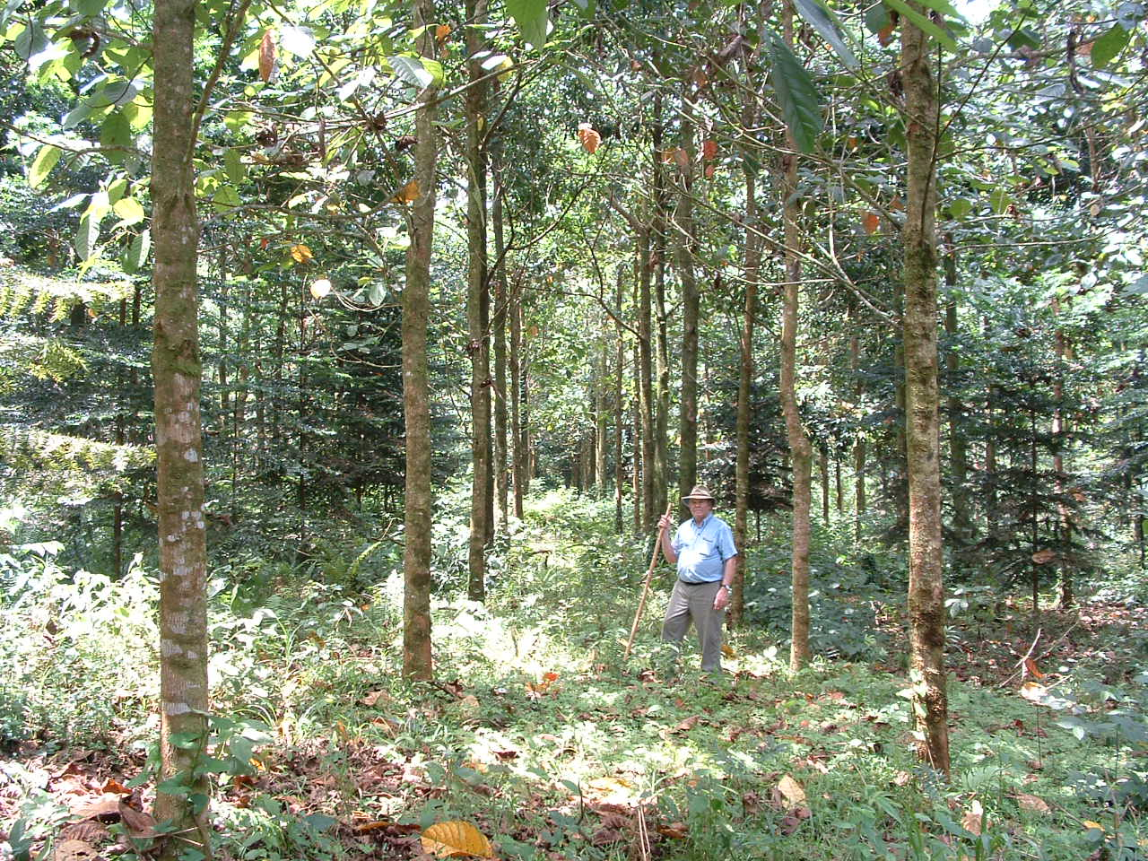

Above: A 6-year old forest established to sequester and store the CO2 emissions of a pool of 26 small emitters from New England. Management of these forests focuses on sustainability to maintain the carbon at a high level in the forest stand for long-term storage. Thinnings for farmer income will be light and frequent to maintain productivity.

The U.S. emitter
In this model, the emitters of CO2 in the U.S. fund demonstration projects in which the cost to sequester a metric ton of CO2 is estimated at about $10. We estimate that this hectare can sequester about 20 to 30 tons of CO2 per hectare each year on the average during the 25-year contract RTT signs with the farmer for each project on behalf of the emitter.

A hectare (2 ½ acres) of this forest requires a one-time, up-front donation of $5,000, namely, a grant of $1,500 to the farmer for his costs in establishing the forest, $2,000 for the first 4 years of technical assistance to establish the forest, and $1,500 to be set aside for long-term management and early insurance.

The sequestered carbon, a function of the measurable forest biomass, is a legal offset to existing carbon emissions in the U.S. Offsets balance specific levels CO2 emissions from your home, a school building, factory or fleet of cars, for instance. Sequestration in this program can be registered in the name of the U. S. emitter with the Energy Information Agency of the DOE in Washington.

Most New England states have developed greenhouse gas management plans. The RTT Model is approved for the Connecticut State Plan, one more tool to manage its carbon emissions.

This Model envisages developing a forest stand indefinitely storing carbon from having processed 1,500 to 2,000 tons of CO2 per hectare. Research measurements have shown that a stand of this volume can still produce from 40-50 m3 of wood per ha per year.

Long-term carbon storage We expect the carbon to be stored indefinitely in economic and sustainable stands.

In the RTT program farmers are learning to cultivate wood as a sustainable crop. The farmer will become a producer of high-quality logs suitable for local use and perhaps for export. After the first 25-year contract, the farmer eventually becomes a producer of carbon credits for sale on the open market, a new farm product.

Biodiversity
RTT is presently testing mixtures of native tree species and plants that may be added to the forest stand to increase biodiversity. Most of the trees used also produce food and shelter for wildlife. In certain cases natural forest is left adjacent to the carbon-offset forests, a source of biodiversity. Howler monkeys sometimes inhabit the natural forests next to our carbon-offset forests in Costa Rica.

Risks
This is an applied research program to learn and demonstrate how to sequester and store U.S. CO2 emissions in new tropical farm forests. Risks include, but are not limited to, insect damage, fire, inappropriate farmer management, inability to fund long-term management, wind storms, disease and political adjustments. Rates of sequestration vary according to site quality and management.

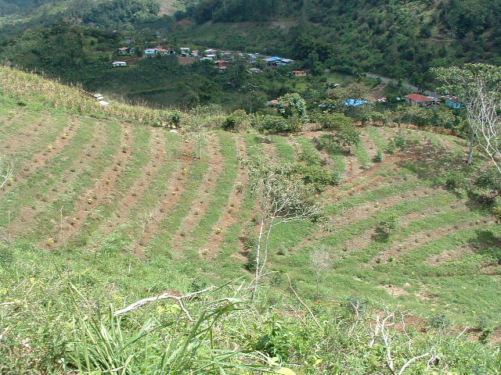

Above: This recent 2 ½-acre project was a wedding gift to the recently married couple, Dave & Tiffany Foley, of Ormond Beach, Florida. The next 25 years should be carbon-balanced for them.

Cooperators
In the U.S., we are working with 45 New England emitters, including The Mohegan Tribal Nation, Connecticut College, The Superior Nut Co. and the Connecticut Municipal Electric Energy Cooperative, schools, Rotary Clubs and individuals. Cooperators in Costa Rica include farmers, the Cantonal Agricultural Center in Turrialba, CATIE, EARTH and the Costa Rican government.

Participating
RTT welcomes partners for this program to reforest the tropics. For photos of our carbon-offset forests and more information, contact: Dr. Herster Barres, Reforest The Tropics, PO Box 601, 5 Holmes St., Mystic, CT 06355, tel (860) 572-8199. E-mail: hbarres@aol.

