JOINT IMPLEMENTATION PROJECT DESIGN DOCUMENT FORM
Version 01 - in effect as of: 15 June 2006

CONTENTS

A. General description of the project

B. Baseline

C. Duration of the project / crediting period

D. Monitoring plan

E. Estimation of greenhouse gas emission reductions

F. Environmental impacts

G. Stakeholders’ comments

Annexes

Annex 1: Contact information on project participants

Annex 2: Baseline information

Annex 3: Monitoring plan

SECTION A. General description of the project

A.1. Title of the project:
Pernik District Heating Project
Version 3, 22/10/2007

A.2. Description of the project:
Background
District heating (DH) is the dominant form of space heating in major cities in Bulgaria. DH, compared with other forms of energy, is the most economical way to provide heat to the population in highly urbanized areas. The sector generated approximately 11 GWh of heat energy and 1.8 GWh of electricity in 2004 and represented about 25% of the energy consumption in the country. About 80% of this energy came from natural gas with other sources being coal (12%) and heavy fuel oil (8%).
The price of electricity is relevant for the District Heating Companies (DHCs) that use combined heat and power (CHP) boilers. These companies sell their electricity to the national grid while the heat is sold to domestic and industrial consumers. In 2002, according to the Energy and Energy Efficiency Law, the national power grid has to purchase electricity generated in the CHP plants at preferential rates of around US$ 43/MWh, which is close to the electricity tariffs. This policy was in place to use CHPs to meet peak electricity demand and assist the DH sector by allowing them to generate revenues from the sale of electricity. The contribution of CHPs to the generation of electricity is, however, limited. Installed capacity for electricity generation by CHP plants is about 540 MW compared to a total installed capacity of 11,000 MW. The CHP plants fully recover their costs on the electricity generation and often cross-subsidize the DH operations. The level of cross-subsidization depends on the condition of the CHP plants and the fuel used. Cross-subsidy is seen as a temporary phenomenon and is expected to be phased out as the DH sector becomes self sustainable.
While the DH sector has been going through a difficult time, actions taken by the Government are helping the sector to make a turn-around. Since 2000, there have been significant changes, including: tariff increases, which are helping to improve the financial situation of the DHCs; elimination of disconnections from the DH system; an increase in demand-side measures through metering of consumption, and some rehabilitation of sub-stations. To support the turn-around and place the sector on a sustainable footing, the DHCs and the Government have to continue to address the key issues in the sector.
The Pernik DH system has one combined heat and power (CHP) plant that produces heat for the district heating, and steam for industry and power. The total annual heat production in 2004 was approximately 400 GWh and electricity production about 500 GWh. The plant has five steam boilers and three turbines with the total power production capacity of 105 MWe and the heat capacity is about 270 MWt.
In Pernik, about 20,000 households receive heat from DH, accounting for about 60,000 people out of Pernik’s total population of 86,000. Each residential building contains one or more substations that distribute hot water to individual radiators within flats. Many older substations are direct type and supply hot water directly from the main distribution network into the building. Newer buildings use indirect type substations, which use a secondary circulation network and pump, and a heat exchanger connected to the primary distribution network.
Description of the project
The aim of the project is to rehabilitate the district heating (DH) system in the city of Pernik by rehabilitating 10 km of pipes (the total length of the DH system is 60 km), all 700 substations and installation of valves, compensators, heat exchanger and pumps. The substations are being operated with modern controls and monitoring equipment that has resulted in increased operating efficiency of the DH system.
The project has converted Pernik DH network to a variable flow and allow groups of consumers to automatically regulate their heat consumption. The goal of the project is to reduce heat losses and improve efficiency of the network so energy consumption and hence CO₂ emissions are correspondingly reduced up to around 11% annually depending on the performance of the project.
The majority of heating goes to residential buildings, which are mostly high-rise apartment complexes. Each residential building contains one or more substations that distribute hot water to individual radiators within flats. Older substations are mostly “direct”, and bleed hot water directly from the main distribution network into the building. Newer buildings use “indirect” substations, which use a secondary circulation network and pump, and a heat exchanger connected to the primary distribution network.
Suppliers have provided the necessary training for the staff of the Pernik District Heating Company based on signed contracts. Suppliers have also prepared instructions for operation and maintenance of new equipment.
This project was positively pre-determined by TŰV SŰD in 2004. However, initial verification revealed some mistakes in the calculations and discrepancies between the calculation sheets and the Monitoring Plan leading to the need to revise the documentations such as Project Design Document and Monitoring Plan including the spreadsheet for tracking the emission reductions, so called Tracking Database.
The project was originally bundled with similar Sofia project. Projects have now been separated into two independent projects for re-determination due to the facts that projects have been implemented by different project entities and project characteristics are slightly different e.g. with differing implementation timetables. Project is to be re-determined under JI Track 1 subject to relevant eligibility criteria expected to be met in Bulgaria.

A.3. Project participants:

Party involved | Legal entity project participant (as applicable) | Please indicate if the Party involved wishes to e considered as project participant (Yes/No)
Bulgaria | Toplofikacia Pernik | No
To be determined | IBRD as a Trustee for Prototype Carbon Fund (PCF) | Yes

A.4. Technical description of the project:

A.4.1. Location of the project:
The project is located in Pernik (southwest) in Bulgaria.
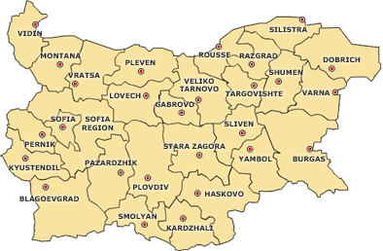
Figure 1. Map of Bulgaria.

A.4.1.1. Host Party(ies):

Bulgaria is the host party. Bulgaria ratified the Kyoto Protocol to the UNFCCC on July 17, 2002.

A.4.1.2. Region/State/Province etc.:

Region of Sofia

A.4.1.3. City/Town/Community etc.:
The town of Pernik has 86,200 inhabitants and is the largest town in Southwestern Bulgaria after Sofia. It is situated in the high Pernik Plain between Vitosha, Lyulin and Golo Burdo Mountains, along the Strouma River. The town is 30 km to the southwest of Sofia.

A.4.1.4. Detail of physical location, including information allowing the unique identification of the project (maximum one page):
The project is located in Pernik managed by Pernik District Heating Company, also referred to as Toplofikacia Pernik (TP). TP is a state owned company supplying process steam to residential and commercial customers.

A.4.2. Technology(ies) to be employed, or measures, operations or actions to be implemented by the project:
The project belongs to sectoral scope 2, Energy Distribution. The measures that have been implemented as a result of the project include:
1. Replacement of piping—network rehabilitation involving the replacement of approximately 10 km of transmission pipelines (the total length of the DH system is 60 km) and over-ground thermal insulation is expected. All pipelines being replaced are old foam-concrete types that have become increasingly difficult to maintain.
2. Replacement of substations - all 700 substations will be replaced. These substations are a mix of direct substations that directly use the hot water from TP and older indirect substations that are due for replacement. All of the replaced substations will be modern, indirect substations using plate-in-tube heat exchangers and variable-speed pumps to control the flow of hot water to the flats served by the substation. Replacement of substations will have the major impact on savings.
3. Variable-speed pumping - the current strategy of using constant-flow pumps to disperse hot water through the primary distribution network will be improved by adding variable flow pumping. Significant savings will result due to being able to more closely match the required heat output to actual, real-time consumer demand.
4. Replacement of electrostatic precipitator – old electrostatic precipitator (ESP) for a boiler plant will be replaced which will reduce particulate emissions and improve the air quality with no significant impact on CO₂ emissions.
The combination of the measures identified above has resulted in aggregate savings of input fuel to the CHPs and boilers, and electricity used by the primary distribution pumps.
The project has almost been fully implemented. Two kilometers of piping will still be replaced and electrostatic precipitator will be installed.
Table 1. Measures implemented by the project.

Measure | Beginning of implementation | Finalization of implementation
Installation of pre-insulated pipes, 1st stage | July 1, 2004 | September 30, 2004
Installation of pre-insulated pipes, 2nd stage | July 1, 2005 | September 30, 2005
Installation of network pumps and frequency regulators | September 1, 2004 | October 30, 2004
Installation of compensators and substations | June 1, 2004 | September 30, 2004

A.4.3. Brief explanation of how the anthropogenic emissions of greenhouse gases by sources are to be reduced by the proposed JI project, including why the emission reductions would not occur in the absence of the proposed project, taking into account national and/or sectoral policies and circumstances:
The emission reductions would be achieved through (i) reductions in heat and water losses in the pipeline distribution system, (ii) improved heat exchangers and better control systems at substations and (iii) lower electricity consumption by Pernik DH system due to the installation of variable-frequency pump drive system at the main transmission lines. This will generate emission reductions from the decreased fuel consumption for the grid.
The project has installed variable speed pump systems at the DH plants. This has significantly reduced pumping electricity consumption in the distribution system, especially during periods of low heat demand. The reduced demand for power from the national grid will in turn reduce emissions from the marginal plant on the national Bulgarian electricity grid.
All three efficiency gains lead to lower consumption of fossil fuels and thus lower CO₂ emissions.
The financial situation of the TP deteriorated steadily in the end of 1990s. Main factors affecting TP were (i) loss of sales due to voluntary disconnections by customers, (ii) low domestic tariff that were below the unit cost of heat production, (iii) low bill collection rates and (iv) rising operation expenses, including fuel costs. Given the financial constraints of TP, rehabilitation of the network was not affordable, which has led to an increase in heat losses. In the absence of the project, the TP would have not been able to raise the required capital to improve the energy efficiency, and thus the project would not be implemented in the absence of the JI component due to the investment and institutional barriers as described in section B.

A.4.3.1. Estimated amount of emission reductions over the crediting period:
The estimated amount of emission reduction over the crediting period of 2008-2012 is 418,458 tCO₂e. The estimated amount of emission reductions (ERs) over the period of 2004-2007 is 230,038 tCO₂e planned to be transferred as AAUs before the first commitment period. The 2004-2006 ERs are based on monitored results and 2007-2012 are estimated based on average 2005-2006 input data.

Table 2. Emission reductions in 2004-2007

 | Years
Length of the period prior to 2008 | 4
Year | Estimate of annual emission reductions in tonnes of CO₂ equivalent
2004 | 7,442
2005 | 43,548
2006 | 90,156
2007 | 88,891
Total estimated emission reductions over the period prior to 2008 (tonnes of CO₂ equivalent) | 230,038
Annual average of estimated emission reductions over the crediting period (tonnes of CO₂ equivalent) | 57,509

Table 3. Emission reductions during the crediting period 2008-2012

 | Years
Length of the crediting period | 5
Year | Estimate of annual emission reductions in tonnes of CO₂ equivalent
2008 | 87,074
2009 | 85,163
2010 | 83,584
2011 | 82,103
2012 | 80,534
Total estimated emission reductions over the crediting period (tonnes of CO₂ equivalent) | 418,458
Annual average of estimated emission reductions over the crediting period (tonnes of CO₂ equivalent) | 83,692

A.5. Project approval by the Parties involved:

Ministry of Environment and Water as an authorized representative of the Republic of Bulgaria approved the project in 2004.
A number of investing Parties involved may need to provide Letters of Approval and added to the list of Parties involved at a later stage since the receiver of the ERUs is a multilateral Fund consisting of 23 participants.

SECTION B. Baseline

B.1. Description and justification of the baseline chosen:
Baseline methodology
A baseline study for Pernik DH project was conducted in 2004. No approved CDM baseline methodology existed at the time the project was designed. The different approaches considered when establishing the baseline methodology were taken from the Modalities and Procedure for Clean Development Mechanism, which offered guidance in selection of project specific baseline approaches. Three approaches were studied and the approach based on existing actual or historical emissions was chosen. The chosen approach is in compliance with the current Guidance on criteria for baseline setting by Joint Implementation Supervisory Committee for JI Track 2 projects.
The approach based on existing actual or historical emissions is appropriate in those projects where the energy consumption and emissions can be expected to follow historical trends in the absence of the project. This approach assumes that the “business as usual” scenario (including the observed business-as-usual maintenance and operational practices and the historical rate of replacement of the equipment) would have continued into the future in the absence of any interventions that would change the historical trend. This approach is applicable to a variety of technology projects and especially to projects such as the Pernik DH project where energy consumption in the DH plants is expected to follow past trends in the absence of major system changes.

Identification of alternatives and determination of the baseline
The financial situation of TP deteriorated steadily in the end of 1990s (when the investment decision was made) due to (i) loss of sales to voluntary disconnections by customers; (ii) low domestic tariffs that are below the unit cost of heat production; (iii) low bill collection rates; and (iv) rising operating expenses, including fuel costs.
DH systems have been supply-driven providing no opportunity for the consumer to control consumption or maintain temperatures at individual comfort levels. This inflexible technical design has led to consumers preferring to fully or partially be disconnected from the DH system and benefit from the free-rider effect, in which they would be able to receive heat from hot water pipes running through the apartment or through common walls with neighboring apartments using DH services.
In spite of price increase of domestic tariffs, tariffs still did not cover the operating costs. Tariffs were close to the cost of production. The regulated domestic tariffs have not kept pace with costs due to affordability considerations for consumers. See also section A.2. for further discussion concerning the state of DH sector in 2000 – 2004.
The operating revenues of TP in 2001 was BGN (Bulgarian lev) 30 million whereas operations and maintenance expenses was BGN 36 million. The annual operating deficit was 6 million BGN. Part of the deficit was covered through subsidies from the central government.
Several scenarios were considered in the baseline study covering the alternative sources of heating such as electricity, natural gas and individual heating systems using solid or liquid fuels. All such means of heating would result in higher cost for consumers and will require much higher infrastructure investments than those needed to rehabilitate and upgrade the existing DH system.
There are no specific legal requirements related to the energy efficiency improvements in the DH systems in Bulgaria, especially regarding the rehabilitation of DH network and substations. The project has been established in full compliance with the elaborated Energy Strategy by the Council of Ministers of Republic Bulgaria and approved by the National Assembly.

Thus, only two plausible and credible alternatives which dominated other scenarios were listed as candidate to the baseline:
- the continuation of the current operation and maintenance practices,
- the implementation of the project activity in the business-as-usual conditions (without JI).
Given the financial state of TP, the company would have not been able to raise the required capital to rehabilitate the DH system. Therefore the baseline scenario that represent the most plausible and credible scenario was the continuation with the operation of the DH system for the foreseeable future, with no changes to the operation of the system.
The baseline over the life of the project was expected to remain unchanged over the duration of the project. The monitoring plan, however, allows for the baseline to be adjusted for any essential changes that could not be anticipated when the baseline was made. The baseline for this project was estimated using correlation between heat production, electricity production and fuel use developed by Nexant in 2004. Historical annual data for 3 years and monthly plant data for a 12 month period was used to conduct a regression analysis and develop the necessary regression models to estimate the fuel used in the TP CHP plant. In order to calculate heat production in baseline case, reduction of losses of pipeline and substation replacement has been taken into account.

B.2. Description of how the anthropogenic emissions of greenhouse gases by sources are reduced below those that would have occurred in the absence of the JI project:
Investment barrier faced by the Project
The project is financed by International Bank of Reconstruction and Development (IBRD), European Bank for Reconstruction and Development (EBRD), Kozloduy International Decommissioning Support Fund (KIDS, an EU grant) and emission reductions purchase of the Prototype Carbon Fund.
The company requested a loan from IBRD and EBRD in 1999. However, the Government of Bulgaria was not able to provide the State guarantee required for a Bank loan from IBRD and EBRD since the financial viability of the enterprise would be jeopardized if the entire investments were to be financed through debt. As mentioned earlier in B.1, the financial situation of TP deteriorated steadily at the time of the investment decision. Given its financial state, the TP would not have been able to raise the required capital needed to rehabilitate the DH system. KIDS and the carbon revenues were necessary leverage to provide a guarantee and thus contributed to alleviate the financial barrier that would not have been possible to overcome.
The Project is not a common practice
The use of external sources of financing for investment in the rehabilitation of the DH systems was not a common practice in Bulgaria at the time of the investment decision for the project. As discussed above, the heat tariffs were insufficient to even compensate current operating expenditure of DH companies and did not allow the implementation of the mid-term and long-term investment in the DH rehabilitation, in particular using the debt financing. In addition, the system of state subsidies was not providing sufficient resources and incentives to the DH companies for such investments.

It can be therefore concluded that the proposed JI project is additional to what would occur otherwise.

B.3. Description of how the definition of the project boundary is applied to the project:
The project boundary for Pernik DH encompasses the entire DH system which includes the CHP plant, distribution network and substations. In effect, the boundary encompasses the emission sources that will be materially impacted by the project.

Table 4. Sources of emissions

 | Source | GHG |  | Justification/Explanation
Project | Emissions from heat and power production due to coal consumption | CO₂ | Included | The main source or project emissions
Project | Emissions from heat and power production due to heavy fuel oil consumption | CO₂ | Included | Insignificant source for emissions. Included to take into account possible changes in fuel consumption in the future.
Project | Emissions from BAU pipeline replacement | CO₂ | Included | Emissions are added to project scenario to reflect the expected BAU pipeline replacement (please see Figure 4).
Project | Emissions from pump replacement | CO₂ | Included | Reduced emissions from the grid due to lower electricity consumption deducted from the project emissions (please see Fig. 4).
Baseline | Emissions from heat and power production due to coal consumption | CO₂ | Included | The main source of baseline emissions
Baseline | Emissions from heat and power production due to heavy fuel oil consumption | CO₂ | Excluded | Insignificant source for emissions, as no correlation could have been established between the heavy fuel use and energy production based on historical data. Emissions are excluded for the reason of conservativeness of baseline emissions estimates.

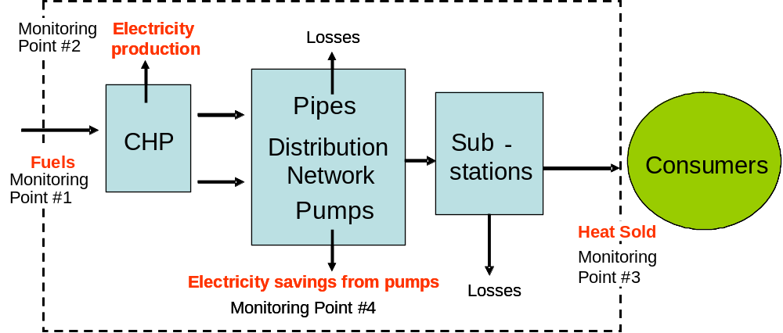
Figure 2: Pernik DH Project Boundary and main monitoring points.

B.4. Further baseline information, including the date of baseline setting and the name(s) of the person(s)/entity(ies) setting the baseline:

A baseline study was conducted and finalized in 16/01/2004 by Anand Subiah in Nexant and updated by Sari Siitonen Poyry Energy in 31/05/2007.

Nexant, Inc
1030 15th street, NW 750
Washington D.C 20005

Nexant and Poyry Energy are not project participants.

SECTION C. Duration of the project / crediting period

C.1. Starting date of the project:

The project started in October 2003.

C.2. Expected operational lifetime of the project:

The operational lifetime of the project is 25 years.
C.3. Length of the crediting period:

The crediting period is 5 years, 01/01/2008-31/12/2012 for ERUs
In addition, ERs generated 01/11/2004-31/12/2007 will be transferred as AAUs.

SECTION D. Monitoring plan

D.1. Description of monitoring plan chosen:

There were no approved monitoring methodologies available at the time project was designed. The monitoring plan describes the methodology that has been developed for this project. The monitoring plan describes how the emission reductions are estimated and monitored and how the baseline and project emissions are calculated. A Tracking Database (Excel-based workbook) has been developed to monitor and calculate emissions for the project and baseline scenario and to calculate the emission reductions. Baseline is monitored ex-post.
The following figure provides an algorithm of the monitoring of the emissions in the baseline scenario.
Figure 3- Algorithm of the monitoring and calculation of the baseline emissions.
CO2 emissions from
Fuel consumption for heat and power generation
2.
Gross Power generation
(measured at MP2)
Adjustment for the reduction
of heat consumption
due to substation replacement
(ex
-
ante estimate)
3.
1.
Gross Heat production
(calculated)
Baseline efficiency of Heat
Transmission & Distribution
system (estimated ex
-
ante)
4.
1.
Baseline Heat sold to consumers
(calculated)
Heat sold to consumers
(measured at MP 3)
Coal used
Emission factor for the fuel used for electricity and heat generation
(IPCC default factors)
(calculated based on ex
-
ante regression)
5.
CO2 emissions from
Fuel consumption for heat and power generation
2.
Gross Power generation
(measured at MP2)
Adjustment for the reduction
of heat consumption
due to substation replacement
(ex
-
ante estimate)
3.
1.
Gross Heat production
(calculated)
Baseline efficiency of Heat
Transmission & Distribution
system (estimated ex
-
ante)
4.
1.
Baseline Heat sold to consumers
(calculated )
Heat sold to consumers
(measured at MP 3)
for heat and power generation
(IPCC default factors)
(calculated based on ex
-
ante regression)
5.

The baseline emissions are due to the fuel consumption for gross heat and power generation necessary to provide a required amount of heat to the consumers taking into account heat losses. These emissions are calculated based on the ex-post measured amount of heat sold to consumers, adjusted to take into account two parameters impacted by the project activity:
- the historical level of losses in the heat distribution system, and
- the level of specific heat consumption (kWh/m³ of living space per year), which was reduced due to the introduction of the new substations by the project.
The following figure reflects the algorithm of project emission reductions monitoring and calculation.
Figure 4 - Algorithm of project emission monitoring and calculation.
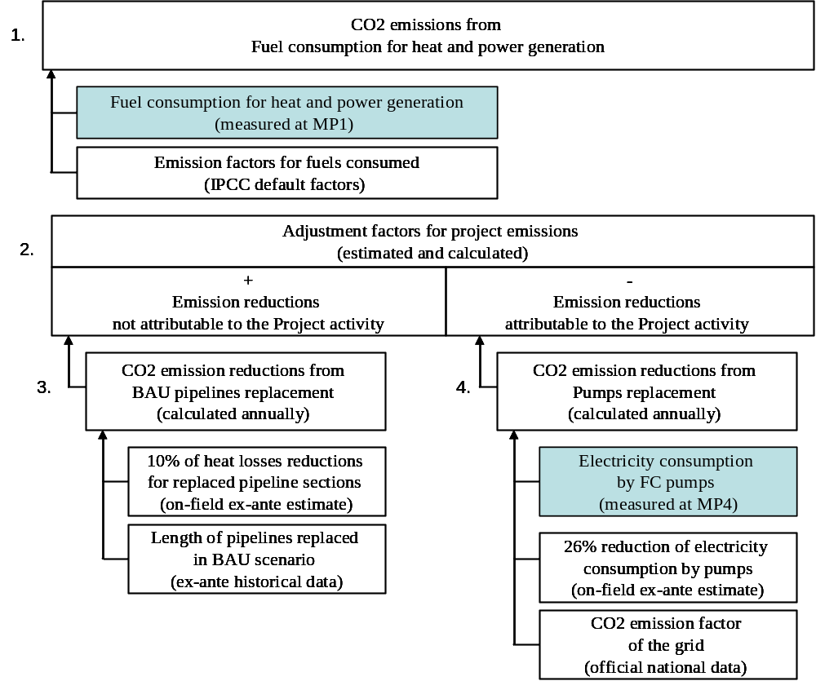

The project emissions are also due to the fuel consumption for gross heat and power generation. These emissions are calculated based on the ex-post monitored fuel consumption (Step 1 in the figure 4). Two adjustments are applied to the amount of the project emissions (Step 2 in the figure 4):
- First (Step 3), to take into account the emission reductions that would be generated anyway in the business-as-usual scenario (baseline) and are not attributable to the project activity. These emissions reductions will be achieved through continuation of the historical maintenance & repair practices. The replacement of 2 km of pipelines per year in the baseline will reduce heat losses from the replaced sections by 10%. The correspondent emission reductions are estimated using ex-ante historical data and are added to the project emissions.
- Second (Step 4), the replacement of the old pumps by the frequency controlled (FC) pumps in the project allows to reduce the electricity consumption by the district heating distribution system. The emissions reduction will be achieved due to the project via lower electricity generation by the regional power plants. The correspondent emission reductions are deducted from the total project emissions.

D.1.1. Option 1 – Monitoring of the emissions in the project scenario and the baseline scenario:

D.1.1.1. Data to be collected in order to monitor emissions from the project, and how these data will be archived:
ID number  (Please use numbers to ease cross-referencing to D.2.) | Data variable | Source of data | Data unit | Measured (m), calculated (c), estimated (e) | Recording frequency | Proportion of data to be monitored | How will the data be archived? (electronic/  paper) | Comment
P1 | Coal consumption | TP | Tonne | M | Monthly | 100% | Electronic | Coal consumption is measured by weighting belts (band scales)
P2 | Heavy Fuel Oil consumption | TP | Tonne | M | Monthly | 100% | Electronic | Fuel consumption at each HOB is measured by gauge readings monthly.
P3 | Emission factor, coal | Revised 1996 IPCC Guidelines for National GHG Inventories | gCO₂/MJ |  | Annual | 100% | Electronic
P4 | Emission factor, heavy fuel oil | Revised 1996 IPCC Guidelines for National GHG Inventories | gCO₂/MJ |  | Annual | 100% | Electronic
P5 | Electricity consumed in frequency controlled pumps | TP | MWh | M | Monthly | 100% | Electronic | Electricity consumption is measured by meters installed at each pump.
P6 | Electricity grid CO₂ emission factor | www.moew.goverment.bg | Kg CO₂/MWh |  | Annual | 100% | Electronic
P7 | Adjustment factor for infrastructure improvement | Kalkum B, 2000. District Heating Strategy and Action Plan. Sofia, Bulgaria | Scalar | E | Annual | 100% | Electronic | The reduction of heat losses in the distribution system due to the pipeline replacement was established ex-ante by the independent study

D.1.1.2. Description of formulae used to estimate project emissions (for each gas, source etc.; emissions in units of CO₂ equivalent):

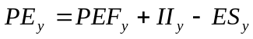 (1)
Where:
PE_{y} | total project emissions in year y (tCO₂e) .
PEF_{y} | Project emissions in year y resulting from the fossil fuel combustion for gross heat and power generation by the DH system (tCO₂e).
II_{y} | emission reductions in year y due to the replacement of the heat transmission and distribution pipes in continuation of the historical maintenance & repair practices (tCO₂e). These emissions reductions are not attributable to the project activity as they will be implemented anyway.
ES_{y} | emission reductions in year y due to the reduced grid electricity consumption by the frequency controlled pumps replacing the old pumps (tCO₂e).

Fossil fuel combustion for gross heat and power generation
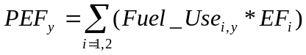 (2)
Where:
PEF_{y} | project emissions in year y resulting from the fossil fuel combustion for gross heat and power generation by the DH system (tCO₂e).
Fuel_Use_{i, y} | fuel i used in year y for gross heat and power generation (MJ). The fuel type 1 is a heavy fuel oil and the fuel type 2 is coal
EF_{i} | emission factor of the fuel i from the Revised 1996 IPCC Guidelines for National GHG Inventories (gCO₂e/MJ).

Replacement of pipes in continuation of historic maintenance & repair practices
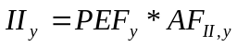 (3)
Where:
II_{y} | emission reductions in year y due to the replacement of the heat transmission and distribution pipes in continuation of the historical maintenance & repair practices (tCO₂e). These emissions reductions are not attributable to the project activity as they will be implemented anyway.
PEF_{y} | project emissions in year y resulting from the fossil fuel combustion for gross heat and power generation by the DH system (tCO₂e).
AF_{II, y} | adjustment factor in terms of heat losses reduction due to the replacement of the pipes in continuation of the historical maintenance & repair practices.

Adjustment factor for heat losses reduction due to pipes replacement in continuation of historic practices
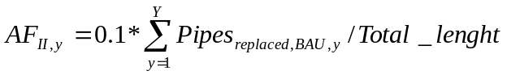 (4)
Where:
AF_{II, y} | adjustment factor in terms of heat losses reduction due to the replacement of the pipes in continuation of the historical maintenance & repair practices.
0.1 | share of heat losses reduced for each section of replaced heat pipes, estimated at 10% in the study District Heating Strategy and Action Plan. (Kalkum B, 2000. Sofia, Bulgaria).
Pipes_{replaced, BAU, y} | total length of heat pipes replaced from the start of the project in year y in continuation of historic practices (km). The estimated replacement of pipe per year without the project is 2 km/year.
Total_lengh | Total length of pipes in operation equal to 60 km.

Adjustment factor for reduced grid electricity consumption by the new frequency controlled pumps
(5)
Where:
ES_{, y} | emission reductions in year y due to the reduced grid electricity consumption by the frequency controlled pumps replacing the old pumps (tCO₂e). These emissions reductions are directly attributable to the project activity. Due to the expected reduction of the carbon intensity of the grid power generation in the coming years, the contribution of this factor on the total emission reduction by the project will be slightly lower.
El_cons | electricity consumption from the national grid by frequency controlled pumps in year y (MWh).
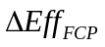 | share of electricity consumption reduced due to the installation of frequency controlled pumps. Based on the ex-ante monitored data, the pumps are 26% more energy efficient than the old pumps.
EF_{CO2_grid, y} | Emission factor of the electricity generation by the grid power plants in year y (kgCO₂/MWh).

Insignificant project emissions: The replacement of the old direct substations by the project with new indirect substations will lead to the marginal increase of electricity consumption since the old direct substations are hydrostatic and do not have an electric pump or electronic controls that the new substations employ. At the same time, the replacement of old indirect substations by new indirect substations will lead to the reduction of electricity consumption due to the installed variable flow pumping. In comparison to the electricity savings due to the installation of variable flow pumping, the possible increase of electricity consumption related to the substation replacements is likely to be insignificant and will not be taken into account in the calculations.

D.1.1.3. Relevant data necessary for determining the baseline of anthropogenic emissions of greenhouse gases by sources within the project boundary, and how such data will be collected and archived:
ID number  (Please use numbers to ease cross-referencing to D.2.) | Data variable | Source of data | Data unit | Measured (m), calculated (c), estimated (e) | Recording frequency | Proportion of data to be monitored | How will the data be archived? (electronic/  paper) | Comment
B1 | Coal consumption | TP | Tonne | C | Monthly | 100% | electronic
B2 | Emission factor, coal | Revised 1996 IPCC Guidelines for National GHG Inventories | gCO₂/MJ |  | Annual | 100% | Electronic
B3 | Electricity production | TP | MWh | M | Monthly | 100% | electronic | Electricity production are metered and read by TP.
B4 | Baseline heat production | TP | MWh | C | Monthly | 100% | electronic | Calculated based on baseline heat sold by dividing heat sold by transmission and distribution losses.
B5 | Baseline Heat sold | TP | MWh | M | Monthly | 100% | electronic | Heat meters are installed at the substations in each district are read monthly and adjusted by Adjustment factor due to savings of new substations in residential sector.

D.1.1.4. Description of formulae used to estimate baseline emissions (for each gas, source etc.; emissions in units of CO₂ equivalent):

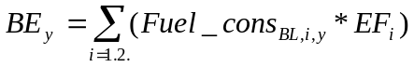 (6)
Where:
BE_{y} | total baseline emissions in year y (tCO₂e) .
Fuel_cons_{BL,i, y} | consumption of fuel i in year y for gross heat and power generation by the DH system in the baseline (MJ). The fuel type 1 is coal.
EF_{i} | emission factor of the fuel i from the Revised 1996 IPCC Guidelines for National GHG Inventories (gCO₂e/MJ).

Baseline coal consumption for gross heat and power generation
(7)
Where:

Fuel_cons_CO_{y} | Coal consumption in year y to generate heat and power in the baseline. It is calculated using a correlation between the heat and power generation and fuel consumption (tonnes). The correlation has been developed by Nexant in 2004 and is based on the historical data.
El_gen_gross_{y} | gross power generation in year y (MWh). The amount of electricity generation is not impacted by the project activity.
Heat_gen_gross_{y} | Gross heat generation in year y (MWh).

Gross heat generation in the baseline scenario

(8)
Where:
Heat_gen_gross_{y} | gross heat generation in year y (MWh).
Heat_sold_{BL,y} | baseline heat sold to the consumers in year y (MWh).
Eff_{transm_distrib} | Efficiency of heat transmission and distribution system in the baseline expressed by a share of gross heat production supplied to the consumers. The estimation of the district heating transmission and distribution efficiency is based on data from 1999-2002.

District heating transmission & distribution efficiency

(9)

Where:

Heat_sold_{BL,y} | baseline heat sold to the consumers in year y (MWh).
Eff_{transm_distrib} | efficiency of heat transmission and distribution system in the baseline expressed by a share of gross heat production supplied to the consumers. The estimation of the district heating transmission and distribution efficiency is based on data from 1999-2002.

The efficiency of district heating transmission and distribution depends on the throughput of the system estimated based on the amount of heat sold as it is represented on the figure 5. The relationship between these two parameters as developed by Pöyry Energy has a satisfactory high correlation factor (R² = 0.962).

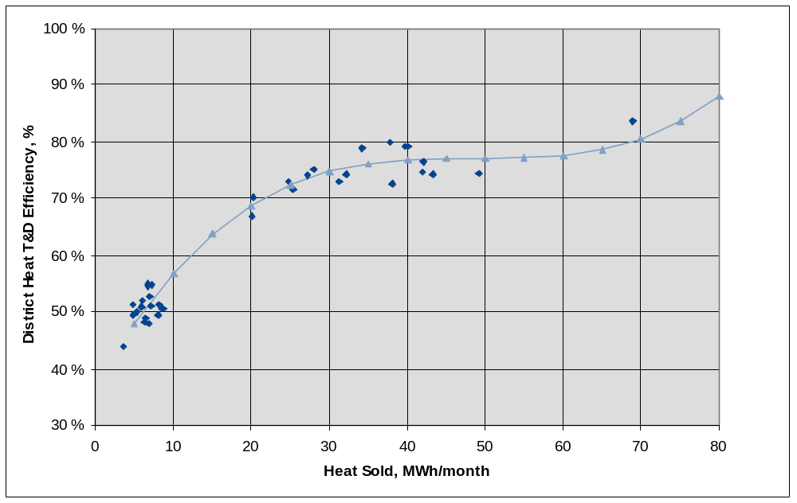
Figure 5 - Historical relationship between Heat Sold and Transmission & Distribution Efficiency.
Baseline heat sold to the consumers

(10)
Where:
Heat_sold_{BL,y} | baseline heat sold to the consumers in year y (MWh).
Heat_sold_{measured,y} | heat sold to the consumers in year y, measured during the project implementation (MWh)
ΔEff_{substation} | adjustment factor that takes into account the monitored reduction of specific heat consumption by residential consumers due to the installation of indirect substations by the project (%). More detailed information of the calculation of the adjustment factor is included in the Annex 2.

Events or trigger that could impact the correlations used to calculate the baseline emissions

Certain events, or triggers, can be substantial enough to warrant a change to the baseline. Such triggers are assumed to be major events that take place outside of the scope of the present project. It is assumed that these changes would have taken place irrespective of this project, and thus the baseline must be modified to reflect these changes. For example, the installation of a fluidized bed boiler (planned but with no certain timeframe for installation), will cause significant changes to the baseline. While it is impossible to know in advance the details of these triggers, the monitored baseline is adjusted to account for such changes as appropriate. The monitoring plan incorporates adjustment factors for changes in plant efficiency and these are used in conjunction with the correlation equations to adjust the baseline and project case. This adjustment ensures that major changes to the Pernik DH plant system are accounted and emission reductions are calculated only for the investment project related interventions. This also ensures that no revisions are needed to the monitoring plan. Triggers could include:
- Installation of a fluidized bed boiler to replace the existing boiler at the TP CHP.
- Very significant changes to the loading of the TP DH system (system plant load drops below 40%). These changes, whether due to huge changes is customer base or customer energy use, would change the operating plant characteristics and would require an adjustment to the baseline.

The likely impacts of these triggers and the changes that may be required to the baseline and monitoring plan are shown in Table 5 below.

Table 5: Likely Impact of Triggers

Triggers | Likely Impact on Baseline | Impact on Monitoring System
Installation of a new fluidized bed boiler to DHC Pernik to better combust poor quality coal | This can significantly alter the correlation between fuel use and electricity and heat generation. The baseline correlations developed may no longer be applicable and new correlations will have to be developed to redefine the baseline | The monitoring plan will not need to be changed since the measuring points will remain the same. The baseline correlation equation incorporates a factor that accounts for plant efficiency and this corrects for any change that may be necessary. Thus no changes will need to be made to the monitoring plan or the baseline correlation.
Very significant changes to the loading of the TP DH plant system (system plant load drops below 40%) | Very significant changes in plant operating conditions, whether due to huge changes is the customer base or customer energy use, may change the operating plant characteristics to the point that the correlation equation developed using historical data may not apply, requiring a new correlation to be developed. | The monitoring plan will not need to be changed since the measuring points will remain the same. The baseline correlation equation incorporates a factor that accounts for plant efficiency and this corrects for any change that may be necessary. Thus no changes will need to be made to the monitoring plan or the baseline correlation.

In addition, rehabilitation projects at apartment level impacting specific heat consumption could trigger the need to revise the baseline. This can monitored via change of specific heat consumption during verification stage, i.e. should specific heat consumption decrease after implementation of the project.

D. 1.2. Option 2 – Direct monitoring of emission reductions from the project (values should be consistent with those in section E.):

D.1.2.1. Data to be collected in order to monitor emission reductions from the project, and how these data will be archived:
ID number  (Please use numbers to ease cross-referencing to D.2.) | Data variable | Source of data | Data unit | Measured (m), calculated (c), estimated (e) | Recording frequency | Proportion of data to be monitored | How will the data be archived? (electronic/  paper) | Comment

This section is left blank on purpose.

D.1.2.2. Description of formulae used to calculate emission reductions from the project (for each gas, source etc.; emissions/emission reductions in units of CO₂ equivalent):

This section is left blank on purpose.

D.1.3. Treatment of leakage in the monitoring plan:

D.1.3.1. If applicable, please describe the data and information that will be collected in order to monitor leakage effects of the project:
ID number  (Please use numbers to ease cross-referencing to D.2.) | Data variable | Source of data | Data unit | Measured (m), calculated (c), estimated (e) | Recording frequency | Proportion of data to be monitored | How will the data be archived? (electronic/  paper) | Comment

D.1.3.2. Description of formulae used to estimate leakage (for each gas, source etc.; emissions in units of CO₂ equivalent):

No leakages are attributable to the project.

D.1.4. Description of formulae used to estimate emission reductions for the project (for each gas, source etc.; emissions/emission reductions in units of CO₂ equivalent):

ER_{y} = BE_{y} – PE_{y} (12)

ER_{y} | emissions reductions from the project in year y (tCO₂e)
BE_{y} | baseline emissions in year y (tCO₂e)
PE_{y} | project emissions in year y (tCO₂e)

D.1.5. Where applicable, in accordance with procedures as required by the host Party, information on the collection and archiving of information on the environmental impacts of the project:

An Environmental Assessment (EA) was completed in 1997 which was part of the feasibility study for the rehabilitation of the Sofia DH system. Remedial measures to address environmental concerns raised in the EA were incorporated in the Environmental Management Plan, which was completed in late 2001.

D.2. Quality control (QC) and quality assurance (QA) procedures undertaken for data monitored:
Data  (Indicate table and  ID number) | Uncertainty level of data  (high/medium/low) | Explain QA/QC procedures planned for these data, or why such procedures are not necessary.
(P1) Coal consumption | Low, ± 1% | Measured by band scales of the supplier and 3 band scales on site based on Instruction approved by Executive Director of TP and implemented by a special committee responsible for ER reporting within TP. Internal control is performed by Economic Director of TP.
(P2) Heavy fuel oil consumption | Medium | Fuel oil is delivered by rail into storage tanks. Deliveries from these tanks to local heat only boilers sites are made by road tanker. Consumption at each site is measured by gauge monthly based on Instruction approved by Executive Director of TP and implemented by a special committee responsible for ER reporting. Internal control is performed by Economic Director. Heavy fuel consumption is currently insignificant.
(P5) Electricity consumed in frequency controlled pumps | Low, ± 0.2% | Electricity consumed by network pumps are measured by installed electricity meters which are periodically calibrated by the Laboratory of the Electric Department to the Plant based on Instruction approved by Executive Director and implemented by a special committee responsible for ER reporting. Internal control is performed by Economic Director.
(B5) Electricity production | Low, ± 0.2-0.5% | Electricity meters at CHP are read every 10 days by Committee represented by Toplofikacia Pernik EAD and National Electricity Company which prepares a Protocol. At the end of the month a summarized monthly statement is prepared and approved by the Executive Directors of both companies.
(B7) Baseline Heat sold | Low, ± 4% | Produced quantity of heat is measured by heat meters, which produced automatically records for all measured parameters. This parameter is manually entered in the computer and used as basis for calculation of produced heat. The data are gathered on a monthly basis and are processed by Production-Technical Department. The gathered data is kept in both departments for archiving. Cross checking of the monthly reports is carried out by the heads of departments together with the Deputy Director of the Plant for Production and with the Director of the Plant for heat energy distribution and transmission.. Measured heat sold is further adjusted by savings due to new substations in residential sector.

Bulgarian regulations require that all measurement equipment should be calibrated at regular intervals according to specified standards. The calibrations are undertaken either by government organisations or in some cases by private companies. Heat meters are calibrated based on national requirement every two years.

D.3. Please describe the operational and management structure that the project operator will apply in implementing the monitoring plan:
Operational instructions
The company is managed by an Executive director designated by the Board of Directors.
To ensure compliance with the above-mentioned regulatory framework Toplofikacia – Pernik EAD has developed and the Executive director has approved of the following Rules and In-company instructions:
1. Rules for the organizational and management structure of „Toplofikacia - Pernik” EAD and its operations outlining the management principles and regulating operations of enterprises included in the structure of the company, and the company relations with third parties.
2. Rules on consumer relations
3. Rules on the work of the heat supply system operator
4. Working instructions on the way of collecting, handling, recording and storage of data related to the main parameters of the maintained technological processes and the quantity of production that are used as a baseline for setting the technical and economic indicators of the company.
5. Working instructions on: Organizational and technical operation, staff management, operational services, technical control, technical services, repair services, keeping of technical and operational documentation on environmental protection.

Technical Documentation
All parameters related to operation of process equipment are recorded in journals, reports, protocols etc. Each working station for operation of main facilities is equipped with an operational register where the specific process parameters are recorded on a monthly basis. Data processing, data analysis and maintenance are performed by the Production and Technical department. Primary data are kept on hard copy for at least 5 years. Data required for JI purposes are kept to cover adequately the crediting period. All processed data are stored in electronic form on personal computers and CD-ROM.
In view of securing the data required for input in the “follow-up database” additional concrete instructions for data collection, processing a keeping have been developed. The instructions comprise specific procedures for reporting on the quality and quantity of fuels, power and heat production, transmission, distribution and sale of heat energy.
Calibration of measuring devices is performed regularly, in compliance with the in-company procedures and the legal requirements.

Quality Assurance and Quality Control Procedure
Bulgarian regulations require that all measurement equipment should be calibrated at regular intervals according to specified standards. The calibrations are undertaken either by government organizations or in some cases by private companies.
Internal quality control
The in-company quality control is exercised by the following inspection units within the company:
1. Consumers Department to the enterprise for transmission and distribution of heat – responsible for control on heat supplied to consumers, analyses of heat allocation of consumed heat by consumers, and their individual bills; processing of claims submitted by consumers. The department reports to the Director of the Enterprise for transmission and distribution of heat, and he/she reports to the Executive director.
2. Inspectorate - responsible for the overall compliance of company operations to Regulation No 9 and the Rules on technical safety, operational instructions of plant and equipment and work stations, Law on healthy and safe conditions at work and all byelaws for its enforcement and the regulations for technical supervision of facilities involving higher risk. The Inspectorate comprises: Engineer on mechanical safety and technical supervision, who is also inspector on electric safety, and expert on health and safety issues; Environmental specialist and specialist in crisis management, general mobilization preparedness and fire safety.
3. Company specialist in metrology – responsible for control of power and heat measuring devices and their regular calibration according to the law. Measuring devices for trade purposes are subject to state checking every one or two years, depending of the type and application of the device. The Inspectorate and the metrology specialist of the company report directly to the Executive director. Orders for corrective measures to the three inspection units may be issued by the Executive director of the company.
Reporting and control
The operations of Toplofikacia – Pernik EAD are controlled by the following authorities: Ministry of Economy and Energy /MEE/, the State Commission for Energy and Water Regulation /SCEWR/, Ministry of Environment and Water /MOEW/ and the State Agency for metrology and technical supervision /SAMTS/.
The company submits regularly the following reports to these authorities:
- To MEE - monthly reports on the actual technical, economic and financial indicators.
- To SCEWR – at the end of each semester /six months/ reports on the actual indicators on the quality of heat supplies and data on the company relations with heat consumers.
- To MOEW, Regional inspectorate of environment and water /RIEW/- at the end of each semester - report in compliance with Regulation No 10 and annually – Annual Report on environment. Reports on the implementation of the monitoring plan are also submitted regularly.

Project Management
The implementation of the specific aspects of JI project is handled by the Project Management Unit /PMU/. The PMU files and records the entire documentation flow on the Agreement. The baseline documentation used to determine the amount of emission reductions has been handled by a Committee established by order of the Executive director. Chair of the Committee is the Director of the enterprise for co-generation.
The quantities of emission reductions are defined based on a calculation model (Tracking database), which requires input of baseline data on the following parameters: quantities of coal, HFO power and heat production and heat sold. Instructions, approved by the Executive director of the company are observed in relation to the manner of collecting, handling and recording the data referring to determining the quantities of the above-mentioned parameters.
The Committee has the following responsibilities:
1. Preparation, handling and record keeping of all the required monthly documents to be used for calculation of emission reduction quantities resulting form Project implementation.
2. Control on compliance with the instructions for collection, handling and recording of data referring to determining the quantities of coal, H.F.O., power and heat and heat sold for preparation and submission to the verifier.
3. Preparation of monthly and annual reports on the quantities of emission reductions, based on the monitoring plan approved by the IBRD.
4. Preparation of all required accounting documents related to annual payments under the Agreement.
The internal control on Agreement implementation is performed by the Economic Director, expressly assigned to this end by the Executive director.

Tracking Database Data Entry
The TP operating personnel will be responsible for ensuring that all required information is collected each month and input into the Tracking Database on a routine basis. Much of the data are being gathered on a daily basis. However, for the project monitoring plan, the data from all the individual sources that comprise the Pernik DH System will have to be summed up and recorded entered in a tracking database. After the baseline and project models have been calculated by the Tracking Database, the resulting GHG emissions reductions will be calculated as the difference of the two values. The result is the monthly carbon dioxide emission reduction due to project impacts. The monthly results will be aggregated annually. The Tracking Database will produce the project results, including monthly reductions of carbon dioxide equivalents. The recording of data is done at the TP head office where the MIS staff prepares daily, weekly, and monthly management reports. Individual plants report the data electronically to head office and summarize it to the system level on a monthly basis.
The TP will be responsible for ensuring that all required information is collected each month as well as annually and input into the Tracking Database. The Tracking Database will use the monthly data to calculate the project model GHG impacts. After the baseline and project models have been calculated by the Tracking Database, the resulting GHG emissions reductions will be calculated as the difference of the two values. The result is the monthly carbon dioxide emission reduction due to project impacts. The monthly results will be aggregated annually. The Tracking Database will output the project results, including monthly reductions of carbon dioxide equivalents, which will be periodically sent for verification throughout the lifetime of the project.
The following parameters must be monitored also on annual basis, and the results are input into the Tracking Database (i) annual Heat Sold, (ii) Heat Consumption of Residential Sector, (iii) reduction of heat consumption (%) in residential sector, and (iv) Adjustment Factor in order calculate Baseline Heat Sold.

D.4. Name of person(s)/entity(ies) establishing the monitoring plan:

The monitoring plan was established by Anand Subiah in Nexant in 16/01/2004 and updated by Sari Siitonen Poyry Energy in 31/05/2007.
Nexant and Poyry Energy are not project participants.

SECTION E. Estimation of greenhouse gas emission reductions

E.1. Estimated project emissions:

The estimated project emissions are:

Table 6a: Project emissions 2004-2007
Year | Project Case Fuel Emissions, CO₂e tonnes
2004 | 170,489
2005 | 861,597
2006 | 693,728
2007 | 694,993
Total | 2,420,808

Table 6b: Project emissions 2008-2012
Year | Project Case Fuel Emissions, CO₂e tonnes
2008 | 696,811
2009 | 698,722
2010 | 700,300
2011 | 701,781
2012 | 703,350
Total | 3,500,964

E.2. Estimated leakage:

There is no leakage identified for the project.

E.3. The sum of E.1. and E.2.:

See E.1.

E.4. Estimated baseline emissions:

The estimated baseline emissions are:

Table 7a: Baseline emissions 2004-2007

Year | Baseline Emissions, CO₂e tonnes
2004 | 177,932
2005 | 905,146
2006 | 783,884
2007 | 783,884
Total | 2,650,846

Table 7b: Baseline emissions 2008-2012

Year | Baseline Emissions, CO₂e tonnes
2008 | 783,884
2009 | 783,884
2010 | 783,884
2011 | 783,884
2012 | 783,884
Total | 3,919,422

E.5. Difference between E.4. and E.3. representing the emission reductions of the project:

The total emission reduction from the project is 230,038 tonnes CO₂e for the years 2004-2007 and 418,458 tonnes CO₂e for the years 2008 – 2012.

E.6. Table providing values obtained when applying formulae above:

Table 8a: Summary

Year | Estimated project emissions (tonnes of CO₂ equivalent) | Estimated leakage  (tonnes of CO₂ equivalent) | Estimated baseline emissions (tonnes of CO₂ equivalent) | Estimated emission reductions (tonnes of CO₂ equivalent)
2004 | 170,489 | 0 | 177,932 | 7,442
2005 | 861,597 | 0 | 905,146 | 43,548
2006 | 693,728 | 0 | 783,884 | 90,156
2007 | 694,993 | 0 | 783,884 | 88,891
Total (tonnes of CO₂ equivalent) | 2,420,808 | 0 | 2,650,846 | 230,038

Table 8b: Summary

Year | Estimated project emissions (tonnes of CO₂ equivalent) | Estimated leakage  (tonnes of CO₂ equivalent) | Estimated baseline emissions (tonnes of CO₂ equivalent) | Estimated emission reductions (tonnes of CO₂ equivalent)
2008 | 696,811 | 0 | 783,884 | 87,074
2009 | 698,722 | 0 | 783,884 | 85,163
2010 | 700,300 | 0 | 783,884 | 83,584
2011 | 701,781 | 0 | 783,884 | 82,103
2012 | 703,350 | 0 | 783,884 | 80,534
Total (tonnes of CO₂ equivalent) | 3,500,964 | 0 | 3,919,422 | 418,458

SECTION F. Environmental impacts

F.1. Documentation on the analysis of the environmental impacts of the project, including transboundary impacts, in accordance with procedures as determined by the host Party:
An Environmental Assessment (EA) was completed by the World Bank in June 1997 as part of the feasibility study for the rehabilitation of the Pernik DH project. The project was classified as Category B according the IBRD’s Operational Policy on Environmental Assessment which indicates that the impacts were site specific and do not affect the environment in a significant manner. The environmental issues were related to construction activities and include dust, noise, minor traffic disruptions, and handling of hazardous waste.
The project’s environmental benefits include fuel savings due to network efficiency gains; a reduction in the DHCs’ water consumption as a result of the rehabilitation program; and a reduction in particulate emissions due to the installation of an electrostatic precipitator.

F.2. If environmental impacts are considered significant by the project participants or the
host Party, please provide conclusions and all references to supporting documentation of an environmental impact assessment undertaken in accordance with the procedures as required by
the host Party:

Not applicable.

SECTION G. Stakeholders’ comments

G.1. Information on stakeholders’ comments on the project, as appropriate:

The environmental issues related to the project were made public through the Environmental Management Plan (EMP). The EMP was published in local newspapers and also was placed in he WB’s website. Public meetings were also held to discuss the EMPs. In these meetings, no concerns about the environment were raised.
Annex 1

CONTACT INFORMATION ON PROJECT PARTICIPANTS

Organisation: | Toplofikacia Pernik
Street/P.O.Box: | Moshino estate
Building: | CHPP Republika
City: | Pernik
State/Region:
Postal code: | 2303
Country: | Bulgaria
Phone: | +359-76-600-681
Fax: | +359-76-670-683
E-mail: | Koleva_gergana@abv.bg
URL:
Represented by:
Title: | PIU Manager
Salutation:
Last name: | Stanimirov
Middle name:
First name: | Milen
Department:
Phone (direct): | + 359 76 670 675
Fax (direct): | + 359 76 670675
Mobile:
Personal e-mail: | Koleva_gergana@abv.bg

Organisation: | IBRD as a Trustee of the Prototype Carbon Fund
Street/P.O.Box: | 1818 H street, NW/66 avenue d’Iéna
Building: | MC
City: | Washington D.C/ Paris
State/Region:
Postal code: | 20433/75116
Country: | USA/France
Phone: | +1-202-812-8407
Fax: | +1-202-522-7432
E-mail: | Ibrd-carbonfinance@worldbank.org
URL: | www.carbonfinance.org
Represented by:
Title: | Manager, Carbon Finance Unit
Salutation: | Mrs
Last name: | Chassard
Middle name:
First name: | Joelle
Department:
Phone (direct):
Fax (direct):
Mobile:
Personal e-mail:

Annex 2

BASELINE INFORMATION

Baseline emissions (parameter 6 in table 5) are calculated based on actual heat sold (4) measured at substation level. Measured heat sold in residential sector is adjusted by historical losses in network (see equation 9) and also adjusted by reduction of losses due to substation replacement (-12.24 % in 2006, see table 6) in residential. Baseline fuel consumption (5) is further calculated based on historical correlation between energy produced in baseline case and natural gas and heavy fuel oil consumption (see equation 7). Baseline CO₂ emissions are calculated utilizing IPCC conversion factor of 101.2 kg CO₂/GJ and caloric value of coal is provided by the project entity (2228 kWh/tonne).

Project emissions are calculated based on fuel consumption (1 and 2). Caloric value of fuels is provided by the project entity as 33.3 and 39.8 MJ/kg.

Emissions related to BAU pipeline replacement are added to project emissions based on chosen approach (see equation 3).

Table 5. Tracking database results for 2004- 2006

Year | Coal usage,  tonnes | Heavy Fuel Oil usage, tonnes | Electricity. Prod.  MWh | Heat Sold,  MWh | Baseline Fuel usage (coal),  tonnes | Baseline  tCO2e | Project  tCO2e | Reductions  tCO2e
No. | 1 | 2 | 3 | 4 | 5 | 6 | 7 | 8
2004 | 213,090 | 122 | 95,284 | 57,528 | 222,668 | 177,932 | 170,489 | 7,442
2005 | 1,076,611 | 1,072 | 489,419 | 232,317 | 1,132,723 | 905,146 | 861,597 | 43,548
2006 | 865,850 | 498 | 400,427 | 237,124 | 980,974 | 783,884 | 693,728 | 90,156

Additional detailed information is provided in this section for Adjustment factor calculation needed for Baseline heat sold (B5) calculation, i.e. how substation replacement reduction of specific heat consumption due to the project is monitored. Source for the methodology is Pöyry Energy Report 60K05788.01.Q010 to EBRD, September 25, 2006: Preliminary methodology for Monitoring and Verification of Energy Efficiency Measures, Annex 5. Methodology has been developed for the monitoring of specific substations. The adjustment factor used for ER monitoring is calculated based on reduction of normalized specific heat consumption.

Table 6. Calculation of Adjustment factor.

Degree days of the normal year | 2767
Year |  | 2001 | 2002 | 2003 | 2004 | 2005 | 2006
Adjustment factor:  Increase (+) / Decrease (-) compared to the level of the year 2001 | % |  | -4.29% | -5.45% | -10.52% | -14.25% | -12.24%
Make-up water consumption, t/a | t/a | 495604 | 608721 | 595559 | 545477 | 283968 | 204822
to level of 2001 | % |  | 22.82% | 20.17% | 10.06% | -42.70% | -58.67%
annual change | % |  | 22.82% | -2.16% | -8.41% | -47.94% | -27.87%
Heat output to DH network ( DH water), MWh | MWh/a | 320544 | 341975 | 352430 | 328040 | 318583 | 301375
DH consumption (DH water), MWh | MWh/a | 241728 | 226115 | 240457 | 218748 | 224443 | 223498
Heat losses in DH network (DH water), MWh | MWh/a | 78816 | 115860 | 111973 | 109292 | 94140 | 77877
Heat losses in DH network (DH water) | % | 24.59% | 33.88% | 31.77% | 33.32% | 29.55% | 25.84%
Average temp. of heat carrier (DH water) | degC | 70 | 72 | 73 | 73 | 74 | 74
Degree days |  | 2774 | 3030 | 3358 | 3212 | 3577 | 3468
Average outdoor temperature degC | degC | 11.4 | 10.7 | 9.8 | 10.2 | 9.2 | 9.5
Heat (DH) consumption of residential consumers, MWh | MWh/a | 181836 | 185682 | 195896 | 179363 | 181541 | 182709
Entire space heated volume for residential consumers | 1000m3 | 3152 | 3194 | 3210 | 3195 | 3194 | 3202
Specific heat consumption inc. DHW (residential) | kWh/m3,a | 57.69 | 58.14 | 61.03 | 56.14 | 56.84 | 57.06
DH consumption for space heating | MWh/a | 114601 | 111145 | 119980 | 106230 | 105141 | 103219
DH consumption for DHW preparation, MWh | MWh/a | 67234 | 74537 | 75916 | 73132 | 76399 | 79490
DH consumption for DHW preparation, % | % | 36.98% | 40.14% | 38.75% | 40.77% | 42.08% | 43.51%
Adjusted heat consumption in respect of a normal year inc. DHW | MWh | 181551 | 176055 | 174783 | 164649 | 157735 | 161860
Adjusted specific heat consumption in respect of a normal year inc. DHW | kWh/m3,a | 57.59 | 55.12 | 54.45 | 51.53 | 49.39 | 50.55

Substations are replaced only in the residential sector. As not all heat is sold to the residential consumers, the total heat sold is taken proportionally into account when calculating annually Adjustment factor. Calculation is included Tracking Database.

Annex 3

MONITORING PLAN

Please see Section D of the PDD.

Nexant, 2004, Baseline Study Bulgaria Sofia Pernik District Heating Project.
Modalities and Procedures for Clean Development Mechanism as defined in Article 12 of the Kyoto Protocol, FCCC/KP/CMP/2005/8/Add.1
CH₄ and N₂O emissions from heat and power production are in fact calculated in Tracking database. They are, however, insignificant.
The original calculation model (Tracking database) was developed in January 2004 by Nexant and PDD was positively pre-determined by TÜV. The calculation of the project emission was structured in a way where emission reductions from expected infrastructure improvement is added to the project emission, to reduce the total emission reductions from the project, since the expected infrastructure improvements would have happened without the project. Also, reductions from electricity savings due to frequency controlled pumps are subtracted from the project emissions.
Heavy fuel oil consumption showed no historical correlation with heat and power production, so it not taken into account in baseline case. It is, however, taken into account in project case (a conservative approach)
No other measures are taken to reduce specific heat consumption, e.g. heat meters were installed in apartments before the implementation of the project.
Emission reductions not attributable to project activity refer to adjustment factor in terms of heat losses reduction due to the replacement of the pipes in continuation of the historical maintenance & repair practices.
Nexant, 2004, Baseline Study Bulgaria Sofia Pernik District Heating Project.
Pöyry Energy Oy, 2007, Explanation Note, Baseline Model and Monitoring Database Revision of Sofia and Pernik District Heating Projects –PERNIK
2004 was partial year

