JOINT IMPLEMENTATION PROJECT DESIGN DOCUMENT FORM
Version 01 - in effect as of: 15 June 2006

CONTENTS
A. General description of the project
B. Baseline
C. Duration of the project / crediting period
D. Monitoring plan
E. Estimation of greenhouse gas emission reductions
F. Environmental impacts
G. Stakeholders’ comments

Annexes
Annex 1: Contact information on project participants
Annex 2: Baseline information
Annex 3: Monitoring plan
Annex 4: The calculation of the operating margin and build margin emission factors

SECTION A. General description of the project

A.1. Title of the project:
Reconstruction of Pervomayskaia CHP -14 with installation of combined cycle units.
Sectoral scope: (1) Energy industries (renewable/non-renewable sources)
PDD version: 8
Date: 06/09/2010
A.2. Description of the project:
Situation existing prior to the starting date of the project
The Pervomayskaia Combined Heat and Power Plant (CHP) -14 began operations in 1957. The installed capacity of the existing CHP-14 is:
- Electricity – 330 MW;
- Heat – 1773 Gcal/hour (7423 GJ/h).
The Pervomayskaia CHP is a thermal power plant initially designed to run on powdered coal (from Kuznetskyi coal fields) as primary fuel. Currently CHP primarily uses natural gas that is supplied via high pressure gas pipeline.
Project scenario
The purpose of the project is to increase the reliability and quality of the heat and electricity supply system of the residential and industrial sectors of Kirovskiy district and other districts of Saint-Petersburg using modern technology that decreases the environmental pollution including greenhouse gas emissions.
The reconstruction project of the Pervomayskaia CHP proposes the installation of three combined cycle units CCGT-180 instead of conventional cycle units based on steam turbines. The old CHP units based on two turbines PT-30-90/10, two turbines PT-60-130/13 and one T-50-130-1 would be removed from service except two units with T-50-130-1 steam turbines which will be used as reserve.
The installed capacity of CHP-14 will be 671.2 MW after the completion of the reconstruction. The Pervomayskaia CHP will include 3 combined cycle power plants, each with 190.4 MW installed capacity and two additional steam turbines of 50 MW each. New heat capacity for hot water production after reconstruction will be 1271 Gcal/h (5321 GJ/h). The equipment details are presented in Section A.4.2.
The implementation of the Pervomayskaia CHP reconstruction project will have the following advantages:
- Increased efficiency of electricity generation;
- Improve the cost effectiveness of combined heat and power production (CHP);
Under project implementation the up-to-date equipment with higher energy efficiency indexes as compared with average values within the energy system will be put into operation. Fuel saving in the energy system will be reached at the expense of increase in power output from new unit and replacing of ineffective equipment by the respective value Pervomayskaia CHP-14.
The essence of the investment project “Reconstruction of Pervomayskaia CHP-14” lies in the expansion of installed capacity of the existing power plant and as a consequence the increase in power output supplied to the North-west Consolidated Energy System. Additional energy, generated by Pervomayskaia CHP-14 replaces the electricity, generated at burning fuel plants connected with energy system, where the project is implemented.
Baseline scenario
The baseline scenario is based on the assumption of electricity supplied to the power grid, in which the project activity, in the absence of the project, carried out on existing equipment Pervomayskaya CHP-14 and thermal power plants belonging to this grid. Existing capacity of thermal power stations of the North-West region can provide additional generation of electricity, equivalent project formulation PSU. This means that the generation of electricity at power (thermal power stations) URES “North-West” should be reduced by an appropriate amount.
A JI specific approach was used for the baseline setting. Please see Section B for more detailed information.
Brief history of the Project
"UES of Russia" (Unified Energy System of the Russian Federation) RJSC has started to get prepared for implementing the mechanisms of Kyoto Protocol long before its ratification in Russia. "UES of Russia" RJSC has made every effort to cooperate with the UNFCCC (United Nations Framework Convention on Climate Change). For those purposes, the Energy Carbon Fund was established in 2001.
The Fund’s main achievements:
- The Fund took a complete physical inventory of the greenhouse gas emissions from 1990 to the present day at the power plants belonging to "UES of Russia" RJSC. Taking such an inventory met the world’s standards. A greenhouse gas emissions inventory has been created.
- A greenhouse gas emissions monitoring system that includes an accounting system is well adjusted and in operation. The greenhouse gas emissions inventory is being put together.
- Joint implementation projects were prepared for approval by state authorities. Of them, a number of projects successfully went through the international determination. Foreign investors were attracted to take part in the joint implementation projects that passes such determination. Together with regional energy companies, the Fund took part in international tenders for buying greenhouse gas emissions quotas.
- The information analysis system Greenhouse Gases was developed and then implemented at most of the energy companies.
- Prospective volumes of the greenhouse gas emissions generated by the Unified Energy Network of Russia were determined.
- Several regulatory-and-procedural documents, including a procedure for calculating greenhouse gas emissions generated by thermal power plants have been issued and is in effect.
In 2006, the Energy Carbon Fund estimated whether it is possible to implement the project “Reconstruction of Pervomayskaia CHP -14 with installation of combined cycle units” as a joint implementation project.
On June 20, 2006 the decision of execution of JI Agreement by and between TGK-1 and Fortum was approved by Board of Director of TGK-1 (minutes No. 2)
On February 20, 2008 Fortum, the Russian Territorial Generating Company No. 1 (TGC-1) and ECF Project Ltd. (subsidiary of Energy Carbon Fund) had signed an agreement according to which Fortum would purchase approximately 5 million tones of emission reduction units (ERU) from TGC-1.
The purchase agreement is based on the Memorandum of Understanding between Fortum and United Energy Systems of Russia (RAO UES) in 2006, and it is the biggest of its kind ever made in Russia. The ERUs purchased cover approximately half of Fortum’s annual CO2 emissions and their value is approximately EUR 70 million based on the current market value of Certified Emission Units in developing countries.
The ERUs will come from Joint Implementation projects conducted at TGC-1’s production facilities during the Kyoto Period (2008-2012) of the European Emissions Trading Scheme. The projects TGC-1 will implement include reconstruction of hydro power plants in Leningrad Region, expansion and reconstruction of combined heat and power generation facilities as well as energy efficiency improvements with district heating network in St.Petersburg. Fortum can use the received ERUs to cover part of its own emissions once these projects are completed and their emission reduction has been verified.
In 2006, "UES of Russia" RJSC developed “The Master Plan for placing power plants up to 2020”. This Master Plan is virtually a consolidated investment that was prepared based on the plans developed by those plants themselves and was later approved by the Government of the Russian Federation (the Government of the Russian Federation Executive Order No. 215-r of February 22, 2008). JSC “TGC-1” (TGK stands for Territorial Generating Company) was founded in March 2005 as part of Russia’s power industry reform. JSCs “Lenenergo”, “Kolenergo” and “Karelenergogeneratsiya” acted as founders of TGC-1. On October 1, 2005 the company started its operating activity. On November 1, 2006 TGC-1 completed the merging of its assets and establishment of an integrated operating company, which is a legal successor in rights and obligations of the merged legal entities. In connection with closing down "UES of Russia" RJSC, the company inherited the investment plans of "UES of Russia" RJSC. However, it is not obliged to implement them.
Even though the project is part of “The Master Plan for placing power plants up to 2020”, JSC “TGK-1” has no obligations to the state to implement it. The Master Plan does not provide a list of companies, the facilities of which are its part. Therefore, in case the schedule to put new power facilities in operation is not followed to, the state cannot impose penalties on any of such companies. It is also confirmed by the fact that actual deadlines and volumes for putting new power plants in operation considerably differs from those in the Master Plan.

A.3. Project participants:
Party involved | Legal entity project participant  (as applicable) | Please indicate if  the Party involved  wishes to be  considered as  project participant  (Yes/No)
Russian Federation (Host Party) | - JSC “TGC-1”  - ECF Project Ltd. | No  No
Finland | - Fortum Power and Heat Oy | No
JSC “TGC-1” is the leading producer and supplier of electricity and heat power in the North-West region of Russia and the third largest territorial generating company in Russia in terms of installed capacity. It operates 55 power generating stations in four regions of Russia – the City of St Petersburg, Republic of Karelia, Leningrad Region and Murmansk Region. The company’s generation assets include thermal, hydroelectric, diesel and co-generation power plants and it has a heating network of 940 km.
The state registration of the company took place on March 25, 2005. TGC-1 began operating on October 1, 2005.
A.4. Technical description of the project:

A.4.1. Location of the project:
The location of the project is shown on the figure 1 below.
A.4.1.1. Host Party(ies):
Russian Federation
A.4.1.2. Region/State/Province etc.:
Leningrad region
A.4.1.3. City/Town/Community etc.:
St. Petersburg
A.4.1.4. Detail of physical location, including information allowing the unique identification of the project (maximum one page):
The Pervomayskaia CHP is located in the south-west part of St. Petersburg in Kirovskiy district. The CHP-14 location has geographical coordinates of 59°52′21″ north latitude and 30°14′47″ east longitude.
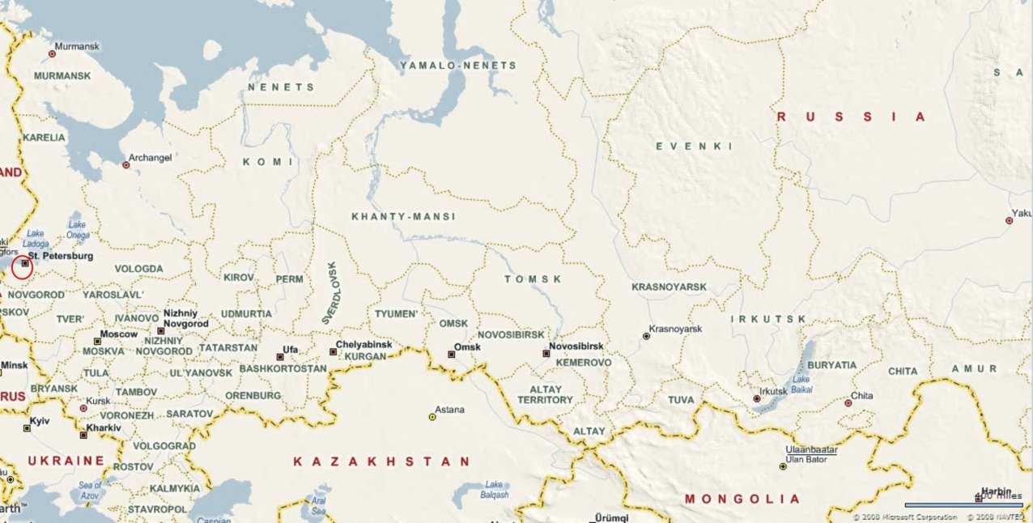
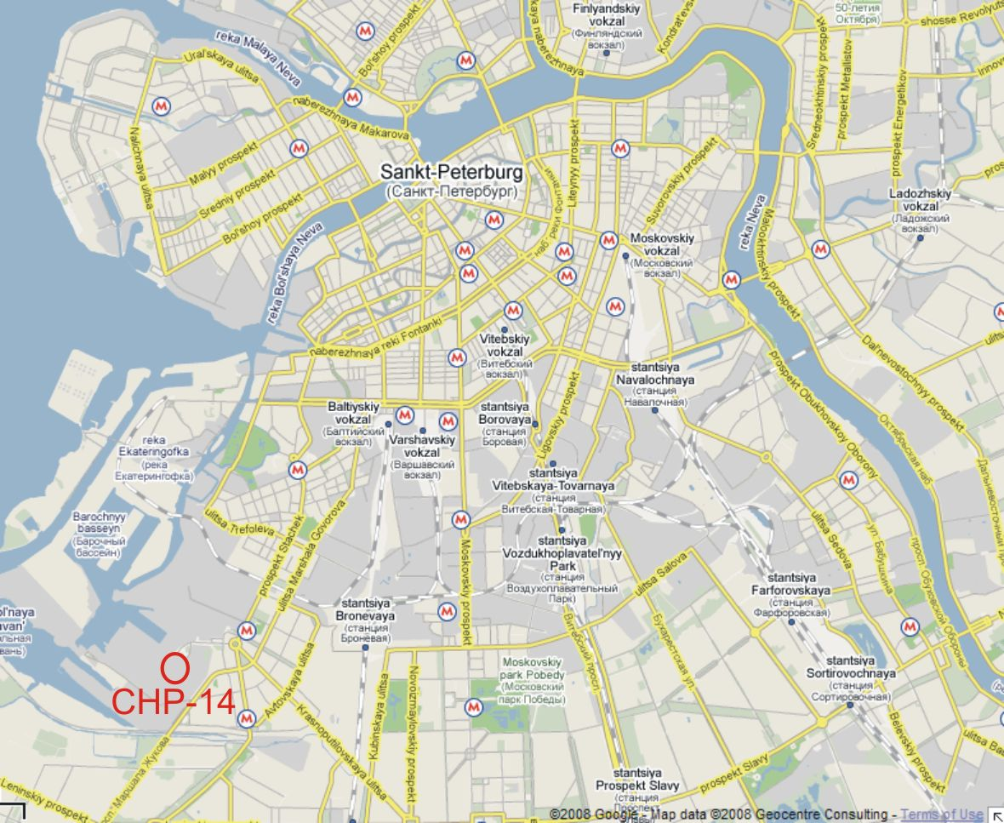
Figure A.4.1 Project location
A.4.2. Technology(ies) to be employed, or measures, operations or actions to be implemented by the project:
The reconstruction of the Pervomayskaia CHP consists of the installation of three sets of CCGT-180 that use combined cycle (CC) for power generation.
Each CCGT-180 set is made up of the following equipment:
- Two gas turbine units of V64.3A type manufactured by Ansaldo Energia together with WY18Z generator;
- Two horizontal waste heat boilers (Heat Recovery Steam Generator) to generate steam at two pressures Е-99.5/13.5-7.61/0.59-542/210 manufactured by Podolskyi Machinery Construction Plant OJSC;
- One Т-50/64-7.4/0.12 condensing steam turbine with bleed manufactured by “Kaluzhskyi Turbine Plant” OJSC, with TZFP-63-2MUZ generator manufactured by Elektrosila OJSC, installed on the single footing with turbine;
Also reconstruction of plant foresees installation new hot water boilers
- Seven hot-water boilers of KV-GM -175-150 type.
The CCGT sets will work in the regime of base loads.
The system configuration prior to project implementation is shown in Figure 2.
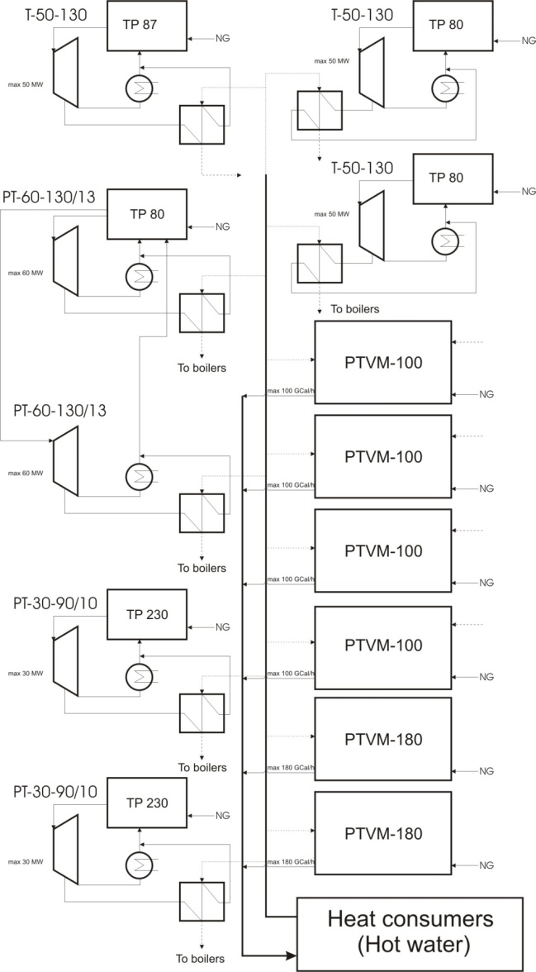
Figure A.4.2 System configuration before project implementation
The situation following project implementation is shown in figure 3. It corresponds to heat and power output at the coldest winter “design” condition: -26 °C ambient temperature. During the heating season the station works according to the heating schedule with maximum electricity generation. Installed heat capacity after reconstruction will constitute 1301.9 Gcal/hour total, out of which 30.9 Gcal/hour heat load is for steam generation and 1271 Gcal/hour is for hot water production. Release of heat from CHP is maintained at a supply temperature of 150/130 °C with return water temperature at 70 °С.
CCGT-180 energy blocks work in heat-extraction mode. The remaining heat load is covered by seven hot-water boilers of KV-GM -175-150 type that are installed in the assembled auxiliary building.
During the non-heating season the station provides domestic and service water heating only. This non-heating configuration is shown in Figure 4.
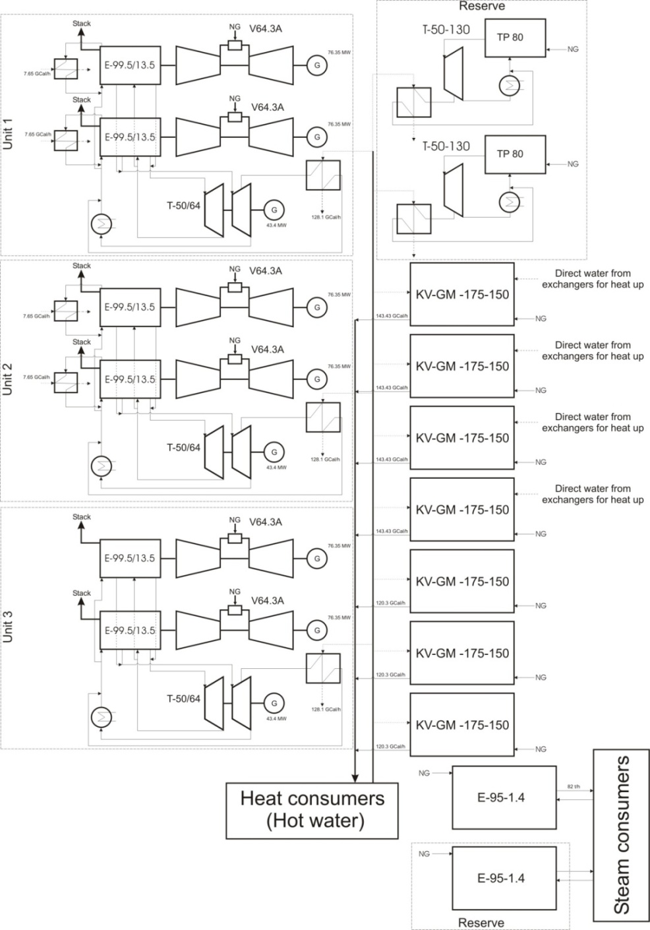
Figure A.4.3 Configuration after project implementation (winter design: -26 °C ambient temperature)
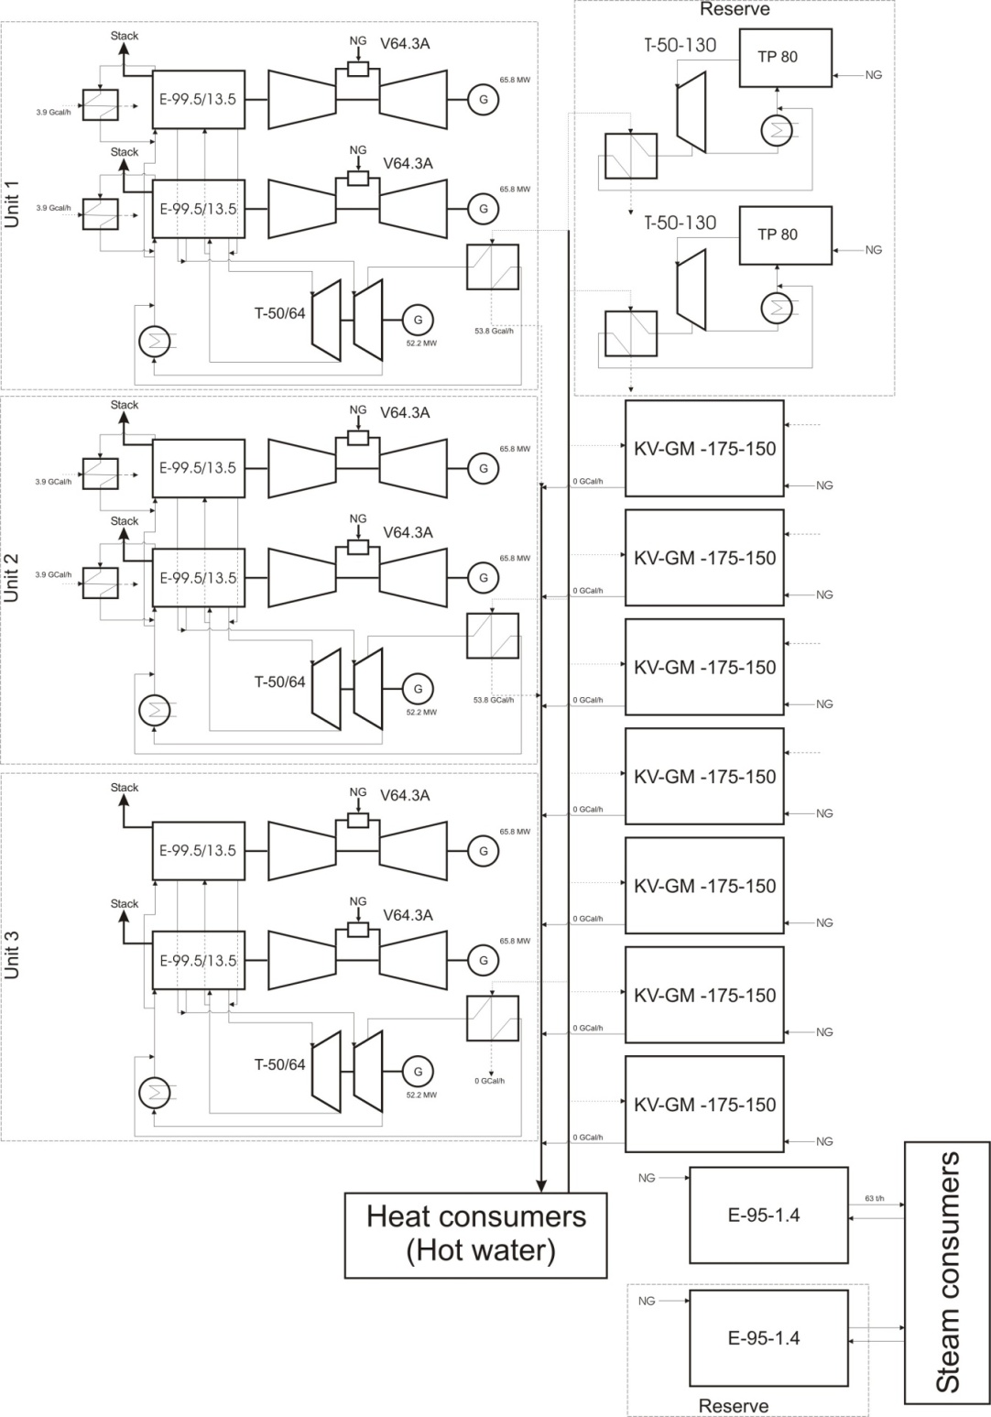
Figure A.4.4 System configuration after project implementation (summer season)
Connected load in steam (constant throughout the year) is released by the steam boiler of Е-95-1.4-250GM type (one of two is a back-up).
The release of the generators capacity is maintained through block scheme with 110 kV voltage in 110 kV switchgear. The connection of each generators of the CCGT-180 MW block is designed into individual cells of 110 kV switchgear and later into the grid of 110 kV.
Double-wound transformers of TDC-100000/110U1 type of 100 МVА output are designed to be installed in the block of turbo generators of gas turbine units. Double-wound transformers of TDC -80000/110-UHL1 type of 80 МVА output are designed to be installed in the turbogenerator block of steam turbine units. Turbo generators of gas and steam turbines are connected to the low-voltage winding of two double-wound transformers.
Implementation schedule
The reconstruction of CHP will be done in four stages. The schedule for the different stages is presented in table 1 and corresponding changes of equipment composition at each stage is shown in table 2.
Table 1 Schedule of reconstruction of CHP-14
Stage | Duration, months | Expected time of stage completion
1st stage | 29 | April 2010
2nd stage | 12 | January 2011
3rd stage | 18 | July 2012
4th stage | 22 | May 2014
Table 2 Change of existing equipment after completion of each stage
Name | 1st stage | # | 2nd stage | # | 3rd stage | # | 4th stage | #
New equipment installed in project scenario
Gas turbines | V64.3A | 2 | V64.3A | 4 | V64.3A | 4 | V64.3A | 6
Steam turbines | Т-50/64-7.4/0.12 | 1 | Т-50/64-7.4/0.12 | 2 | Т-50/64-7.4/0.12 | 2 | Т-50/64-7.4/0.12 | 3
Water boilers |  |  |  |  | KV-GM -175-150 | 4 | KV-GM -175-150 | 7
Steam Boilers |  |  |  |  | Е-95-1.4-250GM | 2 | Е-95-1.4-250GM | 2
Heat-recovery boiler | Е-99.5/13.5-7.61/0.59-542/210 | 2 | Е-99.5/13.5-7.61/0.59-542/210 | 4 | Е-99.5/13.5-7.61/0.59-542/210 | 4 | Е-99.5/13.5-7.61/0.59-542/210 | 6
Existing equipment kept in project scenario
Steam turbines | PT-30-90/10  PT-60-130/13  T-50-130-1 | 2  2  3 | PT-30-90/10  PT-60-130/13  T-50-130-1 | 2  2  3 | T-50-130-1 | 2 | T-50-130-1 | 2
Power boiler | TP 230  TP 87  TP 80 | 2  1  3 | TP 230  TP 87  TP 80 | 2  1  3 | TP 80 | 2 | TP 80 | 2
Water boilers | PTVM-100  PTVM-180 | 4  2 | PTVM-100  PTVM-180 | 3  2
Expected power delivery to the grid and net heat generation after first stage completion (from January 2010) up to the end of the first commitment period of the Kyoto Protocol (2012) is presented in table 3.
Table 3 Expected net power and heat generation in 2010-2012
Year | 2010 | 2011 | 2012
Power generation, MWh | 2 115 222 | 3 607 698 | 3 824 650
Heat generation, Gcal | 2 373 468 | 2 859 608 | 2 859 610
Using combined-cycle (CC) technology for electricity production is not widespread in the Russian Federation. The majority of big power plants are based on single-cycle operation. So the plant reconstruction by installing CC unit will have significantly better performance in comparison with traditional steam-turbine technology.
Training programme
According to the contract with a company JCS "EMK-Engineering" comprehensive training program is conducted for a selected number of Employer’s shift engineers, operations and maintenance personnel. The training will be conducted at the Employer’s site.
A.4.3. Brief explanation of how the anthropogenic emissions of greenhouse gases by sources are to be reduced by the proposed JI project, including why the emission reductions would not occur in the absence of the proposed project, taking into account national and/or sectoral policies and circumstances:
Greenhouse gas emissions will be reduced due to displacement of electricity from the grid produced by fossil fuel power plants that use traditional steam-turbine technology by electricity generated by Pervomayskaia CHP that will produce electricity through combined cycle units with lower carbon intensity in comparison with electricity from the grid.
A.4.3.1. Estimated amount of emission reductions over the crediting period:

 | Years
Length of the crediting period | 2 years
Year | Estimate of annual emission reductions  in tonnes of CO₂ equivalent
2010 | 210 273
2011 | 372 227
2012 | 404 000
Total estimated emission reductions over the crediting period  (tonnes of CO₂ equivalent) | 986 501
Annual average of estimated emission reductions over the crediting period  (tonnes of CO₂ equivalent) | 328 834

From 2013 to 2017
 | Years
Length of the crediting period | 5 years
Year | Estimate of annual emission reductions  in tonnes of CO₂ equivalent
2013 | 504 749
2014 | 707 520
2015 | 898 664
2016 | 898 664
2017 | 898 664
Total estimated emission reductions over the crediting period  (tonnes of CO₂ equivalent) | 3 908 262
Annual average of estimated emission reductions over the crediting period  (tonnes of CO₂ equivalent) | 781 652

A.5. Project approval by the Parties involved:
The project will be approved by the Russian Federation after the approval of the Russian procedure for the registration of JI projects. The Parties’ Letter of Approval will be received later.

SECTION B. Baseline

B.1. Description and justification of the baseline chosen:
Indication and description of the approach chosen regarding baseline setting
According to paragraph 9 of the “Guidance on criteria for the baseline setting and monitoring”, version 02 (hereinafter referred to as “Guidance”), the project participants may select either:
(a) An approach for baseline setting and monitoring developed in accordance with appendix B of the JI guidelines (JI specific approach); or
(b) A methodology for baseline setting and monitoring approved by Executive Board of clean development mechanism (CDM).
During the preparation of PDD there was approved by Executive Board of CDM Methodology AM0048 “New cogeneration facilities supplying electricity and/or steam to multiple customers and displacing grid/off-grid steam and electricity generation with more carbon-intensive fuels”. The Methodology AM0048 is applicable to new natural gas combined cycle power plants and could be used for development of the PDD. However the Guidance is not binding any restriction whether we must use Option (a) or (b). Take advantage of this right we use the Option (a) – JI specific approach, partially based on the following approved methodologies and methodological tools:
- AM0029 (“Baseline Methodology for Grid Connected Electricity Generation Plants using Natural Gas” (version 3)) is applicable to new natural gas combined cycle (NGCC) power plants that only produce electricity. The proposed project involves the use of some existing equipment as well as the installation of new NGCC equipment. Moreover, the proposed project would produce both electricity and heat. Thus AM0029 is not applicable for the proposed project.
- AM0061 (“Methodology for rehabilitation and/or energy efficiency improvement in existing power plants” (version 2.1)) is not applicable where new equipment is added.
- AM0062 (“Energy efficiency improvements of a power plant through retrofitting turbines” (version 1.1)) is not applicable where cogeneration is involved.
- ACM0007 (“Baseline methodology for conversion from single cycle to combined cycle power generation” (version 3)) is only applicable when the initial state was a gas turbine or internal combustion engines, and that the original equipment remains operational after project implementation. Neither is the case here. The initial state here was the use of steam turbines.
- “Combined tool for identification of baseline scenario and demonstration of additionality” (version 2.2),
- “Tool to calculate the emission factor for an electricity system” (version 2)
In the following text, we describe the methodological procedure step by step, followed by its application to the specific project.
Applicability
The proposed JI specific approach is applicable to project activities that implement rehabilitation measures in an existing fossil fuel fired cogeneration plant for and the purpose of enhancing its energy efficiency.
The following conditions apply:
- The project activity plant supplies electricity to the electricity grid and heat to consumers through a heat distribution centre.
- The project activity is implemented in an existing cogeneration plant and involves its reconstruction. The installed power and/or heat generation capacity may increase as a result of the project activity.
- Only rehabilitation measures which require capital investment and improve efficiency (as per the definition above) shall be included. Regular maintenance and housekeeping measures cannot be included in the proposed project activity;
- All major equipment in use prior to project implementation (boilers, turbines, generators, and heat exchangers) should have a remaining life that is equal to or exceed the proposed crediting period. Thus the current equipment could supply electricity and heat for the duration of the proposed crediting period.
- The lifetime of any new equipment installed should also equal or exceed the proposed crediting period.
- The project is limited to the case where natural gas is the main fuel used both before and after project implementation. Because of supply interruptions and other problems, it is permissible to use other fuels in the project scenario, taking into consideration additional emissions from such fuel use.
The proposed methodology is not applicable to:
- Greenfield cogeneration plants;
- Captive cogeneration plants that produce heat and power for in-house consumption.
In addition, the applicability conditions included in the tools referred to above apply.
The proposed project meets all the applicability conditions specified above, as well as those relevant to the Tools used.
The basic fuel used on Pervomaiskaia CHP is natural gas. Liquid gas turbine fuel and residual fuel oil are used as reserve fuel. Note that since these fuels have higher emissions factor compared to the main fuel, natural gas, any use of the reserve fuels would increase project emissions, and reduce emissions reductions. This is therefore conservative.
Procedure for estimating remaining lifetime of the existing equipments
The following approaches are used to estimate the remaining lifetime of the existing equipments, i.e. the time when the existing equipments would need to be replaced/rehabilitated in the absence of the project activity:
- The typical average technical lifetime of the different type of equipments may be determined taking into account common practices in the sector and country (e.g. based on industry surveys, statistics, technical literature, etc.);
- The practices of the responsible company regarding replacement/rehabilitation schedules may be evaluated and documented (e.g. based on historical replacement records for similar equipments).
The time of replacement/rehabilitation of the existing equipments in the absence of the project activity should be chosen in a conservative manner, i.e. the earliest point in time should be chosen in cases where only a time frame can be estimated and should be documented.
The baseline established below assumes continuation use of the installed equipment in spite of the fact that this equipment reached its depreciation stage. In the Russian Federation the time for depreciation of equipment of various stages is estimated and approved. In accordance with power strategy of Russia the 50 % of all capacities of thermal power stations and hydro power stations of Russia will wear out their resource (reach its depreciation stage) by 2010. However by 2010, the equipment upgrade on power station blocks that reached its depreciation stage (worn its resource) will not have time to take place. The further prolongation of equipment use requires an individual approach for each block. In particular that such prolongation is possible on CHP - 14 anticipates that the reconstruction project will leave two extraction turbines and boilers in a cold reserve. Individual prolongation of equipment depreciation time (lifetime) in accordance with publication equals to 1.35-1.5 of its initial duration (economic life), i.e. in our case for the blocks installed on CHP - 14 it is 77-110 thousand working hours or more. This approximately equals to 10-15 years of operation.
Procedure for the identification of the most plausible baseline scenario and assessment of additionality
For the selection of the most plausible baseline scenario and assessment of additionality, use the latest version of the “Combined tool to identify the baseline scenario and demonstrate additionality”. Version 02.2. is used here.
Description and application of these tool presented in section B.2
Normally, a baseline methodology determines baseline emissions first followed by project emissions. In this case, the baseline scenario must match the heat and electricity output of the project scenario and provide the same amount of heat and power with the baseline technology. Therefore, for this project, we first consider Project emissions.
Project emissions
The project activity is power and heat generation using CCGT-180 combined cycle units. Old CHP units and boilers, as well as peak load boiler will be used during the construction period. So combustion of natural gas (as primary fuel) in gas turbines to generate electricity and heat is main source of emissions. Also project foresees combustion of natural gas (as primary fuel) and residual fuel oil (as reserve fuel) in peak load boilers. The CO₂ emissions from project activity (PE_{y}) are calculated as follows:
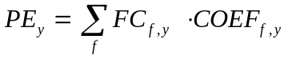 (1)
where:
FC_{f,y}: = the total volume of natural gas or other fuel ‘f’ combusted in the project plant or other startup fuel (m³ or similar) in year(s) y
COEF_{f,y}: = the CO₂ emission coefficient (tCO₂/m³ or similar) in year(s) for each fuel and obtained as:
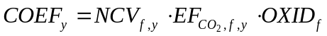 (2)
where:
NCV _{f,y} : = the net calorific value (energy content) per volume unit of fuel f in year y (GJ/m³ or similar) as determined from the fuel supplier;
EF_{CO2},_{f,y}: = the CO₂ emission factor per unit of energy of fuel f in year y (tCO₂/GJ) as determined from the fuel supplier, wherever possible, otherwise from local or national data;
OXID_{f}: = the oxidation factor of fuel f.
Baseline emissions
The reconstructed plant or additional unit can change heat and power output of plant. Moreover heat and power output depends on power deficit or excess in region, number of heat consumers, ambient temperatures etc. So there is considerable uncertainty relating to which type of other power and heat generation is substituted by the power and heat generation of the project plant.
Baseline emissions are those emissions that are associated with the production of heat and electricity that are identical to the output of the project CHP plant. Baseline emissions are determined by emissions from existing CHP equipment for generating heat and power to their limit. Then additional emissions are from fuel use in boiler for excess heat requirement in project scenario and/or emissions in the grid for excess power demand. The calculation of baseline emissions is therefore based on different emission factors for different quantities of electricity and heat generated. As represented in figure 5, the following cases are differentiated:
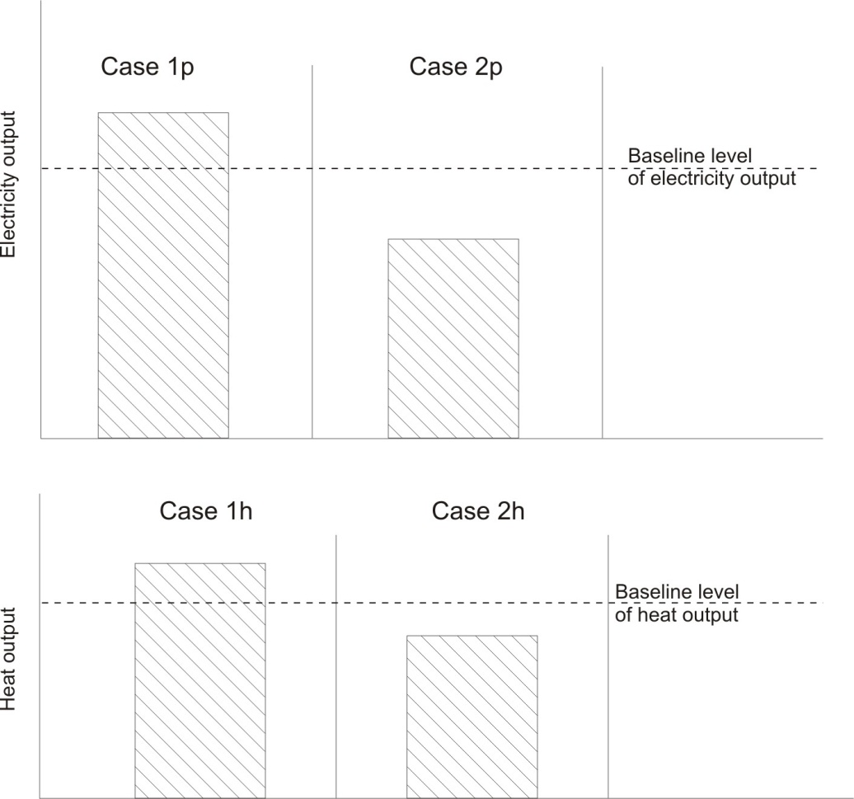
Figure B.1.1 Baseline cases
The any combination of cases 1p, 2p, 1h, 2h are possible. Determine the baseline level of electricity output. The conservative approach is used to determine baseline of power output. We cannot separate fuel in CHP only for heat and only for electricity generation. Therefore the comparison of fuel uses for historical level of heat and electricity output from CHP uses to determine baseline level.
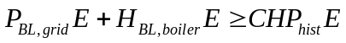 (3)
where
P_{BL,grid}E: = the CO₂ emission (tCO₂) from electricity grid in equivalent of historical level from CHP;
H_{BL,boiler}E: = the CO₂ emission (tCO₂) from heat generation in equivalent of historical level from CHP;
CHP_{hist}E: = the CO₂ emission (tCO₂) from CHP for heat and electricity generation at historical level.
If this inequality is true then as limit of baseline power generation uses maximum of historical electricity generation at the plant. And all historical level of fuel consumption and heat generation also corresponds to this year of electricity generation.
(4)
where
EG_{BL,lim}: = the limit of baseline electricity generation (MWh or similar);
EG_{CHP, max,hist,yh}: = the maximum level of historical electricity generation (MWh or similar) in the year y_{h};
y_{h}: = is year of the maximum historical electricity generation;
HG_{BL,lim}: = the limit of baseline heat generation (GJ or similar);
HG_{CHP, yh}: = the heat generation (GJ or similar) that corresponds to the year y_{h};
FC_{BL,lim}: = the limit of baseline fuel consumption (m³ or similar);
FC_{CHP, yh}: = the fuel consumption (m³ or similar) that corresponds to the year y_{h}.
If the inequality is false then as limit of baseline power generation uses minimum of historical electricity generation at the plant. And all historical level of fuel consumption and heat generation also corresponds to this year of electricity generation.
(5)
where
EG_{BL,lim}: = the limit of baseline electricity generation (MWh or similar);
EG_{CHP, min,hist,yh}: = the minimum level of historical electricity generation (MWh or similar) in the year y_{h};
y_{h}: = is year of the minimum historical electricity generation;
HG_{BL,lim}: = the limit of baseline heat generation(GJ or similar);
HG_{CHP, yh}: = the heat generation (GJ or similar) that corresponds to the year y_{h};
FC_{BL,lim}: = the limit of baseline fuel consumption (t.c.e. or similar);
FC_{CHP, yh}: = the fuel consumption (t.c.e. or similar) that corresponds to the year y_{h}.
Emission from the electricity grid (P_{BL,grid}E) in equivalent of historical level from CHP calculated as follow:
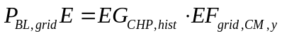 (6)
where
EG_{CHP, hist}: = average historical electricity generation (MWh or similar) for the last 5 years;
EFgrid,CM,y : = the baseline emission factor (tCO_{2e}/MWh) for the UES of Russia electricity grid is calculated as a combined margin (CM) emission factor, consisting of the combination of operating margin (OM) and build margin (BM) emission factors according to the methodological tool version 01.1 “Tool to calculate the emission factor for an electricity system”.
Emission from the boilers (P_{BL,grid}E) in equivalent of historical level from CHP calculated as follow:
 (7)
where
EF_{CO2,NG}: = CO₂ emission factor per unit of energy of natural gas (tCO₂/GJ) as determined based on national average fuel data, if available, otherwise IPCC defaults can be used;
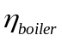: = efficiency of the boilers that generates heat in equivalent of historical quantity, determines in conservative way;
HG_{CHP, hist}: = average historical heat generation (GJ or similar) for the last 5 years;
OXID_{NG} : = the oxidation factor of natural gas.
Emission from CHP plant (CHP_{hist}E) for heat and electricity generation at historical level;
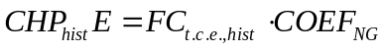 (8)
where:
FC_{t.c.e.,hist}: = the annual average fuel consumption in tons of coal equivalent (t.c.e.) combusted in the CHP during the last 5 years;
COEF_{NG}: = the CO₂ emission coefficient (tCO₂/m³ or similar) for natural gas and obtained as:
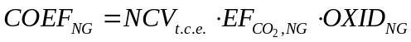 (9)
where:
NCV _{t.c.e.}: = the net calorific value (energy content) of t.c.e. (GJ/t.c.e.).
Define baseline emission BE for the following cases:
a) 1p+1h; 1p+2h (10)
(11)
b) 2p+1h; 2p+2h (12)
The decreasing of electricity output also can lead to decreasing of heat generated in heating cycle and may increase heat output from peak load boilers. If decreasing of electricity generation will happen in summer season heat generation in heating cycle may not changes. Taking into account this uncertainty the conservative decreasing of fuel consumption is used to obtain baseline emissions.
 (13)
where
EG_{P,y} : = the electricity (MWh or similar) generated by project plant in year y;
HG_{P,y}: = the heat (GJ or similar) generated by project plant in year y.
For determination of the combined margin (CM) emission factor EF_{grid,CM,y} the methodological tool used version 01.1 “Tool to calculate the emission factor for an electricity system”. The CM emission factor is calculated as the sum of operating margin (OM) and build margin (BM) emission factors multiplied by corresponding weightage coefficients. The data for CM calculation are obtained from statistical forms 6-TP.
STEP 1. Identify the relevant electric power system.
The relevant electric power plant is URES “North-West” (see Section B.3).
STEP 2. Select an operating margin (OM) method.
See Annex 2.
STEP 3. Calculate the operating margin emission factor according to the selected method.
See Annex 2.
STEP 4. Identify the cohort of power units to be included in the build margin (BM).
The cohort of five plants and units that were built most recently are presented in Annex 2 Table 6.
STEP 5. Calculate the build margin emission factor.
See Annex 2.
STEP 6. Calculate the combined margin (CM) emission factor.
See Annex 2.
Leakage
Leakages in project are associated with increased fuel use at the plant. At the same time leakage will decrease because of reduced fuel use in other power plants in the grid.
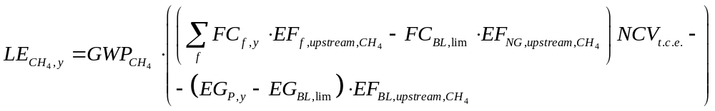 (14)
where
LE_{CH4,y}: = leakage emissions due to fugitive upstream CH₄ emissions in the year y in t CO_{2e};
GWP_{CH4}: = global warming potential of methane valid for the relevant commitment period;
EF_{f,upstream,CH4}: = emission factor for upstream fugitive methane emissions from production, transportation and distribution of fuel f. It is obtained from the table 2 of CDM methodology AM0029;
EF_{BL,upstream,CH4}: = emission factor for upstream fugitive methane emissions occurring in the absence of the project activity in tCH₄ per MWh electricity generation in the project site, as defined below:
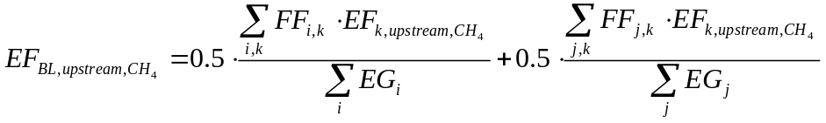 (15)
FF_{j,k} : = quantity of fuel type k combusted in power plant j included in the build margin
EF_{k,upstream,CH4}: = emission factor for upstream fugitive methane emissions from production of the fuel type k in t CH₄ per PJ fuel produced
i: = plants included in the operating margin
j: = plants included in the build margin
EG: = electricity generation in the plant i or j (MWh/yr)
In accordance with methodology AM0029 where total net leakage effects are negative (LE_{y} < 0), project participants should assume LE_{y} = 0.
Emission Reductions
Emission reductions are calculated as follows:
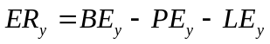 (16)
where;
ER_{y} ; = emission reductions in year y (tCO₂e/yr);
BE_{y} ; = baseline emissions in year y (tCO₂e/yr);
PE_{y} ; = project emissions in year y (tCO₂/yr);
LE_{y} ; = leakage emissions in year y (tCO₂/yr).
Not monitored data:
Data/Parameter | Remaining lifetime of the power equipments
Data unit | Years
Description | Time when the existing equipment would need to be replaced in the absence of the project activity.
Time of  determination/monitoring | not applicable
Source of data (to be) used | Project activity
Value of data applied  (for ex ante calculations/determinations) | 10
Justification f the choice of  data or description of  measurement methods and  procedures (to be) applied | Determined as described in the “Procedure for estimating remaining lifetime of the power equipments”.
QA/QC procedures (to be)  applied | not applicable
Any comment | -

Data/Parameter | EG_{CHP, max,hist,yh}
Data unit | MWh
Description | Maximum level of net historical electricity generation by the CHP plant at the project site.
Time of  determination/monitoring | not applicable
Source of data (to be) used | On-site measurement, statistical data
Value of data applied  (for ex ante calculations/determinations) | Historical data presented in Annex 2 Table Anx.2.11.
Justification f the choice of  data or description of  measurement methods and  procedures (to be) applied | Determined as described in the “Procedure for estimating remaining lifetime of the power equipments”.
QA/QC procedures (to be)  applied | not applicable
Any comment | -

Data/Parameter | EG_{CHP, min,hist,yh}
Data unit | MWh
Description | Minimum level of net historical electricity generation by the CHP plant at the project site.
Time of  determination/monitoring | not applicable
Source of data (to be) used | On-site measurement, statistical data
Value of data applied  (for ex ante calculations/determinations) | Historical data presented in Annex 2 Table Anx.2.11.
Justification f the choice of  data or description of  measurement methods and  procedures (to be) applied | Determined as described in the “Procedure for estimating remaining lifetime of the power equipments”.
QA/QC procedures (to be)  applied | not applicable
Any comment | -

Data/Parameter | y_{h}
Data unit | Year
Description | Year that uses to establish baseline level of fuel consumption, electricity and heat generation at baseline CHP.
Time of  determination/monitoring | not applicable
Source of data (to be) used | Calendar
Value of data applied  (for ex ante calculations/determinations) | 2005
Justification f the choice of  data or description of  measurement methods and  procedures (to be) applied | not applicable
QA/QC procedures (to be)  applied | not applicable
Any comment | -

Data/Parameter | HG_{CHP, yh}
Data unit | GJ
Description | Annual net heat generation that corresponds to the year y_{h};
Time of  determination/monitoring | not applicable
Source of data (to be) used | On-site measurement, statistical data
Value of data applied  (for ex ante calculations/determinations) | Please see file:  table.xls
Justification f the choice of  data or description of  measurement methods and  procedures (to be) applied | not applicable
QA/QC procedures (to be)  applied | not applicable
Any comment | -

Data/Parameter | FC_{CHP, yh}, FC_{t.c.e.,hist}
Data unit | t.c.e.
Description | Annual and average fuel consumption that corresponds to the year
Time of  determination/monitoring | not applicable
Source of data (to be) used | Statistical data
Value of data applied  (for ex ante calculations/determinations) | Please see file: table.xls
Justification f the choice of  data or description of  measurement methods and  procedures (to be) applied | not applicable
QA/QC procedures (to be)  applied | not applicable
Any comment | -

Data/Parameter | η_{boiler}
Data unit | Non dimensional
Description | Efficiency of boilers
Time of  determination/monitoring | not applicable
Source of data (to be) used | Data from supplier
Value of data applied  (for ex ante calculations/determinations) | 93.3%
Justification f the choice of  data or description of  measurement methods and  procedures (to be) applied | For purposes of conservatism, it is assumed that natural gas will be the fuel for the new boiler house. For the estimation of baseline СО₂ emissions during the heat energy generation at the new boiler house we shall determine the efficiency factor of the new boilers. According to the Biysk boiler plant – the leading plant in terms of the steam and water heating boilers of medium and low power boilers for industrial and small-scale power generation in Russia – the water heating boilers’ efficiency factor amounts to 90-93%. For the estimate of baseline emissions efficiency factor of the new St. Petersburg boiler house accepted as maximum one in the range of similar boilers of the Biysk boiler plant – 93.3%.
QA/QC procedures (to be)  applied | not applicable
Any comment | -

Data/Parameter | GWP_{CH4}
Data unit | tCO₂/tCH₄
Description | Global warming potential of methane valid for the relevant commitment period
Time of  determination/monitoring | Once for the commitment period
Source of data (to be) used | IPCC Guidelines
Value of data applied  (for ex ante calculations/determinations) | 21
Justification f the choice of  data or description of  measurement methods and  procedures (to be) applied | The default value of IPCC
QA/QC procedures (to be)  applied | not applicable
Any comment | -

Data/Parameter | EF _{grid, OMsimple, y}
Data unit | tCO2/MWh
Description | Simple operating margin CO2 emission
Time of  determination/monitoring | Determined ex-ante
Source of data (to be) used | Parameter is calculated according to the formula 1 of Annex 2
Value of data applied  (for ex ante calculations/determinations) | 0.5831
Justification f the choice of  data or description of  measurement methods and  procedures (to be) applied | The coefficient was designed for the period from 2010 to 2012.
QA/QC procedures (to be)  applied | not applicable
Any comment | -

Data/Parameter | EF _{grid, BM, y}
Data unit | tCO2/MWh
Description | BM emission factor
Time of  determination/monitoring | Determined ex-ante
Source of data (to be) used | Parameter is calculated according to the formula 2 of Annex 2
Value of data applied  (for ex ante calculations/determinations) | 0.4431
Justification f the choice of  data or description of  measurement methods and  procedures (to be) applied | The coefficient was designed for the period from 2010 to 2012.
QA/QC procedures (to be)  applied | not applicable
Any comment | -

Data/Parameter | EF _{grid, CM, y}
Data unit | tCO2/MWh
Description | Combined margin emission factor
Time of  determination/monitoring | Determined ex-ante
Source of data (to be) used | Parameter is calculated according to the formula 4 of Annex 2
Value of data applied  (for ex ante calculations/determinations) | 0.5481
Justification f the choice of  data or description of  measurement methods and  procedures (to be) applied | The coefficient was designed for the period from 2010 to 2012.
QA/QC procedures (to be)  applied | not applicable
Any comment | -

Data and parameters monitored

Data/Parameter | EG_{P,y}
Data unit | MWh
Description | Net quantity of electricity generated by the project activity plant in year y
Time of  determination/monitoring | Continuous
Source of data (to be) used | On-site measurement
Value of data applied  (for ex ante calculations/determinations) | Please see file: table.xls
Justification f the choice of  data or description of  measurement methods and  procedures (to be) applied | Use energy meters. The consistency of metered net heat generation should be cross-checked with receipts from sales (if available) and the quantity of fuels fired.
QA/QC procedures (to be)  applied | Cross check measurement results with invoices for sale of electricity if relevant.
Any comment | -

Data/Parameter | HG_{P,y}
Data unit | Gcal
Description | Total quantity of heat generated by the project plant in year y
Time of  determination/monitoring | Continuous
Source of data (to be) used | On-site measurement
Value of data applied  (for ex ante calculations/determinations) | Please see file: table.xls
Justification f the choice of  data or description of  measurement methods and  procedures (to be) applied | The consistency of metered net heat generation should be cross-checked with receipts from sales (if available) and the quantity of fuels fired.
QA/QC procedures (to be)  applied | Cross check measurement results with invoices for sale of electricity if relevant.
Any comment | -

Data/Parameter | FC_{f,y}
Data unit | t.c.e.
Description | Total quantity of fuel ‘f’ consumed by the project activity plant in the year y
Time of  determination/monitoring | Continuously
Source of data (to be) used | On site measurement, statistical data
Value of data applied  (for ex ante calculations/determinations) | Please see file: table.xls
Justification f the choice of  data or description of  measurement methods and  procedures (to be) applied | Use mass or volume meters
QA/QC procedures (to be)  applied | not applicable
Any comment: | -

Data/Parameter | FFj,k
Data unit | Mass or Volume units
Description | Total quantity of fuel ‘f’ consumed by the plant included in the project boundary
Time of  determination/monitoring | yearly
Source of data (to be) used | Statistical data
Value of data applied  (for ex ante calculations/determinations) | Please see file: table.xls.
Justification f the choice of  data or description of  measurement methods and  procedures (to be) applied | not applicable
QA/QC procedures (to be)  applied | not applicable
Any comment | Measuring instruments and metering gas mounted CHP produce volume flow measurement of gas, reduced to standard conditions (T = 293.15 K (20° C) and Fc = 101,325 kPa). Documents defining the procedure for the measurement: GOST 8.563.2-97, OL 50.2.019 -96, ISO: 14532:2001.

Data/Parameter | EF_{CO2},_{f,y}
Data unit | tCO₂/TJ
Description | CO₂ emission factor per unit of energy of fuel ‘f’
Time of  determination/monitoring | Yearly
Source of data (to be) used | Fuel supplier, measurements by the project participants, regional or national default values, IPCC default values
Value of data applied  (for ex ante calculations/determinations)
  Natural Gas | 56.1
  Heavy fuel oil | 77.4
  Coal | 96.1
Justification f the choice of  data or description of  measurement methods and  procedures (to be) applied | Measurements should be undertaken in line with national or international fuel standards
QA/QC procedures (to be)  applied | not applicable
Any comment | Time of determination depends on source

Data/Parameter | NCV_{NG,y}
Data unit | GJ/mass or volume units
Description | Weighted average net calorific value of the of fuel ‘f’ consumed by the plant in the year y
Time of  determination/monitoring | Monthly
Source of data (to be) used | Supplier-provided data
Value of data applied  (for ex ante calculations/determinations)
  Natural Gas | 33.46 GJ/m³
  Heavy fuel oil | 40.52 GJ/t
Justification f the choice of  data or description of  measurement methods and  procedures (to be) applied | The NCV should be obtained for each fuel delivery, from which weighted average annual values should be calculated.
QA/QC procedures (to be)  applied | Verify if the values are within the uncertainty range of the IPCC default values as provided in Table 1.2, Vol. 2 of the 2006 IPCC Guidelines. If the values fall below this range collect additional information from the testing laboratory to justify the outcome or conduct additional measurements. The laboratories should have ISO17025 accreditation or justify that they can comply with similar quality standards.
Any comment | -

B.2. Description of how the anthropogenic emissions of greenhouse gases by sources are reduced below those that would have occurred in the absence of the JI project:
According to paragraph 2 of Annex 1 of the Guidance, additionality can be demonstrated, inter alia, by using one of the following approaches:
(a) Provision of traceable and transparent information showing that the baseline was identified on the basis of conservative assumptions, that the project scenario is not part of the identified baseline scenario and that the project will lead to reductions of anthropogenic emissions by sources or enhancements of net anthropogenic removals by sinks of GHGs;
(b) Provision of traceable and transparent information that an accredited independent entity has already positively determined that a comparable project (to be) implemented under comparable circumstances (same GHG mitigation measure, same country, similar technology, similar scale) would result in a reduction of anthropogenic emissions by sources or an enhancement of net anthropogenic removals by sinks that is additional to any that would otherwise occur and a justification why this determination is relevant for the project at hand.
(c) Application of the most recent version of the “Tool for the demonstration and assessment of additionality” approved by the CDM Executive Board;
In this PDD, the most recent version of the “Tool for the demonstration and assessment of additionality” (version 05.2) (hereinafter referred to as “Additionality Tool”) is applied to prove that the emission reductions by the proposed JI project are additional to any that would otherwise occur.
Step 1: Identification of alternatives to the project consistent with current laws and regulations
Sub-step 1a: Define alternatives to the project
Plausible alternatives to the project were identified in Section B.1 above:
Alternative scenario 1: The proposed project not developed as a JI project;
Alternative scenario 2: The electricity to be generated by project is provided by the other existing plants of URES “North-West”;
Alternative scenario 3: The electricity to be generated by project is provided by the other new energy units of URES “North-West”,
Alternative scenario 4: The electricity to be generated by project is provided by the other existing plants and the other new energy units of URES “North-West”.
Only alternatives 1 and 4 were identified as realistic and credible.
Sub-step 1b: Consistency with mandatory laws and regulations
All the alternatives defined in sub-step 1a are in compliance with mandatory legislation and regulations.
Step 2: Investment analysis
The main goal of the investment analysis is to determine whether the proposed project is not:
(a) The most economically or financially attractive; or
(b) Economically or financially feasible, without the revenue from the sale of ERUs associated with the JI project.
To conduct the investment analysis, the following sub-steps have to be applied.
Sub-step 2a: Determine appropriate analysis method
In principle, there are three methods applicable for an investment analysis: simple cost analysis, investment comparison analysis and benchmark analysis.
A simple cost analysis (Option I) shall be applied if the proposed JI project and the alternatives identified in step 1 generate no financial or economic benefits other than JI related income. The proposed JI project results in additional sales revenues due to the electricity that will be generated. Thus, this analysis method is not applicable.
The Additionality Tool allows for an investment comparison analysis which compares suitable financial indicators for realistic and credible investment alternatives (Option II) or a benchmark analysis (Option III). For this project a benchmark analysis (Option III) is appropriate in accordance with the attached guidance to the Additionality Tool (paragraph 15).
Sub-step 2b: Option III. Apply benchmark analysis
The proposed project, installation of CCGT unit, shall be implemented by the project participant Open Joint-Stock Company «TGK-1». The approach recommended in p. 6 (a) of Additionality Tool is applied —using “government bonds rates increased by a suitable risk premium”. As Russia does not have long term governmental bonds, a conservative approach of using Central Bank RF interest rate of 13% is proposed in the analysis including a county risk premium and inflation 3%. Thus the overall IRR benchmark amounts to 16%. If the proposed project (not being implemented as JI project) has a less favorable indicator, i.e. a lower IRR, than the benchmark, then the project cannot be considered as financially attractive.
Sub-step 2c: Calculation and comparison of financial indicators
The financial analysis refers to the time of investment decision-making.
The following assumptions have been used based on the information provided by the enterprise:
- Investment decision: 20/06/2006, commissioning date: December 2010;
- The project requires investments of approximately EUR 414,97 mln. (exchange rate of Central Bank of Russia 36.971 RUB/€ as of 1 July 2008);
- The project lifetime is 30 years (lifetime of CCGT in line with contract);
- Fuel consumption and electricity generation is taken into account in line with the technical specifications of the project design;
- Natural gas is the biggest cost component constituting more than 80% of total operation cost.
- The scrap value is calculated as CCGT weight (documented) multiplied by scrap price.
The project cash flow focuses, in addition to investment-related outflows, on revenue flows generated by additional sales of electricity produced by the new CCGT unit.
The project’s financial indicators are presented in the Table B.2.1 below.
Table B.2.1. Financial indicators of the project
Scenario | IRR (%) | Discounted PBP | Simple payback period (years)
Base case | 10 | Out of project lifetime | 19
The cash flow analysis shows an IRR of 10%, which is well below the IRR benchmark identified as 16%. As a result a negative NPV is obtained. Hence, the project cannot be considered as financially attractive.
Sub-step 2d: Sensitivity analysis
A sensitivity analysis shall be conducted to show whether the conclusion regarding the financial/economic attractiveness is robust to reasonable variations in the critical assumptions.
The following four key factors were considered in the sensitivity analysis: electricity and gas tariffs, investment and maintenance cost. The other cost components account for much less than 20% of total cost and therefore are not considered in the sensitivity analysis. In line with the guidance to the Additionality Tool (par. 17) the sensitivity analysis should be undertaken within the corridor of ±10% for the key indicators.
Table B.2.2. Sensitivity analysis
Parameter | Fluctuation
 | -10% | -5% | 0% | 5% | 10%
Investment costs | 11,43% | 10,69% | 10,00% | 9,40% | 8,83%
Fuel costs | 13,57% | 11,93% | 10,00% | 7,59% | 3,80%
Electricity price | 4,34% | 6,64% | 10,00% | 12,67% | 14,96%
Heat price | 8,00% | 9,06% | 10,00% | 10,89% | 11,70%
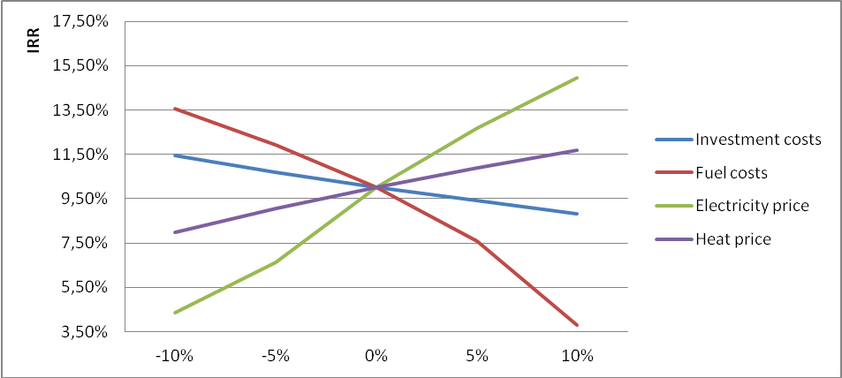
Figure B.2.1. Sensitivity analysis
Sensitivity analysis was applied to evaluate sensitivity of the project to changes that might occur during project implementation and operation.
Analysis of the investment cost within range -10% and +10% showed that IRR changes within 11.43%-8.83%. The 180 MW CCGT unit considered under the project is expensive and increase of investment cost by 5% leads to negative NPV even with ERUs sale. However, at price of investment as expected and with revenue from ERUs sale the project is viable and will generate sufficient income even in the case of financing the project by loan and brings profit even if above changes of investment cost occur.
Another factor that might influence project's IRR and NPV is change of fuel (natural gas) price above projected price range. Based on analysis, IRR ranges from 13.57% to 3.8% within +10% and -10% change of fuel price. The conclusion is the same as in above case.
Electricity is produced by the project after its implementation, therefore changes of electricity selling price affect project's IRR and NPV the opposite way as it is in the case of investment cost change and natural gas price change. The range of IRR change (4.34% - 14.96%) indicates that project is most sensitive to change of electricity price. As it is widely forecasted, price of electricity and natural gas will grow. If natural gas price grows significantly, increased expenses will be compensated by increased electricity prices.
Hence, the sensitivity analysis consistently supports (for a realistic range of assumptions) the conclusion that the project is unlikely to be financially/economically attractive.
Step 3: Barrier analysis
In line with the Additionality Tool, a barrier analysis is not conducted.
Step 4: Common practice analysis
Sub-step 4a: Analyze other activities similar to the proposed project activity:
The project energy unit uses combined cycle (Rankin and Brayton (gas) thermodynamic cycles) for electricity and heat generation. The installed capacity of this combine cycle gas turbine (CCGT) unit is 180MW.
In Russia almost all power plants use the Rankin (steam) cycle (fossil fuel fired boiler(s) with steam turbines). The total installed capacity of all CCGT units (including with cogeneration cycle) is about 2.6 GW (2007). It is approximately 1.7% of total thermal power plants installed capacity.
The Tool recommends to provide an analysis of any other activities if they are in the same country/region and rely on similar technology, are of a similar scale, and take place in the comparable environment.
The new energy units are presented in the Table B.2.3.
Table B.2.3: New energy units in URES «North-West»
Power plant/unit | Commissioning | Capacity, MW | Technology | Fuel | Cycle
Severo-Zapadnaia CHPP | 2000 | 450 | CC GT | Gas | Cogeneration
Vasileostrovskaya TPP-7, #3 | 2009 | 50 | Steam cycle | Gas | Cogeneration
Severo-Zapadnaia CHPP | 2006 | 450 | CC GT | Gas | Cogeneration
Avtovskaya TPP-15 | 2007 | 30 | Steam cycle | Gas | Cogeneration
Pravoberejnaya TPP-5 | 2006 | 180 | Steam cycle | Gas | Cogeneration
The thermal power stations using simple cycle for electricity generation dominate power generation in Russia. Presently only few units of power plants of Russia use combined cycle for power generation. The installed capacity of combined cycle power plants in Russia less than 2% of the total installed capacity of thermal power stations. Until now, these were pilot projects with the main purpose to try new technologies. One of the recently implemented projects – Severo-Zapadnaia CHPP with gas and steam turbines manufactured in the Russian Federation – was implemented as a testing facility. The previously implemented projects were with foreign turbines.
All projects with combined cycle completed up to now had significant support from Russian monopolist RAO UES. After privatization, the company does not have such possibilities as RAO UES.
Sub-step 4b: Discuss any similar Options that are occurring:
The similar activities are not widely observed so this sub-step is not applicable.
Conclusion
The application of the CDM Additionality Tool demonstrates that the emission reductions by the proposed JI project are additional to any that would otherwise occur.
B.3. Description of how the definition of the project boundary is applied to the project:
Project boundary
The new CCTG unit combusts natural gas for electricity generation, most of which is supplied to the grid and minor part is used for internal needs (auxiliary equipment).
Project boundary embraces:
- New CCTG unit;
- Auxiliary equipment of the new CCTG unit.
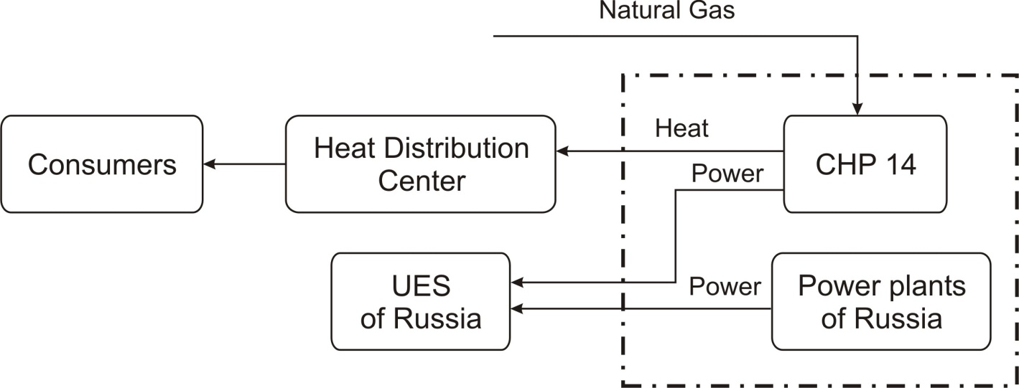
Figure B.3.1 Project Boundary, including the project plant and all power plants in the URESs (URES “North-West”).
Emissions sources and greenhouse gases types included in or excluded from the project boundary are presented in the Table B.3.1.
Table B.3.1. Emissions sources included or excluded from the project boundary
 | Source | Gas | Included? | Justification/Explanation
Baseline | Electricity generation in baseline  (URES “North-West”) | CO2 | Included | Main emission source
Baseline | Electricity generation in baseline  (URES “North-West”) | CH4 | Excluded | Excluding these emission from the baseline is conservative and in line with existing CDM methodologies
Baseline | Electricity generation in baseline  (URES “North-West”) | N2O | Excluded
Project activity | On-site natural gas combustion | CO2 | Included | Main emission source
Project activity | On-site natural gas combustion | CH4 | Excluded | Exclusions is for simplification as the emission are negligible and in line with existing CDM methodologies
Project activity | On-site natural gas combustion | N2O | Excluded

B.4. Further baseline information, including the date of baseline setting and the name(s) of the person(s)/entity(ies) setting the baseline:
Date of completion of the baseline study: 28/04/2009
Name of person/entity setting the baseline:
ECF Project Ltd.
ECF Project Ltd. is a project participant. See Annex 1 for detailed contact information.

SECTION C. Duration of the project / crediting period

C.1. Starting date of the project:
Starting date of the project is 07/09/2007.
C.2. Expected operational lifetime of the project:
The operational lifetime of the proposed JI project is 30 years or 360 months.
C.3. Length of the crediting period:
2 years, 9 months (33 months from 1 April 2010 to 31 December 2012).
The starting date of the crediting period is 01/04/2010.
The status of emission reductions or enhancements of net removals generated by JI projects after the end of the first commitment period may be determined by any relevant agreement under the UNFCCC.
The second crediting period will be within agreement but not exceed life time of existing equipment at CHP-14.

SECTION D. Monitoring plan

D.1. Description of monitoring plan chosen:
The monitoring plan includes the measurement, maintenance, recording and calibration tasks that should be performed to fulfill the requirements of the selected monitoring methodology and guarantee traceability in emission reduction calculations. The main steps of the monitoring plan are described below.
In this project a JI specific approach regarding monitoring is used. As elaborated in Section B.3, the project activity only affects the emissions related to the natural gas combustion. To establish the baseline emissions and to monitor the project emissions, only these emissions will be monitored.
The following assumptions for calculation of both baseline and project emissions were used:
- Used start-up fuel at the new CCGT unit is excluded;
- Project electricity is net electricity generation by the new CCGT unit defined as electricity generation minus electricity consumption for internal needs;
- Electricity demand in the market is not influenced by the project (i.e. baseline net electricity generation = project net electricity generation);
- The baseline emissions of the grid are established using the combined margin emission factor as described in Annex 2;
- The combined margin emission factor is set ex-ante for the length of the crediting period;
- The new CCGT lifetime extends to 2020.
General remarks:
- Social indicators such as number of people employed, safety records, training records, etc, will be available to the Verifier upon request;
- Environmental indicators such as NO_{x} and other will be available to the Verifier upon request; For the greenhouse gas emissions only the CO₂ emissions are taken into account. See section B.3.
Data management system
A person will be appointed by the project owner to take responsibility for data handling, preparing monitoring reports of greenhouse gas emission reductions and collecting the data for emission reduction verification. (See Section D.3.)
Verification
The verification of project emission reductions will be done annually. The project owner should be responsible for preparing documentation for verification by the Accredited Independent Entity (AIE).
D.1.1. Option 1 – Monitoring of the emissions in the project scenario and the baseline scenario:
This Option 1 is chosen for this project.
D.1.1.1. Data to be collected in order to monitor emissions from the project, and how these data will be archived:
ID number  (Please use numbers to ease cross-referencing to D.2.) | Data variable | Source of data | Data unit | Measured (m), calculated (c), estimated (e) | Recording frequency | Proportion of data to be monitored | How will the data be archived? (electronic/  paper) | Comment
The table D.1.1.1. is left blank on purpose since the data to be collected are presented in the tables of Section B.1.
D.1.1.2. Description of formulae used to estimate project emissions (for each gas, source etc.; emissions in units of CO₂ equivalent):
The section D.1.1.2. is left blank on purpose since relevant formulae to be collected are presented in the Section B.1.
D.1.1.3. Relevant data necessary for determining the baseline of anthropogenic emissions of greenhouse gases by sources within the project boundary, and how such data will be collected and archived:
ID number  (Please use numbers to ease cross-referencing to D.2.) | Data variable | Source of data | Data unit | Measured (m), calculated (c), estimated (e) | Recording frequency | Proportion of data to be monitored | How will the data be archived? (electronic/  paper) | Comment
The table D.1.1.3. is left blank on purpose since the data to be collected are presented in the tables of Section B.1.
D.1.1.4. Description of formulae used to estimate baseline emissions (for each gas, source etc.; emissions in units of CO₂ equivalent):
The section D.1.1.4. is left blank on purpose since relevant formulae to be collected are presented in the Section B.1.
D. 1.2. Option 2 – Direct monitoring of emission reductions from the project (values should be consistent with those in section E.):
This Option 2 is not used in the project.
D.1.2.1. Data to be collected in order to monitor emission reductions from the project, and how these data will be archived:
ID number  (Please use numbers to ease cross-referencing to D.2.) | Data variable | Source of data | Data unit | Measured (m), calculated (c), estimated (e) | Recording frequency | Proportion of data to be monitored | How will the data be archived? (electronic/  paper) | Comment
This option is not used in the project.
D.1.2.2. Description of formulae used to calculate emission reductions from the project (for each gas, source etc.; emissions/emission reductions in units of CO₂ equivalent):
This option is not used in the project.
D.1.3. Treatment of leakage in the monitoring plan:
The section D.1.3. is left blank on purpose since the data to be collected and relevant formulae are presented in the Section B.1.
D.1.3.1. If applicable, please describe the data and information that will be collected in order to monitor leakage effects of the project:
ID number  (Please use numbers to ease cross-referencing to D.2.) | Data variable | Source of data | Data unit | Measured (m), calculated (c), estimated (e) | Recording frequency | Proportion of data to be monitored | How will the data be archived? (electronic/  paper) | Comment
The table D.1.3.1. is left blank on purpose since the data to be collected are presented in the tables of Section B.1.

D.1.3.2. Description of formulae used to estimate leakage (for each gas, source etc.; emissions in units of CO₂ equivalent):
The section D.1.3.2. is left blank on purpose since relevant formulae to be collected are presented in the Section B.1.
D.1.4. Description of formulae used to estimate emission reductions for the project (for each gas, source etc.; emissions/emission reductions in units of CO₂ equivalent):
The section D.1.4. is left blank on purpose since relevant formulae are presented in the Section B.1.
D.1.5. Where applicable, in accordance with procedures as required by the host Party, information on the collection and archiving of information on the environmental impacts of the project:
The information about environmental volume of air, waste water and other pollutants at CHP-14 collects in accordance with legislation. The monitoring process must comply with the rules and regulations to ensure uniformity of measurements specified in the Federal Law "On ensuring the unity of measurements from 26 June 2008 N 102-FZ, and in the statutes of the State system to ensure traceability (GSI).
D.2. Quality control (QC) and quality assurance (QA) procedures undertaken for data monitored:
Data  (Indicate table and  ID number) | Uncertainty level of data  (high/medium/low) | Explain QA/QC procedures planned for these data, or why such procedures are not necessary.
The section D.2. is left blank on purpose since relevant QA/QC procedures are presented in the table of Section B.1.
D.3. Please describe the operational and management structure that the project operator will apply in implementing the monitoring plan:
The monitoring plan will be implemented by the OJSC “TGC-1” to ensure that the project emission reductions during the crediting period are verifiable. Monitoring plan for the project activity includes the details of the operation and management of the project activity during the crediting period and the measurement of the parameters in baseline and project scenarios that will be used to calculate actual emission reductions. The basic management structure is shown below in the fig. 8.
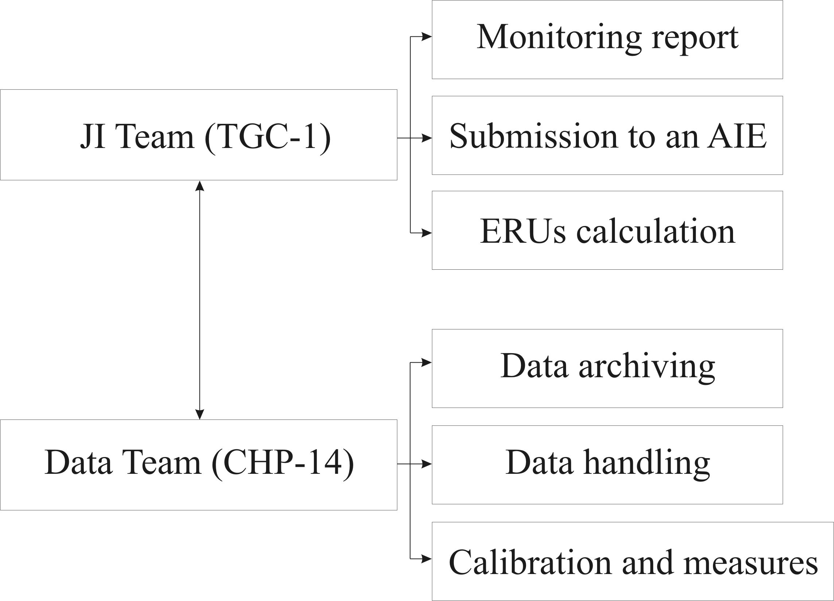
Figure D.3.1: The management structure
The management and operational structure for monitoring of the project activity is as follows. The project owner will set up a JI Team to take charge of preparing and archiving monitoring reports, checking obtaining data, support validation process. Also TGC-1 establishes personnel (Data team) who will be responsible for data support of JI Team at CHP 14. The monitoring plan does not foresee any additional measures. All data collects from measurement equipment that will install with project implementation and standardized form of data handling are used. The personnel of CHP-14 are responsible for calibration and maintenance of measurement equipment in accordance with national rules and standards and providing measurement of parameters. The project owner will organize the training of personnel for providing monitoring plan management and support of ERUs verification procedures.
D.4. Name of person(s)/entity(ies) establishing the monitoring plan:
Name of person/entity determining the monitoring plan:
- OJSC “TGC-1”,
OJSC “TGC-1” is a project participant. The contact information is presented in Annex 1.
- ECF Project Ltd.,
ECF Project Ltd. is a project participant. See Annex 1 for detailed contact information.
SECTION E. Estimation of greenhouse gas emission reductions

E.1. Estimated project emissions:
The project activity is electricity and heat generation using natural gas.
Table E.1.1 Project GHG emissions
Year | 2010 | 2011 | 2012
PE_{y}, tCO₂/year | 1 661 531 | 2 440 038 | 2 527 185
Table E.1.2 Project GHG emissions after 2012
Year | 2013 | 2014 | 2015 | 2016 | 2017
PE_{y}, tCO₂/year | 1 914 741 | 2 237 276 | 2 571 405 | 2 571 405 | 2 571 405

E.2. Estimated leakage:
Not applicable
E.3. The sum of E.1. and E.2.:
Table E.3.1 The sum of project GHG emissions and leakage (taken to be zero)
Year | 2010 | 2011 | 2012
PE_{y},+ LEy tCO₂/year | 1 661 531 | 2 440 038 | 2 527 185
Table E.3.2 The sum of project GHG emissions and leakage (taken to be zero) after 2012
Year | 2013 | 2014 | 2015 | 2016 | 2017
PE_{y},+ LEy tCO₂/year | 1 914 741 | 2 237 276 | 2 571 405 | 2 571 405 | 2 571 405

E.4. Estimated baseline emissions:
Table E.4.1 Baseline GHG emissions
Year | 2010 | 2011 | 2012
BE_{y}, tCO₂/year | 1 871 804 | 2 812 265 | 2 931 185
Table E.4.2 Baseline GHG emissions after 2012
Year | 2013 | 2014 | 2015 | 2016 | 2017
BE_{y}, tCO₂/year | 2 419 490 | 2 944 796 | 3 470 069 | 3 470 069 | 3 470 069

E.5. Difference between E.4. and E.3. representing the emission reductions of the project:
Table E.5.1 GHG emission reductions
Year | 2010 | 2011 | 2012
BE_{y}, - PE_{y},+ LEy tCO₂/year | 210 273 | 372 227 | 404 000

Table E.5.2 GHG emission reductions after 2012
Year | 2013 | 2014 | 2015 | 2016 | 2017
BE_{y}, - PE_{y},+ LEy tCO₂/year | 504 749 | 707 520 | 898 664 | 898 664 | 898 664

E.6. Table providing values obtained when applying formulae above:
Table E.6.1: Project, baseline, and emission reductions within the crediting period
Year | Estimated  project  emissions  (tonnes of  CO₂  equivalent) | Estimated  leakage  (tonnes of  CO₂  equivalent) | Estimated  baseline  emissions  (tonnes of  CO₂  equivalent) | Estimated  emission  reductions  (tonnes of  CO₂  equivalent)
2010 | 1 661 531 | 0 | 1 871 804 | 210 273
2011 | 2 440 038 | 0 | 2 812 265 | 372 227
2012 | 2 527 185 | 0 | 2 931 185 | 404 000
Total  (tonnes of  CO₂  equivalent) | 6 628 753 | 0 | 7 615 254 | 986 501
Table E.6.2: .Project, baseline, and emission reductions after the crediting period
Year | Estimated  project  emissions  (tonnes of  CO₂  equivalent) | Estimated  leakage  (tonnes of  CO₂  equivalent) | Estimated  baseline  emissions  (tonnes of  CO₂  equivalent) | Estimated  emission  reductions  (tonnes of  CO₂  equivalent)
2013 | 1 914 741 | 0 | 2 419 490 | 504 749
2014 | 2 237 276 | 0 | 2 944 796 | 707 520
2015 | 2 571 405 | 0 | 3 470 069 | 898 664
2016 | 2 571 405 | 0 | 3 470 069 | 898 664
2017 | 2 571 405 | 0 | 3 470 069 | 898 664
Total  (tonnes of  CO₂  equivalent) | 11 866 233 | 0 | 15 774 495 | 3 908 262

SECTION F. Environmental impacts

F.1. Documentation on the analysis of the environmental impacts of the project, including transboundary impacts, in accordance with procedures as determined by the host Party:
The necessity of an Environmental Impact Assessment (EIA) in Russia is regulated by the Federal Law “On the Environmental Expertise” and consists of two stages: EIA (OVOS —in Russian abbreviation) and state environmental expertise (SEE). Significant changes into this procedure were made by the Law in Amendments to the Construction Code which came into force on the 1st of January 2007. This Law reduced the scope of activities subject to SEE transferred them to the so called State Expertise (SE) done in line with the Article 49 of the Construction Code of the Russian Federation. In line with the Construction code the Design Document should contain the Section “Environment Protection” (Environmental Protection). Compliance with the environmental regulations (so called technical regulation in Russian on Environmental Safety) should be checked during the process of SE.
Thermal power plants with capacities of 150 MW and higher are considered to be dangerous, technical complicated and unique facilities in line with the Article 48.1 of the Construction Code RF. Design Document of such installations are subject to the state expertise at federal level. Open Joint-Stock Company «TGC-1» submitted a Design Document for this project to the Federal State Institution “The Main Agency of the State expertise” (FGU “Glavgosexpertiza” in Russian abbreviation) and received an approval (Expert Conclusion).
The main pollutants for CCGT burned natural gas are considered: nitrogen oxides and carbon oxide. The other negative effects are: the noise pollution, the water protection and the hazardous waste. All of them were considered in the section “Environmental Protection” of the Design Document.
The main conclusions of the Environmental Protection for this project and Expert Conclusion by FGU “Glavgosexpertiza” are quoted below:
Air protection:
“. the exceeding of the maximum allowable concentrations of all pollutants will not be .”.
Noise pollution:
“... will be ensured within the required noise level limits regulated by the Sanitary regulation.”.
Water protection:
“... the project technologies provide the water protection lows compliance and the exclusion of the negative impact on the region natural conditions ...”.
Hazardous waste:
All hazardous waste will be utilized by the special accredited organization.
Labor safety and welfare of inhabitants:
“... The installation of CCGT-180 at Pervomayskaya CHP-14 will not lead to the essential changes of biosphere state and population health ...”.
The main conclusions:
The proposed project “.complies with the environment protection requirements of the Russian Federation” and the project impact is considered insignificant.
Transboundary impact.
Although the project on local level will lead to increasing NO_{x} emission in country level the emission will be reduced due to increasing efficiency of fuel using. Therefore the project does not have transboundary impact.
F.2. If environmental impacts are considered significant by the project participants or the
host Party, please provide conclusions and all references to supporting documentation of an environmental impact assessment undertaken in accordance with the procedures as required by
the host Party:
On the basis of material presented to the AIE it was concluded that there is no significant impact on the environment.

SECTION G. Stakeholders’ comments

G.1. Information on stakeholders’ comments on the project, as appropriate:
Since October 29 until December 4, 2007 public hearings had been held under the Project. Representatives of environmental organizations, state and local authorities, mass media attended the public hearings (http://www.tgc-1.ru/responsibility/socOtchet/). No negative comments were received on the project during the public hearings. Project information was published on the JSC “TGC-1” website:
http://www.tgc-1.ru/about/invProgramma/all/. JSC “TGC-1” has publications about the project in mass media. The short list of publications is presented below.
Table G.1.1 Identity of stakeholders
Stakeholder 1
Name | Alexander Bobrov (Chairman of the Committee on Energy and Engineering Support of the Government of St. Petersburg )
Description of the effects of the project on the stakeholder | 11/09/2008  Newspaper “Energy and Industry of Russia” (http://www.eprussia.ru/news/base/2008/37577.htm)  "Subdivisions of TGC-1 to the beginning of the heating season are ready."  The Company is currently implementing the most ambitious in recent years, the investment program. In 2008, in St. Petersburg continued construction of new power Pervomayskaya CHP-14, the construction of new reactors in Yuzhnaia CHP -22 and west of the Dnieper HPP-5.
Address | St. Petersburg, Smolny, 4-th entrance  PO Box 191060
Phone | Phone: +7 (812) 576-60-94;
E-mail | press_centre@gov.spb.ru
Internet reception | http://www.gov.spb.ru/contacts
Contact person | Alexander Bobrov (Chairman of the Committee on Energy and Engineering Support of the Government of St. Petersburg )

Stakeholder 2
Name | Larisa Semenova G. (Head of the Department of Public Relations)
Description of the effects of the project on the stakeholder | 20/07/2007  Press Agency REGNUM (http://www.regnum.ru/news/866819.html)  "Moscow companies will be the reconstruction of Pervomayskaya CHP-14 and the expansion of Yuzhnaia CHP -22."  The results of the open competitions of TGK-1 "to select a contractor for work on a" turnkey "for the reconstruction Pervomaiskaya TEC-14 and the expansion of Yuzhnaia CHP -22. Told a news agency REGNUM was informed at the press-service of JSC "TGC-1".  03/09/2007  Interfax North-West  "TGK-1 will begin on September 7 reconstruction Pervomayskaya CHP in St. Petersburg"  OJSC "TGK-1" September 7, will begin reconstruction of Pervomayskaya CHP-14, the press service of the TGC-1... Reconstruction of the CHP is a list of priority projects of the investment program of TGC-1 for 2006-2015, funding for which is about 130 billion rubles…
Address | St. Petersburg, Marsovo Pole, 1  PO Box 191186
Phone/fax | Phone: +7 (812) 901- 30-30;  Fax: +7 (812) 710- 60-70.
E-mail | Semenova.LG@tgc1.ru
Internet reception | http://www.tgc1.ru/press/contakt3/
Contact person | Larisa Semenova G. (Head of the Department of Public Relations)

Stakeholder 3
Name | Valentina Matvienko (Governor of St. Petersburg)
Description of the effects of the project on the stakeholder | 07/09/2007  Broadcasting Channel 5, "Show and tell Petersburg"  "Today, the south-west of St. Petersburg marked the beginning of a new energy era."  Valentina Matvienko, Governor of St. Petersburg: - Even without the naked eye specialist can see that the CHP had already exceeded their life, so well that there was a free territory and it was decided to build a new CHP…  Valentina Matvienko today recalled that in the past 2 decades in a city does not have commissioned a single electrical substation, depreciation of equipment reached 80 percent, power outages have become commonplace.  Valentina Matvienko, Governor of St. Petersburg: - We were just on the verge of collapse, every winter - this is a huge anxiety and excitement - whether we survive the winter. The city was practically no power, no longer only in the center, but in all areas has been practically no one kilowatt of electricity free.  Once the energy will be put into operation two new block Pervomaiskaya, dismantle the old station, half a century ago, the latest turbo startup assumed load of 10 megawatts, the power of the new station is 55 times more precisely as many increased demands metropolis.
Address | St. Petersburg, Smolny, 4-th entrance  PO Box 191060
Phone/fax | Phone: +7 (812) 576-60-94;
E-mail | press_centre@gov.spb.ru
Internet reception | http://www.gov.spb.ru/contacts
Contact person | Latyshev Marina Eduardovna (specialist press service of the governor of St. Petersburg)

Stakeholder 4
Name | Boris Vainzikher (General Director of OJSC "Silovie Machiny")
Description of the effects of the project on the stakeholder | 07/09/2007  Rosbalt - Petersburg. News  "The most unreliable CHP Petersburg and across Russia to Reconstruct"  We are pleased that the reconstruction of one of the most unreliable CHP not only St. Petersburg, but throughout Russia. We are pleased that "TGC-1" chose "Silovie Machiny" as a supplier of equipment
Address | St. Petersburg, Vatutina st., 3, Lit. A  PO Box 191000
Phone/fax | Phone: +7 (812) 346-70-37;  Fax: +7 (812) 346-70-35.
E-mail | mail@power-m.ru
Internet reception | www.power-m.ru
Contact person | Boris Vainzikher (General Director of OJSC "Silovie Machiny")
Annex 1

CONTACT INFORMATION ON PROJECT PARTICIPANTS
Organisation: | OJSC “TGC-1”
Street/P.O.Box: | Marsovo Pole
Building: | 1
City: | St. Petersburg
State/Region:
Postal code: | 191186
Country: | Russian Federation
Phone: | +7 (812) 901 36 06
Fax: | +7 (812) 494 3477
E-mail: | office@tgc1.ru
URL: | http://www.tgc1.ru
Represented by: | Boris Feliksovich Vainzikher
Title: | Mr.
Salutation:
Last name: | Vainzikher
Middle name: | Feliksovich
First name: | Boris
Department:
Phone (direct): | +7 (812) 901-31-22; +7 (812) 901-32-14
Fax (direct): | +7 (812) 4943477
Mobile:
Personal e-mail: | office@tgc1.ru

Organisation: | ECF Project Ltd.
Street/P.O.Box: | Alexandra Solzhenitsyna street
Building: | 18
City: | Moscow
State/Region:
Postal code: | 109004
Country: | Russia
Phone: | +7 495 748 79 60
Fax:
E-mail: | ecf@energyfund.ru
URL: | http://www.carbonfund.ru/home/
Represented by: | Gleb Anikin
Title: | Mr.
Salutation:
Last name: | Anikin
Middle name: | Vladislavovich
First name: | Gleb
Department:
Phone (direct): | +7 495 748 79 60
Fax (direct): | +7 495 748 79 60
Mobile:
Personal e-mail: | anikingv@energyfund.ru

Organisation: | Fortum Power and Heat Oy
Street/P.O.Box: | Keilaniementie / P.O. Box 100,
Building: | 1
City: | Espoo
State/Region:
Postal code: | 00048
Country: | Finland
Phone: | +358104528900
Fax: | +358104528900
E-mail: | communications@fortum.com
URL: | http://www.fortum.com/
Represented by: | Evgenia Tkachenko
Title: | Environmental manager
Salutation: | Mrs.
Last name: | Tkachenko
Middle name:
First name: | Evgenia
Department: | Fortum Service
Phone (direct): | +7 922 639 41 73
Fax (direct):
Mobile: | +7 922 639 41 73
Personal e-mail: | Evgenia.tkachenko@fortum.com
Annex 2
BASELINE INFORMATION
CO₂ baseline emission factor
This baseline emission factor was defined in accordance with approved CDM “Tool to calculate the emission factor for an electricity system” (version 02) with some deviations, further referred as “The Tool”. The full version of the Tool is published on the UFCCC website at the following address: http://cdm.unfccc.int/methodologies/PAmethodologies/approved.html.
Scope and applicability
This Tool “...may be applied to estimate the OM, BM and/or CM when calculating baseline emissions for a project activity that substitutes grid electricity, i.e. where a project activity supplies electricity to a grid…”.
The combined cycle gas turbine unit with electricity capacity of 180 MW each will be constructed at Pervomayskaia CHP and commissioned in 2010. After project implementation the new electricity energy unit will supply electricity to grid of United Regional Energy System (URES) “North-West”. It will substitute electricity that would have been otherwise generated by the other power plants of URES “North-West”. Therefore, this Tool can be used for determination of CO₂ baseline emission factor.
Parameters
The Tool provides procedures to determine the following parameters:
Parameter | SI Unit | Description
EFgrid,CM,y | tCO2/MWh | Combined margin CO₂ emission factor for grid connected power generation in year y
EFgrid,BM,y | tCO2/MWh | Build margin CO₂ emission factor for grid connected power generation in year y
EFgrid,OM,y | tCO2/MWh | Operating margin CO₂ emission factor for grid connected power generation in year y
Data source
The following sources of information were used for the OM development:
- Federal Service of State Statistics (RosStat RF). This is aggregated data provided by energy companies using the official statistical form 6-TP;
- JSC “Unified Energy System of Russia” (UES);
- OJSC <System Operator of Unified Energy System> (JSC “SO of UES”);
- CJSC “Agency of Energy Balances in the power industry”.
The combined heat and power plants (CHP) can operate as cogeneration and as simple (only electricity generation) cycles and some TPPs have cogeneration energy units. Each power plant submits the electricity and heat generation and fuel consumption data in RosStat RF according to the annually statistic report (6-TP).
CHPs produce electricity predominantly in the prescribed heat supply mode. Therefore they can be excluded from OM and BM calculation. However the reports (according to form 6-TP) do not contain any information about fired fuel amount for cogeneration or simple cycles and it is impossible to exclude from calculation the fired fuel amount and electricity generation with cogeneration cycle. Therefore, the parameters of cogeneration energy units were taken into account in the OM and BM calculation. It is a deviation from the Tool but it is conservative because cogeneration cycles are more efficient than simple (or combined) cycles.
The reports contain information about the total fired fuel amount (for each fuel type), fired amount fuel for electricity and heat generation (separately). The part of the fired amount fuel for electricity generation was used in the OM and BM emission factors calculation.
BM calculation is based on the data from:
- Official annual reports of JSC UES;
- Official annual reports of energy companies;
- Energy companies investment programs;
- Technical manual “Territorial Generating Companies”, CJSC “IT energy analyst”, 2007;
- Reports containing information on new power capacities put in operation in recent years, “General Scheme of Allocation of Energy Objects up to 2020” approved by the Government of the Russian Federation (Order of February 22 2008 # 2l5p).
The “General Scheme” is not a legislative act but a research work which was implemented by a commission of the Government of the Russian Federation. OJSC “RAO UES of Russia” (and some research institutes) prepared the draft of “General Scheme” in 2007. It was based on the electricity consumption forecast and the inquiry of energy companies about their investment plans. The “General Scheme” is compilation of such information and doesn’t contain any recommendations and is not responsible for where, when, what and who will construct energy units etc. The main aim of “General Scheme” is definition of the sufficiency of consumers power supply. In case of insufficiency of consumers power supply the Government of RF will prepare the arrangements on stimulation of new energy project implementation. The Government of RF approved this document in 2008 (Order of February 22 2008 # 2l5p). It means that this work was done according to the commission of the Government of the Russian Federation.
Also according to the Order the Ministry of Energy organizes the monitoring of the GS implementation. Currently CJSC “Agency of Energy Balances in the power industry” is preparing a revised version of the “General Scheme”. The new power consumption forecast and the revised investment plans of energy companies are taken into account. In comparison with the previous version of the “General Scheme” some supposed power projects are delayed and some supposed power projects are stopped.
As stated above the “General Scheme” is not an obligatory document especially for private energy companies but data from the “General Scheme” can be used for emission factors calculation in accordance with the Tool.
Methodology procedure
The Tool determines the CO₂ emission factor for an electricity, generated by power plants, displacement in an electricity system, by calculating the “operating margin” (OM) and “build margin” (BM) as well as the “combined margin” (CM). Operating margin is the emission factor that refers to the group of existing power plants whose electricity generation would be affected by the proposed project activity. Build margin is the emission factor that refers to the group of prospective power units whose construction would be affected by the proposed project activity.
In line with the Tool the following steps presented in detail below should be followed. Possible deviations should be identified and justified.
STEP 1: Identify the relevant electric power systems
A project electricity system is the system defined by the spatial extent of the power plants that are physically connected through transmission and distribution lines to the project activity and that can be dispatched without significant transmission constraints.
Similarly, a connected electricity system is defined as a system that is connected by transmission lines to the project electricity system. Power plants within connected system can be dispatched without significant transmission constraints but transmission to the project electricity system has significant transmission constraint.
If the Designated National Authority of the host country (in Russia it is the Ministry of Economic Development RF) has published a delineation of the project electricity system and connected power systems, these delineations should be used. The Designated Focal Point (DFP) of the Russian Federation didn’t publish a delineation of the project electricity system and connected electricity systems. In this case the Tool recommends: “. to use a regional grid definition in case of large countries with layered dispatch systems (e.g. provincial I regional I national)”.
Electric power industry in Russian Federation comprises nearly 400 power plants: thermal power plants (about 70% of total installed capacity), hydro power stations (20% of total installed capacity) and nuclear power stations (10% of total installed capacity). Power stations and consumers are connected by transmission lines. Power stations, consumers and regulatory organizations (JSC “SO of UES” for instance) constitute the national energy system (hereinafter referred to as UES of Russia). The UES of Russia is functioning centralized. JSC “SO of UES” contributes a great value to the operative-dispatching management. Power stations are unified by transmission lines in 60 area electricity systems (AESs), while these systems have in its turn the electric connections with the neighboring ones (excluding some isolated area systems). AESs are unified in seven united regional electricity systems (URESs), that are connected between each other through backbone and interconnection networks: “North-West”, “Centre”, “The South”, “Volga”, “Ural”, “Siberia” and “The East”.
The scheme of UES of Russia is presented in Figure Anx.2.1.
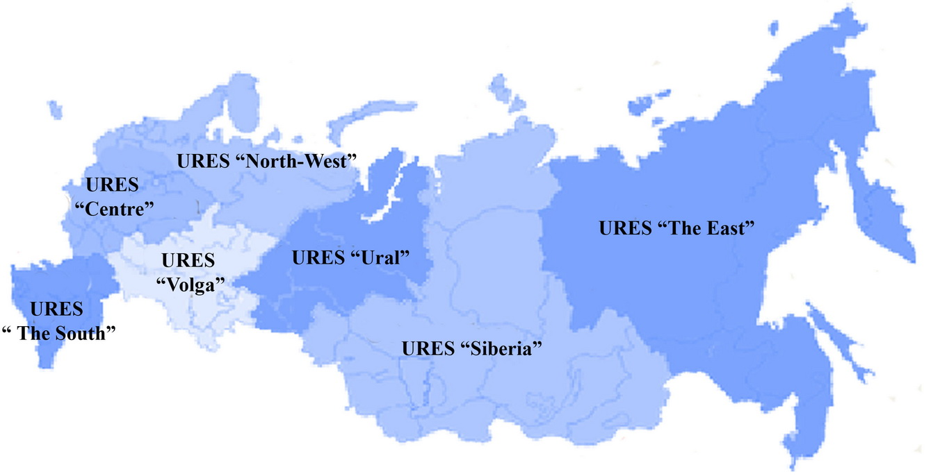Figure Anx.2.1: Scheme of UES of Russia
Source: JSC “SO of UES”( http://www.so-ups.ru/)
The status of these URESs is defined in State Standard (GOST) 21027-75 “Power systems. Terms and definitions” as: “the group of some area energy systems with common operating conditions and dispatching management”.
Pervomayskaia CHP-14 is located in URES “North-West”. Installed capacity of this URES is 21 038 MW (status 2009). Project capacity (360 MW) is only 1.7% of the URES “North-West” total electric capacity, therefore project capacity ‘”.can be dispatched without significant transmission constraints”.
As a result URES “North-West” is selected as a project electricity system.
URES “North-West” is located in 10 regions of the Russian Federation North-West Federal District: Saint-Petersburg, Murmansk, Kaliningrad, Leningrad, Novgorod, Pskov and Arkhangelsk regions, the republics of Karelia and Komi, Nenets autonomous district.
The structure of installed capacity of URES “North-West” (status 2009) is as follows:
- 48.4.4% — TPPs (including combined heat and power plants and units);
- 14.3% — Hydro power stations (HPSs);
- 37.3% — Nuclear power stations (NPSs);
NPSs operate as “must-run” resources and HPSs and WPSs — as “low-cost”.
URES “North-West” is bordered by the URES “Centre” and URES “Ural”, which have no effect on her. The most recently available date of annual URES “North-West” electricity import is presented in Table Anx.2.1.
Table Anx.2.1: The recently date of annual URES “North-West” electricity generation, consumption and import
Indicator | Unit | 2007 | 2008 | 2009 | Average
Generation | mln. MWh | 94.7 | 100.7 | 97.6 | 97.7
Consumption | mln. MWh | 89.3 | 91.3 | 88.3 | 89.6
Electricity import | mln. MWh | -5.4 | -9.4 | -9.3 | -8.0
Electricity import | % | -5.7% | -9.3% | -9.5% | -8.2%
STEP 2: Choose whether to include off-grid power plants in the project electricity system (optional)
Some power plants can be considered as off-grid power plants. For North-West region they can be power plants of oil and gas companies (located on the remote oil and gas deposits) and power plants of villages located within sparsely populated area. Usually these power plants are based on the gas turbine and diesel-engine technologies with a small electric and heat capacity.
As shown above in the Russian Federation the individual plant data is considered strictly confidential and only aggregate data on the regional basis are available. The off-grid power plants report according to statistic form also. Therefore Rosstat RF data includes off-grid power plants data.
Part of off-grid power plants electricity generation can be estimated using the “ODU “North-West” (branch of “SO UES” is superior body of operating-dispatching management in URES “North-West”) operative data. The comparison of Rosstat RF and “ODU“North-West” data by 2007 are presented in Table Anx.2.2.
Table Anx.2.2: The comparison of Rosstat RF and “ODU “North-West” data by 2007
 | Installed capacity. kW |  | Diff | Electricity generation. thous.kWh |  | Diff
Area (Republic) | Rosstat RF | ODU  “North-West” | % | Rosstat RF | ODU  “North-West” | %
The Arkhangelsk area | 1 946 | 1 908 | 1,9% | 7 719 | 7 086 | 8,2%
The Kaliningrad area | 647 | 639 | 1,2% | 2 764 | 2 761 | 0,1%
The Republic of Karelia | 1 101 | 1 094 | 0,7% | 4 952 | 4 926 | 0,5%
The Murmansk area | 3 743 | 3 737 | 0,2% | 17 551 | 17 540 | 0,1%
The Komi Republic | 2 322 | 2 215 | 4,6% | 9 063 | 8 897 | 1,8%
Novgorod Region | 216 | 216 | 0,4% | 926 | 921 | 0,6%
Pskov Region | 434 | 432 | 0,4% | 1 751 | 1 736 | 0,8%
St. Petersburg and Leningrad Region | 10 841 | 10 931 | 0,8% | 51 019 | 50 743 | 0,5%
Total | 21 250 | 21 173 | 0,36% | 95 745 | 94 610 | 1,19%

The off-grid power electricity generation of URES “North-West” is only 1.19 percent of total electricity generation.
According to the Tool project participants may choose between the following two options:
- Option I: Only grid power plants are included in the calculation.
- Option II: Both grid power plants and off-grid power plants are included in the calculation.
In accordance with the Tool, “Option II aims to reflect that in some countries off-grid power generation is significant and can partially be displaced by CDM project activities, e.g. if off-grid power plants are operated due to an unreliable and unstable electricity grid.”. As the off-grid power generation is not significant, Option I was chosen.
STEP 3: Select an operating margin (OM) method
The Tool recommends calculating the EF _{grid. OM. y} based on one of the following methods:
(a) Simple OM. or
(b) Simple adjusted OM. or
(c) Dispatch data analysis. or
(d) Average OM.
Any of these listed methods can be used; however. the simple OM method (a) can only be used if low- cost/must run resources constitute less than 50% of total grid generation calculated:
1) As average of the five most recent years or.
2) Based on long-term averages for hydroelectricity production.
Low-cost/must run resources are defined as power plants with low marginal generation costs or that are dispatched independently of the daily or seasonal load of the grid. Typically they include hydro. geothermal. wind. low-cost biomass. nuclear and solar generation. In URES “North-West” geothermal. low-cost biomass. and solar generation are negligible for the power balance. Therefore nuclear stations (as “must-run”) and wind (1 MW) and hydro plants (as “low-cost”) are defined as low-cost/must run resources. Table Anx.2.3 represents” total electricity generation during the five last years and the five year average share of low-cost/must run resources in URES “North-West” (2003-2007).
Table Anx.2.3: Total electricity generation during the last five years and share of RES‘s low-cost/must run net electricity generation (MWh)
URES  “North-West” | 2005 | 2006 | 2007 | 2008 | 2009 | Five year average %  of low-cost
All power plants | 94 911 879 | 99 168 490 | 103 352 040 | 100 664 000 | 97 597 600 | 49.11
Hydro (with wind) | 12 953 642 | 11 980 721 | 13 340 302 | 13 553 100 | 13 979 500 | 49.11
Nuclear | 34 194 021 | 33 770 747 | 34 923 872 | 38 385 800 | 36 376 700 | 49.11
Source: JSC “SO of UES” and Rosstat RF
As this indicator is lower than 50% the nuclear and hydro energy generation may not be taken into account. Therefore simple OM (method “a”) can be used and is selected for calculation of emission factor of URES “North-West”.
STEP 4: Calculate the operating margin emission factor according to the selected method
The Tool specifies how simple OM is calculated - as the generation-weighted average CO₂ emissions per unit net electricity generation (tCO₂/MWh) of all generating power plants serving the system. not including low-cost/must run plants/units (e.g. hydro and nuclear).
The Tool suggests making calculations based on:
- the net electricity generation and CO₂ emission factor of each power unit (Option A);
- total net electricity generation of all power plants serving the system and the fuel types and total fuel consumption of the project electricity system (Option B).
The Option A was chosen because the necessary data for Option A is available.
Under this option the simple OM emission factor is defined by the following formula:
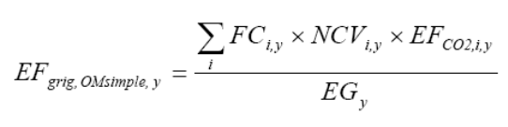 (1)
Where:
EF_{grid.OMsimple.y} | = | simple operating margin CO₂ emission factor in year y (tCO₂/MWh);
FC_{i.m.y} | = | amount of fossil fuel i consumed in the project electricity system in year y (mass or volume unit);
NCV_{i.y} | = | net calorific value (energy content) of fossil fuel type i in year y (GJ / mass or volume unit);
EF_{CO2.i.y} | = | CO₂ emission factor of fossil fuel type _{i} in year y (tCO₂/GJ);
EG_{m.y} | = | net electricity generated and delivered to the grid by all power sources serving the system. not including low-cost/must-run power plants/units. in year y (MWh);
m | = | all power plants / units serving the grid in year y except low-cost / must-run power plants / units;
i | = | all fossil fuel types combusted in power plant / unit m in year y;
y | = | three most recent years for which data is available (2006-2008).
The net electricity generation and fossil fuels consumed in the project electricity system are received from Rosstat RF. The amount of fossil fuels are expressed in tonne of coal equivalent with net calorific value is equal to 7.000 kcal/kg c.e. or 29.33 GJ/t.c.e.
The net electricity generation and emission factors data at all TPPs of URES “North-West” in 2003-2007 are presented in the Annex 4..
Exclusion off-grid power plants data
The above mention data includes net electricity generation and fuel consumption of the off-grid power plants. And the individual data of off-grid power plants is not available by this source. To exclude the off- grid power plants the following conservative assumptions were taken:
- The net electricity generation of the off-grid power plants is 49.11 percent (as shown in the Table Anx.2.3) of total net electricity generation of URES “North-West” in year y;
- Efficiency factor of the off-grid power plants was defined according to the Annex 1 of the Tool.
The off-grid power plants fuel consumption is defined based on the analysis of OJSC “Zvezda Energetika” (the biggest company constructing such type of power plant in Russia). The results of the analysis are presented in Table Anx.2.4.
Table Anx.2.4: The analysis results of OJSC “Zvezda Energetika” activity and value of default efficiency factors of the energy unit types
Type of power unit  (CAP is nominal capacity in MW) | Total capacity | Percentage | Default efficiency factor
Type of power unit  (CAP is nominal capacity in MW) | MW | % | %
Diesel-engine units (10<CAP<50) | 105.4 | 49.3 | 33.0
Diesel-engine units (CAP<10) | 34.0 | 15.9 | 28.0
Gas turbine units (10<CAP<50) | 24.0 | 11.2 | 32.0
Gas turbine units (CAP<10) | 50.3 | 23.5 | 28.0
Total | 213.7 | 100.0 | -
Source: http://www.energostar.com/activity/activity_map.php
The net electricity generation and fuel consumption data at TPPs of URES “Ural” excluding off-grid power plants in 2006-2008 are presented in the Table Anx.2.6.
Table Anx.2.5: The net electricity generation and fuel consumption data excluding off-grid power plants
Indicator | Unit | 2005 | 2006 | 2007
Net electricity generation | MWh | 218 010 | 247 731 | 249 064
Natural gas | GJ | 2 871 847 | 3 195 328 | 3 766 764
Heavy fuel oil | GJ | 482 244 | 512 395 | 577 625
Coal | GJ | 0 | 0 | 47 515
Peat | GJ | 0 | 0 | 0
Other | GJ | 0 | 0 | 0
Definition of other fuel types
According to statistic form 6-TP the electricity and heat producers must indicate following fuel types: natural gas (including associated gas). heavy fuel oil. coal. peat. oil-shales (slate). firewood and other fuels are indicated as other fuel types.
In North-West region some power stations use such type of fuel as blast furnace and coke even gases (power plants at the metallurgical works) and wood waste. These types are reflected in statistic form 6-TP as other fuel types. The “other” fuel type (see table above) is third fuel of URES “North-West” power plants for last years. The most relevant areas are Murmansk, Leningrad and Arkhangelsk regions, the republics of Karelia and Komi.
The amount of other fuel type consumption on the regional basis during 2005-2007 is presented in the Table Anx.2.6.
Table Anx.2.6: The other fuel type consumption on the regional basis during 2005-2007
Area (Republic) | Unit | 2005 | 2006 | 2007
The Arkhangelsk area | GJ | 29 506 831 | 30 365 320 | 29 735 341
The Republic of Karelia | GJ | 6 533 023 | 7 040 520 | 7 599 843
The Murmansk area | GJ | 13 550 | 9 122 | 8 858
The Komi Republic | GJ | 13 093 909 | 13 245 076 | 13 072 352
Novgorod Region | GJ | 0 | 0 | 0
Pskov Region | GJ | 0 | 0 | 0
St. Petersburg and Leningrad Region | GJ | 1 837 671 | 1 530 586 | 1 309 086
Total | GJ | 50 984 984 | 52 190 623 | 51 725 479
Source: Rosstat RF
For emission calculation the following assumptions were taken: The proportion of other fuel in the fuel balance of North-West region is 5.5% and the emission factor of other fuel types in North-West region was considered as zero.
Table Anx.2.7: The data of total fuel balance and net electricity generation of URES “North-West”
Indicator | Unit | 2005 | 2006 | 2007
Net electricity generation | MWh | 47 758 867 | 53 412 399 | 55 082 048
Natural gas | GJ | 574 154 460 | 599 737 171 | 636 293 614
Heavy fuel oil | GJ | 101 004 924 | 107 701 754 | 91 278 509
Coal | GJ | 80 852 251 | 100 731 304 | 96 119 044
Peat | GJ | 74 029 | 12 113 | 4 253
Firewood | GJ | 8 861 356 | 4 563 807 | 4 490 159
Other | GJ | 43 272 455 | 48 286 800 | 48 316 541
Calculation of emission at the TPPs of URES “North-West”
The default fuel emission factors are presented in the Table Anx.2.6.
Table Anx.2.6: The default fuel emission factors
Fuel type | Default emission factor
Fuel type | tCO₂/GJ
Natural gas | 0.0561
Heavy fuel oil | 0.0774
Coal | 0.0961
Peat | 0.1060
Other fuel types | 0.0
Emission calculation of the net electricity consumption from a connected electricity system (see Annex 4).
And the results of EF _{grid, OMsimple, y} and the average electricity weighted OM emission factor calculation are presented in the Table Anx.2.7.
Table Anx.2.7: Results of calculation EF _{grid, OM, y} and the average electricity weighted OM emission factor
Indicator | Unit | 2003 | 2004 | 2005 | 2006 | 2007
OM emission factor URES “North-West” | tCO₂/MWh | 0.592 | 0.587 | 0.579 | 0.582 | 0.595
Average electricity weighted OM emission factor | tCO₂/MWh | 0.583
The OM emission factor is fixed ex-ante for the period 2008-2012.
STEP 5: Identify the cohort of power units to be included in the BM
The Tool provides the recommendations on how to form the sample groups of power units used to calculate the BM. They consist of either:
(a) The set of five power units that most recently have been built. or
(b) The set of power capacity additions in the electricity system that comprise 20% of the system generation (in MWh) and that have been built most recently.
If the recommended approach does not reasonably reflect the power plants that would likely be built in the absence of the project activity. the participants are encouraged to submit alternative proposals.
Capacity additions from retrofits of power plants should not be included in the calculations of BM.
The main principle stated by the Tool is that “the build margin is the emission factor that refers to the group of prospective power plants whose construction and future operation would be affected by the proposed” project which means that the BM capacity is counterfactual and the power plants are assembled just to determine the parameters of such capacity to calculate GHG emissions.
In the Table Anx.2.8 lists all the plants/units commissioned recently (since 1991) in URES “North-West”.
Table Anx.2.8: URES “North-West”. Power plants/units commissioned recently
N | Power plant/unit | Year of commissioning | Capacity, MW | Technology | Fuel
Commissioned in 1991-2009
1 | Severo-Zapadnaia CHPP | 2000 | 450 | CC GT | Gas
2 | Vasileostrovskaya TPP-7, #3 | 2009 | 50 | Steam cycle | Gas
3 | Severo-Zapadnaia CHPP | 2006 | 450 | CC GT | Gas
4 | Avtovskaya TPP-15 | 2007 | 30 | Steam cycle | Gas
5 | Pravoberejnaya TPP-5 | 2006 | 180 | Steam cycle | Gas
Source: Energy companies
For the first commitment period of the Kyoto Protocol projects participants can choose between one of the two options:
(1) ex-ante based on the most recent information available on units already built;
(2) ex-post based on information updated during each relevant monitoring period.
The approach presented above is based upon ex-ante option.
STEP 6: Calculate the build margin emission factor
In line with the Tool the BM emission factor is the generated-weighted average emission factor of all power units m during the year y and is calculated as follows:
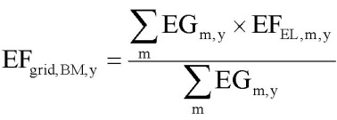 (2)
Where:
EF_{grid.BM.y} | = | Build margin CO₂ emission factor in year y (tCO₂/MWh)
EG_{m.y} | = | Net quantity of electricity generated and delivered to the grid by power unit m in year y (MWh)
EF_{EL.m.y} | = | CO₂ emission factor of power unit m in year y (tCO₂/MWh)
m | = | Power units included in the build margin
y | = | Most recent historical year for which power generation data is available
Method of EF _{EL. m. y} calculation here is the same as for EF _{grid. OMsimple. y} described under Step 4. i.e. by using specific fuel consumption per 1 kWh of energy output b_{m. y} (kg c.e./kWh).
EF _{EL. m. y}= b _{m. y x} EF _{CO2. fuel} (3)
Where:
EF _{CO2. fuel} | = | fuel emission factor (fuel type weighted) in tCO₂/MJ or tCO₂/t.c.e; the IPCC factors for main types of fuel values;
b_{m. y} | = | specific fuel consumption by the unit m (MJ/MWh or t.c.e./MWh)
In the Russian Federation individual plant based data is considered strictly confidential. Therefore the specific factors of the power units (or similar power units) from open sources were used.
The background data for EF grid. BM. y calculation is presented in the Table Anx.2.9.
Table Anx.2.9: Background data for EF _{grid. BM. y} calculation
Indicator | Unit | Severo-Zapadnaia CHPP, #1 | Severo-Zapadnaia CHPP, #2 | Vasileostrovskaya TPP-7, #3 | Avtovskaya TPP-15 | Pravoberejnaya TPP
Electric capacity | MW | 900 | 900 |  | 30 | 180
Annual net generation of electricity | MWh | 3 313 266 |  | 539 469 | 1 261 715 | 1 002 805
Specific fuel consumption | g c.e./kWh | 233 |  | 312,7 | 349,4 | 260,6
Specific fuel consumption | GJ/MWh | 6,85 |  | 9,20 | 10,28 | 7,66
Fuel | - | Natural gas
Fuel | GJ | 22 705 617 |  | 4 961 528 | 12 965 977 | 7 686 205
Fuel emission factor | tCО2/GJ | 0,0561
Source: Rosstat RF
The results of EF _{grid. BM. y} calculation are presented in the Table Anx.2.10.
EL, m, y
Table Anx.2.10: Results of EF _{grid. BM. y} calculation
Indicator | Unit | Severo-Zapadnaia CHPP, #1 | Severo-Zapadnaia CHPP, #2 | Vasileostrovskaya TPP-7, #3 | Avtovskaya TPP-15 | Pravoberejnaya TPP
Power unit CO2  emission factor | tCО2/MWh | 0,384 | 0,384 | 0,516 | 0,577 | 0,430
Average weighted BM  emission factor | tCО2/MWh | 0,443
BM emission factor is ex-ante for period 2008-2012.
STEP 7: Calculate combined margin emission factor
The combined margin emission factor (CM) is calculated as follows:
EF grid. CM. y= w 0Mx EF grid. 0M. y + w BMx EF grid. BM. y (4)
Where:
EF grid. CM. y | = | CM emission factor in year y (tCO₂/MWh);
EF grid. OM. y |  | OM emission factor in year y (tCO₂/MWh);
EF grid. BM. y | = | BM emission factor in year y (tCO₂/MWh);
w0M | = | weight of OM emission factor;
w BM | = | weight of BM emission factor.
In most cases the Tool recommends to apply w0M = w BM = 0.5. But developers may propose other weights. as long as w0M + w BM = 1.
As a starting point the weighting factor for w_{0M} is taken as 0.5.
When looking at the factor for w BM the conditions of the Russian power system have to be taken into account. The Russian power system has a big quantity of old. worn-out low efficient power plants being in operation for decades. According to the JSC “UES of Russia” average turbines operational life time is around 30 years. Most of these capacities were put in operation in 1971-1980 that corresponds to 31.4% of the whole installed capacities.
In accordance with General Scheme. dated 22 February 2008. it was planned to approximately 33 GW of old capacity has to be dismantled by 2015. To meet the growth in demand for new energy units with total capacity of 120 GW will be commissioned by 2015. This means that the JI project will not only initiate the construction of new power plants. but also accelerate the decommissioning of existing capacities. Given the impact of the financial crises on demand growth and the capability to finance new projects. the new estimation (September 2008) expects that out of the planned 120 GW only about 80 GW will be operational by 2015. Out of the 33 GW of old capacity only 10 GW will be dismantled. This means that 1 GW of any project delay leads to a delay of 0.5 GW of old capacity dismantling. So the effect of the JI project on the acceleration of decommissioning of existing capacities will only be stronger as result of the financial crisis.
The estimation. that the effect of the JI project on the decommissioning of power plants and the delays of new power plants construction is approximately 50% / 50%. For the avoidance of new power plants the emission factor of the BM is representative whereas for the accelerated decommissioning effect the emission factor of the OM is representative. And it means that 0.25 of BM refers to the group of prospective power plants and another 0.25 of BM refers to the dismantling of existing capacities and can be related to OM.
Therefore effective w_{OM} = 0.50 + 0.25 = 0.75 and w _{BM} = 0.25.
The resulting grid factor is EF grid. CM. y = 0.5481 tCO2/MWh.
CM emission factor is ex-ante for period 2008-2012. because OM and BM emission factors are ex-ante as well. This emission factor is the baseline emission factor (EF _{BL.C02 .y}) which is used to establish the baseline emissions of the baseline scenario.
Table Anx.2.11: Historical data
Year | 2003 | 2004 | 2005 | 2006 | 2007 | Average
Electricity output, MWh | 848 919 | 726 796 | 724 904 | 758 568 | 900 384 | 791 914
Heat generation, Gcal | 2 256 005 | 1 975 857 | 1 714 832 | 1 992 256 | 1 913 699 | 1 970 530
Fuel consumption, t.c.e. | 639 658 | 602 263 | 574 102 | 599 320 | 631 407 | 609 350
Table Anx.2.12: Total fuel consumption of power plants included in project boundary
Year | 2003 | 2004 | 2005 | 2006 | 2007
Natural Gas, kt.c.e. | 540.6 | 529.3 | 566.6 | 595.4 | 628.4
Fuel oil, kt.c.e. | 7.5 | 0.2 | 7.5 | 3.6 | 2.7
Coal, kt.c.e. | 91.6 | 72.8 | 0.0 | 0.3 | 0.2
Table Anx.2.13: Key Information and Data used for Setting the Baseline.
ID number | Symbol | Data variable | Measuring unit | Value
b1 | FC_{NG,PJ,y} | Annual natural gas consumption | Thous.m³
b2 | EG_{PJ,y} | Annual electricity supply | MW• hour/year
b3 | HG_{PJ,y} | Annual heat energy supply | Gcal/year
b4 | NCV_{NG,y} | Natural gas net calorific value | GJ/ t | 33.46
b5 | EF_{NG} | Natural gas emission factor | tCO₂/TJ | 56.1
b6 | EF_{CO2 grid,y} | Baseline emission factor | tCO₂/MWh | 0.5481
b7 | η_{boiler} | Efficiency of boilers | % | 93.3

Annex 3
MONITORING PLAN

See Section D for monitoring plan.

Annex 4
The calculation of the operating margin and
build margin emission factors
See file:  table.xls

http://ji.unfccc.int/Ref/Documents/List_Sectoral_Scopes_version_02.pdf
Letter from the Director of Investment Policy and Market Development of Energy Carbon Fund Kolesnikov D.A. No. DK-557 dated 18.12.2006
Source: Data provided by Open Joint-Stock Company «TGC-1» (file:Training of Personnel.pdf.).
http://cdm.unfccc.int/UserManagement/FileStorage/CDMWF_AM_15YH7UTNQ40J8MGMVX62CGNE0K49Y0
http://cdm.unfccc.int/UserManagement/FileStorage/9K6GRQITX27OVG3CAS2MVDN1IWXJX1
http://cdm.unfccc.int/UserManagement/FileStorage/PGZZ4XP5JIB9TSXN30YLQTRZQKO859
http://cdm.unfccc.int/UserManagement/FileStorage/CDMWF_AM_5CJO927L0ASINNC90KWHKMM9X1RMVN
http://stra.teg.ru/lenta/energy/1108 (Rus)
http://www.rosteplo.ru/Tech_stat/stat_shablon.php?id=692 (Rus)
AM0061 “Methodology for rehabilitation and/or energy efficiency improvement in existing power plants” (version 2.1)
http://www.docload.ru/Basesdoc/9/9657/index.htm
http://metrologu.ru/ntd/item326.html
http://www.gazanaliz.ru/standards/iso14532-2001ru/iso14532-2001ru.html
http://www.cbr.ru/print.asp?file=/statistics/credit_statistics/refinancing_rates.htm
The discounted payback period would be outside of the project lifetime.
Feasibility Study of Pervomayskaia CHP -14, CCGT 180. #00PRM65EE001
Net present value
See Annex 2.
Baseline Methodology for Grid Connected Electricity Generation Plants using Natural Gas, AM0029/version 03, Approved Methodology, CDM Executive board
Baseline Methodology for Grid Connected Electricity Generation Plants using Natural Gas, AM0029/version 03, Approved Methodology, CDM Executive board
Baseline Methodology for Grid Connected Electricity Generation Plants using Natural Gas, AM0029/version 03, Approved Methodology, CDM Executive board
Project Design “Reconstruction of the Pervomayskaya CHP-14”, Volume 00PRM650S001: “Environment Protection”, OJSC "Kompaniya EMK-Injiniring ", 2008
The conclusion about results of public hearings under the documentation, The report of discussion of the documentation.
http://www.e-apbe.ru/scheme
Tool to calculate the emission factor for an electricity system, version 02, Methodological Tool, CDM Executive board
http://www.so-ups.ru/fileadmin/files/company/reports/disclosure/2009/pokazateli_2008.pdf
http://www.so-ups.ru/fileadmin/files/company/reports/disclosure/2009/pokazateli_2008.pdf
http://www.so-ups.ru/fileadmin/files/company/reports/disclosure/2010/ues_rep_2009.pdf
Difference
http://www.so-ups.ru/fileadmin/files/company/reports/disclosure/2010/ues_rep_2009.pdf
Guidelines for National Greenhouse Gas Inventories, Volume 2: Energy, Chapter 2: Stationary Combustion (corrected chapter as of April 2007), IPCC, 2006
Emission factor for other types of fuel is taken as zero. It is conservative
See Annex 4.
http://www.so-ups.ru/index.php?id=tech_disc
http://www.e-apbe.ru/library/detail.php?ID=11106
http://www.e-apbe.ru/library/detail.php?ID=11106

