Project Idea Note (PIN) for JI investor country approval by Germany

Version 1.0

PROJECT IDEA NOTE

Project title

Name of the applying institution/entity

Place, date

Introduction
This PIN form supports project proponents of JI projects (taking place outside of Germany) applying for investor country approval with the German DFP (DEHSt). The form offers guidance on the information to be provided to the DEHSt that is needed for the application for a ‘Letter of Endorsement’.

At present, Germany has to fulfil the eligibility requirements for acquiring ERUs (criteria a. to f. in Section 1.A of the PIN) in order to be able to act as an investor country under JI. Furthermore, all EU Member States have to fulfil the Track 1 eligibility criteria. The Compliance Committee under the Kyoto Protocol still has to take decisions on Track 1 eligibility of Parties. Germany is now eligible. Information on the eligibility of host countries will be provided online by the UNFCCC secretariat. Once eligible for JI Track 1, host countries may choose between Track 1 and Track 2.

In some host countries, a MoU with the investor country is a requirement for the approval of a JI project. Germany does, however, not require a MoU in order to participate as an investor country in a JI project so that projects may be approved, regardless of a MoU with a particular host country.
- Pre-check of basic JI requirements
  - Host country eligibility (list of eligibility criteria)
Host country

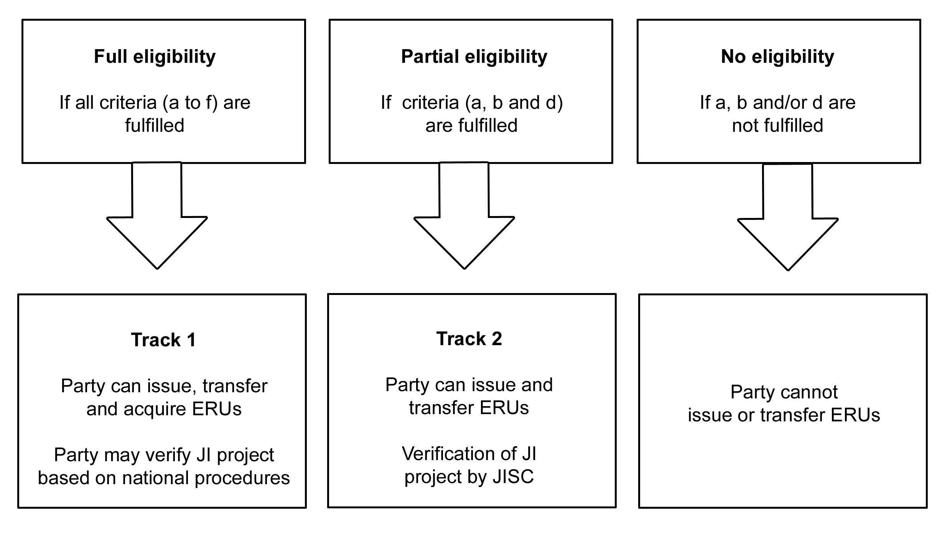
The host country is eligible for (see illustration above)
Track 1 (verification by host country)
Track 2 (verification procedure of JI Supervisory Committee)
not eligible to issue or transfer ERUs

  - JI Track chosen for the project
If the host country is eligible for Track 1, it may at any time elect to use the verification procedure under the JISC (Track 2). In this case, which of the two procedures will be selected?
Track 1
Track 2

  - Requirements for JI projects hosted by EU countries
 | Yes | No
Is the host country a Member State of the European Union (EU-27)?
Has the host party specified set-asides in its national allocation plan in order to avoid double counting?
If yes, is the project included in the set-asides?
→ If not, then no ERUs can be issued
  - National JI requirements of the host country
If the country has national guidelines specifying national requirements for JI project approval, list them below (Please specify the title and version of the respective documents and/or source of information, e.g. website of DFP)?
Memorandum of Understanding (MoU) with the investor country
Other national requirement
Other national requirement
Other national requirement
Other national requirement
 | Yes | No
If the country has national guidelines, does the project fulfill them?
Please explain, why:

- General description of the project
  - Information on the project participants

Project participants
(The table has to be filled separately for each project participant, please copy the table if necessary)
Name of the entity/organisation
Core business/activities
Role in the project (project developer, investor, etc.)
Street
Postal code, City
Country
Telephone
Fax
Email
Contact person for the project
Market position in core business (e.g. market share)
Trade registry number and date of registration

Government bodies/agencies of the host country involved in the project
(The table has to be filled separately for each body/agency, please copy the table if necessary)
Name of the government body/agency
Street
Postal code, City
Country
Telephone
Fax
Email
Contact person for the project
Role in the project

  - Information on the project

General information
Full title of the project
Project type/category (see sectoral scopes under 3.3. of the JI Manual)
Short description of the project and its objectives
Project location

Technology and project implementation
Technology

(Please describe the technology to be used and possible implementation problems)
Planned activities

(Please describe the exact activities which are planned in order to reach the expected emission reductions)
Date of decision for the JI activity
(Expected) Starting and end date of the project
Stage of the project

(Please endicate as well which documents, contracts, permits exist already or when they are expected to be signed/approved)
Project risks

(Please indicate potential risks during project implementation)

Phase during which emission reductions are expected to occur
Crediting period | (Until there is no international COP/MOP-decision on a climate policy framework post-2012, the crediting period for JI projects is 2008-2012)

Simplified modalities and procedures for small-scale projects:
Does the project belong to one of the following categories?  → These project types are subject to simplified modalities and procedures under Track 2. |  | Type I: Renewable energy project activities with a maximum output capacity of 15 MW (or an appropriate equivalent)
 |  | Type II: Energy efficiency projects reducing energy consumption on the supply and/or demand side with a maximum output of 60 GWh per year (or an appropriate equivalent)
 |  | Type III: Other project activities resulting in emission reductions of less than or equal to 60 kt CO2eq annually.

  - Baseline, additionality and emission reductions

Baseline
Greenhouse gases to be reduced | CO₂ | N₂O | CH₄ | HFCs | PFCs | SF₆
Baseline: Expected GHG emissions (t CO_{2eq}/yr) if the project would not have been implemented

(Please describe the baseline and explain how it was identified and calculated)
Project case: Expected GHG emissions (t CO_{2eq}/yr) with project implementation

(Explain how it was calculated)
 | Yes |  |  | No
Is there any leakage to be expected?
Please explain, why or why not:
If yes, indicate the amount in t CO_{2eq}/yr

Additionality
 | Yes | No
Would the project have taken place without JI?
Please explain (using the structure provided by the additionality tool)
Are there any policies or financial support programmes in place which apply to the JI project activity?
Only for projects hosted by EU Member States:
Is the ‘Acquis Communautaire’ considered with regard to the additionality of the project?
Please explain:
Only for EU accession countries:
Are there any transitional arrangements?
Please explain:

Emission reductions due to the project
Which is the amount of  expected annual ERUs and  the total amount of ERUs to be delivered during the crediting period
  Year | ERUs/year | Cumulative
  2008
  2009
  2010
  2011
  2012
   | Total

  - Monitoring
Specify the data and parameters to be monitored

  - Financial aspects
(if not specified with regards to additionality, above)
Estimation of the total investment

(specify the currency)
Estimation of the annual costs of maintenance and operation, including the costs associated with the determination (verification) of emissions reductions generated

(specify the currency)
Estimation of the annual incomes, excluding the income from the ERU transfer

(please specify the currency)
Description of the financial scheme

(own cash flow, equity, loans, subsidies, benefits)

http://unfccc.int/files/kyoto_protocol/compliance/enforcement_branch/application/pdf/eligibility_list_080201.pdf
http://ji.unfccc.int/Eligibility/index.html
http://cdm.unfccc.int/methodologies/PAmethodologies/AdditionalityTools/Additionality_tool.pdf

