PFS Joint Implementation Project
Biomass and Energy Efficiency Project
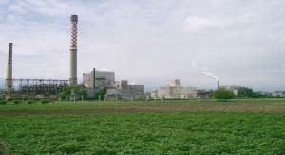

Draft Project Design Document
October 2004

Table of contents
1 PROJECT DETAILS .................................................................................................................................. 6
2 CURRENT SITUATION .......................................................................................................................... 11
3 GREENHOUSE GAS SOURCES AND PROJECT BOUNDARIES ................................................... 26
4 KEY FACTORS ........................................................................................................................................ 31
5 ADDITIONALITY .................................................................................................................................... 32
6 IDENTIFICATION OF THE MOST LIKELY BASELINE SCENARIO AND ASSOCIATED GHG
EMISSIONS ........................................................................................................................................................ 36
7 ESTIMATION OF PROJECT EMISSIONS .......................................................................................... 59
8 ESTIMATION OF EMISSION REDUCTIONS .................................................................................... 80
9 ENVIRONMENTAL IMPACT................................................................................................................ 81
10 LOCAL STAKEHOLDER PROCESS.................................................................................................... 83
11 MONITORING ......................................................................................................................................... 84
12 ANNEX....................................................................................................................................................... 91

List of Tables

Table 1 : Tentative Project Time Schedule .............................................................................................. 8
Table 2 : PFS JI Project: GHG Emission Reduction Summary ............................................................... 8
Table 3 : PFS Production Characteristics 1998-2003 ............................................................................. 11
Table 4 : Dumping Site Biomass Waste 2000-2006 .............................................................................. 14
Table 5 : PFS Production Process .......................................................................................................... 27
Table 6 : Direct on-site emissions .......................................................................................................... 29
Table 7 : Direct off-site emissions ......................................................................................................... 29
Table 8 : Indirect emissions .................................................................................................................... 30
Table 9 : BAU Investments .................................................................................................................... 32
Table 10 : JI Project Investment Schedule ............................................................................................. 33
Table 11 : Sensitivity of GHG Emission Reduction 2006-2012 on Kraft Paper Output ........................ 41
Table 12 : Sensitivity of Methane Emission Reduction 2006-2012 on Kraft Paper Output .................. 41
Table 13 : Sensitivity of Methane Emission Reduction 2006-2012 on Utilization of old Waste .......... 42
Table 14 : Sensitivity of Project Emission Reduction 2006-2012 on Biomass Boiler Efficiency ......... 42
Table 15 : PFS JI Project Baseline Scenario Overview ......................................................................... 43
Table 16 : PFS Output 2005 – 2012 ....................................................................................................... 44
Table 17 : Bulgarian Electricity Emission Factors – 2004-2012 ............................................................ 44
Table 18 : BTG Spreadsheet Model - Input Parameter .......................................................................... 47
Table 19 : Methane Emission Factors .................................................................................................... 47
Table 20 : Biomass from the Stockpile .................................................................................................. 47
Table 21 : Baseline Methane Emissions ................................................................................................. 48
Table 22 : Baseline Methane Emissions Details (BTG Spreadsheet Model) ......................................... 49
Table 23 : PFS Boiler System 2005-2012 .............................................................................................. 50
Table 24 : BL Gas Boiler and Transport Emissions ............................................................................... 50
Table 25 : Total BL Emissions BB Project ............................................................................................ 50
Table 26 : BL Steam & Condensate System PM 1 ................................................................................ 51
Table 27 : BL Steam and Condensate System PM 1: GHG Emissions .................................................. 51
Table 28 : BL Condensate Tanks Energy inputs (unused condensate) .................................................. 52
Table 29 : BL: Condensate tanks – GHG emissions .............................................................................. 52
Table 30 : BL: Space Heating – PFS Heat Demand ............................................................................... 53
Table 31 : BL – Space Heating GHG emissions .................................................................................... 53
Table 32 : BL: Soot Blowers Energy Demand ....................................................................................... 54
Table 33 : BL: Soot Blower GHG emissions ......................................................................................... 54
Table 34 : BL: Fine screening energydemand ....................................................................................... 55
Table 35 : BL: Fine screening GHG emissions ...................................................................................... 55
Table 36 : BL: Energy Demand Blow Heat Recovery System .............................................................. 55
Table 37 : BL: Blow Heat Recovery System GHG emissions ............................................................... 56
Table 38 : BL: Electrostatic Precipitator - Energy Output SRB System ................................................ 56
Table 39 : BL: Electrostatic Precipitator – SRB GHG emissions .......................................................... 57
Table 40 : BL: Black Liquor Concentrator GHG emissions .................................................................. 57
Table 41 : Total Baseline GHG Emissions ............................................................................................. 58
Table 42 : Biomass Boiler Input ............................................................................................................. 71
Table 43 : Biomass Boiler Output .......................................................................................................... 72
Table 44 : Project Gas Boiler and Transport Emissions ......................................................................... 72
Table 45 : Total Project GHG Emissions BB Project ............................................................................ 72
Table 46 : Project: Steam& Condensate Energy Inputs ........................................................................ 73
Table 47 : Project: SteamAnd Condensate System PM 1 - GHG Emissions ........................................ 73
Table 48 : Project: Condensate Tanks Energy Inputs ............................................................................ 74
Table 49 : Project: Condensate Tanks – GHG emissions .....................................................................74
Table 50 : Project: PFS Heat Demand .................................................................................................... 74
Table 51 : Project – PFS Space Heating GHG emissions ...................................................................... 75
Table 52 : Project: Soot Blower EnergyDemand ..................................................................................75
Table 53 : Project: Soot Blower GHG emissions ................................................................................... 76
Table 54 : Project: Fine screening energy demand ................................................................................ 76
Table 55 : Project: Fine screening GHG emissions ................................................................................ 76
Table 56 : Project: Blow Heat RecoverySystem Energy Demand ........................................................ 77
Table 57 : Project: Blow Heat RecoverySystem GHG Emissions ........................................................ 77
Table 58 : Project: Electrostatic Precipitator – Energy Output SRB System ......................................... 78
Table 59 : Project: Electrostatic Precipitator SRB GHG Emissions ...................................................... 78
Table 60 : Project: Black Liquor Concentrator GHG emissions ............................................................ 79
Table 61 : Total Project GHG Emissions ............................................................................................... 79
Table 62 : Baseline GHG Emissions ...................................................................................................... 80
Table 63 : Project GHG Emissions ........................................................................................................ 80
Table 64 : Total GHG Emission Reduction ........................................................................................... 80
Table 65 : PFS Monitoring Responsibilities Overview .......................................................................... 85
Table 66 : PFS Monitoring Responsible Persons ................................................................................... 86
Table 67 : Methane Emissions Factors ................................................................................................... 88
Table 68 : Monitoring Data .................................................................................................................... 89
Table 69 : PFS Workbook Overview ..................................................................................................... 90
Table 70 : PFS Workbook Color Keys ................................................................................................... 90

List of Figures

Figure 1 : Paper Factory – Stambolijski ................................................................................................... 7
Figure 2 : Chart PFS Paper Factory ........................................................................................................ 12
Figure 3: Landfill Site ........................................................................................................................... 14
Figure 4 : Technical Scheme of the Existing Steam/Condensate System at PM1 .................................. 15
Figure 5 : Existing Flash Steam Condensate System in Pulp Mill and Power Plant .............................. 16
Figure 6 : Picture of a radiator in the existing space heating system ..................................................... 17
Figure 7 : Scheme of existing space heating system .............................................................................. 18
Figure 8 : Scheme of Installed Soot Blower ........................................................................................... 19
Figure 9 : Existing System of Pulp Screening ........................................................................................ 20
Figure 10 : Existing Blow Heat Recovery System ................................................................................. 22
Figure 11 : Picture of Existing Sock Filter ............................................................................................. 23
Figure 12 : Technical Scheme of the Soda Recovery System with Sock Filters .................................... 24
Figure 13 : Technical Scheme of the Vacuum Evaporation System ...................................................... 25
Figure 14 : Flow Chart – Actual Production System ............................................................................. 26
Figure 15 : Flow Chart – Boiler System Actual ..................................................................................... 27
Figure 16 : Flow Chart – Project Production System ............................................................................. 28
Figure 17 : Flow Chart – Boiler System Project .................................................................................... 28
Figure 18 : Project Boundary ................................................................................................................. 30
Figure 19 : (1) BAU Investments ........................................................................................................... 34
Figure 20 : (2) BAU investments + JI investments w/o JI revenue ........................................................ 35
Figure 21 : (3) BAU investments + JI investments and JI revenues ...................................................... 35
Figure 22 : Planned Condensate System (Pulp Mill, Power Plant) - Project ......................................... 63
Figure 23 : Scheme of the planned Space Heating System – Project ..................................................... 65
Figure 24 : Overall View of a Modern Soot Blower .............................................................................. 66
Figure 25 : Scheme of Fine Screening Project ..................................................................................7
Figure 26 : Blow Heat Recovery System ............................................................................................... 68
Figure 27 : Electrostatic Precipitator ...................................................................................................... 69

Abbreviations
AAU BAU BL BLS CDM CO2e EIE ERRD EPS ERU EU GDP GHG GWh IFC JI kWh mio. MOEW MW MWh NSSC PFS PDD PIN t UNFCCC Assigned Amount Unit Business as Usual Baseline Baseline Study Clean Development Mechanism Carbon Dioxide equivalents Environmental Impact Evaluation European Bank for Reconstruction and Development Electric Power System Emission Reduction Unit European Union Gross Domestic Product Greenhouse Gas Gigawatt hours International Finance Corporation Joint Implementation Kilowatt hours Million Bulgarian Ministry of Environment and Water Megawatt Megawatt hours Neutral Sulphite Semi-Chemical Paper Factory – Stambolijski Project Design Document Project Idea Note ton United Nations Framework Convention on Climate Change

1 Project Details
1.1 Project characteristics
Project developer:
Company name: Paper Factory – Stambolijski (PFS)
Address: 1 Zavodska str, Stambolijski, Plovdiv Region
Zip code + city address: 4210 Stambolijski
Postal address: | see above
Country: | Bulgaria
Contact person: | Mr. Avinash Taneja
Job title: | CEO and Executive Director
Telephone number: | +359 32 909 205
Fax number: | +359 32 909 554
E-mail address: | ataneja@pfs.bg
Date of registration: | 28. January 2002

Shareholder name: | European Bank for Reconstruction and Development
Address: | One Exchange Square, London EC2A 2JN, United Kingdom
Contact person: |  | Mr.Andrzej Witak
Telephone number: | +44 20 7338 7346
Fax number: | +44 20 7338 7595
E-mail address: | Witak@ebrd.com
Shareholder name: | International Finance Corporation
Address: | 2121 Pennsylvania Avenue, NW, F-6K-272; Washington DC 20433;
USA
Contact person: |  |  | Mr.G.K.van der Mandele
Telephone number: |  |  | +420 29636 8400
Fax number: |  |  | +420 29636 8410
E-mail address: |  |  | Gkvandermandele@ifc.org

1.2 Project Abstract
Project Title:
Paper Factory – Stambolijski Biomass and Energy Efficiency Joint Implementation Project
Abstract:
The objective of the Paper Factory – Stambolijski (PFS) Joint Implementation project is the utilization of renewable energy sources and the improvement of the energy efficiency in the PFS paper factory. PFS plans to implement a number of measures in the coming years, leading to GHG emission reductions. The installation of a biomass boiler in envisaged with the purpose of utilizing the bark and the sediment material for thermal energy generation. Additionally, energy efficiency measures are planned, leading to GHG emission reductions by reduced consumption of natural gas, heavy fuel oil and electricity.
Project location:
Republic of Bulgaria
Stambolijski 4210;
Plovdiv region
Company: Paper Factory Stambolijski
Address: 1 Zavodska str
Stambolijski 4210
Plovdiv region
The Paper Factory – Stambolijski (PFS) is located in the region of Plovdiv as shown in Figure
1. PFS is located as at 2 km south of Stambolijski, a town with approximately 17,000 residents.
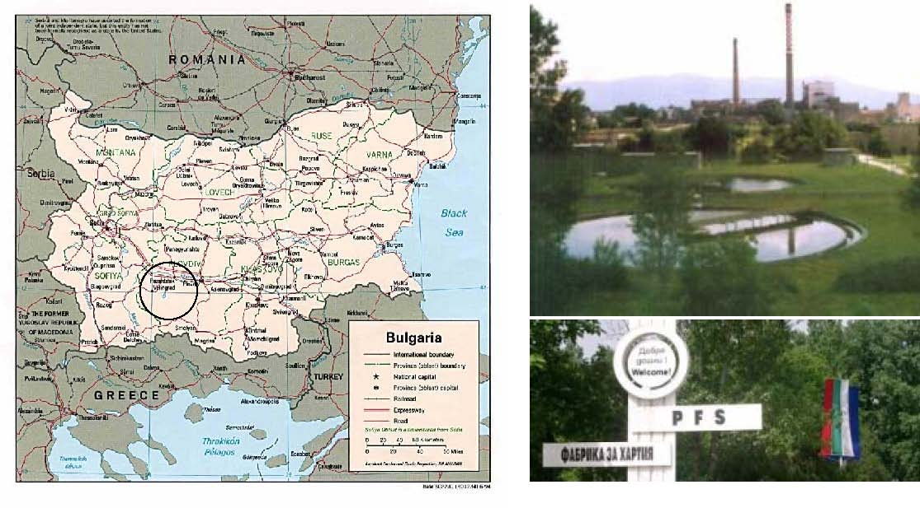
Figure 1: Paper Factory – Stambolijski
Date go/no-go decision of project
Expected date go-on of the project is the approval as Joint Implementation project, around November 2004.
(Expected) construction starting date
Construction/assembly starting date: November 2004
(Expected) construction finishing date
Construction/assembly finishing date: December 2006
Details are shown below.
The tentative schedule for the key milestones and the starting date of the PFS project activities is shown in the following table. The first bar indicates the planning phase, the second the financing phase, the third the engineering phase and the fourth the implementation phase. The end of the implementation phase is also the commissioning date.
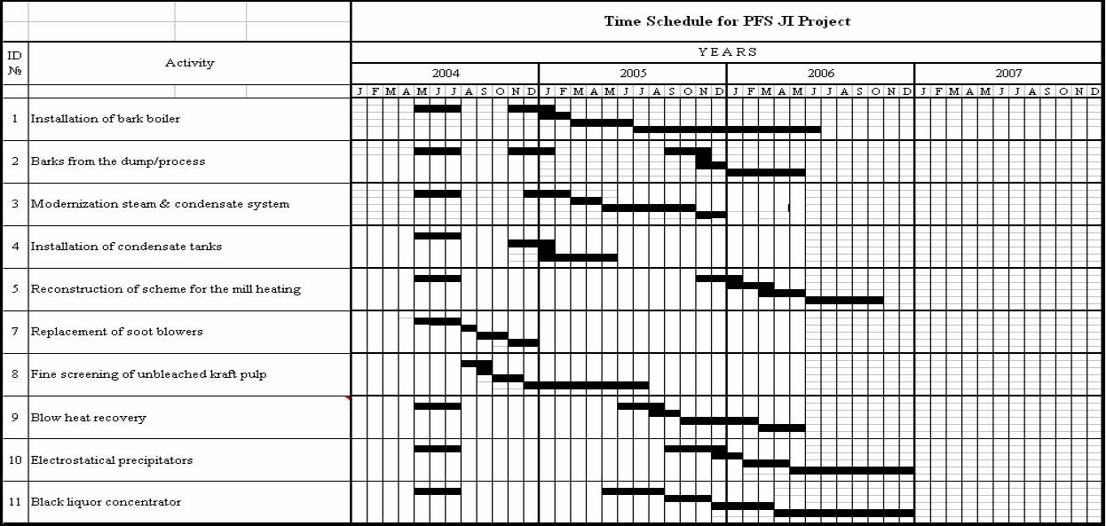
Table 1: Tentative Project Time Schedule
Expected operation lifetime of the project activity is at least 15 years.

1.3 Background and justification
The Paper Factory – Stambolijski (PFS) is the largest sack paper producer in Bulgaria and on the Balkan Peninsula, owned by IFC and EBRD. The company was founded in 1952 and has therefore over 50 years experience in pulp and paper production. PFS is an independent, fully integrated and well established Pulp and Paper Mill. It is a high quality and competitive Sack Kraft Mill producing 80,000 tons sack kraft paper per annum; designed capacity is 100,000 tons per annum. It also produces NSSC based fluting and high quality paper sacks. It is the biggest Paper Mill of its kind on the Balkan Peninsula.
Present Share Holding:
European Bank for Reconstruction and Development (EBRD), London: 50 %
International Finance Corporation (IFC), Washington: 50 %
Now the company is among the leading top quality sack paper producers. The products are: Sack Kraft Paper (natural and semi-extensible), Fluting (NSSC and waste paper based and only waste paper based), Paper Bags (0.5 – 5kg), Paper Sacks (open mouth and valved), Paper Cord (diameter 2-3 mm), format paper, turpentine, tall oil as by-products. The high quality of the products starts with the excellent fibre coming from the well-managed Bulgarian forests, where replanting and proper cutting programs are the most important activities.
The main focus of PFS future investments will be the increase in output up to 100,000 t kraft paper and further improvements of the paper quality. In addition to the Business as Usual investments the proposed Joint Implementation project aims for the reduction of the specific energy consumption and the utilization of biomass side products.
The production process requires steam, actual produced on the basis of natural gas, mazut and black liquor. Barks and other wood wastes are readily available as side product and are land filled. The proposed PFS Joint Implementation project takes aim at the utilization of the wood waste by the installation of a biomass boiler.

The key issue which must be resolved for the JI project to proceed, is the availability of funds. Availability of required funding of the project is directly linked to the approval as Joint Implementation project under article 6 of the Kyoto Protocol, since expected Joint
Implementation revenues amount to about one third of the total project investments.
Based on the Memorandum of Understanding on co-operation between the Kingdom of the Netherlands and the Republic of Bulgaria in reducing emissions of greenhouse gases under article 6 of the Kyoto Protocol the proposed PFS Biomass. The Project aims at reduction of greenhouse gases due to the (1) utilization of renewable energy sources, (2) avoidance of methane emissions.

1.4. Intervention
Project goals
The long-term strategic objectives of the PFS Joint Implementation project are to:
- utilize renewable energy sources by the implementation of a biomass boiler,
- improve the energy efficiency and associated reduction of specific energy demand,
- and therefore the reduction of the fossil fuel consumption, in particular natural gas,
- conserve and establish employment opportunities in the region of Plovdiv
 
Purpose of the project
The key purpose of the PFS Joint Implementation project is to make a contribution to (1) a more economically way of operation of the paper factory and (2) the sustainable development achieved through fossil fuel consumption reduction. Thus the project will assist the commercial operation of PFS and contribute to the objectives of national and global energy and environmental policies including alleviation of global warming and sustainable development.
Results of the project
The results of the project will be an operational biomass boiler and an improved energy efficiency of the PFS plant. Delivery of wood waste to the biomass stockpile will no longer be necessary and methane emissions will be avoided. The project will result in the installation of the biomass boiler. Therefore the project will abate greenhouse gas emissions due to the (1) displacement of natural gas and fuel oil by renewable energy sources (biomass), (2) avoidance of methane emissions from the wood waste, which is stockpiled at the municipal waste dump.

- Biomass Boiler Output: about 196,000 MWh/a
- Bark boiler installation: reduction of about 358,900 t CO2e (2005-2012)
Project activities
To achieve the results as described above, PFS will finish the project preparation phase (including JI approval) and the project planning in terms of financial contracting, detailed planning and supplier contracting. Project implementation and start up will be assisted by the suppliers. The tentative time schedule is shown in Table 1.

- Detailed planning of energy efficiency measures
- Designing of the biomass boiler
- Financial contracting
- Production and delivery of the equipment
- Construction on site
- Installation of the equipment
- Commissioning of the biomass boiler
- Operation and monitoring
Actors
Aside from PFS the Netherlands EBRD Carbon Fund, different suppliers and the Bulgarian Ministry of Environment and Water are the main actors for the proposed PFS Joint Implementation project.
The project’s application under Joint Implementation is being supported by CAMCO International (CAMCO International was founded as a joint-venture between ESD (UK) and KWI (Austria)). CAMCO International is a globally leading company in the identification and development of projects under the CDM, JI and other emissions trading regimes.

2 Current situation
2.1 Introduction
PFS is the largest pulp and sack paper producer in Bulgaria, owned by IFC and EBRD. PFS is a fully integrated pulp and paper mill – from wood, fiber material – pulp and NSSC, chemical recovery zone to the final products. PFS produces a wide variety of paper products in its production facilities: Sack Kraft Paper (natural and semi-extensible), fluting, paper bags, paper sacks (open mouth and valved), paper cord and format paper. PFS is self sufficient in pulp, which means a high quality of products with excellent fibre coming from Bulgarian forests.
In 1999 an investment program of more than 50 million USD for general rebuild of the main production line-paper machine PM 2, the sack line and some other important utilities was launched. To increase the output as planned (100,000 tons kraft paper in 2009), further investments will be required carried out under the business as usual investment program as described in chapter 5.
The mill has been issued permission for production activity (No. 21-10/1998) by the Ministry of Environment and Water with commencement date 15, July 2002, after having complied with all requirements set out in the resolution of Assessment of Environmental impact. PFS also holds permission for carrying out activities related to collecting, storing, treating, transporting and recycling of industrial waste, generated by the mill or imported, issued by the Regional Inspectorate of Environment and Water Resources. The state authority is represented by the Environment and Water Resource Regional Inspectorate in Plovdiv.
Environmental activities are managed in accordance with Bulgarian Environmental Regulations, which comprise the proper treatment, strict control and accountability of environment components (air, water, soil, waste), as well as appropriate process performance and prevention of non regulated raw materials and energy losses.
In 2003, the operation of the mill was regular, with the only exception being a 15 day stoppage in the kraft paper line in January, due to the lack of soft wood. The following table gives an overview on the PFS output, energy consumption and associated CO2 emissions during the last years.
Production
Pulp  Kraft paper Fluting  Sacks | t t t 1000pcs |  | 35,120  31,072  15,424  35,573 |  | 16,406  14,976  8,737  14,377 |  | 17,674  16,205  10,771  10,890 | 16,210  14,924  4,790  16,222 |  | 23,539  22,006  5,734  1,807 |  |  | 60,709  62,457  17,439  13,624
Energy consumption
Electricty onsumption  Fuel consumption natural gas  heavy fuel il/mazut/  Black liqour | MWh  1000m3 t t | 95,792  40,169  18,955 103,510 |  | 58,986  10,611  19,912  43,000 |  | 73,134  25,807  7,700  64,415 |  |  | 48,674  14,476  3,179 41,500 |  | 58,603  5,492  7,735  58,020 | 137,494  40,517  5,576  137,825

Table 3: PFS Production Characteristics 1998-2003
Based on the consumption of about (1) 40.5 million m³ natural gas, (2) 5,500 t mazut and (3) 138,000 t black liquor, the total input 2003 was about 712,000 MWh resulting in a heat output of about 550,000 MWh. Total fuel based CO2 emissions amount to about 95,000 t CO2 in 2003.
The production capacity of the kraft paper line is 80,000 t kraft pulp per year. Actual 2003 kraft pulp output was 60,700 t BD pulp, corresponding output was about 62,500 t kraft paper. The production line for Fluting made of NSSC and Waste paper has a capacity 20,000 t fluting per year. As a result of the PFS investment program fluting output could be tripled in 2003 to 17,400 t.
Consumed power in 2003 was about 137,500 MWh; 94,350 MWh purchased and 43,150 MWh generated by the two turbines in the power plant of the mill.
The mill applies procedures for monthly evaluation of energy efficiency. Actual specific energy demand could be summarized as follows:
  | - Mazut: | 0.07 t/t output (Sack Kraft Paper +Fluting)
  | - Natural Gas | 507 Nm³/t
  | - Total steam demand | 8.18 MWh/t
  | - Power | 1.7 MWh/t

Paper Factory – Stambolijski has three basic lines: (1) Sack Kraft Paper Line, (2) Fluting Line and (3) Paper Sack Line. The following chart gives an overview on PFS production process.

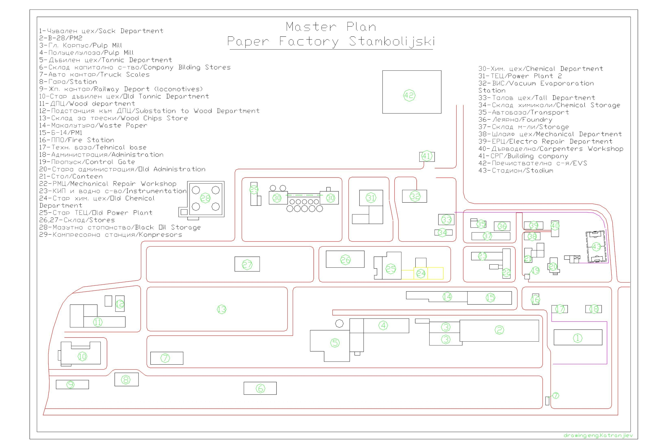

Figure 2: Chart PFS Paper Factory
A detailed description of the kraft paper line, the NSSC Based Fluting Production Line and the paper sack line is attached in Annex 12.17 Annex PDD PFS Process of Production.

2.2 Boiler System
Steam is generated by two steam boilers operated with natural gas and by one soda recovery boiler operated with a mixture of black liquor and mazut only as a supporting fuel.
The steam boilers are with drums, U-shaped arrangement, and half-open type with natural circulation. Initially they had been designed for 35 t/h. Due to a higher steam demand they had been rebuilt and upgraded for production of 50 t/h. The rebuilding was carried out according to the Russian project and it includes all the changes regarding the separation units, sootblowers, economizer, furnace chamber etc. The burning unit of the boiler consists of four burners arranged in two rows with two burners in the front wall.
The steam generator is two-staged and between the two stages PFS have installed surface steam regulator. It is located in the horizontal gas duct after the furnace. The air preheater is with vertical tubes, three-speeded according to the air. The technical parameters of the steam generators are:
• Nominal steam production 50 t/h
• Working pressure in the drum 44 atm
• Working pressure after the main steam valve 40 atm
• Feed water temperature 140 °C
• Overheated steam temperature 440 °C
• Fuel – mazut or /and/ gas.

The soda recovery boiler consists of two drums, with natural circulation, two-staged sootblower and an economizer. The burning unit consists of five mazut burners and up to 6 working with liquor. A tube filter is installed to the boiler in order to clean the flue gases. Technical parameters of the soda recovery boiler:
• Present steam capacity 70 t/h
• Steam production when 500 tons dry solid is burnt 95 t/h
• Working pressure after the main steam valve 40 atm
• Overheated steam temperature 440 °C
• Feed water temperature 145 °C
• Nominal liquor flow 20,8 t/h ADS
• Thick black liquor dryness 58% ADS
• Main fuel – thick black liquor, auxiliary fuel – mazut.

Latest available measurement reports (2004) on the boiler efficiencies show an average efficiency of 85,16% for the gas boilers and of 68,18% for the soda recovery boiler. Detailed information is attached in chapter 12.14 Annex PDD Measurement Report Boiler Efficiency.

2.3 Dumping area
The dumping site is owned by the municipality of Stambolijski and is located beside the railway. On the other side of the railway the pulp plant is located. The dump has a height of about 7 meter and a size of 300 by 500 meters. It is situated on level ground and has a surface of about 130,000 m². About 600,000 tonnes of biomass has been dumped at the location in the last years.
The landfill is well organized and it is managed according the relevant National Regulations No 12 and No. 13¹. The regulations of the Ministry of Environment and Water determine the places, which can be used for dumping waste, the conditions that must be satisfied and the way of exploitation².

The wastes from the soft wood wet debarking and the sludge from the mechanical stage of separation at the Effluent Treatment Plant are classified as non hazard wastes, which are allowed to be dumped/stored with no further treatment (Art. 2, paragraph 3 (a), Regulation No. 12). For the territory of each municipality the municipal authorities provide the needed places for waste dumping. Therefore the dumping area is property and responsibility of the Municipality of Stambolijski³. .
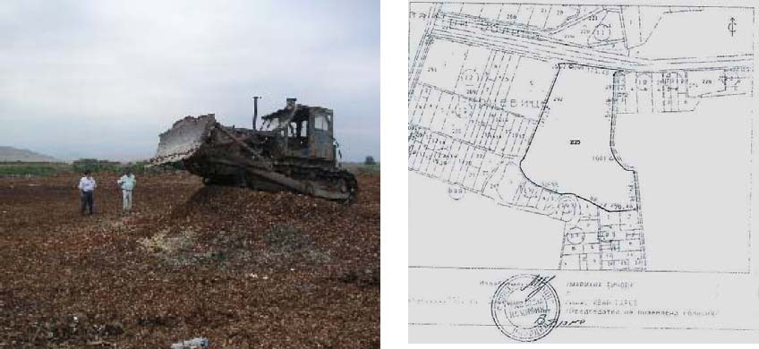
Figure 3: Landfill Site
From the factory the bark is transported by lorry to the dump. The distance to the dump is about
5.3 km now. After the wastes have been dumped, a bulldozer is levelling and compacting the waste. In 2003 about 16,000 tBD waste was dumped. The following table summarizes the expected amount of waste to be dumped until 2006.
BD Waste Wood to dump site t 4,209 3,877 5,716 16,223 19,157 20,780 22,079

Table 4: Dumping Site Biomass Waste 2000-2006

Additionality
In the history of paper production at PFS, investments in the capacity of the plant and the quality of the products took place rather irregularly. After major investments in additional capacities in the 60ies, in the drying section 1985 and in the press section in 1990, it took many years to launch the next massive investment program. In 1999 an investment program of more than 50 million USD for general rehabilitation of the main production line-paper machine PM 2, fibre line, the sack line, environmental protection and other important utilities was launched. The investment in the plant and machinery has transformed PFS plant into a state-of-the-art plant for high quality sack kraft paper. One main objective of this investment program was to increase the output of the plant. The other major objective was to increase the quality of the production process after years of little improvement. The investment program included the following areas:
• Soda recovery boiler- reconditioning and alteration
• Textile tube filter - reconditioning and alteration
• Evaporation station - reconditioning and alteration
• Digester and wash plant – reconditioning, alteration and (Digital Control System)
• Brand new stock preparation (stock preparation area, approach flow system, valmet chemical preparation and dosing system ) connected to DCS and QCS (Quality Control System)
• Completely renovated Paper Machine II (valmet head box, wire section, extensible unit, pope reel and unwinding station, new electrical drive). All of them integrated through DCS, QCS, and MCS ( Machine Control System)
• Other measures (international standard paper control laboratory, reconditioned sack making line)

After these major improvements in 1999/2000, a new investment program is now planned for the years 2004 to 2010. The output of the sack kraft line will be increased as planned progressively to 100,000 tons kraft paper in 2009, which includes a long list of measures to be implemented. With this investment program, the main units of the paper mill will have the necessary design capacity. All investments for capacity expansion, quality improvement, rationalization and safety will be done under the Business as Usual investment program. The total investment costs amount to more than 15 Million Euro.
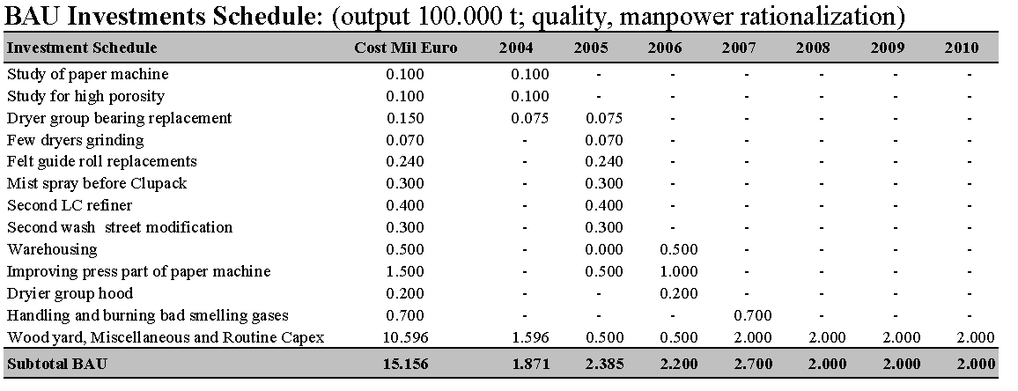Table 9: BAU Investments
In key areas of the factory (like recovery boiler, PM2, Pulp mill etc.) PFS has already the capacity to produce at an annual output of 100,000 t. To increase the capacity for the entire factory to 100,000 t, only relatively small investments need to be made (see the list of BAU investments above). The other aspect PFS is focusing on is improvement in quality. Increased production also gives savings not only by reducing fixed expenses but also reducing variable expenses to some extent. Investment in that area is, therefore, most attractive to all stakeholders of the company.
Therefore, all the measures of the investment programs 1999/2000 and 2004/2010 mentioned above were and are focusing on increasing the output of the plant to the planned level and to increase the quality of the products to a level, which enables PFS to maintain competitiveness on national and international markets apart from improving the performance substantially.
When setting up the 2004/2010 investment program, a number of additional measures have been presented and discussed. These additional measures are focusing on energy efficiency and the utilization of renewable energy sources and are having no or low impact on the quality and quantity aspects of the production.
The identification of these energy efficiency and renewable energy measures can mainly be explained by the activities of EBRD. Based on the important role EBRD is playing as an owner of PFS, the Bank urged PFS to investigate the potential in these areas, as this has not been done before. For this purpose, EBRD financed a preliminary energy audit, which led to a number of measures to be implemented. The PFS energy audit was performed by “The Energo Group S.A. Greece”, with co-operation of EBRD in autumn 2003. The Final Report has been presented in December 2003. The energy audit has been followed by the constitution and training of an Energy Management Team, performed again by “The Energo Group S.A.” at PFS.

Table 10: JI Project Investment Schedule
These additional measures were presented to the PFS management board. As most of the projects are attractive, the board expressed no objection provided PFS is able to manage the projects from its own cash flow or by borrowing from the market without support of the present share holders. The present share holders (IFC and EBRD) are not ready to increase their exposure in PFS. So the board decided not to implement these measures without being able to generate carbon emission reductions for the following reasons:
• Above all, increasing the output of the company and improving the quality of the products is the main objective for the management. Measures in these areas are necessary to support a sustainable position of PFS on the market. Therefore all lending opportunities and its own cash generation are dedicated to finance measures necessary regarding output and quality.
• IFC and EBRD made loans at PFS’ disposal in two tranches, totalling to around 35 mio. USD. Tranche “A” (about 27 mio. USD) has to be repaid in 4 semi-annual instalments starting from starting from 15 April 2006 till 15 October 2007. Tranche “B” (about 8 mio USD) has also to be repaid in 4 semi-annual instalments but starting from 15 April 2005 till 15 October 2006. These financial obligations, which are based on investments already made, limit the ability of PFS to take out new loans to finance additional measures.
• Even measures originally included in the investment program 2004/2010 will not be implemented, due to lack of funding. Funds will be spent for the most important measures of the investment program. This will also be the case, if a restructuring of the present loans is not done by the IFIs.
• Another important objective of the current management is to prepare the sale of the company. IFC and EBRD, the shareholders of the company, want to back out of the company in the medium term future (2 to 4 years). Additional investment in measures, which are not influencing output and quality of the production are seen as a potential risk in reducing the value of the company as additional loan repayments have to be made.
• Investment in BAU measures is done over the next years, with annual investments between
1.9 and 2.7 mio. €. The additional investments necessary for energy efficiency and renewable energies would require an investment of 7.4 mio. USD in 2005 and 8.4 mio. € in 2006. Taking into account the arguments mentioned above, the risk for these investments would be too high unless some clear and substantial incentive is there to make it attractive for the future lender as well as the present lenders (for restructuring the existing loans)
The following graphs show the financial performance of the company with and without the measures presented under the JI program. In the first graph, only BAU investment measures are carried out. Due to investment and repayment of loans, net cash has a minimum in 2007 with some -10.5 mio. €.
The second graph shows the BAU investments plus the JI investments. Net cash reaches a minimum in 2006 of -12.6 mio. €, if no carbon income is taken into consideration. Calculating the carbon income stream as indicated by the Netherlands EBRD Carbon Fund, the minimum of net cash is -10.8 mio. € in 2006.
So this comparison shows that the carbon income stream envisaged by selling the emission reductions to the Netherlands EBRD Carbon Fund enables PFS to have a similar development of net cash as if no JI measures were implemented. In combination with the limitation PFS is having to raise additional loans for the implementation of additional measures this shows that the carbon income can facilitate the implementation of the energy efficiency and renewable energy measures. Thus it can be argued that the emission reductions generated by the project are additional.
Charts:
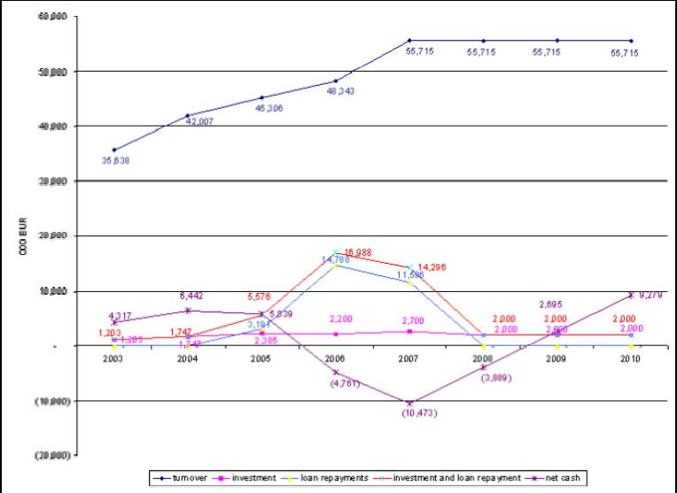
Figure 19: (1) BAU Investments

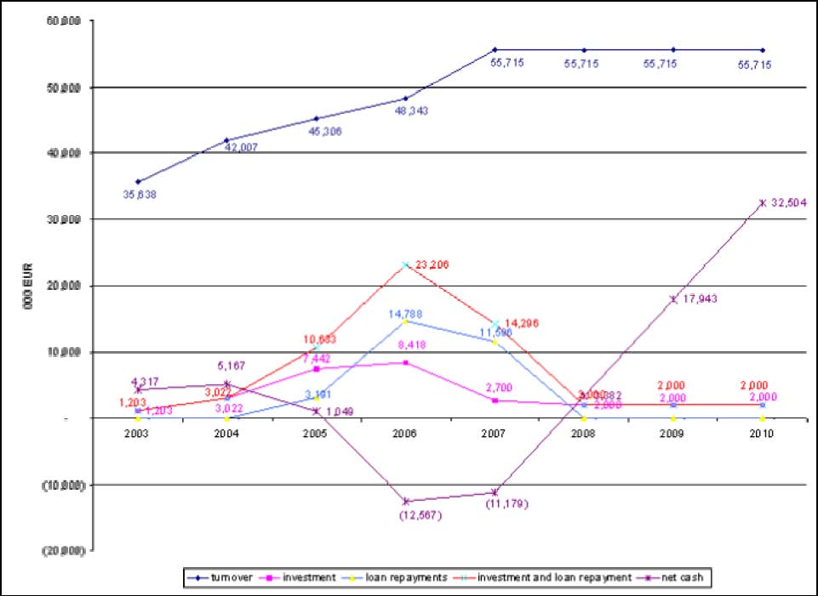
Figure 20: (2) BAU investments + JI investments w/o JI revenue

6 Identification of the Most Likely Baseline Scenario and Associated GHG Emissions
6.1 Key Factor Analysis
According to the key factors identified (see chapter 4.1), potential scenarios are discussed and the baseline scenario is selected.
6.1.1 Political Key Factors
Baseline Scenarios:
(1) EU Accession 2007
(2) EU Accession after 2007

Bulgaria aims to become a European Union Member state in 2007. The clear objective of both, the EU and Bulgaria is the accession date 1, January 2007. The conclusion of the accession negotiation is expected for the end of 2004. Therefore the Accession Treaty could be signed in 2005. At present negotiations are well on track and therefore no obstacle to Bulgaria’s EU accession in 2007 could be identified. The ‘2003 Regular Report on Bulgaria’s progress towards accession’⁴ demonstrates the Bulgarian progress in membership talks.
Therefore baseline scenario ‘(1) EU Accession 2007’ is the most likely scenario.

6.1.2 Legislation development
Legal factors are determined both by the current Bulgarian legislation and by the EU accession process e.g. aligning many of Bulgaria’s national policies with policies of the EU. The most important legal factors linked to the PFS Joint Implementation project refer to:
a) PFS operating licence
b) Current national legislation
c) EU directive on the landfill of waste
a) PFS Operating Licence
Baseline Scenarios:
(1) Permanent licence
(2) Suspension of licence

The present operating licence is based on the resolution of the Ministry of Environment and Water of Bulgaria (WEA No. 21-10/1998) with the commencement data 15, July 2002, after having complied with all requirements set out in the ‘Resolution of Assessment of Environmental Impacts’5. The state authority is represented by the Environment and Water Resources Regional Inspectorate – Plovdiv. Detailed information regarding the PFS operating licence is attached in chapter 12.1 Annex PDD PFS Operating License.
Due to the compliance with all requirements no reasons for future operating limitation could be identified and baseline scenario (1) Permanent licence is the most likely baseline scenario.
b) National legislation
Baseline Scenarios:
(1) Land filling of wood waste up to 2013 w/o gas capture
(2) Suspension of licence prior to 2013

The current Bulgarian legislation, concerning waste disposal and landfills is based on the following documents:
- Environmental Protection Law, published in Darzhaven Vestnik (the Bulgarian Official Gazette), issue 91 from 2002;
- Waste Management Law, published in Darzhaven Vestnik, issue 86 from 2003.
According to Article 15 of the Waste Management Law, the conditions and requirements for the construction and operation of waste disposal systems (including landfills) are specified in Regulations, issued by the Minister of Environment and Water and approved by the Minister of Regional Development and Public Works, the Minister of Agriculture and Forests and the Minister of Health Protection. The currently officially published regulations (by 16 September 2004), covering these issues, are as follows:
- Regulation No. 12 from 6th November 1998, concerning the requirements for the sites of waste disposal systems (including landfills) – published in Darzhaven Vestnik, issue No. 152 from 1998
- Regulation No. 13 from 6th November 1998, concerning the conditions and requirements for construction and operation of landfills – published in Darzhaven Vestnik, issue No. 152 from 1998
The wastes from the PFS soft wood debarking and the sludge from the mechanical stage of separation in the effluent treatment plant are classified as non-hazardous wastes. According to Regulation No. 12 (Article 2), it is allowed to store such waste in landfills without further treatment. Regulation No. 13 (Annex No. 2 to Article 19, paragraph 46) states that detected gas emissions from landfills have to be captured and combusted or flared. However, this Regulation does not indicate any deadlines for implementation of such measures on existing landfills.
According to the national legislation, the municipalities provide places for dumping of wastes. Concerning the PFS JI project it should be noted, that the Municipality of Stambolijski holds the property of the stockpile site. As discussed with and confirmed by the Municipality of Stambolijski no limitation on dumping of non hazard wastes are expected until 2012. An official statement of the municipality is attached in Chapter 12.6 Annex PDD Landfill Site Statement Municipality. Nevertheless the Municipality of Stambolijski fully supports the proposed Joint Implementation Project as demonstrated in chapter 10. Based on the discussions with the relevant ministry and with the Municipality of Stambolijski, scenario ‘(1) Land filling of wood waste up to 2013 w/o gas capture’ is clearly identified as the most likely scenario.
c) EU Directive (EULFD) on the landfill of waste (Council Directive 1999/31/EC)
Baseline Scenarios:
(1) Fully Implementation of EULFD after 2012
(2) Fully Implementation of EULFD prior to 2013

As part of the accession process, Bulgaria is aligning many of its national policies with the policies of the EU. Negotiations on the environmental chapter have been provisionally closed, transitional arrangements have been agreed, e.g. until 2014 for land filling of certain wastes. Therefore Bulgaria needs to incorporate the EU Landfill Directive after its entry into force, which was in July 1999 (Art. 19). The deadlines for landfills to comply with the requirements of the EU-Directive are given in years compared to when the EU Landfill Directive is accepted in the country’s National law (Art. 18).
Therefore the question of what will happen after Bulgaria’s EU accession has to be answered. Several meetings with the relevant departments of the Bulgarian Ministry of Environment and Water were held.
Most probably, a new regulation with requirements for the construction and operation of landfills will be issued, complying with the EU Directive on the landfill of waste (Council Directive 1999/31/EC). The deadline for existing landfills to comply with the requirements of the Directive is specified to be 8 years after the acceptance of the Directive in a country’s national Law (Article 18). What this implies is that 8 years after the Directive becomes applicable in Bulgaria, landfill gas collection must be fully operational on existing landfills. It is expected that Bulgaria will join the EU in 2007, so the Directive must be fully implemented in 2015 at earliest. Especially the high costs of alignment, full implementation could not be expected before the end of the first commitment period.
According to the Bulgarian Ministry of Environment and Water the time path for implementation of the EULFD is quite uncertain. Therefore it is concluded that the most likely scenario is ‘(1) Fully Implementation of EULFD after 2012’.
6.1.3 | Economic Factors
 | a) PFS output:
 | Baseline Scenarios:
 | (1) Kraft Paper output up to 100,000t⁶:
 | 2005 | 2006 | 2007 | 2008 | 2009
 | 80,000t | 85,000t | 90,000t | 95,000t | 100,000t
 | (2) As described (1), in each year -10 %
 | (3) As described (1), in each year +10 %

The PFS Output development is connected with the assumptive macro-economic indices of the main markets and the PFS strategy regarding increase in sales and production. PFS’ business strategy includes: (1) lowering of costs, (2) strengthening its position in its key markets by producing best quality products at competitive prices and on-time delivery, (3) achievement of high efficiency of its machinery and continuous improvement of products and services, (4) focus on higher environmental standards. The central geographical location of PFS in Bulgaria and in the Balkans allows optimizing of the relations with the customers and the logistics department insures just in time delivery to provide top quality services with highest professional standards. PFS has valuable clients in various countries, which are characterized by an economic development which is higher as the average. Therefore PFS sales potential have good prospects. In 1999 an investment program of more than 50 million USD for general reconstruction was launched. Actual output in 2003 is about 62,500 t kraft paper. To increase the output as planned (100,000 tons kraft paper in 2009), PFS launches a new investment program. It will be focused on increasing the quality and production capacity. The most expensive single equipment in Pulp and Paper production is the Soda Recovery Boiler, which has a capacity to ensure the production of 100 000 tons of Sack Kraft Paper. Higher production means:

- lower direct costs,
- lower variable costs,
- lower energy costs.

All investments for capacity expansion, quality improvement and safety will be done under the Business as Usual investment program. Based on PFS general settings, future investments and expected market development, scenario ‘(1) Sack Kraft Paper Output up to 100,000t’ is the most likely baseline scenario.

(2) Wood Waste taken from the Stockpile:
Baseline Scenarios:
(1) Waste taken from the Stockpile:
2006-2011: Biomass from Stockpile = 18,409 tBD/a
(2) Waste taken from the Stockpile:
2006-2011: Biomass from Stockpile < 18,409 tBD/a
(3) Waste taken from the Stockpile:
2006-2011: Biomass from Stockpile > 18,409 tBD/a

One factor for the calculation of the baseline GHG emissions is the prediction of the methane emissions until 2012. For the PFS Joint Implementation project the BTG model ‘Methane and Nitrous Oxide Emissions from Biomass Waste Stockpiles’7 is used for precise calculations of methane emissions. As mentioned in the BTG report the provided spreadsheet model is applicable for a variety of locations and is able to incorporate wood waste of various ages and types. The BTG spreadsheet model is based on a multiphase model, founded on first order kinetics. For the specific case of wood stockpiles, the general multiphase was adapted as described below. The applied spreadsheet model is therefore reliable for the PFS Joint Implementation project.
The final result of baseline methane emissions is determined by the amount of bark taken from the landfill and the actual PFS output after implementation of the biomass boiler. In order to apply a conservative baseline approach, just biomass waste which was (will be) dumped in the period 2000 to 2006 is taken into consideration for this baseline study (total about 92,000 tBD). However, the monitoring plan will make the allowance for using additional waste.
Therefore scenario (1) 18,409 tBD/a (2007-2011) waste is the most likely baseline cenario.

6.1.4 Capital availability
Baseline Scenarios:
(1) Funding is available for proposed JI projects
(2) Funding is not available for proposed JI projects

The most significant key factor in PFS baseline development is the availability of capital. Being in progress of economic stabilization, the conditions of the Bulgarian credit market improves, but is still considered risky. However, it should be mentioned that PFS investment programs are focusing on increasing output up to 100,000 t in 2009 and quality improvements. As discussed and demonstrated in chapter 5 it is obvious, that for the proposed JI project no funding will be available in the absence of generating additional cash flow from the sale of emission reductions under the JI project, therefore scenario ‘(2) Funding is not available for proposed JI projects’ is the most likely baseline scenario.

6.1.5 Technical Factors
a) Biomass Boiler Efficiency:
Baseline Scenarios:
(1) Biomass Boiler efficiency < 85%
(2) Biomass Boiler efficiency = 85%
(3) Biomass Boiler efficiency > 85%

In the case of PFS JI project, different technologies will be used. For energy efficiency measures (both for heat and electricity), state of the art or well-proven technologies will be implemented. Final decision on the biomass boiler type will be taken in the next project phase, after approval of the proposed JI project. However, all equipment to be installed will be well proven or state-of-the-art technology. Technology transfer will be realized by the support of reputable suppliers and with the assistance of PFS and EBRD managers and external technical experts.
One specific technical key factor influencing the project emission reductions is the biomass boiler efficiency. Based on experience of already installed similar biomass boiler systems8 and state of the art technology boiler efficiency is presumed at 85%. Therefore scenario ‘(2) Biomass Boiler efficiency = 85%’ is identified as the most likely (conservative) baseline scenario.
(2) Reliability of existing equipment:
Baseline Scenarios:
(1) Already installed equipment, affected by the JI project, operated until 2012
(2) Already installed equipment, affected by the JI project, not operated until 2012

Generally speaking, all installed equipment can be operated until 2012. All required rehabilitation and expansion work to reach 100,000 t output will be done under the BAU investment program. As the installed equipment and technology, affected by the implementation of the JI project, is appropriate for the expected output capacity of 100,000 t and the technology is well proven and spare parts availability is guaranteed, equipment could be used for at least ten more years. Based on the assessment of experienced internal and external experts, scenario (1) represents the most likely scenario.

6.4.2 BL: Boiler System and Biomass Stockpile
Methane emissions from biomass waste stockpiles:
The anaerobic digestion of biomass that is currently left rotting in the dump is a significant source of GHG emissions and is therefore included in the baseline scenario (and also in the project scenario). Landfilling of PFS biomass waste represents a source of GHG emissions; methane (CH4, anaerobic digestion) and nitrous oxide (N2O) are emitted. The proposed PFS Joint Implementation project would mitigate the stockpiling of wood residuals and will therefore claim GHG emission reductions. In order to calculate these GHG emission reductions all further calculations are based on the BTG study ‘Methane and Nitrous Oxide Emissions from Biomass Waste Stockpiles – Final Report’13. The studywas financed by PCFplus research and gives a general methodology for assessing methane emissions from wood residue stockpiles. The model and the measurements taken by BTG have been combined into spreadsheet model that can be used by project developers. BTG’s resulting spreadsheet model is used by the proposed JI project to calculate avoided methane emissions from biomass stockpile. To adapt the spreadsheet model to the PFS JI project, biomass and site-specific parameters are replaced by measured data or (conservative) default values presented in BTG’s spreadsheet model.
Beside methane emissions, nitrous oxide emissions from biomass stockpiles may contribute to the GHG effect. As discussed in the BTG report, actual no data on N2O emissions from biomass stockpiles are available, and will therefore not taken into consideration in this baseline study. Nevertheless it shall be mentioned, that neglecting N2O emissions will contribute to a conservative baseline approach, as postulated by JI guidelines (international, Netherlands).
The assignment of BTG model consists of three main parts:
  - A literature survey
  - Field measurements of methane emissions in Bulgarian bark stockpiles
  - Construction, calibration and validation of the spreadsheet model for methane emissions
from biomass stockpiles.
As described in the recommendations of the final BTG report, the methane emissions spreadsheet model is applicable to a wide variety of biomass stockpiles. The model has been validated for the specific case of wood stockpiles in Bulgaria, and is therefore very well applicable for the proposed PFS JI project.
The spreadsheet model does only calculate the avoided methane emissions which is associated with the methane emissions resulting from anaerobic degradation of the wood waste. GHG emission reductions associated with the use of the biomass (replacing natural gas) are calculated separately. The model takes two types of methane emissions into consideration:

- Methane emissions that will occur during the coming years when new biomass is
dumped on the piles;
- Methane emissions for the existing biomass in the piles that will occur during the
coming years when the biomass in not otherwise utilised.

Parameters used in the Spreadsheet model14:
(1) Methane content of the landfill gas Vm:
For the methane content of the landfill gas (Vm), a literature value of 0.6 is used [Oonk and Boom, 1995]. Oonk and Boom measured sometimes lower concentrations of methane, which are according to them attributable to methane oxidation. Since methane oxidation is separately accounted for in the model, it is not included in this factor.

(2) Generation factor z:
In the IPCC guidelines, a default value of 0.77 is given for the generation factor in landfills, with the remark that it should only be used when lignin is excluded from the generation factor. In the model used here, lignin is indeed excluded. Furthermore, the favourable circumstances for anaerobic digestion inside the PFS pile, such as:

- small particles,
- presence of water, and
- regular compaction
will likely result in degradation of a large part of the available carbon. Therefore the IPCC default value of 0.77 for the generation factor is considered conservative in this case.
(3) Wood volume under aerobic conditions Aox,j
In the case of the PFS JI project it is clearly stated, that mobile measuring devises are not available in Bulgaria. The BTG spreadsheet model recommends a default value of 10%. Based on the an estimated thickness of the oxidation layer of min. 0.5 – 1.0 meter and the total height of the stockpile of about 7 meters, the biomass volume under aerobic conditions can be estimated at about 7% - 15%. In order to apply a conservative baseline approach 15% are taken for the PFS JI project.

(4) Methane density:
The methane density depends on climatic conditions (pressure and temperature). According to approved UNFCCC Methodology AM0006 the methane density is 0.67 kg/m³ at room temperature (20°C and 1 atm pressure). At a temperature of 15°C the density is 0.68 kg/m³. Applying the methane density of the already approved methodology (0.67 kg/m³) meets the conservative baseline approach.

(5) Decomposition rate constant k
The decomposition rate constant is directly related to the half-life. As recommended in the BTG report a half-life of 15 years for wood decomposition in landfills is used. Reasons for using 15 years half-life are that conditions for rapid digestion are favourable inside the pile. It was already mentioned that small particles, bruised in the debarking process, with abundant presence of water, and regularly compacted, would likely result in fast decomposition. The k-value corresponding to a half-life of 15 years is k = ln2/t½ = 0.046 year-1.

(6) Initial organic carbon content Co,j
The IPCC default value for the initial carbon content is 0.3 (on a wet basis). Literature range for the initial carbon content is 0,4 – 0,6 on a dry basis. In the case of the PFS JI project 0.5 on a dry basis and 0.186 on a wet basis is applied. Therefore calculations are conservative in any case. It is assumed that the initial organic carbon content remains the same during the years in which wood waste was dumped.

(7) Non-lignin fraction u0
The fraction of the initial organic carbon content (C0,j) which is hemicellulose and cellulose can taken from literature. A normal lignin fraction in wood bark is 0.25, so for the non-lignin fraction a value of 0.75 is taken. In the case of PFS JI project, chemical analysis performed by
the PFS Quality Control Department reports a lignin fraction of 49.17% (fresh soft wood barks). Using PFS measurement results will lead to a conservative baseline approach. It is assumed that this fraction remains the same for the fresh dumped wood during the years in which wood waste was dumped.
(8) Oxidation factor
The oxidation factor is taken to be 0.1, which is the default IPCC value for well-managed landfills. This fraction is considered justified for PFS pile, because the wood waste is regularly compacted. For unmanaged waste sites, it is known that most of the methane is emitted through cracks and channels, therefore this fraction should be zero according to IPCC guidelines.
The following table summarizes all spreadsheet input data.
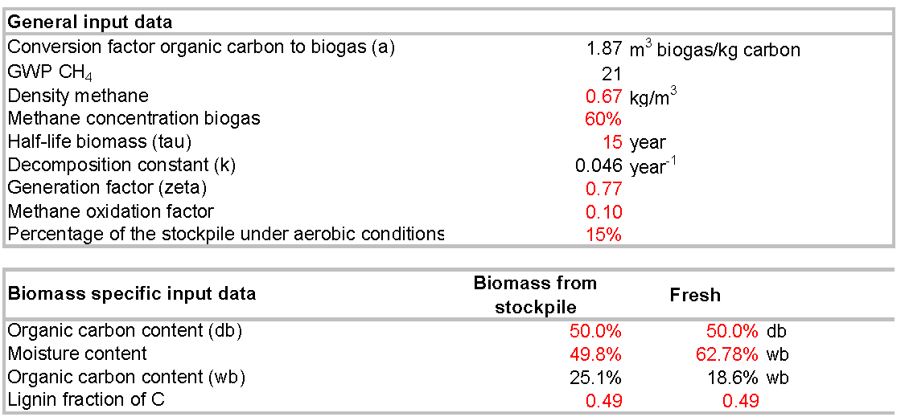
Table 18: BTG Spreadsheet Model - Input Parameter

For the purpose of the emissions calculation it has been assumed theat the waste management situation remains unchanged throughout the crediting period. PFS’s waste will continue to be stockpiled. This assumption is based on the best available information as elaborated in chapter
6.1.2.
Based on the input parameter presented and discussed above, the following table summarizes
the methane emissions factors on an annual basis.
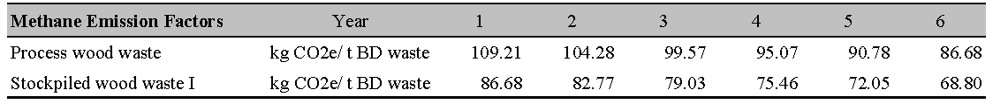
Table 19: Methane emission Factors

The biomass boiler which has been proposed has a capacity of about 20 t/h. In addition to the process waste wood the project aims to incinerate biomass waste from the stockpile. In order to apply a conservative baseline approach only stockpiled waste from the year 2000 onward is taken into consideration in this baseline study. The monitoring plan provides the possibility to use additional waste; separate CH4 emission factors are calculated. Based on the expected output development and the corresponding amount of process biomass waste the following table shows the annual biomass from the stockpile, which will be used in the biomass boiler.

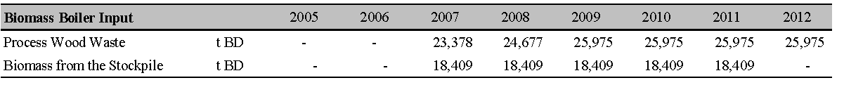
Table 20: Biomass from the Stockpile

Finally, on the basis of the expected output development as described in chapter 6.4.1 and the assumption on the stockpiled waste as described in the table above, Table 21 summarizes the baseline methane emissions. Details are shown in
Table 21: Baseline Methane Emissions
The BTG spreadsheet model does only calculate the avoided methane emissions which are associated with utilizing process waste and already stockpiled waste. Due to the expected implementation of the biomass boiler in 2007, neither BL methane emissions for 2005 nor for 2006 are calculated. In total BL stockpile GHG emissions are about 80,600 t CO2e.

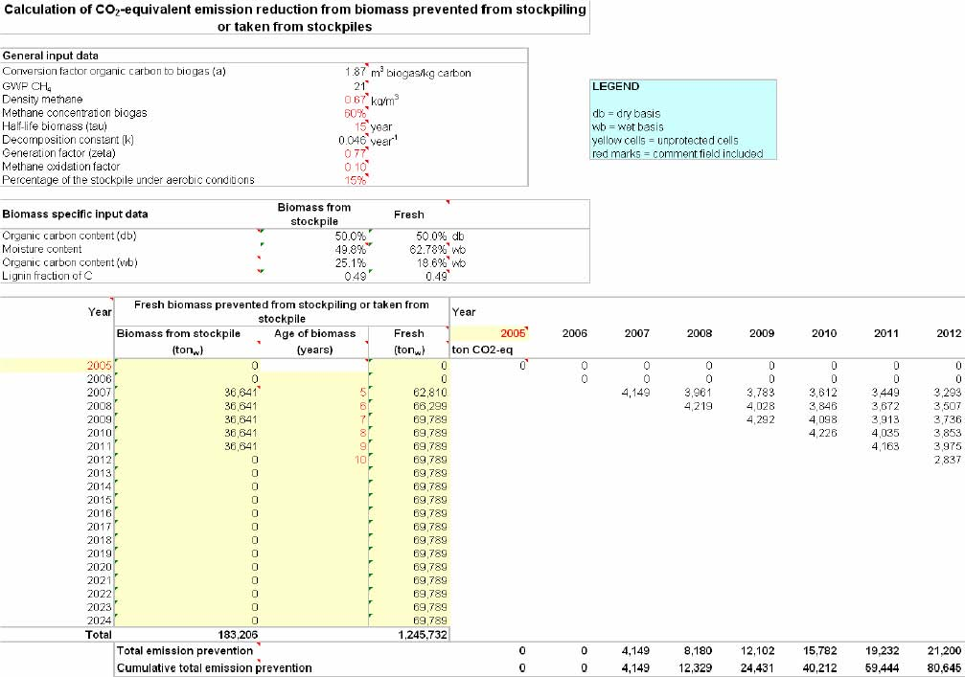

Boiler System - Fuel Emissions
Starting point for the calculation of the fuel based GHG emissions is the overall PFS production process steam demand. The latest available energy report shows an average figure of about 7.034 GCal/t Sack Kraft Paper and Fluting. Taking autonomous energy efficiency measures into consideration an energy efficiency potential of 0.5% per year is applied in this baseline study. In order to apply a conservative baseline approach, a minimum Mazut demand of 50 kg/t BD pulp is used, representing the technical minimum demand of the Soda Recovery Boiler. Table 23 summarizes the PFS boiler system.
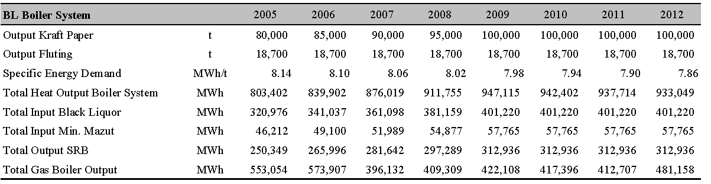
Table 23: PFS Boiler System 2005-2012

By using the minimum (technical) mazut input in the baseline scenario, only gas input will be influenced by the biomass boiler installation in 2007. Therefore the baseline emissions are determined by the natural gas input, taking a fraction of carbon oxidized of 99.5 % into consideration. Furthermore the GHG emissions linked to the biomass transport to the stockpile are considered.

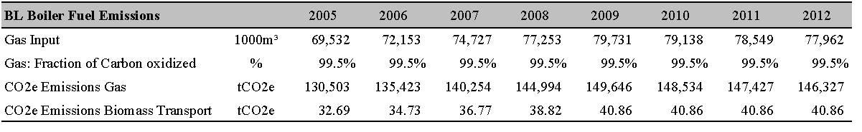
Table 24: BL Gas Boiler and Transport Emissions

Total BL Emissions: Bark Boiler Project:
Based on results shown in Table 21and Table 24 the following table summarizes the total baseline GHG emissions of the biomass boiler project.
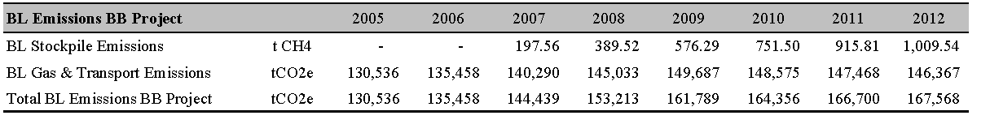
Table 25: Total BL Emissions BB Project

CAMCO International 57

6.4.11 Total Baseline GHG Emissions
Table 41: Total Baseline GHG Emissions) summarizes the baseline GHG emissions as described above.

7 Estimation of project emissions
7.1 Description of the Project Scenario
7.1.1 Biomass Boiler
Basic technical description:
Boiler technical data:
Rated output | 20 t/h
Rated pressure of superheated steam | 40 bar
Rated temperature of superheated steam | 430 °C
Rated feed water temperature | 105 °C
Air preheated temp. | 150 °C

The steam generator is designed for natural circulation with three membrane-type cooled passes arranged in vertical direction, and a vertical non-cooled EKO pass. The fuel for the boiler is the mixture of barks, saw dust, fibrous deposition (mechanical water treatment) and active deposition (biological water treatment).
Before coming into contact with the heated surfaces of the superheater the flue gasses pass along the so called protective evaporator. This rather cold heating surface lowers the number of burned-in particles and reduces the corrosion effects at the downstream surfaces of the superheater.
The superheater arrangement is designed in a way as follows: Three-step superheater with two injections used for the control of steam temperature in between the superheaters No. 1 and 2, and No. 2 and 3, respectively. When seen from the flue gas side this is first the superheater No. 3 which is encountered in the downstream direction, and then the No. 2 and 1/1 and 1/2 superheaters in the upstream direction. Tube transverse spacing of protective evaporator and superheater 3 is 240 mm because of surface dirtiness reduction. Tube transverse spacing of superheater 2 and 1 is 120 mm.

The boiler provided with an economiser placed in separate steel duct. The design of the economiser provides heating of water to the temperature close to saturated temperature corresponding with pressure in steam drum.
The contamination on the pipes, which emerges on the pipes of the superheaters are removed by the action of the lance-type screw soot blower. The heating surfaces of the EKO bundles within the third pass are cleaned using rotating pipe blowers.
The boiler is equipped with steam-heated air preheater for primary air temperature increasing. The preheater is in operation for fuel with high moisture and make easier the combustion process and adapt the combustion process in an optimum way to the respective fuel.
Ash from the grate falls down into the wet slag remover installed below the throw-off edge of the grate, it cools down and is transported into the slag container arranged downright in the path.
The fuel storage container, located directly in front of the boiler, is charged with fuel via the fuel conveyer. The fuel bunker is equipped with a level monitoring device which prevents the bunker from overflow, and controls the fuel transport system by using the corresponding signals from the conveyer.
Using the process of air gradation by the secondary air the generation of NOx can be prevented. Temperatures in the combustion chamber should be lower then 1200 °C because of preclusion ash melting and can be controlled through fuel gas recirculation equipment.
The collecting bunker at the entry and the upper hoppers are equipped with temperature sensors used for the tripping of fire protection measures in case of fire and for the activation of water connections for fire extinguishing. The fuel charging via the bucket conveyers is controlled by signals from sensors installed in the entrance shaft, which give information about the fuel level.
Description of individual parts

Steel structure:
The steel structures serve also for mounting of servicing platforms and stairs as well as for
suspension of piping. The servicing platforms serve for access to important places on the boiler
and to the accessories that require handling, maintenance or monitoring.
Boiler drums and internals:
Boiler is equipped with steam drum. Drum is electrically welded with hemispherical ends
provided with manholes and manhole closures. The internals consisting of cyclone type
separators, which ensure that the required steam purity can be achieved, are arranged in the top
drum.
Evaporator:
The evaporator includes membrane walls of the furnace, I and II boiler passes, headers, downcomers and distributing tubes of walls and connecting tubes for feeding the steam-water mixture from the upper headers to the drum. The membrane walls are made of plain tubes with welded in flats.
Steam superheater:
Bare tubes, horizontal coils superheater is suspended on the supporting tubes in the second
boiler pass. The superheater is convection type. It is divided in three parts with built-in
desuperheater, designed for feed water injection and located in superheater connecting. All the
superheater heating surfaces are drainable.
Economizer:
The economizer consists of banks of horizontal tubes, located in separate steel duct behind
boiler, connected to the boiler through the flue gas duct. The flue gas duct is made of steel sheet,
gastight welded, reinforced end equipped with external insulation.
Air pre-heater:
Air pre-heater consists of banks of horizontal fined tubes located in steel duct. Steam flows
through fined tubes, where is chilled and condense by action of air flowing around finned tubes.
Condensate outlet is from bottom air pre-heater.
Boiler valves and fittings:
Within the scope of this group there are outlet piping from safety valves and start up fittings to
the stokehold roof including noise silencers, all small piping for deaeration, draining and all
necessary connecting piping including collecting headers.
Ducts:

The scope of this group includes primary, secondary air ducts as well as recirculation duct. The
ducts are welded of steel plates, properly reinforced, provided with necessary closing flaps,
expansion joints, access doors with closures, supports and suspensions.
Boiler flue gas ducts:
This group includes connecting duct between the boiler bank pass and the separate steel plate economizer duct, connecting duct from economiser duct to the precipitator inlet.
Fans:
The boiler is equipped with primary and secondary air fans for combustion air supply to the boiler; flue gas fan for transport of flue gas from the furnace through the boiler passes into the stack and fan for flue gasses recirculation. Fans are provided with control device and driven with electric motor.
Sootblowers:
Lance-type screw soot blowers are used for superheaters and turning pipe blowers are used for economizers. All blowers interconnected completely with tubing and equipped with the corresponding valves for pressure reduction and preheating. Superheated steam is used as medium for soot blowers.
Boiler ash handling:
Two wet type ash conveyers to an ash container carry a siftings. A slag from grate falls through hopper to the wet type conveyer and it is transported to the separate ash container. Boiler ash generated by the 2nd path falls through hopper and screw conveyer through turnstile into the recirculation gasses flow and is returned to the combustion chamber. Boiler ash generated by the 3th path falls through hopper and turnstile into the ash conveyor. Ductings are made from abrasive resistant material.
Electrostatic precipitators (ESP) with ash handling:
The separation of fly ash from the flue gasses will be by means of electrostatic precipitators. Electrostatic precipitator is located in front of the flue gas ventilator. The flue gasses are exhausted from the boiler by means of a fan and led through the electrostatic precipitator. The flue gasses enter through the inlet part with the distribution screens into the ESP casing and proceed through the system of collecting and discharge electrodes. The discharge electrodes are connected to the rectified very high voltage. Due to the strong electric field the gas gets ionized and the dust particles are charged with negative ions. The charged dust particles are attracted to the collecting electrodes due to the electric field where they deposit. For the cleaning of the collecting and discharge electrodes the raping system is used. The dust falls through hopper and turnstile into the ash conveyor.
Grate:
Area of the grate is 15 m², width is 2.15 m and length is 7.0 m. The stocker has holes for primary air supply for ideal combustion. The ash falls from the grate through hopper down into the wet ash hopper. The hopper is made from abrasive resistant material. Grate consisting of a moving grate with continuous ash unloading and fuel charging, with air-jet spreader stoker, incl. a dosing tank for biomass and discharging system, which in principle consists of the following:
- 1 Stoker with heat resistant ductile iron grates.
- 1 dosing silo of single metal sheets of St 37-2 material or similar including the filling level measurement, temperature measurement, fire extinguishing water jets and deaeration equipment, dust removal equipment.
- 1 pcs movable frame for homogenous fuel charging
- 2 pcs screw dischargers, with frequency controlled electric motor drive
- pneumatic choke valves to be operated in case of fire
- pressure-shock proof vertical shafts, with thermal expansion elimination
- spreader stokers
- air distribution box with ash disposal
- the corresponding supplementary parts

Igniting burner:
It is a fully automatic controlled oil or gas firing burner incl. the control box and switchboard panel, with cable connections and cable ducts, designed for start-up.
SNCR system
- Tank for auxiliary process material
- Mixing and distribution equipment
- Jet injection system
- Control and operating
Measuring equipment
- Temperature
- Pressure and differential pressure
- Flow
- Level Measuring
- Water, Condensate and Steam Analysers
- Cabling for Check and Control System
- Cable Core Sections and Material
Control system:
The system is based on components of PCL Siemens. It performs as a modern control system, which features large variability and high reliability. The architecture of this system allows designed application to be enlarged to operate another technological complex (for example another boiler).
Investment Costs
The total investment costs of the bark boiler are about 5,577,000 €. The investment costs include the technical equipment and machinery, costs for construction, project development costs and 10% contingencies. The costs have been estimated on discussions with potential suppliers.
Expected Net Savings / Costs
Boiler operation will result in gas savings mainly. Additional some transport costs of biomass to the dumping area are also saved. On the other hand the boiler operation is related to operational costs of 0.49 mio. € per year, because of additional feeding water demand, personal costs (2 manual workers and 1 technician) and additional electricity demand.

7.2 Estimation of Project Emissions
As described in chapter 3.2 neither significant indirect on-site emissions nor significant indirect off-site emissions were identified. Therefore only direct emissions are taken into consideration.
7.2.1 Project Scenario: Boiler System and Biomass Stockpile
The proposed investment solution for PFS is to install a biomass boiler that will utilize both past biomass wastes produced by the plant and future wastes19. The capacity of the biomass boiler will generate a significant contribution to the energy balance at the site whilst annually consuming 100% of process wood waste and additional 18,400 t/a BD waste from the stockpile in the period 2007-2011 from the stockpile. The amount of process waste wood is directly linked to PFS output. Barks, saw dust and waste from the water treatment plant will be utilized. As described in chapter 6.4.2 the biomass resource will substitute natural gas.
Methane emission savings will be generated by consuming the biomass waste. Due to the fact, that the baseline methane emissions are calculated on the basis of waste, that would otherwise be utilized in the project scenario, nether methane emissions from process waste nor methane emissions form stockpiled waste could occur in the project scenario. Note, all methane emissions calculations shows avoidable CH4 emissions.
The project boundary of the proposed project contains the biomass boiler, the gas boiler system and the stockpile. Input and output of the SR Boiler will not be influenced by the implementation of the biomass boiler.
To evaluate the expected future biomass boiler energy input extensive chemical analysis were executed by the PFS Quality Control Department. Both fresh material (barks, saw dust, fiber sediments from ETP, active sediments, waste from hard wood) and stockpiled waste (new and old depot) were analyzed. The following list summarizes the calorific values, details are shown in chapter 12.8 ‘Annex PDD Chemical Analysis Dumping Site’ and chapter 12.9 ‘Annex PDD Chemical Analysis Process Waste’.
  | - Process saw dust: | 5620 kcal/kg BD
  | - Process barks : | 5134 kcal/kg BD
  | - Process fiber Sediments: | 3972 kcal/kg BD
  | - Process active Sediments: | 4274 kcal/kg BD
  | - Process hard wood waste: | 4960 kcal/kg BD
  | - Stockpile waste new area: | 4715 kcal/kg BD
  | - Stockpile waste old area: | 2578 kcal/kg BD

Actual, barks from the kraft paper production and fiber sediments (mechanical stage of the water treatment plant) are stockpiled. According to the PFS JI project 100% of process waste (saw dust, barks, fiber sediments, active sediments, NSSC hard wood waste) and dumped waste material (2000-2006) will be incinerated in the biomass boiler during the period 2007-2011.

Table 42: Biomass Boiler Input
19 See chapter 7.1.1 CAMCO International
Based on the expected amount of available waste, both process and stockpile waste, the following table shows the total input and output of the biomass boiler. Therefore the biomass boiler efficiency is assumed to be 85%, which represents a conservative baseline approach.
Total Input BB MWh -233,229 241,362 249,495 249,495 249,495 163,476 Total Heat Output BB MWh -198,244 205,157 212,070 212,070 212,070 138,954
Table 43: Biomass Boiler Output
In consequence of raising paper output the total heat output of the biomass boiler will increase until 2011 to about 212,000 MWh. Due to the baseline assumption, that the mazut input will reach the technical required minimum prior to the biomass boiler installation, 100% natural gas input will be replaced.
Total Input gas boiler | 1000m³ |  |  | 72,153 |  | 49,803 |  | 51,460 |  | 53,069 |  | 52,476 |  | 51,887 |  | 60,493
Gas: Fraction of Carbon oxidized | % |  |  | 99.5% |  | 99.5% |  | 99.5% |  | 99.5% |  | 99.5% |  | 99.5% |  | 99.5%
CO2e Emissions Biomass | tCO2e |  |  | - |  | - |  | - |  | - |  | - |  | - |  | -
CO2e Emissions gas | tCO2e |  |  | 135,423 |  | 93,474 |  | 96,584 |  | 99,604 |  | 98,492 |  | 97,386 |  | 113,538
CO2e Emissions Transport | tCO2e |  |  | 34.73 |  | 28.96 |  | 28.96 |  | 28.96 |  | 28.96 |  | 28.96 |  | -
Table 44: Project Gas Boiler and Transport Emissions  Applying the gas emission factor of 15.3 tC/TJ20, Table 44 shows the project GHG emissions. According to the baseline assumptions, biomass transport will and associated GHG emissions will be stopped in 2012.  Based on results shown in Table 44 the following table summarizes the total project GHG emissions of the biomass boiler project.  Project Stockpile Emissions |  | t CH4 | - |  | - |  | - |  | - |  | - |  | - |  | -
Project Gas & Transport Emissions |  | tCO2e | 135,458 |  | 93,503 |  | 96,613 |  | 99,633 |  | 98,521 |  | 97,415 |  | 113,538
Total Project Emissions BB Project |  | tCO2e | 135,458 |  | 93,503 |  | 96,613 |  | 99,633 |  | 98,521 |  | 97,415 |  | 113,538

Table 45: Total Project GHG Emissions BB Project

7.2.2 Project: Steam & Condensate System PM 1
The installation of the proposed project will result in more efficient utilization of the flash steam. Due to the installation of flash steam recovery after and before last drying groups heat losses will be reduced.
Condensate Return: project input data
 Rate of condensate return: 90% (PFS experts).
Steam & condensate closure: project input data
 Increase in efficiency steam & condensate system: 18% (PFS experts)
PFS Joint Implementation Project – Draft Project Design Document
Fluting Output | t |  |  |  | 18,700 | 18,700 |  |  | 18,700 |  |  | 18,700 | 18,700 | 18,700 | 18,700 | 18,700
Fluting operating hours | h/a |  |  |  | 8,000 | 8,000 |  |  | 8,000 |  |  | 8,000 | 8,000 | 8,000 | 8,000 | 8,000
Fluting operating hours | h/month |  |  |  | 667 | 667 |  |  | 667 |  |  | 667 | 667 | 667 | 667 | 667
CONDENSATE Return
Rate of return condensate |  |  | % |  | 90% |  |  | 90% |  |  | 90% | 90% | 90% | 90% | 90% | 90%
Energy Content Condensate (100%) |  |  | Gcal |  | 3,600 |  |  | 3,600 |  |  | 3,600 | 3,600 | 3,600 | 3,600 | 3,600 | 3,600
Energy Content Condensate (100%) |  |  | MWh |  | 4,187 |  |  | 4,187 |  |  | 4,187 | 4,187 | 4,187 | 4,187 | 4,187 | 4,187
Energy Content returned Condensate |  |  | MWh |  | 3,768 |  |  | 3,768 |  |  | 3,768 | 3,768 | 3,768 | 3,768 | 3,768 | 3,768
Net energy input gas boiler for condensate |  |  | MWh |  | 419 |  |  | 419 |  |  | 419 | 419 | 419 | 419 | 419 | 419
Gas Boiler Efficiency |  |  | % |  | 85% |  |  | 85% |  |  | 85% | 85% | 85% | 85% | 85% | 85%
Gas Input Boiler (net for condensate) |  |  | MWh |  | 491.6 |  |  | 491.6 |  |  | 491.6 | 491.6 | 491.6 | 491.6 | 491.6 | 491.6
Steam and Condensate (closure)
Energy (steam demand) per ton fluting |  | Gcal/t |  | 1.59 |  |  | 1.59 |  |  | 1.59 |  | 1.59 | 1.59 | 1.59 | 1.59 | 1.59
Energy (steam demand) per ton fluting |  | MWh/t |  | 1.85 |  |  | 1.85 |  |  | 1.85 |  | 1.85 | 1.85 | 1.85 | 1.85 | 1.85
Fluting Output |  | t |  | 18,700 |  |  | 18,700 |  |  | 18,700 |  | 18,700 | 18,700 | 18,700 | 18,700 | 18,700
Total energy (steam demand) |  | MWh |  | 34,597 |  |  | 34,597 |  |  | 34,597 |  | 34,597 | 34,597 | 34,597 | 34,597 | 34,597
Gas Boiler Effciency |  | % |  | 85% |  |  | 85% |  |  | 85% |  | 85% | 85% | 85% | 85% | 85%
Gas Input |  | MWh |  | 40,626 |  |  | 40,626 |  |  | 40,626 |  | 40,626 | 40,626 | 40,626 | 40,626 | 40,626
Table 46: Project: Steam & Condensate Energy Inputs

Fluting (hard wood)
Output | t |  |  | 18,700 | 18,700 | 18,700 | 18,700 | 18,700 | 18,700 | 18,700 | 18,700
Fluting operating hours | h/a |  |  | 8,000 | 8,000 | 8,000 | 8,000 | 8,000 | 8,000 | 8,000 | 8,000
Fluting operating hours | h/month |  |  | 667 | 667 | 667 | 667 | 667 | 667 | 667 | 667
CONDENSATE Return
Gas Input Boiler (net for condensate) |  |  | MWh | 1,902 | 492 | 492 | 492 | 492 | 492 | 492 | 492
Gas Input Boiler (net for condensate) |  | 1000m³ |  | 204 | 53 | 53 | 53 | 53 | 53 | 53 | 53
Gas costs I |  | Euro |  | 22,310 | 5,826 | 5,884 | 5,943 | 6,002 | 6,062 | 6,123 | 6,184
CO2 Emissions Gas I |  | t CO2 |  | 384 | 99 | 99 | 99 | 99 | 99 | 99 | 99
Steam and Condensate (closure)
Gas Input |  | MWh |  | 49,544 | 40,626 | 40,626 | 40,626 | 40,626 | 40,626 | 40,626 | 40,626
Gas Input |  | 1000m³ |  | 5,304 | 4,350 | 4,350 | 4,350 | 4,350 | 4,350 | 4,350 | 4,350
Gas Costs II |  | Euro |  | 581,274 | 481,411 | 486,225 | 491,088 | 495,999 | 500,958 | 505,968 | 511,028

Table 47: Project: Steam And Condensate System PM 1 - GHG Emissions
Table 47 summarized the energy demand and the GHG emissions of the project scenario. After installation of the proposed project in 2005, the total GHG emissions of the steam and condensate system at PM1 will be reduced, resulting in total project GHG emissions of about 8,300 tCO2e.

7.2.3 Project: Condensate Tanks for Flash Steam
Washing line II: project input data
 Condensate temperature liquor heater out: 161°C
 Condensate temperate condensate tanks in: 100°C
 Heat recovery washing line II: 60%
Condensate Power Plant: project input data
 Power plant condensate temperature: 95°C
 Energy content condensate: 0,363 MWh/h
 Utilized heat at deaerators: 20%
CAMCO International
PFS Joint Implementation Project – Draft Project Design Document
Operating Hours | h |  | 8,000 |  |  | 8,200 |  | 8,300 | 8,400 | 8,400 | 8,400 | 8,400 | 8,400
Operating Days | d |  | 333 |  |  | 342 |  | 346 | 350 | 350 | 350 | 350 | 350
Output | t |  | 127 |  |  | 85,000 |  | 90,000 | 95,000 | 100,000 | 100,000 | 100,000 | 100,000
Pulp Demand | t |  | 77,600 |  |  | 82,450 |  | 87,300 | 92,150 | 97,000 | 97,000 | 97,000 | 97,000
Heat Demand (condensate - washing line 2)
Pulp Demand |  | t |  | 77,600 | 82,450 |  | 87,300 |  | 92,150 | 97,000 | 97,000 | 97,000 | 97,000
Condensate temp. after liquor heater |  | °C |  | 161 | 161 |  | 161 |  | 161 | 161 | 161 | 161 | 161
Condensate temp. In condensate tank |  | °C |  | 100 | 100 |  | 100 |  | 100 | 100 | 100 | 100 | 100
Difference in temperature |  | °C |  | 61 | 61 |  | 61 |  | 61 | 61 | 61 | 61 | 61
Heat Energy for heating and cooking pulp per ton |  | MWh/t |  | 1.69 | 1.69 |  | 1.69 |  | 1.69 | 1.69 | 1.69 | 1.69 | 1.69
Heat Input |  | MWh |  | 130,861 | 139,040 |  | 147,218 |  | 155,397 | 163,576 | 163,576 | 163,576 | 163,576
Heat from steam area to flash tanks |  | MWh/t Pulp |  | 0.1029 | 0.1029 |  | 0.1029 |  | 0.1029 | 0.1029 | 0.1029 | 0.1029 | 0.1029
Heat from steam area to flash tanks |  | MWh |  | 7,983 | 8,481 |  | 8,980 |  | 9,479 | 9,978 | 9,978 | 9,978 | 9,978
Heat recovery |  | % |  | 60% | 60% |  | 60% |  | 60% | 60% | 60% | 60% | 60%
Total heat input (net) |  | MWh |  | 126,071 | 133,951 |  | 141,830 |  | 149,710 | 157,589 | 157,589 | 157,589 | 157,589
Heat demand (condensate - power plant)
Power plant condensate temperature |  | °C |  | 95 | 95 |  | 95 |  | 95 | 95 | 95 | 95 | 95
Energy Content condensate |  | MWh/h |  | 0.363 | 0.363 |  | 0.363 |  | 0.363 | 0.363 | 0.363 | 0.363 | 0.363
Energy Content condensate |  | MWh/a |  | 2,908 | 2,980 |  | 3,017 |  | 3,053 | 3,053 | 3,053 | 3,053 | 3,053
Project: Utilized heat at deaerators |  | % |  | 20% | 20% |  | 20% |  | 20% | 20% | 20% | 20% | 20%
Heat Input (condensate) |  | MWh |  | 2,326 | 2,384 |  | 2,413 |  | 2,442 | 2,442 | 2,442 | 2,442 | 2,442
Table 48: Project: Condensate Tanks Energy Inputs

Kraft Paper (soft wood)
Output Kraft Paper t 80,000 BD Pulp Demand t 77,600 Operating Hours h 8,000 Operating Days d 333
85,000 90,000 95,000 100,000 100,000 100,000 100,000 82,450 87,300 92,150 97,000 97,000 97,000 97,000 8,200 8,300 8,400 8,400 8,400 8,400 8,400 342 346 350 350 350 350 350

Gas Demand (condensate washing line 2)
Heat input (net) MWh 130,861 133,951 141,830 149,710 157,589 157,589 157,589 157,589 Gas Input MWh 153,665 157,293 166,546 175,798 185,051 185,051 185,051 185,051 Gas Input 1000m³ 16,452 16,841 17,831 18,822 19,813 19,813 19,813 19,813 Gas costs Euro 1,802,882 1,863,908 1,993,285 2,125,063 2,259,277 2,281,870 2,304,689 2,327,736 CO2 Emissions t CO2 31,034 31,767 33,636 35,504 37,373 37,373 37,373 37,373
Gas Demand (condensate power plant)
Heat input (net) MWh 2,908 Gas Input MWh 3,414 Gas Input 1000m³ 366 Gas costs Euro 40,057 CO2 Emissions t CO2 690
2,384 2,413 2,442 2,442 2,442 2,442 2,442 2,800 2,834 2,868 2,868 2,868 2,868 2,868 300 303 307 307 307 307 307 33,175 33,916 34,667 35,014 35,364 35,718 36,075 565 572 579 579 579 579 579
CO2e Emissions
CO2 Emissions t CO2 31,724 32,332 34,208 36,083 37,952 37,952 37,952 37,952 Other tCO2e--------
Table 49: Project: Condensate Tanks – GHG emissions

7.2.4 Project: Space Heating System
Project Scenario: Input Data
 PFS heated volume: 50,000 m³  Energy demand for 1m³ at 18°C and outside temp 2°C: 0.064 kWh/(m³*h)  Heat Losses 0.002 kWh/(m³*h)  Heating season: 4 month/a  Heating hours: 2,880 h/a
Operating Hours |  | h |  |  | 8,000 |  |  |  | 8,200 |  | 8,300 | 8,400 | 8,400 | 8,400 | 8,400 | 8,400
Operating Days |  | d |  |  | 333 |  |  |  | 342 |  | 346 | 350 | 350 | 350 | 350 | 350
Output |  | t |  |  | 80,000 |  |  |  | 85,000 |  | 90,000 | 95,000 | 100,000 | 100,000 | 100,000 | 100,000
Heat Demand
Heated Volume | m³ |  |  |  |  | 50,000 |  |  | 50,000 |  | 50,000 | 50,000 | 50,000 | 50,000 | 50,000 | 50,000
Specific Heat demand per hour and m kWh/m³ |  |  |  |  |  |  | 0.06397 | 0.06397 |  |  | 0.06397 | 0.06397 | 0.06397 | 0.06397 | 0.06397 | 0.06397
Heat losses per hours and m³ |  |  |  | kWh/m³ |  |  | 0.00242 | 0.00242 |  |  | 0.00242 | 0.00242 | 0.00242 | 0.00242 | 0.00242 | 0.00242
Heating Hours |  |  |  | h |  |  | 2,880 | 2,880 |  |  | 2,880 | 2,880 | 2,880 | 2,880 | 2,880 | 2,880
Total Heat Demand |  |  |  | MWh |  |  | 9,560 | 9,560 |  |  | 9,560 | 9,560 | 9,560 | 9,560 | 9,560 | 9,560
Fuel Input
Total Heat Demand |  |  | MWh |  |  |  | 9,560 |  |  | 9,560 | 9,560 | 9,560 | 9,560 | 9,560 | 9,560 | 9,560
Gas Boiler Efficiency |  |  | % |  |  |  | 85% |  |  | 85% | 85% | 85% | 85% | 85% | 85% | 85%
Gas Input |  |  | MWh |  |  |  | 11,226 |  |  | 11,226 | 11,226 | 11,226 | 11,226 | 11,226 | 11,226 | 11,226
Table 50: Project: PFS Heat Demand
CAMCO International |  |  |  |  |  |  |  |  |  |  |  |  |  |  |  | 74

PFS Joint Implementation Project – Draft Project Design Document

Kraft Paper (soft wood)
Output Kraft Paper | t | 80,000 | 85,000 | 90,000 | 95,000 | 100,000 | 100,000 | 100,000 | 100,000
BD Pulp Demand | t | 77,600 | 82,450 | 87,300 | 92,150 | 97,000 | 97,000 | 97,000 | 97,000
Operating Hours | h | 8,000 | 8,200 | 8,300 | 8,400 | 8,400 | 8,400 | 8,400 | 8,400
Operating Days | d | 333 | 342 | 346 | 350 | 350 | 350 | 350 | 350
Gas Demand
Gas Input | MWh | 19,119 | 19,119 | 11,226 | 11,226 | 11,226 | 11,226 | 11,226 | 11,226
Gas Input | 1000m³ | 2,047 | 2,047 | 1,202 | 1,202 | 1,202 | 1,202 | 1,202 | 1,202
Gas costs | Euro | 224,319 | 226,562 | 134,355 | 135,698 | 137,055 | 138,426 | 139,810 | 141,208
CO2 Emissions | t CO2 | 3,861 | 3,861 | 2,267 | 2,267 | 2,267 | 2,267 | 2,267 | 2,267
CO2e Emissions
CO2 Emissions | t CO2 | 3,861 | 3,861 | 2,267 | 2,267 | 2,267 | 2,267 | 2,267 | 2,267
other | tCO2e | - | - | - | - | - | - | - | -
Table 51: Project – PFS Space Heating GHG emissions  7.2.5 Project: Soot Blowers  Project Scenario: Input Data   Blowing cycles per soot blower per day:   Number of (regular) soot blowers:   Additional blowing cycles:   Total regular blowing cycles per year:   Total additional blowing cycles:   Blowing nozzle diameter:   Number of nozzles per blower   Steam output per nozzle:   Steam pressure:   Steam temperature:  3 15 0 15,000 10,333 25 mm² 2  1.25 t/h 25 bar 400°C  Operating Hours |  |  | h |  | 8,000 |  | 8,200 | 8,300 |  | 8,400 |  | 8,400 |  | 8,400 |  | 8,400 | 8,400
Operating Hours SB |  |  | h |  | 8,000 |  | 8,200 | 8,300 |  | 8,400 |  | 8,400 |  | 8,400 |  | 8,400 | 8,400
Blowing cycles per soot blower |  |  | no/d |  | 3 |  | 3 | 3 |  | 3 |  | 3 |  | 3 |  | 3 | 3
Number of (regular) soot blowers |  |  | no |  | 15 |  | 15 | 15 |  | 15 |  | 15 |  | 15 |  | 15 | 15
Regular blowing cycles |  |  | no. |  | 15,000 |  | 15,375 | 15,563 |  | 15,750 |  | 15,750 |  | 15,750 |  | 15,750 | 15,750
Additional blowing cycles |  |  | no./d |  | - |  | - | - |  | - |  | - |  | - |  | - | -
Additional blowing cycles |  |  | no. |  | - |  | - | - |  | - |  | - |  | - |  | - | -
Total blowing cycles |  |  | no. |  | 15,000 |  | 15,375 | 15,563 |  | 15,750 |  | 15,750 |  | 15,750 |  | 15,750 | 15,750
Blowing nozzle diameter |  |  | mm² |  | 25 |  | 25 | 25 |  | 25 |  | 25 |  | 25 |  | 25 | 25
Number of Nozzles per blower |  |  | no. |  | 2 |  | 2 | 2 |  | 2 |  | 2 |  | 2 |  | 2 | 2
Steam output per nozzle |  |  | t/h |  | 1.25 |  | 1.25 | 1.25 |  | 1.25 |  | 1.25 |  | 1.25 |  | 1.25 | 1.25
Steam output per blower |  |  | t/h |  | 2.50 |  | 2.50 | 2.50 |  | 2.50 |  | 2.50 |  | 2.50 |  | 2.50 | 2.50
Steam pressure |  |  | bar |  | 25 |  | 25 | 25 |  | 25 |  | 25 |  | 25 |  | 25 | 25
Steam temperature |  |  | °C |  | 400 |  | 400 | 400 |  | 400 |  | 400 |  | 400 |  | 400 | 400
Steam energy conversion factor (400°C/25bar) |  |  | Gcal/tSteam |  | 0.7 |  | 0.7 | 0.7 |  | 0.7 |  | 0.7 |  | 0.7 |  | 0.7 | 0.7
Steam energy content |  |  | Gcal |  | 1.75 |  | 1.75 | 1.75 |  | 1.75 |  | 1.75 |  | 1.75 |  | 1.75 | 1.75
Duration of blowing cycle |  |  | h |  | 0.25 |  | 0.25 | 0.25 |  | 0.25 |  | 0.25 |  | 0.25 |  | 0.25 | 0.25
Energy per blowing cycle |  |  | Gcal |  | 0.44 |  | 0.44 | 0.44 |  | 0.44 |  | 0.44 |  | 0.44 |  | 0.44 | 0.44
Total Energy bowing |  |  | Gcal |  | 6,563 |  | 6,727 | 6,809 |  | 6,891 |  | 6,891 |  | 6,891 |  | 6,891 | 6,891
Total Energy bowing |  |  | MWh |  | 7,632 |  | 7,823 | 7,918 |  | 8,014 |  | 8,014 |  | 8,014 |  | 8,014 | 8,014
Efficiency Gas Boiler |  |  | % |  | 85% |  | 85% | 85% |  | 85% |  | 85% |  | 85% |  | 85% | 85%
Gas Demand |  |  | MWh |  | 8,962 |  | 9,186 | 9,298 |  | 9,410 |  | 9,410 |  | 9,410 |  | 9,410 | 9,410
Gas Demand |  |  | 1000m³ |  | 960 |  | 984 | 996 |  | 1,008 |  | 1,008 |  | 1,008 |  | 1,008 | 1,008
Table 52: Project: Soot Blower Energy Demand
CAMCO International
PFS Joint Implementation Project – Draft Project Design Document
Kraft Paper (soft wood)
Output Kraft Paper | t | 80,000 |  | 85,000 |  | 90,000 |  |  | 95,000 |  | 100,000 |  | 100,000 |  | 100,000 |  |  | 100,000
BD Pulp Demand | t | 77,600 |  | 82,450 |  | 87,300 |  |  | 92,150 |  | 97,000 |  | 97,000 |  | 97,000 |  |  | 97,000
Operating Hours | h | 8,000 |  | 8,200 |  | 8,300 |  |  | 8,400 |  | 8,400 |  | 8,400 |  | 8,400 |  |  | 8,400
Operating Hours SB | h | 8,000 |  | 8,200 |  | 8,300 |  |  | 8,400 |  | 8,400 |  | 8,400 |  | 8,400 |  |  | 8,400
Gas Demand
Gas Input | 1000m³ | 1,621 |  | 984 |  | 996 |  |  | 1,008 |  | 1,008 |  | 1,008 |  | 1,008 |  |  | 1,008
Gas Input | MWh | 15,136 |  | 9,186 |  | 9,298 |  |  | 9,410 |  | 9,410 |  | 9,410 |  | 9,410 |  |  | 9,410
Gas costs | Euro | 177,586 |  | 108,856 |  | 111,285 |  |  | 113,752 |  | 114,890 |  | 116,039 |  | 117,199 |  |  | 118,371
CO2 Emissions Gas | t CO2 | 3,057 |  | 1,855 |  | 1,878 |  |  | 1,901 |  | 1,901 |  | 1,901 |  | 1,901 |  |  | 1,901
CO2e Emissions
CO2 Emissions Gas | t CO2 | 3,057 |  | 1,855 |  | 1,878 |  |  | 1,901 |  | 1,901 |  | 1,901 |  | 1,901 |  |  | 1,901
other | tCO2e | - |  | - |  | - |  |  | - |  | - |  | - |  | - |  |  | -
Table 53: Project: Soot Blower GHG emissions  7.2.6 Project: Fine Screening  Project Scenario: Input Data   Total installed power screening department: 600 kW  Load factor: 80%  Steam demand per reject batch 19 Gcal/batch  Number of reject batches 0 batches/a  Operating Hours | h |  |  | 8,000 |  |  | 8,200 |  |  | 8,300 | 8,400 | 8,400 | 8,400 | 8,400
Operating Days | d |  |  | 333 |  |  | 342 |  |  | 346 | 350 | 350 | 350 | 350
Output | t |  |  | 80,000 |  |  | 85,000 |  |  | 90,000 | 95,000 | 100,000 | 100,000 | 100,000
ELECTRICITY
Combined screening incl. Auxiliary equipment |  |  | kW |  | 600 |  |  | 600 |  | 600 | 600 | 600 | 600 | 600
other |  |  | kW |  | - |  |  | - |  | - | - | - | - | -
Load factor |  |  | % |  | 80% |  |  | 80% |  | 80% | 80% | 80% | 80% | 80%
Total installed Power capacity (screening departm |  |  | kW |  | 600 |  |  | 600 |  | 600 | 600 | 600 | 600 | 600
Total net power |  |  | kW |  | 480 |  |  | 480 |  | 480 | 480 | 480 | 480 | 480
Electricty demand |  |  | MWh |  | 3,840 |  |  | 3,936 |  | 3,984 | 4,032 | 4,032 | 4,032 | 4,032
GAS
Energy (Steam) Demand per batch |  | Gcal/batch |  |  |  | 19 |  |  | 19 | 19 | 19 | 19 | 19 | 19
Steam Demand per batch |  | MWh/batch |  |  |  | 22 |  |  | 22 | 22 | 22 | 22 | 22 | 22
Number of rejected batches |  | No. |  |  |  | - |  |  | - | - | - | - | - | -
Total Steam demand |  | MWh |  |  |  | - |  |  | - | - | - | - | - | -
Gas Boiler Efficiency |  | % |  |  |  | 85% |  |  | 85% | 85% | 85% | 85% | 85% | 85%
Gas Input |  | MWh |  |  |  | - |  |  | - | - | - | - | - | -
Table 54: Project: Fine screening energy demand

Kraft Paper (soft wood)
Output Kraft Paper | t | 80,000 | 85,000 | 90,000 | 95,000 | 100,000 | 100,000 | 100,000 | 100,000
BD Pulp Demand | t | 77,600 | 82,450 | 87,300 | 92,150 | 97,000 | 97,000 | 97,000 | 97,000
Operating Hours | h | 8,000 | 8,200 | 8,300 | 8,400 | 8,400 | 8,400 | 8,400 | 8,400
Operating Days | d | 333 | 342 | 346 | 350 | 350 | 350 | 350 | 350
Electricity Demand
Electricity Input | MWh | 8,320 | 3,936 | 3,984 | 4,032 | 4,032 | 4,032 | 4,032 | 4,032
Electricty costs | Euro | 266,011 | 127,731 | 131,228 | 134,802 | 136,824 | 138,876 | 140,959 | 143,074
Electricity Emission Fators | tCO2/MWh | 0.957 | 0.934 | 0.912 | 0.890 | 0.867 | 0.845 | 0.822 | 0.800
CO2 Emissions Electricity | t CO2 | 7,962 | 3,676 | 3,633 | 3,588 | 3,496 | 3,407 | 3,314 | 3,226
Gas Demand
Gas Input | MWh | 3,295 | - | - | - | - | - | - | -
Gas Input | 1000m³ | 353 | - | - | - | - | - | - | -
Gas Costs | Euro | 38,663 | - | - | - | - | - | - | -
CO2 Emissions Gas | tCO2 | 666 | - | - | - | - | - | - | -
CO2e Emissions
CO2 Emissions Electricity | t CO2 | 7,962 | 3,676 | 3,633 | 3,588 | 3,496 | 3,407 | 3,314 | 3,226
CO2 Emissions Gas | tCO2 | 666 | - | - | - | - | - | - | -
other | tCO2e | - | - | - | - | - | - | - | -
Table 55: Project: Fine screening GHG emissions  CAMCO International  PFS Joint Implementation Project – Draft Project Design Document  7.2.7 Project: Blow Heat Recovery System  Project scenario: Input Data   Dry Chips per batch 19,000 kg/batch  Energy demand for chips heating (in): 661 kcal/kg  Energy demand for chips heating (out): 121 kcal/kg  Steady energy demand: 7.42 Gcal/batch  Heat recovery potential: 65%  Operating Hours |  |  | h |  | 8,000 |  | 8,200 |  | 8,300 |  | 8,400 |  |  | 8,400 |  |  | 8,400 |  | 8,400 | 8,400 | 8,400
Operating Days |  |  | d |  | 333 |  | 342 |  | 346 |  | 350 |  |  | 350 |  |  | 350 |  | 350 | 350 | 350
Output |  |  | t |  | 80,000 |  | 85,000 |  | 90,000 |  | 95,000 |  |  | 100,000 |  |  | 100,000 |  | 100,000 | 100,000 | 100,000
Chips per batch |  |  | kg |  | 19,000 |  | 19,000 |  | 19,000 |  | 19,000 |  |  | 19,000 |  |  | 19,000 |  | 19,000 | 19,000 | 19,000
Total amount of batches |  |  | no. |  | 8,622 |  | 9,161 |  | 9,541 |  | 10,071 |  |  | 10,601 |  |  | 10,601 |  | 10,601 | 10,601 | 10,601
Heat Energy for chips heating (in) |  |  | kcal/kg |  | 661 |  | 661 |  | 661 |  | 661 |  |  | 661 |  |  | 661 |  | 661 | 661 | 661
Heat Energy for chips heating (in) |  |  | kWh/kg |  | 0.77 |  | 0.77 |  | 0.77 |  | 0.77 |  |  | 0.77 |  |  | 0.77 |  | 0.77 | 0.77 | 0.77
Heat Energy for chips heating (out) |  |  | kcal/kg |  | 121 |  | 121 |  | 121 |  | 121 |  |  | 121 |  |  | 121 |  | 121 | 121 | 121
Heat Energy for chips heating (out) |  |  | kWh/kg |  | 0.14 |  | 0.14 |  | 0.14 |  | 0.14 |  |  | 0.14 |  |  | 0.14 |  | 0.14 | 0.14 | 0.14
Heat Energy (net1) |  |  | kcal/kg |  | 540 |  | 540 |  | 540 |  | 540 |  |  | 540 |  |  | 540 |  | 540 | 540 | 540
Heat Energy (net1) |  |  | kWh/kg |  | 0.63 |  | 0.63 |  | 0.63 |  | 0.63 |  |  | 0.63 |  |  | 0.63 |  | 0.63 | 0.63 | 0.63
Heat Energy Input (net1) |  |  | MWh/batch |  | 11.93 |  | 11.93 |  | 11.93 |  | 11.93 |  |  | 11.93 |  |  | 11.93 |  | 11.93 | 11.93 | 11.93
Heat Energy Input (net1) |  |  | MWh |  | 102,884 |  | 109,314 |  | 113,847 |  | 120,171 |  |  | 126,496 |  |  | 126,496 |  | 126,496 | 126,496 | 126,496
Steady Energy Demand
Energy mixture chemicals | Gcal/batch |  |  |  |  | 5.700 |  | 5.700 |  | 5.700 |  | 5.700 |  |  | 5.700 |  |  | 5.700 | 5.700 | 5.700 | 5.700
Energy for heating construction | Gcal/batch |  |  |  |  | 0.237 |  | 0.237 |  | 0.237 |  | 0.237 |  |  | 0.237 |  |  | 0.237 | 0.237 | 0.237 | 0.237
Energy accumulated from insulation Gcal/batch |  |  |  |  |  | 0.044 |  | 0.044 |  | 0.044 |  | 0.044 |  |  | 0.044 |  |  | 0.044 | 0.044 | 0.044 | 0.044
Losse radiation |  | Gcal/batch |  | 0.459 |  |  | 0.459 |  | 0.459 |  | 0.459 |  | 0.459 |  |  | 0.459 |  |  | 0.459 | 0.459 | 0.459
Losses from turpentine degassing |  | Gcal/batch |  | 0.978 |  |  | 0.978 |  | 0.978 |  | 0.978 |  | 0.978 |  |  | 0.978 |  |  | 0.978 | 0.978 | 0.978
Total Steady Energy Demand |  | Gcal/batch |  | 7.418 |  |  | 7.418 |  | 7.418 |  | 7.418 |  | 7.418 |  |  | 7.418 |  |  | 7.418 | 7.418 | 7.418
Total Steady Energy Demand |  | MWh/batch |  | 8.627 |  |  | 8.627 |  | 8.627 |  | 8.627 |  | 8.627 |  |  | 8.627 |  |  | 8.627 | 8.627 | 8.627
Potential heat recovery |  | MWh/batch |  | 3.31 |  |  | 3.31 |  | 3.31 |  | 3.31 |  | 3.31 |  |  | 3.31 |  |  | 3.31 | 3.31 | 3.31
Potential heat recovery |  | MWh |  | 28,499 |  |  | 30,280 |  | 31,535 |  | 33,287 |  | 35,039 |  |  | 35,039 |  |  | 35,039 | 35,039 | 35,039
Utilized heat |  | % |  | 65% |  |  | 65% |  | 65% |  | 65% |  | 65% |  |  | 65% |  |  | 65% | 65% | 65%
Utilized heat |  | MWh |  | 18,524 |  |  | 19,682 |  | 20,498 |  | 21,637 |  | 22,775 |  |  | 22,775 |  |  | 22,775 | 22,775 | 22,775
Heat energy input (net2) |  | MWh |  | 84,359.6 |  |  | 89,632.0 |  | 93,348.7 |  | 98,534.7 |  | 103,720.8 |  |  | 103,720.8 |  |  | 103,720.8 | 103,720.8 | 103,720.8
Gas Boiler Efficiency |  | % |  | 85.2% |  |  | 85.2% |  | 85.2% |  | 85.2% |  | 85.2% |  |  | 85.2% |  |  | 85.2% | 85.2% | 85.2%
Gas Input (Net2) |  | MWh |  | 99,060 |  |  | 105,251 |  | 109,616 |  | 115,705 |  | 121,795 |  |  | 121,795 |  |  | 121,795 | 121,795 | 121,795
Table 56: Project: Blow Heat Recovery System Energy Demand

Kraft Paper (soft wood)
Output Kraft Paper | t | 80,000 | 85,000 | 90,000 | 95,000 | 100,000 | 100,000 | 100,000 | 100,000
BD Pulp Demand | t | 77,600 | 82,450 | 87,300 | 92,150 | 97,000 | 97,000 | 97,000 | 97,000
Operating Hours | h | 8,000 | 8,200 | 8,300 | 8,400 | 8,400 | 8,400 | 8,400 | 8,400
Operating Days | d | 333 | 342 | 346 | 350 | 350 | 350 | 350 | 350
Gas Demand
Gas Input | MWh | 120,812 | 128,363 | 109,616 | 115,705 | 121,795 | 121,795 | 121,795 | 121,795
Gas Input | 1000m³ | 12,935 | 13,743 | 11,736 | 12,388 | 13,040 | 13,040 | 13,040 | 13,040
Gas costs | Euro | 1,417,439 | 1,521,089 | 1,311,925 | 1,398,658 | 1,486,994 | 1,501,864 | 1,516,883 | 1,532,051
CO2 Emissions | t CO2 | 24,399 | 25,924 | 22,138 | 23,368 | 24,598 | 24,598 | 24,598 | 24,598
CO2e Emissions
CO2 Emissions | t CO2 | 24,399 | 25,924 | 22,138 | 23,368 | 24,598 | 24,598 | 24,598 | 24,598
other | tCO2e | - | - | - | - | - | - | - | -
Table 57: Project: Blow Heat Recovery System GHG Emissions  7.2.8 Project: Electrostatic Precipitator  Project scenario: Input Data   Project Implementation   Efficiency Soda Recovery Boiler:   Total output boiler system (2005; 2012)   Total input SRB (2005; 2012)  2007 73% 803,402 MWh 933,049 MWh 367,188 MWh 458,985 MWh  CAMCO International  PFS Joint Implementation Project – Draft Project Design Document  Operating Hours | h | 8,000 | 8,200 | 8,300 | 8,400 | 8,400 | 8,400 |  | 8,400 |  | 8,400
Operating Days | d | 333 | 342 | 346 | 350 | 350 | 350 |  | 350 |  | 350
Output | t | 80,000 | 85,000 | 90,000 | 95,000 | 100,000 | 100,000 |  | 100,000 |  | 100,000
Total Heat Output Boiler System | MWh | 803,402 | 839,902 | 876,019 | 911,755 | 947,115 | 942,402 |  | 937,714 |  | 933,049
Total Input Black Liquor | MWh | 320,976 | 341,037 | 361,098 | 381,159 | 401,220 | 401,220 |  | 401,220 |  | 401,220
Min Mazut | t | 3,883 | 4,125 | 4,368 | 4,611 | 4,853 | 4,853 |  | 4,853 |  | 4,853
Total Input Min. Mazut | MWh | 46,212 | 49,100 | 51,989 | 54,877 | 57,765 | 57,765 |  | 57,765 |  | 57,765
Total Input SRB | MWh | 367,188 | 390,137 | 413,087 | 436,036 | 458,985 | 458,985 |  | 458,985 |  | 458,985
Efficiency Black Liquor Boiler | % | 68.2% | 68.2% | 73% | 73% | 73% | 73% |  | 73% |  | 73%
Total Output SRB | MWh | 250,349 | 265,996 | 302,297 | 319,091 | 335,885 | 335,885 |  | 335,885 |  | 335,885
Input BB: Energy Content BB | MWh | - | - | 233,229 | 241,362 | 249,495 | 249,495 |  | 249,495 |  | 163,476
Total Output BB | MWh | - | - | 198,244 | 205,157 | 212,070 | 212,070 |  | 212,070 |  | 138,954
Total Output BB + SRB | MWh | 250,349 | 265,996 | 500,541 | 524,248 | 547,956 | 547,956 |  | 547,956 |  | 474,840
Total Gas Boiler Output | MWh | 553,054 | 573,907 | 375,478 | 387,507 | 399,159 | 394,447 |  | 389,758 |  | 458,209
Total Input Gas | MWh | 649,429 | 673,916 | 440,909 | 455,034 | 468,716 | 463,183 |  | 457,678 |  | 538,057
Total Heat Output Boiler System | MWh | 803,402 | 839,902 | 876,019 | 911,755 | 947,115 | 942,402 |  | 937,714 |  | 933,049
Table 58: Project: Electrostatic Precipitator – Energy Output SRB System

Kraft Paper (soft wood)
Output Kraft Paper | t | 80,000 | 85,000 | 90,000 | 95,000 | 100,000 | 100,000 | 100,000 | 100,000
BD Pulp Demand | t | 77,600 | 82,450 | 87,300 | 92,150 | 97,000 | 97,000 | 97,000 | 97,000
Operating Hours | h | 8,000 | 8,200 | 8,300 | 8,400 | 8,400 | 8,400 | 8,400 | 8,400
Operating Days | d | 333 | 342 | 346 | 350 | 350 | 350 | 350 | 350
Output
Total Heat Output Boiler System | MWh | 803,402 | 839,902 | 876,019 | 911,755 | 947,115 | 942,402 | 937,714 | 933,049
Total Output BB | MWh | - | - | 198,244 | 205,157 | 212,070 | 212,070 | 212,070 | 138,954
Total Output SRB | MWh | 250,349 | 265,996 | 302,297 | 319,091 | 335,885 | 335,885 | 335,885 | 335,885
Total Gas Boiler Output | MWh | 553,054 | 573,907 | 375,478 | 387,507 | 399,159 | 394,447 | 389,758 | 458,209
Input
Input BB: Energy Content BB | MWh | - | - | 233,229 | 241,362 | 249,495 | 249,495 | 249,495 | 163,476
Total Input SRB | MWh | 367,188 | 390,137 | 413,087 | 436,036 | 458,985 | 458,985 | 458,985 | 458,985
Total Input Min. Mazut | MWh | 46,212 | 49,100 | 51,989 | 54,877 | 57,765 | 57,765 | 57,765 | 57,765
Total Input Gas | MWh | 649,429 | 673,916 | 440,909 | 455,034 | 468,716 | 463,183 | 457,678 | 538,057
CO2e Emissions
Total Fuel | tCO2e | 144,030 | 149,779 | 103,526 | 107,183 | 110,751 | 109,633 | 108,521 | 124,755
Other | tCO2e | - | - | - | - | - | - | - | -
Table 59: Project: Electrostatic Precipitator SRB GHG Emissions

7.2.9 Project: Black Liquor Concentrator
Project scenario: Input Data
 Minimum mazut demand SRB: 25.00 kg/t BD pulp
 Energy demand moisture evaporation: 0.9 Gcal/t BD pulp
CAMCO International
PFS Joint Implementation Project – Draft Project Design Document
Kraft Paper (soft wood)
Output Kraft Paper | t | 80,000 | 85,000 | 90,000 | 95,000 | 100,000 | 100,000 | 100,000 | 100,000
BD Pulp Demand | t | 77,600 | 82,450 | 87,300 | 92,150 | 97,000 | 97,000 | 97,000 | 97,000
Operating Hours | h | 8,000 | 8,200 | 8,300 | 8,400 | 8,400 | 8,400 | 8,400 | 8,400
Project Part I:
Mazut Demand
Mazut Input | kg/ t BD Pulp | 50.04 | 50.04 | 25.00 | 25.00 | 25.00 | 25.00 | 25.00 | 25.00
Mazut Input | t | 3,883 | 4,125 | 2,182 | 2,304 | 2,425 | 2,425 | 2,425 | 2,425
Mazut Input | MWh | 46,212 | 49,100 | 25,976 | 27,419 | 28,862 | 28,862 | 28,862 | 28,862
Mazut costs | Euro | 703,158 | 765,783 | 415,254 | 449,282 | 484,751 | 496,870 | 509,292 | 522,024
Mazut CO2 Emissions | t CO2 | 12,871 | 13,675 | 7,235 | 7,637 | 8,039 | 8,039 | 8,039 | 8,039
Efficiency SRB | % | 68% | 68% | 73% | 73% | 73% | 73% | 73% | 73%
Heat output (Mazut) | MWh | 31,507 | 33,477 | 19,009 | 20,065 | 21,121 | 21,121 | 21,121 | 21,121
Gas Demand (replaced Mazut)
Gas Boiler Output | MWh | - | - | 19,036 | 20,094 | 21,151 | 21,151 | 21,151 | 21,151
Gas Boiler Efficiency | % | 85% | 85% | 85% | 85% | 85% | 85% | 85% | 85%
Gas Input | MWh | - | - | 22,353 | 23,595 | 24,837 | 24,837 | 24,837 | 24,837
Gas Input | 1000m³ | - | - | 2,393 | 2,526 | 2,659 | 2,659 | 2,659 | 2,659
Gas CO2 emissions | t CO2e | - | - | 4,514 | 4,765 | 5,016 | 5,016 | 5,016 | 5,016
Total CO2e emissions part I | t CO2e | 12,871 | 13,675 | 11,749 | 12,402 | 13,055 | 13,055 | 13,055 | 13,055
Total costs part I | Euro | 703,158 | 765,783 | 682,789 | 734,504 | 787,987 | 803,139 | 818,623 | 834,449
Project Part II:
Heat demand moisture evaporation BL
Heat demand moisture evaporation BL | MWh/t BDP | 1.76 | 1.76 | 1.05 | 1.05 | 1.05 | 1.05 | 1.05 | 1.05
Heat demand moisture evaporation BL | MWh | 136,276 | 144,793 | 91,377 | 96,453 | 101,530 | 101,530 | 101,530 | 101,530
Heat Input Boiler | MWh | 160,023 | 170,025 | 107,300 | 113,261 | 119,223 | 119,223 | 119,223 | 119,223
Gas Input | 1000m³ | 17,133 | 18,204 | 11,488 | 12,126 | 12,765 | 12,765 | 12,765 | 12,765
Gas Input | MWh | 160,023 | 170,025 | 107,300 | 113,261 | 119,223 | 119,223 | 119,223 | 119,223
CO2 Emissions Gas | t CO2 | 32,318 | 34,338 | 21,670 | 22,874 | 24,078 | 24,078 | 24,078 | 24,078
CO2e Emissions
CO2e Part I | t CO2 | 12,871 | 13,675 | 11,749 | 12,402 | 13,055 | 13,055 | 13,055 | 13,055
CO2e Part II | t CO2 | 32,318 | 34,338 | 21,670 | 22,874 | 24,078 | 24,078 | 24,078 | 24,078
other | tCO2e | - | - | - | - | - | - | - | -
Table 60: Project: Black Liquor Concentrator GHG emissions  7.2.10 Total Project Emissions  Summarizing calculations presented above, the following table shows the total project GHG emissions 2005-2012.  Biomass Boiler System | tCO2e | 135,458 | 93,503 | 96,613 | 99,633 | 98,521 | 97,415 | 113,538
Steam & Condensate System | t CO2e | 8,304 | 8,304 | 8,304 | 8,304 | 8,304 | 8,304 | 8,304
Condensate Tanks | t CO2e | 32,332 | 34,208 | 36,083 | 37,952 | 37,952 | 37,952 | 37,952
Reconstruction Mill Scheme | t CO2e | 3,861 | 2,267 | 2,267 | 2,267 | 2,267 | 2,267 | 2,267
Soot Blowers | t CO2e | 1,855 | 1,878 | 1,901 | 1,901 | 1,901 | 1,901 | 1,901
Fine Screening unbleached Pulp | t CO2e | 3,676 | 3,633 | 3,588 | 3,496 | 3,407 | 3,314 | 3,226
Blow Heat Recovery System | t CO2e | 25,924 | 22,138 | 23,368 | 24,598 | 24,598 | 24,598 | 24,598
Electrostatical Precipitator | t CO2e | 149,779 | 103,526 | 107,183 | 110,751 | 109,633 | 108,521 | 124,755
Black Liquor Concentrator | t CO2e | 48,014 | 33,420 | 35,276 | 37,133 | 37,133 | 37,133 | 37,133

Table 61: Total Project GHG Emissions  CAMCO International  PFS Joint Implementation Project – Draft Project Design Document  Estimation of emission reductions  Biomass Boiler System | tCO2e |  |  | 130,536 |  |  | 135,458 |  |  | 144,439 |  |  | 153,213 |  |  | 161,789 |  |  | 164,356 |  |  | 166,700 |  |  | 167,568 |  |  | 1,093,523 |  |  |  | 813,626 |  | 3,145,289
Steam & Condensate System | t CO2e |  |  | 10,390 |  |  | 10,390 |  |  | 10,390 |  |  | 10,390 |  |  | 10,390 |  |  | 10,390 |  |  | 10,390 |  |  | 10,390 |  |  | 72,729 |  |  |  | 51,949 |  | 197,407
Condensate Tanks | t CO2e |  |  | 31,724 |  |  | 33,680 |  |  | 35,629 |  |  | 37,577 |  |  | 39,517 |  |  | 39,517 |  |  | 39,517 |  |  | 39,517 |  |  | 264,953 |  |  |  | 195,643 |  | 739,152
Reconstruction Mill Scheme | t CO2e |  |  | 3,861 |  |  | 3,861 |  |  | 3,861 |  |  | 3,861 |  |  | 3,861 |  |  | 3,861 |  |  | 3,861 |  |  | 3,861 |  |  | 27,029 |  |  |  | 19,307 |  | 73,365
Soot Blowers | t CO2e |  |  | 3,057 |  |  | 3,133 |  |  | 3,172 |  |  | 3,210 |  |  | 3,210 |  |  | 3,210 |  |  | 3,210 |  |  | 3,210 |  |  | 22,354 |  |  |  | 16,049 |  | 60,870
Fine Screening unbleached Pulp | t CO2e |  |  | 8,628 |  |  | 8,715 |  |  | 8,658 |  |  | 8,608 |  |  | 8,407 |  |  | 8,215 |  |  | 8,014 |  |  | 7,822 |  |  | 58,440 |  |  |  | 41,067 |  | 139,851
Blow Heat Recovery System | t CO2e |  |  | 24,399 |  |  | 25,924 |  |  | 26,999 |  |  | 28,499 |  |  | 29,999 |  |  | 29,999 |  |  | 29,999 |  |  | 29,999 |  |  | 201,419 |  |  |  | 148,495 |  | 561,407
Electrostatical Precipitator | t CO2e |  |  | 144,030 |  |  | 149,779 |  |  | 108,424 |  |  | 112,353 |  |  | 116,193 |  |  | 115,076 |  |  | 113,964 |  |  | 130,197 |  |  | 845,987 |  |  |  | 587,783 |  | 2,324,031
Black Liquor Concentrator | t CO2e |  |  | 45,189 |  |  | 48,014 |  |  | 50,838 |  |  | 53,662 |  |  | 56,487 |  |  | 56,487 |  |  | 56,487 |  |  | 56,487 |  |  | 378,460 |  |  |  | 279,609 |  | 1,056,299
Table 62: Baseline GHG Emissions  Biomass Boiler System |  | tCO2e |  |  | 130,536 |  |  | 135,458 |  |  | 93,503 |  |  | 96,613 |  |  |  | 99,633 |  |  | 98,521 |  |  | 97,415 |  |  | 113,538 |  |  | 734,681 | 505,719 |  |  | 2,013,236
Steam & Condensate System |  | t CO2e |  |  | 10,390 |  |  | 8,304 |  |  | 8,304 |  |  | 8,304 |  |  |  | 8,304 |  |  | 8,304 |  |  | 8,304 |  |  | 8,304 |  |  | 58,128 | 41,520 |  |  | 157,777
Condensate Tanks |  | t CO2e |  |  | 31,724 |  |  | 32,332 |  |  | 34,208 |  |  | 36,083 |  |  |  | 37,952 |  |  | 37,952 |  |  | 37,952 |  |  | 37,952 |  |  | 254,432 | 187,891 |  |  | 709,856
Reconstruction Mill Scheme |  | t CO2e |  |  | 3,861 |  |  | 3,861 |  |  | 2,267 |  |  | 2,267 |  |  |  | 2,267 |  |  | 2,267 |  |  | 2,267 |  |  | 2,267 |  |  | 17,464 | 11,336 |  |  | 44,670
Soot Blowers |  | t CO2e |  |  | 3,057 |  |  | 1,855 |  |  | 1,878 |  |  | 1,901 |  |  |  | 1,901 |  |  | 1,901 |  |  | 1,901 |  |  | 1,901 |  |  | 13,236 | 9,503 |  |  | 36,042
Fine Screening unbleached Pulp |  | t CO2e |  |  | 8,628 |  |  | 3,676 |  |  | 3,633 |  |  | 3,588 |  |  |  | 3,496 |  |  | 3,407 |  |  | 3,314 |  |  | 3,226 |  |  | 24,341 | 17,031 |  |  | 57,300
Blow Heat Recovery System |  | t CO2e |  |  | 24,399 |  |  | 25,924 |  |  | 22,138 |  |  | 23,368 |  |  |  | 24,598 |  |  | 24,598 |  |  | 24,598 |  |  | 24,598 |  |  | 169,821 | 121,759 |  |  | 464,994
Electrostatical Precipitator |  | t CO2e |  |  | 144,030 |  |  | 149,779 |  |  | 103,526 |  |  | 107,183 |  |  |  | 110,751 |  |  | 109,633 |  |  | 108,521 |  |  | 124,755 |  |  | 814,148 | 560,843 |  |  | 2,226,883
Black Liquor Concentrator |  | t CO2e |  |  | 45,189 |  |  | 48,014 |  |  | 33,420 |  |  | 35,276 |  |  |  | 37,133 |  |  | 37,133 |  |  | 37,133 |  |  | 37,133 |  |  | 265,241 | 183,808 |  |  | 710,836
Table 63: Project GHG Emissions  Biomass Boiler System |  |  | tCO2e |  |  | - |  |  | - |  |  | 50,936 |  |  | 56,600 |  | 62,156 |  |  | 65,835 |  |  | 69,286 |  |  | 54,030 |  |  | 358,843 |  |  |  | 307,907 | 1,132,053
Steam & Condensate System |  |  | t CO2e |  |  | - |  |  | 2,086 |  |  | 2,086 |  |  | 2,086 |  | 2,086 |  |  | 2,086 |  |  | 2,086 |  |  | 2,086 |  |  | 14,601 |  |  |  | 10,429 | 39,630
Condensate Tanks |  |  | t CO2e |  |  | - |  |  | 1,348 |  |  | 1,421 |  |  | 1,494 |  | 1,565 |  |  | 1,565 |  |  | 1,565 |  |  | 1,565 |  |  | 10,521 |  |  |  | 7,752 | 29,296
Reconstruction Mill Scheme |  |  | t CO2e |  |  | - |  |  | - |  |  | 1,594 |  |  | 1,594 |  | 1,594 |  |  | 1,594 |  |  | 1,594 |  |  | 1,594 |  |  | 9,565 |  |  |  | 7,971 | 28,695
Soot Blowers |  |  | t CO2e |  |  | - |  |  | 1,278 |  |  | 1,294 |  |  | 1,309 |  | 1,309 |  |  | 1,309 |  |  | 1,309 |  |  | 1,309 |  |  | 9,118 |  |  |  | 6,546 | 24,829
Fine Screening unbleached Pulp |  |  | t CO2e |  |  | - |  |  | 5,038 |  |  | 5,025 |  |  | 5,020 |  | 4,912 |  |  | 4,808 |  |  | 4,700 |  |  | 4,596 |  |  | 34,099 |  |  |  | 24,036 | 82,550
Blow Heat Recovery System |  |  | t CO2e |  |  | - |  |  | - |  |  | 4,861 |  |  | 5,131 |  | 5,401 |  |  | 5,401 |  |  | 5,401 |  |  | 5,401 |  |  | 31,598 |  |  |  | 26,736 | 96,413
Electrostatical Precipitator |  |  | t CO2e |  |  | - |  |  | - |  |  | 4,898 |  |  | 5,170 |  | 5,442 |  |  | 5,442 |  |  | 5,442 |  |  | 5,442 |  |  | 31,839 |  |  |  | 26,940 | 97,149
Black Liquor Concentrator |  |  | t CO2e |  |  | - |  |  | - |  |  | 17,418 |  |  | 18,386 |  | 19,354 |  |  | 19,354 |  |  | 19,354 |  |  | 19,354 |  |  | 113,219 |  |  |  | 95,801 | 345,463

Table 64: Total GHG Emission Reduction  CAMCO International  Environmental Impact  The installation of the biomass boiler is pursuant to the Law of Environmental Protection (No. B91, 2002) of the Republic of Bulgaria. The procedure of public discussion of the biomass boiler is characterized by two main requirements21:  1) Declaring of the support from side of the municipality Stambolijski 2) Preparation and submission of documentation for assessment the necessity of report  preparation under Environmental Impact Evaluation (EIE) to the Ministry of  Environment and Water, according to Appendix 2 of the Regulation arranging the terms  for making EIE of investment projects (State gazette No. 25/2003).  Actually the biomass boiler project is subject to further investigations. No final decision is made, either an Environmental Impact Evaluation will be required or not. An official request was already send to The Ministry of Environment and Waters. As the proposed project is considered as a fuel switch and an energy efficiency project, it is expected, that an Environmental Impact Assessment will not be requested22. After notification of the official position of the Ministry of Environment and Water, PFS will answer all requirements. Official documents will be attached to the first Monitoring Report and are subject of the first verification process.  The installation of the biomass boiler shall positively affect the environment, i.e.:   utilization of renewable energy sources   reduction of fossil fuel demand   maximum reduction of deposited waste quantity   prevention of process wood waste dumping   avoidance of methane emissions   two-stage flue gas cleaning is considered (cyclone, electrostatic precipitator), as well as  design of chimney to meet all regulations  furthermore no direct impact on soil, surface and underground water is expected.  The proposed biomass boiler project is in compliance with the national emissions limit values and will be able to comply with the EU conform emissions limit23. This requirement will be part of the supplier contract. In the case of the proposed biomass boiler system state of the art technology will be installed.  Actual national emissions limit values: 0.5 – 50 MW (O2 7%)24   Dust: 150 mg/m³   NOx: 650 mg/m³   SOx: 2000 mg/m³   CO: 250 mg/m³  The biomass boiler system will replace natural gas based heat production. Therefore the incineration of biomass will result in additional emissions of SO2, dust and NOx. Due to  21 See chapter 12.7 Annex PDD Stakeholder Comments – Procedure Public Discussion 22 Final decisions of the Ministry of Environment and Water: Resolution No. 12-IIP/2004 (19, October 2004): The minister resolved, that a performance of an Assessment of an Environmental Impact for the proposed investment proposal ‘Installation for making harmless of non-dangerous wastes – wood barks and fibrous sediments through incineration and process steam generation’ has not to be carried out. 23 Directive 2000/76/EC of the European Parliament and of the Council of 4th December 2000 on the Incineration of Waste 24 Source: Gazette No. 2/6p 51/1998  technological developments emissions of modern biomass boilers have dropped by two orders of magnitude and efficiency has increased to more than 90%.   NOx emissions will be kept within the EU emissions limit. NOx reduction will be implemented by SNCR method. The Selective Non-Catalytic Reduction (SNCR) includes the complete equipment for storage and injection of a chemical reagent into the combustion chamber of the boiler.   The sulphur content of the dry biomass is minimal, therefore the SO2 emission is almost eliminated.  Particulates and fly ash will be captured in an electrostatical precipitator for controlled removal.   Ash will be sold or disposed of at the already commissioned deposit area. In the event that the ash can not be sold, provisions will be made to bury the ash on the dumping area, thereby preventing it from escaping into the atmosphere.   The biomass boiler system will be equipped with a control system. This performs as a modern control system, which features large variability and high reliability.  As mentioned in the statement of the Bulgarian Ministry and Environmental, with outgoing letter No. 1604/20.06.2004, PFS was informed that the Ministry of Environment and Water accepts the PFS request for supporting the proposed Joint Implementation project.  Environmental impacts of the proposed energy efficiency measures are positive – reduction of fossil fuel demand, as well as reduction in electricity consumption. Neither negative impacts on air, water nor soil could take place.  10 Local Stakeholder Process  Stakeholders have been involved to the PFS Joint Implementation project from very beginning. In particular the biomass boiler project was presented several times. The implementation of the biomass boiler project is subject to further investigations on the necessity for an Evaluation of Environmental Impact (EEI) in accordance with Bulgarian Environmental Law 91/2002 and EEI Regulation of Construction, Activities and Technology Investment Projects (25/2003).  Both, the government of Municipality Stambolijski and the population of the Municipality were officially informed on the intentions of Paper Factory Stambolijski regarding the biomass boiler installation and the further utilization of land filled waste. The proposed JI project was also presented in the local commercial television (February 2004 up to now). Several discussions were hold with the municipality.  An official Letter of Support of the Municipality of Stambolijski is attached in 12.5 Annex PDD Stakeholder Comments. The procedure for the public discussion is detailed in 12.7 Annex PDD Stakeholder Comments – Procedure Public Discussion. Taking the environmental and social benefits into consideration the Municipality of Stambolijski unreserved supports the implementation of the proposed PFS Joint Implementation project25.  The Bulgarian Ministry of Environment and Water (MOEW) has the leading role in the development and enforcement of the climate change policy. The Bulgarian Joint Implementation Unit was established on 1 July 2000 and is part of the MOEW. The staff of the JI Unit Bulgaria assists in the JI policy development, co-ordinates the JI activities, performs negotiations on the transfer of ERUs and maintains close communications with the project developers. Therefore the proposed PFS Joint Implementation project was presented to Bulgarian Ministry of Environment and Water. The Ministry fully supports the PFS JI project and has endorsed the project as a Joint Implementation project in the context of the Memorandum of Understanding26 between the Republic of Bulgaria and the Netherlands. The Letter of Endorsement is attached in chapter 12.4 Annex PDD Letter of Endorsement.  It has to be stated that stakeholder comments are very important for PFS. Local community shall be well disposed to PFS. The company takes care to be well embedded into the community as workforce mainly comes from nearby communities and workforce play a major role in productivity. Therefore PFS handles any comment, especially those dealing with development of PFS and its environment.  11 Monitoring  11.1 Introduction  11.1.1 Purpose of the Monitoring Plan  The Monitoring Plan (MP) for the ‘PFS Joint Implementation Project – Biomass and Energy Efficiency JI Project’ describes the key characteristics of the project related to greenhouse gases (GHG) that will be monitored to provide evidence that the project is performing according to expectations. The MP is part of the Project Design Documents (PDD) and is based on the methodology and results of the Baseline Study.  The MP also provides a practical framework for the collection and management of project performance data which will be used for the verification of actual emission reductions generated. Verification is the periodic auditing of monitoring results by a third party, the assessment of achieved emission reductions. This MP does not contain specific guidelines on ER auditing and verification, but it provides sufficient details on the project structure, the proposed data monitoring methodologies and relevant operational issues, to allow an independent verifier to develop suitable auditing and verification procedures for the PFS Joint Implementation Project.  11.1.2 Use of the Monitoring Plan by the Project Operator  The PFS Joint Implementation Project Monitoring Plan is a working document that identifies the key project performance indicators and sets out the procedures for tracking, monitoring and calculating the impacts of the project, in particular with respect to the project’s emission reductions.  This MP must be used by PFS staff when planning and implementing the project as well as during the project’s operation. Adherence to the instructions in the MP is necessary for the project operator to successfully measure and track the project impacts and prepare for the periodic verification process that must be undertaken to confirm the achieved emission reductions. The MP is thus the basis for the generation and delivery of Emission Reduction Units (ERUs) and Assigned Amount Units (AAUs).  The MP assists the operator in establishing a credible, transparent, and adequate data measurement, collection, recording and management system to successfully develop and maintain the proper information required for an audit of the collected information and for the verification and certification of the achieved emission reductions. Specifically, the PFS JI project Monitoring Plan provides the requirements and instructions for establishing and maintaining the appropriate monitoring system including Worksheets for the calculation of emission reductions and the implementation of the necessary measurement and management operations.  The MP ensures environmental integrity and accuracy of crediting ERs by only allowing actual ERs to be accounted for after it has been achieved. The MP must therefore be used throughout the crediting period of the project by being adopted as a key input into the detailed planning of the project; and included into the operational manuals of PFS.  The Monitoring Plan can be updated and adjusted to meet operational requirements, provided such modifications are approved by the verifier during the process of initial or periodic verification. In particular, any shifts in the applicable baseline may lead to such amendments, which may be mandated by the verifier.  11.1.3 Responsibilities  The project operator (PFS) has to prepare the Monitoring Reports for every year during the crediting period (2006-2012) with at least following scopes:   JI Project Implementation Report (general JI project information, status of  commissioning JI projects)  General description of the socio economic effects  General description ecological effects  GHG emission reduction calculation according to the Monitoring Workbook (chapter  11.3).  PFS is primarily responsible for the management and operation of the monitoring system. The following table summarizes the monitoring responsibilities of the PFS Joint Implementation project: |  | Responsibilities of PFS
Monitoring system |  | -Review the Monitoring Plan and suggest adjustments if necessary.
 |  | -Establish and maintain the monitoring system and
 |  | implement the Monitoring Plan -Prepare for initial verification and project
 |  | commissioning
Data collection |  | -Establish and maintain data measurement and
 |  | collection systems for all Monitoring Plan indicators
 |  | -Check data quality and collection procedures
 |  | regularly -Calibration of measuring devices27
Data computation |  | -Enter data in the Monitoring Plan workbook -Use the Monitoring Plan workbook to calculate emission reductions
Data storage systems |  | -Store and maintain records
 |  | -Implement approval system for completed
 |  | worksheets
Performance monitoring and |  | -Analyze data and compare project performance with
reporting |  | project targets -Analyze system problems and recommend
 |  | improvements (performance management)
 |  | -Prepare and forward annual reports
Monitoring Plan training and |  | -Ensure that operational staff is trained and enabled
capacity building |  | to meet the needs of this Monitoring Plan
Quality assurance, audit and |  | -Establish and maintain an internal approval system
verification |  | with a view to allowing for audits and verification
 |  | -Prepare for, facilitate and co-ordinate audits and
 |  | verification process
Table 65: PFS Monitoring Responsibilities Overview  27 Calibration Reports: Automation & Filed Instruments Department CAMCO International  The monitoring procedure will be started after commissioning of the first Joint Implementation subproject. The collection of required data, recording and reporting is in all cases the responsibility of the project operator (PFS), who will also prepare the above mentioned chapters of the annual Monitoring reports. In following table responsible persons for monitoring are listed:  Name of the responsible person in the project running phase | Name of Contact Person: Address: Phone / Fax E-mail: |  | Nikola Tenov Production & Technical Manager PFS 1 Zavodska Str. 4210 Stambolijski +359 32 909285 ntenov@pfs.bg
Name of the responsible person for business management | Name of Contact Person: Address: Phone / Fax E-mail: |  | Michail Georgiev Chief Financial Officer PFS 1 Zavodska Str. 4210 Stambolijski +359 32 909202 mgeorgiev@pfs.bg
Name of the responsible person for on site data collecting | Name of Contact Person: Manager Address: Phone / Fax E-mail: |  | Atanas Papazov Automation & Field Instruments PFS 1 Zavodska Str. 4210 Stambolijski +359 32 909464 apapazov@pfs.at
Name of the responsible person for final calculation of the achieved emission reductions | Name of Contact Person: Address: Phone / Fax E-mail: |  | Nikola Tenov Production & Technical Manager PFS 1 Zavodska Str. 4210 Stambolijski +359 32 909285 ntenov@pfs.bg
Name of the responsible person for the control of the monitoring results | Name of Contact Person: Address: Phone / Fax E-mail: |  | Avinash Taneja CEO and Executive Director PFS 1 Zavodska Str. 4210 Stambolijski +359 32 909297 ataneja@pfs.bg

Table 66: PFS Monitoring Responsible Persons  CAMCO International  11.1.4 Data Collection and Quality Assurance  Performing the monitoring the Project Operator (PFS) has to collect all required data as described in the Workbook. The Project Operator will transfer all required data into the Workbook provided for this purpose as described in chapter 11.3.  The operator must integrate the JI monitoring and the calculation of the emission reductions into the PFS quality management system. In particular, the operator has to install the electronic workbook. In order to avoid errors based on data transfer, maximum automation of the workbook is desired. The implementation of the monitoring system and the calculation of the emission reductions are subject to review and approval at the verification.  Data recording frequency is described in Table 68, most data will be collected on a shift/ daily or monthly basis. Due to the short regular intervals, a maximum of quality assurance is guarantied. Cumulative will be used as input data for the electronic Workbook (see chapter 11.3). Measuring devices calibration reports will be available at Automation & Field Instruments Department (Mr. Atanas Papazov).  In order to mitigate possible monitoring errors and uncertainties a double stage control system will be applied. First, required data will be collected and prepared by the responsible manager for on site data collection (recording frequency see Table 68). Most data will be available on the Digital Control System (DCS). After passing the plausibility check (two times a month) data will be summarized and used within the PFS Joint Implementation Workbook for preliminary GHG emission reduction calculation. Second, preliminary results will be proved by PFS Production & Technical Manager, Mr. Nikola Tenov. The overall monitoring responsibility lies with PFS Chief Executive Officer.  Based on this double stage control system possible monitoring errors such as potential errors due to the manual transfer of data, wrong metering readings or input errors could be avoided and final figures will be approved by the PFS CEO and Executive Director.  Furthermore PFS will take measures for extensive initial training efforts to work as presumed during the project period, in particular for the operation of the biomass boiler.  All achieved data and monitoring reports have to be kept until 2014 in (1) electronic and (2) paper version.  11.1.5 Internal Audits  In preparation of the external verification audit, PFS Managing Director conducts an internal audit, where all requirements of the PDD and the monitoring plan are checked. The timing of the internal audit has to be coordinated with the external audit to allow for corrective actions before the external audit takes place. In addition, a project performance review has to be part of the internal audit. The corrective actions to remove any deviations to the PDD, the monitoring plan and the monitoring workbook, which are identified during the internal audit, have also to be documented. During an internal audit it is not valid to identify changes to the monitoring plan, the monitoring workbook or the PDD as corrective actions. The Monitoring Plan can be adjusted as necessary and in response to changing circumstances in order to maintain a high quality monitoring and emission reductions calculation system. All adjustments must be approved by the verifier.  11.2 Monitoring Boundary and GHG Emission Calculation  As described in chapter 3.3, the project boundary of the PFS Joint Implementation project is defined by the PFS facilities, the landfill site and the Bulgarian EPS. Also in line with chapter 3.2, no indirect emissions (leakage) can be identified and consequently no discounting of emission reductions due to indirect emissions is included in the Monitoring Plan.  The monitoring methodology and the calculation of GHG emission reduction is based on baseline study results and on real time data. This reduces the likelihood that the monitoring will lead to an overestimation of GHG emission reductions. Furthermore Nitrous Oxide emission reduction from the biomass waste stockpile is not taken into consideration. Applying conservative electricity emission factors will contribute to the conservative GHG emission reduction calculation. Also the lifetime of the project will significantly exceed the crediting time. For these reasons, the monitored GHG emission reductions are seen as conservative with no tendency to overestimate the emission reduction generated by the PFS Joint Implementation project.  The PFS JI project consists of the construction of a biomass boiler and eight energy efficiency measures. Thus the project will lead to both, avoidance of methane emissions due to the utilization of waste wood, and CO2 emission reduction as result of increased energy efficiency and the substitution of natural gas by renewable energy sources.  In order to calculate the avoided methane emissions, results of the baseline calculation will be used. Monitoring emissions factors (note, biomass data on a bone dry basis) are based on the BTG spreadsheet model28. The PFS Monitoring Workbook provides methane emission factors for three different kinds of biomass waste:  - 1. Emission factors process wood waste  - 2. Emission factors stockpiled wood waste I (biomass accumulated on the stockpile from 2000 to 2006 less than 92,043 t BD)  - 3. Emission factors stockpiled wood waste II (biomass accumulated on the stockpile from 2000 to 2006 more than 92,043 t BD)  The following tables summarize the emissions factors.  Process wood waste | kg CO2e/ t BD waste | 109.21 | 104.28 | 99.57 | 95.07 | 90.78 | 86.68
Stockpiled wood waste I | kg CO2e/ t BD waste | 86.68 | 82.77 | 79.03 | 75.46 | 72.05 | 68.80
Stockpiled wood waste II | kg CO2e/ t BD waste | 65.69 | 62.72 | 59.89 | 57.19 | 54.61 | 52.14

Table 67: Methane Emissions Factors
The utilization of biomass and the implementation of the proposed energy efficiency measures will reduce both, the consumption of fossil fuels and electricity. Calculation of CO2 emission reductions is based on the methodology applied in chapter 6.4. Considering the project boundary, the following data (see Table 68) need to be monitored in order to calculate project and baseline emissions, and emission reductions.
Besides these monitored data, outcomes of the baseline study will be required for GHG emission reduction calculation. Details are shown in chapter 12.19 Annex PDD PFS Monitoring Workbook.
28 see chapter 6.4.2 and chapter 12.2 PFS Joint Implementation Project – Draft Project Design Document
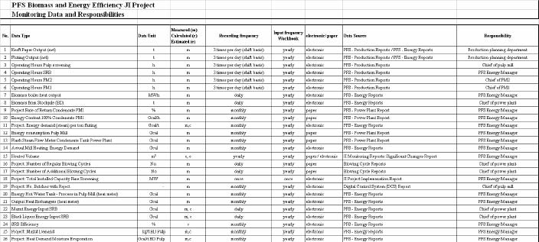
CAMCO International

11.3 The PFS Joint Implementation Workbook
The PFS JI Workbook takes the monitored data as input, and automatically calculates the GHG emission reductions, for each year following project implementation. While emission factors remain unchanged, baseline and project GHG emissions depend on actual PFS output and technical parameters (e.g. biomass boiler efficiency). In order to meet this circumstance monitored data as described in Table 68 will be used within the PFS Workbook. The PFS Joint Implementation project Workbook consists of the following worksheets:

No. | Title |  | Description
Sheet 1 | Instructions |  | General Introduction Workbook
Sheet 2 | Conversion factors and BLS Inputs |  | General Conversion Data, Baseline Study Outcomes
Sheet 3 | Input Data |  | General and Biomass Input Data
Sheet 4 | Biomass Boiler |  | Calculation of (1) avoided CH4 Emissions, (2) reduction of natural gas
Sheet 5 | S & C System |  | Input Data and Calculation Steam & Condensate Project
Sheet 6 | Condensate Tanks |  | Input Data and Calculation Condensate Tanks Project
Sheet 7 | Mill Heating |  | Input Data and Calculation Mill Heating Project
Sheet 8 | Soot Blowers |  | Input Data and Calculation Soot Blowers Project
Sheet 9 | Fine Screening |  | Input Data and Calculation Fine Screening Project
Sheet 10 | BHRS |  | Input Data and Calculation Blow Heat Recovery Project
Sheet 11 | Electrostatic Precipitator |  | Input Data and Calculation Electrostatic Precipitator Project
Sheet 12 | BL Concentrator |  | Input Data and Calculation Black Liquor Project
Sheet 13 | GHG Summary |  | Summary of GHG Emission Reduction
Table 69: PFS Workbook Overview
The following colour keys are used in the PFS Joint Implementation project Workbook:
Key for cell colours:
 |  | Title and Unit Cells
 |  | Conversion Factors + BL Outcome Data Cell
 |  | Input Cells
 |  | Calculation Cells

