JOINT IMPLEMENTATION PROJECT DESIGN DOCUMENT FORM
Version 01 - in effect as of: 15 June 2006

CONTENTS

A. General description of the project

B. Baseline

C. Duration of the project / crediting period

D. Monitoring plan

E. Estimation of greenhouse gas emission reductions

F. Environmental impacts

G. Stakeholders’ comments

Annexes

Annex 1: Contact information on project participants

Annex 2: Baseline information

Annex 3: Monitoring plan

Annex 4: The calculation of the operating margin and build margin emission factors

SECTION A. General description of the project

A.1. Title of the project:
Enhancement of Yuzhnaia CHP – 22 of St-Petersburg. Construction of unit #4
Sectoral scope: (1) Energy industries (renewable/non-renewable sources)
Version: 5
Date: 07/09/2010
A.2. Description of the project:
Situation existing prior to the starting date of the project
The Yuzhnaia Combined Heat and Power Plant – 22 (Yuzhnaia CHP – 22) began operations in 1978. The installed capacity of the existing CHP-22 is:
- Electricity (800 MW) - from three steam turbine units with 250 MW capacity each and one 50 MW gas turbine;
- Heat (2250 Gcal/h) or (9420 GJ/h) - from 6 hot water boilers of 180 Gcal/h capacity and steam extraction from turbines with 330 Gcal/h capacity.
Project scenario
The purpose of the project is to increase the reliability and quality of the heat and electricity supply of the residential and industrial sectors of Moscovskiy, Frunzenskiy and Nevskiy districts of Saint-Petersburg using modern technology. This will also result in lesser green house gas emissions and environmental pollution.
The project activity involves construction of fourth unit at the Yuzhnaia CHP with an installed capacity of 450 MW. The unit will use combined cycle technology and will include two GTE-160 (V 94.2) gas turbines manufactured by “Silovie mashiny”, two heat recovery steam generators, and one cogeneration turbine. Unit will work in base load regime at least 7,000 hours per year.
The contribution of the project activity towards development of St Petersburg is discussed hereunder:
- Ensure the adequacy of the heat capacity and the increase of heat loads for the period up to 2015;
- Increased efficiency of electricity generation;
- Increased reliability of power supply in and around St Petersburg
- The project leads to generation of employment
Greenhouse gas emissions will be reduced due to the displacement of electricity from the grid produced by fossil fuel power plants by the electricity generated by Yuzhnaia CHP that will produce electricity with lower carbon intensity in comparison with electricity from the grid.
Baseline scenario
The baseline scenario is based on the assumption that if the project is not implemented (i.e. additional electricity will not be supplied to the grid) third parties will cover the energy demand. The energy companies within the same regional energy system (URES “North-West”) can increase electricity generation at the existing capacities by delaying decommissioning of outdated capacity and/or installing new energy units. A JI specific approach was used for the baseline setting. Please see Section B for more detailed information.
Brief history of the Project
"UES of Russia" (Unified Energy System of the Russian Federation) RJSC has started to get prepared for implementing the mechanisms of Kyoto Protocol long before its ratification in Russia. "UES of Russia" RJSC has made every effort to cooperate with the UNFCCC (United Nations Framework Convention on Climate Change). For those purposes, the Energy Carbon Fund was established in 2001.
The Fund’s main achievements:
- The Fund took a complete physical inventory of the greenhouse gas emissions from 1990 to the present day at the power plants belonging to "UES of Russia" RJSC. Taking such an inventory met the world’s standards. A greenhouse gas emissions inventory has been created.
- A greenhouse gas emissions monitoring system that includes an accounting system is well adjusted and in operation. The greenhouse gas emissions inventory is being put together.
- Joint implementation projects were prepared for approval by state authorities. Of them, a number of projects successfully went through the international determination. Foreign investors were attracted to take part in the joint implementation projects that passes such determination. Together with regional energy companies, the Fund took part in international tenders for buying greenhouse gas emissions quotas.
- The information analysis system Greenhouse Gases was developed and then implemented at most of the energy companies.
- Prospective volumes of the greenhouse gas emissions generated by the Unified Energy Network of Russia were determined.
- Several regulatory-and-procedural documents, including a procedure for calculating greenhouse gas emissions generated by thermal power plants have been issued and is in effect.
In 2007, the Energy Carbon Fund estimated whether it is possible to implement the project “Enhancement of Yuzhnaia CHP – 22 of St-Petersburg. Construction of unit #4” as a joint implementation project.
On December 26, 2007 the decision of execution of JI Agreement by and between TGK-1 and Fortum was approved by Board of Director of TGK-1 (minute’s No. 20)
On February 20, 2008 Fortum, the Russian Territorial Generating Company No. 1 (TGC-1) and ECF Project Ltd. (subsidiary of Energy Carbon Fund) had signed an agreement according to which Fortum would purchase approximately 5 million tones of emission reduction units (ERU) from TGC-1.
The purchase agreement is based on the Memorandum of Understanding between Fortum and United Energy Systems of Russia (RAO UES) in 2006, and it is the biggest of its kind ever made in Russia. The ERUs purchased cover approximately half of Fortum’s annual CO2 emissions and their value is approximately EUR 70 million based on the current market value of Certified Emission Units in developing countries.
The ERUs will come from Joint Implementation projects conducted at TGC-1’s production facilities during the Kyoto Period (2008-2012) of the European Emissions Trading Scheme. The projects TGC-1 will implement include reconstruction of hydro power plants in Leningrad Region, expansion and reconstruction of combined heat and power generation facilities as well as energy efficiency improvements with district heating network in St.Petersburg. Fortum can use the received ERUs to cover part of its own emissions once these projects are completed and their emission reduction has been verified.
In 2006, "UES of Russia" RJSC developed “The Master Plan for placing power plants up to 2020”. This Master Plan is virtually a consolidated investment that was prepared based on the plans developed by those plants themselves and was later approved by the Government of the Russian Federation (the Government of the Russian Federation Executive Order No. 215-r of February 22, 2008). JSC “TGC-1” (TGK stands for Territorial Generating Company) was founded in March 2005 as part of Russia’s power industry reform. JSCs “Lenenergo”, “Kolenergo” and “Karelenergogeneratsiya” acted as founders of TGC-1. On October 1, 2005 the company started its operating activity. On November 1, 2006 TGC-1 completed the merging of its assets and establishment of an integrated operating company, which is a legal successor in rights and obligations of the merged legal entities. In connection with closing down "UES of Russia" RJSC, the company inherited the investment plans of "UES of Russia" RJSC. However, it is not obliged to implement them.
Even though the project is part of “The Master Plan for placing power plants up to 2020”, JSC “TGK-1” has no obligations to the state to implement it. The Master Plan does not provide a list of companies, the facilities of which are its part. Therefore, in case the schedule to put new power facilities in operation is not followed to, the state cannot impose penalties on any of such companies. It is also confirmed by the fact that actual deadlines and volumes for putting new power plants in operation considerably differs from those in the Master Plan.
A.3. Project participants:

Party Involved | Legal entity project participant  (as applicable) | Please indicate if  the Party involved wishes to be considered as  project participant (Yes/No)
Russian Federation (Host Party) | - JSC “TGC-1”  - ECF Project Ltd | No  No
Finland | Fortum Power and Heat Oy | No
JSC “TGC-1” is the leading producer and supplier of electricity and heat power in the North-West region of Russia and the third largest territorial generating company in Russia in terms of installed capacity. It operates 55 electric generating stations in four regions of Russia – the City of St Petersburg, Republic of Karelia, Leningrad Region and Murmansk Region. The company’s generation assets include thermal, hydroelectric, diesel and co-generation power plants and it has a heating network of 940 km.
The state registration of the company took place March 25, 2005. TGC-1 began operating on October 1, 2005.
A.4. Technical description of the project:

A.4.1. Location of the project:
The location of the project is shown on the figure 1 below.
A.4.1.1. Host Party(ies):
Russian Federation
A.4.1.2. Region/State/Province etc.:
Leningrad region
A.4.1.3. City/Town/Community etc.:
St. Petersburg
A.4.1.4. Detail of physical location, including information allowing the unique identification of the project (maximum one page):
The CHP-22 is situated in south uptown. The location of Yuzhnaia CHP has geographical coordinates of 59°49′39″ north latitude and 30°27′00″ east longitude. The construction of Unit#4 is located in nort-east part of CHP-22 area.
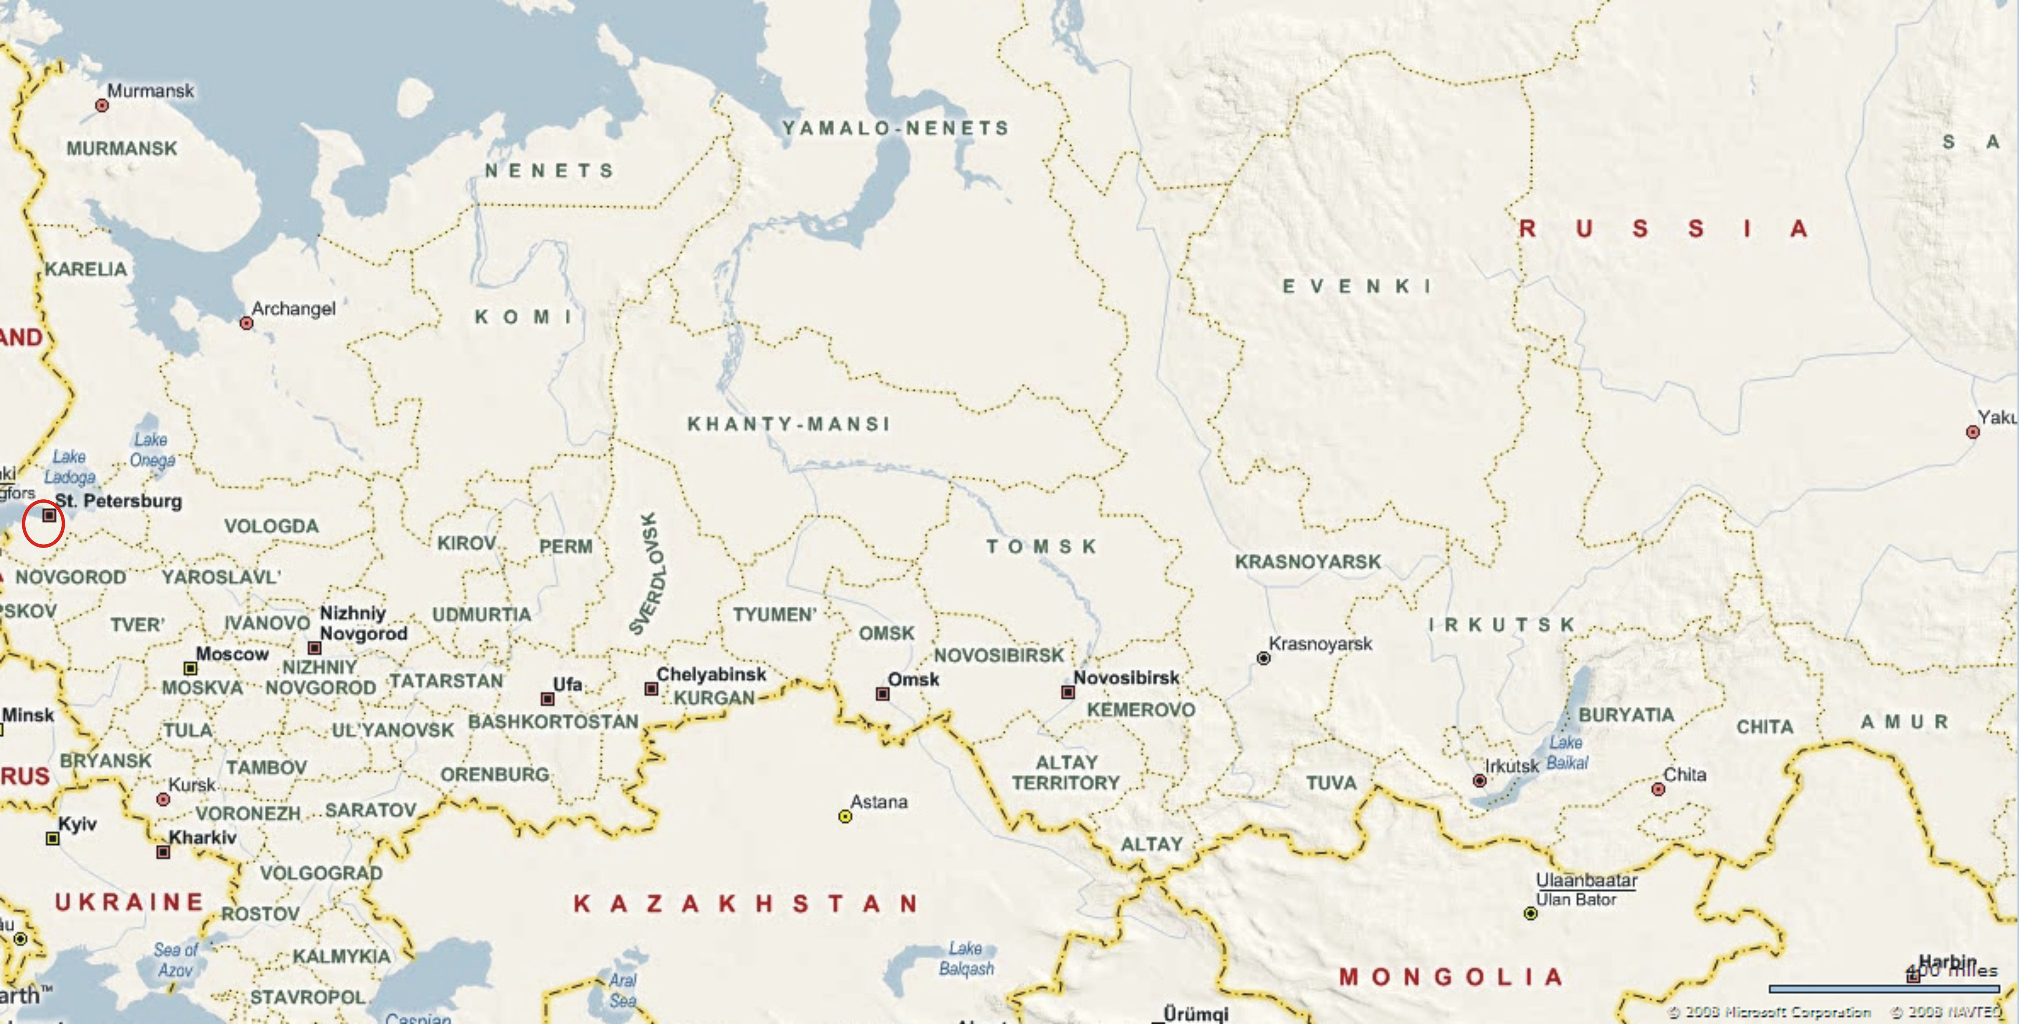
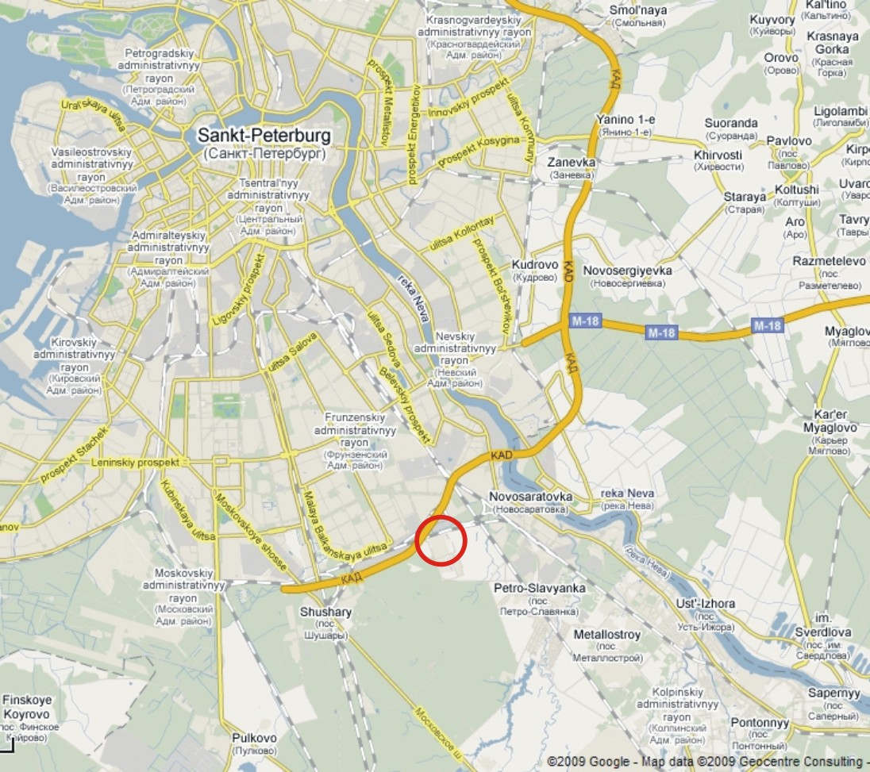
Fig. 1: Project location

A.4.2. Technology(ies) to be employed, or measures, operations or actions to be implemented by the project:
Unit will be constructed using heat recovery combined cycle with following main equipment:
- Two GTE-160 gas turbines known as V94.2 type manufactured by Siemens license and produced at Leningradskiy Metallicheskiy Plant (LMZ) that includes into OJSC “Silovie mashiny”
- Two generators TZFG-160-2MUZ type;
- Two waste heat boilers (Heat Recovery Steam Generator) to generate steam at two pressures Pr-228/47-7,86/0,62-515/230 manufactured by Podolskyi Machinery Construction Plant OJSC;
- One T-125/150-7,4 cogeneration turbine, with TZFP-160-2MUZ generator manufactured by Elektrosila OJSC, installed on the single footing with turbine.
Generators of steam turbine and one generators of gas turbine connects to the KRUE-330 kV of Yuzhnaia substation via 200 MVA transformer with 347/15,75 kV rated voltage
Generators of other gas turbine connects to the KRUE-110 kV of “Yuzhnaia” substation via 200 MVA transformer with 115/15,75 kV rated voltage
Fuel for Yuzhnaia CHP-22 is provided by two independent sources viz., by city gas pipeline and by Yuzhnaia gas distribution station.
For supplying gas turbines with suitable quality of natural gas, the project foresees the need of a compressor station that would provide:
- gas compression
- cooling gas
- automatic maintenance of gas pressure and temperature at required range for use at gas turbine.
The natural gas is basic and reserve fuel for gas turbine.
The Unit#4 is located on territory of existing CHP-22 and intends to supply power and heat to St.Pitersburg industrial and housing and communal services. Rated power capacity of Unit#4 is 450MW and rated heat capacity 341 Gcal/h (at -26 °C ambient temperature)
The CHP 22 will operate in base load mode.
Table A.4.2.1 presents the basic engineering and economical performance of Unit#4.
Table A.4.2.1: Basic engineering and economical performance of Unit#4
Energy annual generation
Power, GWh | 3384.0
Heat, Tcal | 1983.0
Install capacity factor
Power capacity, hours | 7520
Heat capacity, hours | 5815
Energy consumption for auxiliary needs
Power, GWh,(%) | 117.2 (3.46)
Heat, Tcal | 5.6
Energy annual output
Power, GWh | 3 266.8
Heat, Tcal | 1 977.6
Fuel consumption
Hourly consumption (max at -26 °С), m³/h*1 000 | 103.46
Annual natural gas consumption (NCV=8009 Kcal/m³), m³*1 000 000 | 790.2
Annual fuel consumption, t_{c.e.}*1 000 | 904.1
During the heating period unit will work 5000 h in base load and will produce 341 Gcal per hour heat energy. In the summer period unit#4 will generate 82.5 Gcal of heat energy per hour for hot water supply. Below in fig. 2 and 3 the simplified thermal schemes show the power and heat energy generation. Heat is generated at heat exchangers for heating-system water and also in water-to-water heat exchangers. After exchangers, heating-system water with 110 °C temperature is directed to the collector of peak load boilers.
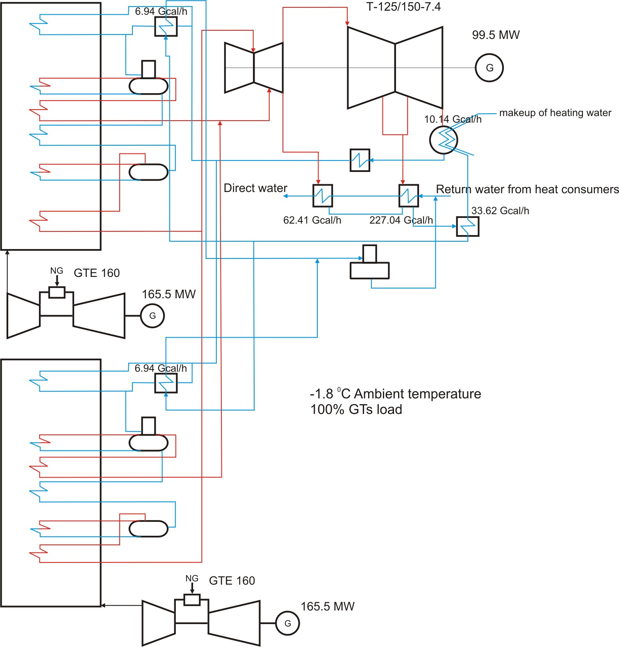
Fig. 2 Simplified scheme of heat and power generation at unit #4 (heating season).
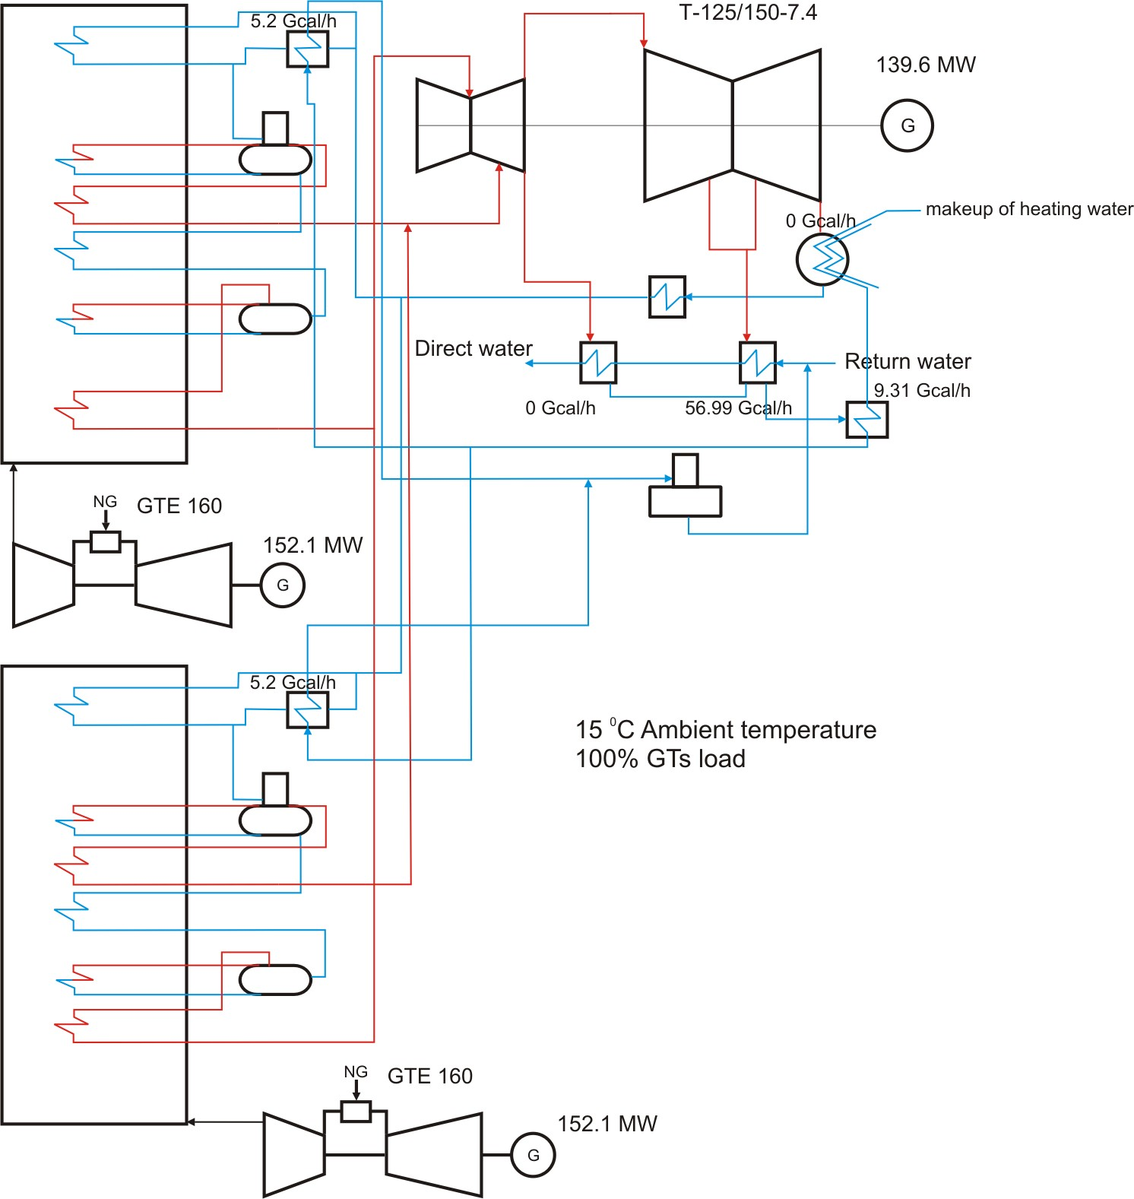
Fig. 3 Simplified scheme of heat and power generation at unit #4 (summer season).
Units #1-3 and peak load boilers will cover other part of heat demand.
Unit#4 will able to work at condensing mode in case of heating load lack.
Expected power delivery to the grid and net heat generation after the completion of first stage (from 2011) up to the end of the first commitment period of the Kyoto Protocol (2012) is presented in table A.4.2.2.
Table A.4.2.2: Expected net power and heat generation in 2011-2012
Year | 2011 | 2012
Power generation, MWh | 3 266 800 | 3 266 800
Heat generation, Gcal | 1 977 600 | 1 977 600
Using combined-cycle (CC) technology for electricity production is not widespread in the Russian Federation. The majority of big power plants are based on single-cycle operation. So the plant reconstruction by installing CC unit will have significantly better performance in comparison to the traditional steam-turbine technology.
Implementation schedule
In 2006, the business plan “Enhancement of Yuzhnaia CHP – 22 of St-Petersburg. Construction of unit #4” was approved at a meeting of the Board of Directors.
28/08/2007 year - signed a contract with JSC "VO Technopromexport to perform work on construction of gas-steam power-generating unit capacity of 450 MW on a turnkey basis.
08/02/2008 year - Ceremony start of construction. First pile.
28/02/2008 year - Start of site preparation.
28/08/2009 year - Supply of gas and steam turbines
28/09/2009 year - Supply of two waste heat boilers
26/08/2009 year - Supply of steam turbine generator
11/12/2009 year - Getting a positive conclusion on the feasibility study in the State expertise
30/12/2009 year - Obtaining a building permit
In accordance with the implementation schedule, launching a 450 MW combined-cycle plant in the territory of Yuzhnaia CHP – 22 is planned in December, 2010. The project implementation schedule is given in Table 4.2.3.
Table A.4.2.3: Project implementation schedule
№ | Title | 2007 |  | 2008 |  |  |  | 2009 |  |  |  | 2010
№ | Title | III | IV | I | II | III | IV | I | II | III | IV | I | II | III | IV
№ | Title | q | q | q | q | q | q | q | q | q | q | q | q | q | q
1 | Activities for the choice of the subcontractor according to ERCM, signing of the contract
2 | Signing the contract with general designer
3 | Feasibility study
4 | Approving the feasibility study by Board of Directors
5 | State expertise of the project feasibility study
6 | Project budgeting, finance scheduling, approving by Board of Directors
7 | Detailed design
8 | Primary equipment supply
9 | Auxiliary equipment supply
10 | Construction and assembly work
11 | Precommissioning
12 | Commissioning
Source: Data provided by Open Joint-Stock Company «TGC-1»
Training programme
According to the contract with a company OJCS "VO "Tehnopromexport" comprehensive training program is conducted for a selected number of Employer’s shift engineers, operations and maintenance personnel. The training will be conducted at the Employer’s site.
A.4.3. Brief explanation of how the anthropogenic emissions of greenhouse gases by sources are to be reduced by the proposed JI project, including why the emission reductions would not occur in the absence of the proposed project, taking into account national and/or sectoral policies and circumstances:
Greenhouse gas (GHG) emissions will be reduced due to displacement of electricity from the grid produced by fossil fuel power plants that use traditional steam-turbine technology by electricity generated by unit #4 of Yuzhnaia CHP – 22 that will produce electricity through combined cycle units with lower carbon intensity in comparison with electricity from the grid. GHG emission reduction will also occur due to increased heat energy generation using combined heat and power generation cycle.
A.4.3.1. Estimated amount of emission reductions over the crediting period:

 | Years
Length of the crediting period | 2 years
Year | Estimate of annual emission reductions  in tonnes of CO₂ equivalent
2011 | 801 720
2012 | 801 720
Total estimated emission reductions over the crediting period  (tonnes of CO₂ equivalent) | 1 603 439
Annual average of estimated emission reductions over the crediting period  (tonnes of CO₂ equivalent) | 801 720

From 2013 to 2017
 | Years
Length of the crediting period | 5 years
Year | Estimate of annual emission reductions  in tonnes of CO₂ equivalent
2013 | 801 720
2014 | 801 720
2015 | 801 720
2016 | 801 720
2017 | 801 720
Total estimated emission reductions over the crediting period  (tonnes of CO₂ equivalent) | 4 008 598
Annual average of estimated emission reductions over the crediting period  (tonnes of CO₂ equivalent) | 801 720

A.5. Project approval by the Parties involved:
The project will be approved by the Russian Federation after completion of the Russian procedure of the project registration as a JI project.
The Parties’ Approval Letters will be received later.

SECTION B. Baseline

B.1. Description and justification of the baseline chosen:
Indication and description of the approach chosen regarding baseline setting
According to paragraph 9 of the “Guidance on criteria for the baseline setting and monitoring”, version 02 (hereinafter referred to as “Guidance”), the project participants may select either:
(a) An approach for baseline setting and monitoring developed in accordance with appendix B of the JI guidelines (JI specific approach); or
(b) A methodology for baseline setting and monitoring approved by Executive Board of clean development mechanism (CDM).
During the preparation of PDD there was approved by Executive Board of CDM Methodology AM0048 “New cogeneration facilities supplying electricity and/or steam to multiple customers and displacing grid/off-grid steam and electricity generation with more carbon-intensive fuels”. The Methodology AM0048 is applicable to new natural gas combined cycle power plants and could be used for development of the PDD. However the Guidance is not binding any restriction whether we must use Option (a) or (b). Take advantage of this right we use the Option (a) – JI specific approach, partially based on the following approved methodologies and methodological tools:
- AM0029 (“Baseline Methodology for Grid Connected Electricity Generation Plants using Natural Gas” (version 3)) is applicable to new natural gas combined cycle (NGCC) power plants that only produce electricity. The proposed project involves the use of some existing equipment as well as the installation of new NGCC equipment. Moreover, the proposed project would produce both electricity and heat. Thus AM0029 is not applicable for the proposed project.
- AM0061 (“Methodology for rehabilitation and/or energy efficiency improvement in existing power plants” (version 2.1)) is not applicable where new equipment is added.
- AM0062 (“Energy efficiency improvements of a power plant through retrofitting turbines” (version 1.1)) is not applicable where cogeneration is involved.
- ACM0007 (“Baseline methodology for conversion from single cycle to combined cycle power generation” (version 3)) is only applicable when the initial state was a gas turbine or internal combustion engines, and that the original equipment remains operational after project implementation. Neither is the case here. The initial state here was the use of steam turbines.
- “Combined tool for identification of baseline scenario and demonstration of additionality” (version 2.2),
- “Tool to calculate the emission factor for an electricity system” (version 2)
In the following text, we describe the methodological procedure step by step, followed by its application to the specific project.
Applicability
Used JI specific approach is applicable to project activities that implement rehabilitation measures in an existing fossil fuel fired cogeneration plant for and the purpose of enhancing its energy efficiency.
The following conditions apply:
- The project activity plant supplies electricity to the electricity grid and heat to consumers through a heat distribution centre.
- The project activity is implemented in an existing cogeneration plant and involves its reconstruction. The installed power and/or heat generation capacity may increase as a result of the project activity.
- Only rehabilitation measures which require capital investment and improve efficiency (as per the definition above) shall be included. Regular maintenance and housekeeping measures cannot be included in the proposed project activity;
- All major equipment in use prior to project implementation (boilers, turbines, generators, and heat exchangers) should have a remaining life that is equal to or exceed the proposed crediting period. Thus the current equipment could supply electricity and heat for the duration of the proposed crediting period.
- The lifetime of any new equipment installed should also equal or exceed the proposed crediting period.
- The project is limited to the case where natural gas is the main fuel used both before and after project implementation. Because of supply interruptions and other problems, it is permissible to use other fuels in the project scenario, taking into consideration additional emissions from such fuel use.
The proposed methodology is not applicable to:
- Greenfield cogeneration plants;
- Captive cogeneration plants that produce heat and power for in-house consumption.
In addition, the applicability conditions included in the tools referred to above apply.
The proposed project meets all the applicability conditions specified above, as well as those relevant to the Tools used.
The basic fuel used on Yuzhnaia CHP is natural gas. Residual fuel oil is used as reserve fuel for boilers and natural gas as reserve fuel for gas turbines. Note that since residual fuel have higher emissions factor compared to the main fuel, natural gas, any use of the residual fuel would increase project emissions, and reduce emissions reductions. This is therefore conservative.
Application of the approach chosen
Step 1: Identification of a baseline based on the selection of the most plausible alternative scenario
Sub-step la: Identification and listing of plausible alternative baseline scenarios
In the proposed project it is planned that new combined cycle gas turbine unit burning natural gas with total electricity capacity of 450 MW will be installed at Yuzhnaia CHP-22 and commissioned in December 2010. As shown in the Section A.2 the other types of energy unit (for example, steam power unit) and other types of fuel were not considered as alternatives of the proposed project. After project implementation the new energy unit will supply electricity to the United Regional Energy System (URES) “North-West” grid.
Therefore based on the JI specific approach is presented above four plausible alternative baseline scenarios are identified:
Alternative scenario 1: The proposed project not developed as a JI project;
Alternative scenario 2: The electricity to be generated by project is provided by the other existing plants of URES “North-West”;
Alternative scenario 3: The electricity to be generated by project is provided by the other new energy units of URES “North-West”,
Alternative scenario 4: The electricity to be generated by project is provided by the other existing plants and the other new energy units of URES “North-West”.
These four alternative scenarios are described below in more detail.
1) The proposed project not developed as a JI project
A combined cycle gas turbine unit with total electrical capacity of 450 MW will be constructed at Yuzhnaia CHP-22 and commissioned in December 2010. Efficiency of new energy unit will be approximately 58%. The natural gas will be used as fuel. After project implementation electricity will be supplied by the new energy unit into grid of URES “North-West”. It will replace electricity which otherwise will be generated at the other power plants of URES “North-West”.
2) The electricity to be generated by project is provided by the other existing plants of URES “North-West”
OJSC «TGK-1» does not install the new energy unit and project electricity generation would have to be covered by the other existing power plants within URES “North-West” that exists in the particular year that the project is generating electricity.
3) The electricity to be generated by project is provided by the other new energy units of URES “North-West”
OJSC «TGK-1» does not install the new energy unit and project electricity generation will be covered by new energy units to be constructed by the other energy companies within URES “North-West”.
4) The electricity to be generated by project is provided by the other existing plants and the other new energy units of URES “North-West”
OJSC « TGK-1» does not install the new energy unit and project electricity generation would have to be covered by the other existing power plants and by the new energy units to be constructed by the other energy companies within URES “North-West”. This alternative is a combination of alternative 2 and 3.
Sub-step lb: Identification of the most plausible alternative scenario
Assessment of alternative scenario l: The proposed project is not developed as a JI project
Projects using gas turbine technologies shall be exclusively applied during modernization and new construction at thermal power plants running on natural gas as indicated in “General Scheme of Allocation of Energy Objects up to 2020” (General Scheme further in the text) approved by the Government of the Russian Federation (Order of February 22 2008 # 215p). The project has no technical barriers as natural gas is available, the technology as such has been implemented in many industrialized countries and electricity produced by the new energy unit can be supplied to the grid.
As is shown in Section B.2 this project is not economically attractive. Therefore this alternative is a not the most plausible scenario.
Assessment of alternative scenario 2: The electricity to be generated by project is provided by the other existing plants of URES “North-West”
Currently installed electricity capacity corresponds to the electricity market demand. But there are many old energy units in Russia. In accordance with CJSC “Agency of Energy Balances in the power industry” estimation approximately 10 GW of old capacities (life time expired several years ago) has to be dismantled by 2015 (3.9 GW by 2010). At the same time their forecast assumes the electricity demand growth will be 27.3 GW in 2012 in comparison with 2009.
Therefore the existing power plants alone cannot cover the future electricity market demand and this alternative scenario is not reasonable and feasible.
Assessment of alternative scenario 3: The electricity to be generated by project is provided by the other new energy units of URES “North-West”
The installed capacity of the power plants within URES “North-West” is 21.038 GW The existing power plants runtime factor of URES “North-West” varies from 0.47 to 0.75. The proper dispatching, network improvements and better energy unit operation (reduction of repair time, etc.) may result in better energy facilities performance thus increasing the net energy output of the existing plants.
Reconstruction of existing energy units can increase both the installed electrical capacity and the runtime factor. In accordance with CJSC “Agency of Energy Balances in the power industry” forecast the incremental (due to the renovation activities) installed capacity at the existing power plants will be approximately 1.9 GW by 2015.
OJSC «System Operator of Unified Energy System» (JSC “SO of UES”) is in charge of the management of the demand and supply side of the energy market. It satisfies the demand by the most efficient way, both from an economic and technical point of view. As soon as more than 87% of the forecasted energy demand is to be provided by the existing energy plants it is unlikely that the system operator will ensure constant coverage of 0.8 GW (the project capacity) by new plants only.
It means that the electricity to be generated by project is to be provided by the existing power plants in addition to new energy units and, therefore, this alternative scenario is not reasonable and feasible.
Assessment of alternative scenario 4: The electricity to be generated by project is provided by the other existing plants and the other new energy units of URES “North-West’
As shown in the assessment of alternatives 2 and 3 the future electricity market demand would be covered by the combination of the other existing plants and the other new energy units.
Thus this alternative is reasonable and feasible.
Conclusion
Only Alternative 4 is realistic and credible and is selected as the baseline scenario.
Step 2: Additionality demonstration
Please see Section B.2.
Step 3: Calculation of emissions of the baseline scenario
To establish the emissions associated with the baseline scenario a baseline emission factor has been calculated in accordance with article 21 of the Guidance and using the CDM Tool “Tool to calculate the emission factor for an electricity system”, version 02 with some deviations. The using of this CDM Tool for baseline emission factor calculation is described in the Annex 2. And the baseline emission calculation methodology using the CDM is described in the Section D.1.1.4.
Project emissions
The project activity is power and heat generation using CCGT-450 combined cycle units. Old CHP units and boilers, as well as peak load boiler will be used during the construction period. So combustion of natural gas (as primary fuel) in gas turbines to generate electricity and heat is main source of emissions. Also project foresees combustion of natural gas (as primary fuel) and residual fuel oil (as reserve fuel) in peak load boilers. The CO₂ emissions from project activity (PE_{y}) are calculated as follows:
(1)
where:
FC_{f,y}: = the total volume of natural gas or other fuel ‘f’ combusted in the project plant or other startup fuel (m³ or similar) in year(s) y
COEF_{f,y}: = the CO₂ emission coefficient (tCO₂/m³ or similar) in year(s) for each fuel and obtained as:
(2)
where:
NCV _{f,y} : = the net calorific value (energy content) per volume unit of fuel f in year y (GJ/m³ or similar) as determined from the fuel supplier;
EF_{CO2},_{f,y}: = the CO₂ emission factor per unit of energy of fuel f in year y (tCO₂/GJ) as determined from the fuel supplier, wherever possible, otherwise from local or national data;
OXID_{f}: = the oxidation factor of fuel f.
Baseline emissions
The reconstructed plant or additional unit can change heat and power output of plant. Moreover heat and power output depends on power deficit or excess in region, number of heat consumers, ambient temperatures etc. So there is considerable uncertainty relating to which type of other power and heat generation is substituted by the power and heat generation of the project plant.
Baseline scenario includes the new boiler house construction in the city of St-Petersburg without construction of new electricity generating capacities. The amount of heat energy, which would be generated by the Yuzhnaia CHP – 22 according to the project scenario, will be generated at the new boiler house according to the baseline scenario.
For purposes of conservatism, it is assumed that natural gas will be the fuel for the new boiler house. For the estimation of baseline СО₂ emissions during the heat energy generation at the new boiler house we shall determine the efficiency factor of the new boilers. According to the Biysk boiler plant – the leading plant in terms of the steam and water heating boilers of medium and low power boilers for industrial and small-scale power generation in Russia – the water heating boilers’ efficiency factor amounts to 90-93%. For the estimate of baseline emissions efficiency factor of the new St-Petersburg boiler house accepted as maximum one in the range of similar boilers of the Biysk boiler plant – 93.3%.
The amount of energy, generated by the Yuzhnaia CHP – 22 according to the project scenario, will be supplied from the Russian Federation Unified Energy System according to the baseline scenario.
To establish the emissions associated with the baseline scenario a baseline emission factor has been calculated in accordance with article 21 of the Guidance and using the CDM Tool “Tool to calculate the emission factor for an electricity system”, version 02 with some deviations. The using of this CDM Tool for baseline emission factor calculation is described in the Annex 2. And the baseline emission calculation methodology using the CDM is described in the Section D.1.1.4.
Emission Reductions
Emission reductions are calculated as follows:
(3)
where;
ER_{y} ; = emission reductions in year y (tCO₂e/yr);
BE_{y} ; = baseline emissions in year y (tCO₂e/yr);
PE_{y} ; = project emissions in year y (tCO₂/yr);
LE_{y} ; = leakage emissions in year y (tCO₂/yr).
The key data and information used to establish the baseline are presented in tabular form below:
Not monitored data:
Data/Parameter | FC i,y
Data unit | GJ
Description | Amount of fossil fuel i (coal, heavy fuel oil, natural gas, peat, blast furnace gas, coke even gas and other fuels) consumed in the project  electricity system in year y (for 2006-2008)
Time of  determination/monitoring | Determined ex-ante
Source of data (to be) used | Federal Service of State Statistics (RosStat)
Value of data applied  (for ex ante calculations/determinations) | Please see file:  table.xls
Justification f the choice of  data or description of  measurement methods and  procedures (to be) applied | Measurements are carried out continuously. Data are recorded monthly.
OA/QC procedures (to be)  applied | In accordance with State Standard the allowed inaccuracy of gas consumption metering is ±0.3-4% (GOST R 8.618-2006). For commercial gas metering for CHP installed meters of gas consumption with an acceptable error has inaccuracy ± 1,5%. This inaccuracy is not included in the calculations in relation to its small size and it will not have a significant impact on the calculations. The gas flow meter is to be installed will provide necessary inaccuracy. The type of meter is based on the method of variable differential pressure on restriction according to GOST R 8.586-2005.  Calibration of the metering devices is made in accordance with the calibration schedule which approved by the Chief Engineer of Yuzhnaia CHP – 22 for one year. Supervision of calibration is performed by the Department of heat automatic and measurement. The metering devices are calibrated by an independent entity which has a state license.  The data from meters are automatically and regularly transferred to the computer system and archived. Supervision of data archiving is performed by the Department of heat automatic and measurement.
Any comment | -

Data/Parameter | η_{boiler}
Data unit | Non dimensional
Description | Efficiency of boilers
Time of  determination/monitoring | Once for the commitment period
Source of data (to be) used | Data from supplier
Value of data applied  (for ex ante calculations/determinations) | 93.3%
Justification f the choice of  data or description of  measurement methods and  procedures (to be) applied | In accordance to the information of technical certificates of the boiler efficiency not exceed 93.3%
OA/QC procedures (to be)  applied | not applicable
Any comment | -

Data/Parameter | FFj,k
Data unit | Mass or Volume units
Description | Total quantity of fuel ‘f’ consumed by the plant included in the project boundary
Time of  determination/monitoring | Once for the commitment period
Source of data (to be) used | Statistical data
Value of data applied  (for ex ante calculations/determinations) | Please see file: table.xls
Justification f the choice of  data or description of  measurement methods and  procedures (to be) applied | not applicable
OA/QC procedures (to be)  applied | not applicable
Any comment | Measuring instruments and metering gas mounted CHP produce volume flow measurement of gas, reduced to standard conditions (T = 293.15 K (20° C) and Fc = 101,325 kPa). Documents defining the procedure for the measurement: GOST 8.563.2-97, OL 50.2.019 -96, ISO: 14532:2001.

Data/Parameter | EF _{grid, OMsimple, y}
Data unit | tCO2/MWh
Description | Simple operating margin CO2 emission
Time of  determination/monitoring | Determined ex-ante
Source of data (to be) used | Parameter is calculated according to the formula 1 of Annex 2
Value of data applied  (for ex ante calculations/determinations) | 0.5831
Justification f the choice of  data or description of  measurement methods and  procedures (to be) applied | The coefficient was designed for the period from 2010 to 2012.
OA/QC procedures (to be)  applied | not applicable
Any comment | -

Data/Parameter | EF _{grid, BM, y}
Data unit | tCO2/MWh
Description | BM emission factor
Time of  determination/monitoring | Determined ex-ante
Source of data (to be) used | Parameter is calculated according to the formula 2 of Annex 2
Value of data applied  (for ex ante calculations/determinations) | 0.4431
Justification f the choice of  data or description of  measurement methods and  procedures (to be) applied | The coefficient was designed for the period from 2010 to 2012.
OA/QC procedures (to be)  applied | not applicable
Any comment | -

Data/Parameter | EF _{grid, CM, y}
Data unit | tCO2/MWh
Description | Combined margin emission factor
Time of  determination/monitoring | Determined ex-ante
Source of data (to be) used | Parameter is calculated according to the formula 4 of Annex 2
Value of data applied  (for ex ante calculations/determinations) | 0.5481
Justification f the choice of  data or description of  measurement methods and  procedures (to be) applied | The coefficient was designed for the period from 2010 to 2012.
OA/QC procedures (to be)  applied | not applicable
Any comment | -
Data and parameters monitored
Data/Parameter | EG_{P,y}
Data unit | MWh
Description | Net quantity of electricity generated by the project activity plant in year y
Time of  determination/monitoring | Continuous
Source of data (to be) used | On-site measurement
Value of data applied  (for ex ante calculations/determinations) | Please see file: table.xls
Justification f the choice of  data or description of  measurement methods and  procedures (to be) applied | Use energy meters. The consistency of metered electricity generation should be cross-checked with receipts from sales (if available) and the quantity of fuels fired.
OA/QC procedures (to be)  applied | Cross check measurement results with invoices for sale of electricity if relevant.
Any comment | -

Data/Parameter | HG_{P,y}
Data unit | GJ
Description | Total quantity of heat generated by the project plant in year y
Time of  determination/monitoring | Continuous
Source of data (to be) used | On-site measurement
Value of data applied  (for ex ante calculations/determinations) | Please see file: table.xls
Justification f the choice of  data or description of  measurement methods and  procedures (to be) applied | The consistency of metered net heat generation should be cross-checked with receipts from sales (if available) and the quantity of fuels fired.
OA/QC procedures (to be)  applied | Cross check measurement results with invoices for sale of heat if relevant.
Any comment | -

Data/Parameter | FC_{f,y}
Data unit | Thous.m³
Description | Total quantity of fuel ‘f’ consumed by the project activity plant in the year y
Time of  determination/monitoring | Continuously
Source of data (to be) used | On site measurement, statistical data
Value of data applied  (for ex ante calculations/determinations) | Please see file: table.xls
Justification f the choice of  data or description of  measurement methods and  procedures (to be) applied | Use mass or volume meters
OA/QC procedures (to be)  applied | not applicable
Any comment | -

Data/Parameter | NCV_{f,y}
Data unit | GJ/mass or volume units
Description | Weighted average net calorific value of the of fuel ‘f’ consumed by the plant in the year y
Time of  determination/monitoring | Monthly
Source of data (to be) used | Supplier-provided data
Value of data applied  (for ex ante calculations/determinations)
  Natural Gas | 33.46 GJ/m³
  Residual oil | 40.52 GJ/m³
Justification f the choice of  data or description of  measurement methods and  procedures (to be) applied | The NCV should be obtained for each fuel delivery, from which weighted average annual values should be calculated.
OA/QC procedures (to be)  applied | Verify if the values are within the uncertainty range of the IPCC default values as provided in Table 1.2, Vol. 2 of the 2006 IPCC Guidelines. If the values fall below this range collect additional information from the testing laboratory to justify the outcome or conduct additional measurements. The laboratories should have ISO17025 accreditation or justify that they can comply with similar quality standards.
Any comment | -

Data/Parameter | EF_{CO2},_{f,y}
Data unit | tCO₂/TJ
Description | CO₂ emission factor per unit of energy of fuel ‘f’
Time of  determination/monitoring | Yearly
Source of data (to be) used | Fuel supplier, measurements by the project participants, regional or national default values, IPCC default values
Value of data applied  (for ex ante calculations/determinations)
  Natural Gas | 56.1
  Residual oil | 77.4
Justification f the choice of  data or description of  measurement methods and  procedures (to be) applied | Measurements should be undertaken in line with national or international fuel standards
OA/QC procedures (to be)  applied | not applicable
Any comment | Time of determination depends on source

B.2. Description of how the anthropogenic emissions of greenhouse gases by sources are reduced below those that would have occurred in the absence of the JI project:
According to paragraph 2 of Annex 1 of the Guidance, additionality can be demonstrated, inter alia, by using one of the following approaches:
(a) Provision of traceable and transparent information showing that the baseline was identified on the basis of conservative assumptions, that the project scenario is not part of the identified baseline scenario and that the project will lead to reductions of anthropogenic emissions by sources or enhancements of net anthropogenic removals by sinks of GHGs;
(b) Provision of traceable and transparent information that an accredited independent entity has already positively determined that a comparable project (to be) implemented under comparable circumstances (same GHG mitigation measure, same country, similar technology, similar scale) would result in a reduction of anthropogenic emissions by sources or an enhancement of net anthropogenic removals by sinks that is additional to any that would otherwise occur and a justification why this determination is relevant for the project at hand.
(c) Application of the most recent version of the “Tool for the demonstration and assessment of additionality” approved by the CDM Executive Board;
In this PDD, the most recent version of the “Tool for the demonstration and assessment of additionality” (version 05.2) (hereinafter referred to as “Additionality Tool”) is applied to prove that the emission reductions by the proposed JI project are additional to any that would otherwise occur.
Step 1: Identification of alternatives to the project consistent with current laws and regulations
Sub-step 1a: Define alternatives to the project
Plausible alternatives to the project were identified in Section B.1 above:
Alternative scenario 1: The proposed project not developed as a JI project;
Alternative scenario 2: The electricity to be generated by project is provided by the other existing plants of URES “North-West”;
Alternative scenario 3: The electricity to be generated by project is provided by the other new energy units of URES “North-West”,
Alternative scenario 4: The electricity to be generated by project is provided by the other existing plants and the other new energy units of URES “North-West”.
Only alternatives 1 and 4 were identified as realistic and credible.
Sub-step 1b: Consistency with mandatory laws and regulations
All the alternatives defined in sub-step 1a are in compliance with mandatory legislation and regulations.
Step 2: Investment analysis
The main goal of the investment analysis is to determine whether the proposed project is not:
(a) The most economically or financially attractive; or
(b) Economically or financially feasible, without the revenue from the sale of ERUs associated with the JI project.
To conduct the investment analysis, the following sub-steps have to be applied.
Sub-step 2a: Determine appropriate analysis method
In principle, there are three methods applicable for an investment analysis: simple cost analysis, investment comparison analysis and benchmark analysis.
A simple cost analysis (Option I) shall be applied if the proposed JI project and the alternatives identified in step 1 generate no financial or economic benefits other than JI related income. The proposed JI project results in additional sales revenues due to the electricity that will be generated. Thus, this analysis method is not applicable.
The Additionality Tool allows for an investment comparison analysis which compares suitable financial indicators for realistic and credible investment alternatives (Option II) or a benchmark analysis (Option III). For this project a benchmark analysis (Option III) is appropriate in accordance with the attached guidance to the Additionality Tool (paragraph 15).
Sub-step 2b: Option III. Apply benchmark analysis
The proposed project, installation of CCGT unit, shall be implemented by the project participant Open Joint-Stock Company «TGK-1». The approach recommended in p. 6 (a) of Additionality Tool is applied —using “government bonds rates increased by a suitable risk premium”. As Russia does not have long term governmental bonds, a conservative approach of using Central Bank RF interest rate of 13% is proposed in the analysis including a county risk premium and inflation 3%. Thus the overall IRR benchmark amounts to 16%. If the proposed project (not being implemented as JI project) has a less favourable indicator, i.e. a lower IRR, than the benchmark, then the project cannot be considered as financially attractive.
Sub-step 2c: Calculation and comparison of financial indicators
The financial analysis refers to the time of investment decision-making.
The following assumptions have been used based on the information provided by the enterprise:
- Investment decision: 20/06/2006, commissioning date: December 2010;
- The project requires investments of approximately EUR 348,89 mln. (exchange rate of Central Bank of Russia 36.971 RUB/€ as of 1 July 2008);
- The project lifetime is 30 years (lifetime of CCGT in line with contract);
- Fuel consumption and electricity generation is taken into account in line with the technical specifications of the project design;
- Natural gas is the biggest cost component constituting more than 80% of total operation cost.
- The scrap value is calculated as CCGT weight (documented) multiplied by scrap price.
The project cash flow focuses, in addition to investment-related outflows, on revenue flows generated by additional sales of electricity produced by the new CCGT unit.
The project’s financial indicators are presented in the Table B.2.1 below.
Table B.2.1. Financial indicators of the project
Scenario | IRR (%) | Discounted PBP | Simple payback period (years)
Base case | 12.2 | Out of project lifetime | 20
The cash flow analysis shows an IRR of 12.2%, which is well below the IRR benchmark identified as 16%. As a result a negative NPV is obtained. Hence, the project cannot be considered as financially attractive.
Sub-step 2d: Sensitivity analysis
A sensitivity analysis shall be conducted to show whether the conclusion regarding the financial/economic attractiveness is robust to reasonable variations in the critical assumptions.
The following four key factors were considered in the sensitivity analysis: electricity and gas tariffs, investment and maintenance cost. The other cost components account for much less than 20% of total cost and therefore are not considered in the sensitivity analysis. In line with the guidance to the Additionality Tool (par. 17) the sensitivity analysis should be undertaken within the corridor of ±10% for the key indicators.
Table B.2.2. Sensitivity analysis
Parameter | Fluctuation
 | -10% | -5% | 0% | 5% | 10%
Investment costs | 14.88% | 13.43% | 12.2% | 11.03% | 10.03%
Fuel costs | 16% | 14.2% | 12.2% | 9.6% | 6.3%
Electricity price | 7.6% | 10% | 12.2% | 14.1% | 15.2%
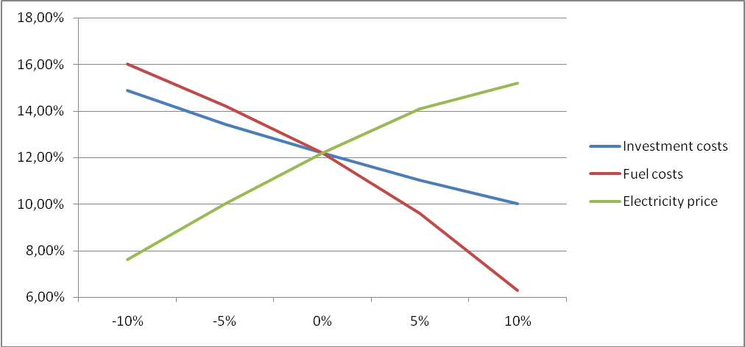
Figure B.2.1. Sensitivity analysis
Sensitivity analysis was applied to evaluate sensitivity of the project to changes that might occur during project implementation and operation.
Analysis of the investment cost within range -10% and +10% showed that IRR changes within 14.88%-10.03%. The 450 MW CCGT unit considered under the project is expensive and increase of investment cost by 5% leads to negative NPV even with ERUs sale. However, at price of investment as expected and with revenue from ERUs sale the project is viable and will generate sufficient income even in the case of financing the project by loan and brings profit even if above changes of investment cost occur.
Another factor that might influence project's IRR and NPV is change of fuel (natural gas) price above projected price range. Based on analysis, IRR ranges from 16% to 6.3% within +10% and -10% change of fuel price. The conclusion is the same as in above case.
Electricity is produced by the project after its implementation, therefore changes of electricity selling price affect project's IRR and NPV the opposite way as it is in the case of investment cost change and natural gas price change. The range of IRR change (7.6% - 15.2%) indicates that project is most sensitive to change of electricity price. As it is widely forecasted, price of electricity and natural gas will grow. If natural gas price grows significantly, increased expenses will be compensated by increased electricity prices.
Hence, the sensitivity analysis consistently supports (for a realistic range of assumptions) the conclusion that the project is unlikely to be financially/economically attractive.
Step 3: Barrier analysis
In line with the Additionality Tool, a barrier analysis is not conducted.
Step 4: Common practice analysis
Sub-step 4a: Analyze other activities similar to the proposed project activity:
The project energy unit uses combined cycle (Rankine and Brayton (gas) thermodynamic cycles) for electricity generation (without heat generation). The installed capacity of this combine cycle gas turbine (CCGT) unit is 450MW.
In Russia almost all power plants use the Rankine (steam) cycle (fossil fuel fired boiler(s) with steam turbines). The total installed capacity of all CCGT units (including with cogeneration cycle) is about 2.6 GW (2007). It is approximately 1.7% of total thermal power plants installed capacity.
The Tool recommends to provide an analysis of any other activities if they are in the same country/region and rely on similar technology, are of a similar scale, and take place in the comparable environment.
The new energy units are presented in the Table B.2.3.
Table B.2.3: New energy units in URES «North-West»
Power plant/unit | Commissioning | Capacity, MW | Technology | Fuel | Cycle
Severo-Zapadnaia CHPP | 2000 | 450 | CC GT | Gas | Cogeneration
Vasileostrovskaya TPP-7, #3 | 2009 | 50 | Steam cycle | Gas | Cogeneration
Severo-Zapadnaia CHPP | 2006 | 450 | CC GT | Gas | Cogeneration
Avtovskaya TPP-15 | 2007 | 30 | Steam cycle | Gas | Cogeneration
Pravoberejnaya TPP-5 | 2006 | 180 | Steam cycle | Gas | Cogeneration
The thermal power stations using simple cycle for electricity generation dominate power generation in Russia. Presently only few units of power plants of Russia use combined cycle for power generation. The installed capacity of combined cycle power plants in Russia less than 2% of the total installed capacity of thermal power stations. Until now, these were pilot projects with the main purpose to try new technologies. One of the recently implemented projects – Severo-Zapadnaia CHPP with gas and steam turbines manufactured in the Russian Federation – was implemented as a testing facility. The previously implemented projects were with foreign turbines.
All projects with combined cycle completed up to now had significant support from Russian monopolist RAO UES. After privatization, the company does not have such possibilities as RAO UES.
Sub-step 4b: Discuss any similar Options that are occurring:
The similar activities are not widely observed so this sub-step is not applicable.
Conclusion
The application of the CDM Additionality Tool demonstrates that the emission reductions by the proposed JI project are additional to any that would otherwise occur.

B.3. Description of how the definition of the project boundary is applied to the project:

Project boundary

The new CCTG unit combusts natural gas for electricity generation, most of which is supplied to the grid and minor part is used for internal needs (auxiliary equipment).
Project boundary embraces:
- New CCTG unit;
- Auxiliary equipment of the new CCTG unit.
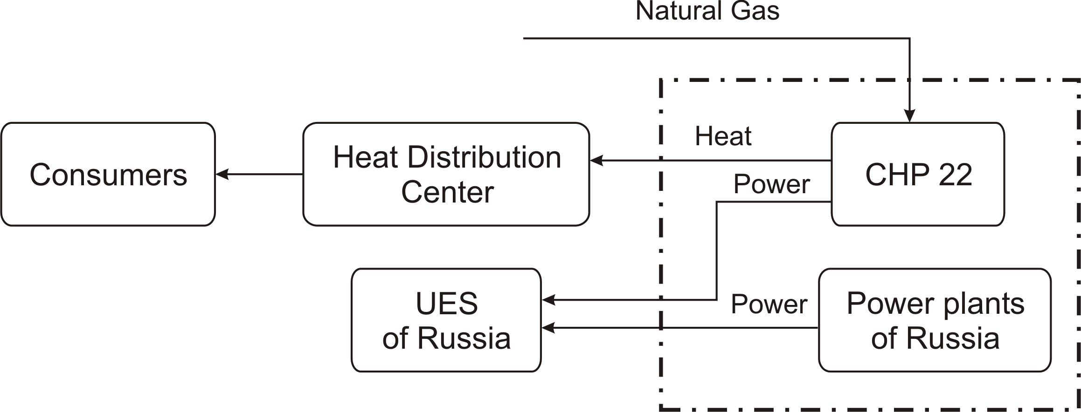
Figure B.3.1 Project Boundary, including the project plant and all power plants in the URESs (URES “North-West”).
Emissions sources and greenhouse gases types included in or excluded from the project boundary are presented in the Table B.3.1.
Table B.3.1. Emissions sources included or excluded from the project boundary
 | Source | Gas | Included? | Justification/Explanation
Baseline | Electricity generation in baseline  (URES “North-West”) | CO2 | Included | Main emission source
Baseline | Electricity generation in baseline  (URES “North-West”) | CH4 | Excluded | Excluding these emission from the baseline is conservative and in line with existing CDM methodologies
Baseline | Electricity generation in baseline  (URES “North-West”) | N2O | Excluded
Project activity | On-site natural gas combustion | CO2 | Included | Main emission source
Project activity | On-site natural gas combustion | CH4 | Excluded | Exclusions is for simplification as the emission are negligible and in line with existing CDM methodologies
Project activity | On-site natural gas combustion | N2O | Excluded
B.4. Further baseline information, including the date of baseline setting and the name(s) of the person(s)/entity(ies) setting the baseline:
Date of completion of the baseline study: 08/05/2009
Name of person/entity setting the baseline:
ECF Project Ltd.
ECF Project Ltd. is a project participant. See Annex 1 for detailed contact information.

SECTION C. Duration of the project / crediting period

C.1. Starting date of the project:
Starting date of the project is 08/02/2008 (Beginning of construction)
C.2. Expected operational lifetime of the project:
The operational lifetime of the proposed JI project is 30 years or 360 months.
C.3. Length of the crediting period:
2 years. (24 months from 1 January 2011 to 31 December 2012).
The starting date of the crediting period is 22/12/2010.
The status of emission reductions or enhancements of net removals generated by JI projects after the end of the first commitment period may be determined by any relevant agreement under the UNFCCC.
The second crediting period will be within agreement but not exceed life time of equipment at unit #4 of Yuzhnaia CHP.

SECTION D. Monitoring plan

D.1. Description of monitoring plan chosen:
The monitoring plan includes the measurement, maintenance, recording and calibration tasks that should be performed to fulfill the requirements of the selected monitoring methodology and guarantee traceability in emission reduction calculations. The main steps of the monitoring plan are described below.
In this project a JI specific approach regarding monitoring is used. As elaborated in Section B.3, the project activity only affects the emissions related to the natural gas combustion. To establish the baseline emissions and to monitor the project emissions, only these emissions will be monitored.
The following assumptions for calculation of both baseline and project emissions were used:
- Used start-up fuel at the new CCGT unit is excluded;
- Project electricity is net electricity generation by the new CCGT unit defined as electricity generation minus electricity consumption for internal needs;
- Electricity demand in the market is not influenced by the project (i.e. baseline net electricity generation = project net electricity generation);
- The baseline emissions of the grid are established using the combined margin emission factor as described in Annex 2;
- The combined margin emission factor is set ex-ante for the length of the crediting period;
- The new CCGT lifetime extends to 2020.
General remarks:
- Social indicators such as number of people employed, safety records, training records, etc, will be available to the Verifier upon request;
- Environmental indicators such as NO_{x} and other will be available to the Verifier upon request; For the greenhouse gas emissions only the CO₂ emissions are taken into account. See section B.3.
Data management system
A person will be appointed by the project owner to take responsibility for data handling, preparing monitoring reports of greenhouse gas emission reductions and collecting the data for emission reduction verification. (See Section D.3.)
Verification
The verification of project emission reductions will be done annually. The project owner should be responsible for preparing documentation for verification by the Accredited Independent Entity (AIE).

D.1.1. Option 1 – Monitoring of the emissions in the project scenario and the baseline scenario:

D.1.1.1. Data to be collected in order to monitor emissions from the project, and how these data will be archived:
ID number  (Please use numbers to ease cross-referencing to D.2.) | Data variable | Source of data | Data unit | Measured (m), calculated (c), estimated (e) | Recording frequency | Proportion of data to be monitored | How will the data be archived? (electronic/  paper) | Comment
P1 PE y | Project emission | Calculated under project activity | tCO₂ | c | Annually | 100% | Electronic | Defined according to formula 1
P2 FCf,y | Annual quantity of natural gas consumed at the new CCGT unit | Fuel flow meter reading | m³ | m | Continuously | 100% | Electronic | Data unit (m3) means the volume of gas under standard conditions (temperature is 2930K, Fc = 101,325 kPa).
P3 COEF _{f, y} | CO₂ emission coefficient | Calculated under project activity | tCO₂/ m³ | c | Annually | 100% | Electronic | Defined according to formula 2
P4 NCV _{f, y} | Net Calorific  Value of natural gas | Fuel supplier/IPCC | GJ/ m³ | e | Monthly | 100% | Electronic | Fuel supplier  provided data/ IPCC default value can be  used (that order  of preference)
P5 EF _{CO2, f, y} | Emission factor for natural gas | IPCC | tCO₂/GJ | e | Annually | 100% | Electronic | Guidelines for  National Greenhouse Gas Inventories,  Volume 2:  Energy, Chapter  2: Stationary Combustion (corrected chapter as of April 2007), IPCC, 2006

D.1.1.2. Description of formulae used to estimate project emissions (for each gas, source etc.; emissions in units of CO₂ equivalent):
The project activity is on-site combustion of natural gas to generate electricity and heat. The CO₂ emissions from electricity and heat generation (PE_{y}) are calculated as follows:
PE_{y} = FC_{y} * COEF _{NG,y} (4)
Where:
PE _{y} | Project emission in year y (tCO₂);
FC_{y} | Is the total volume of natural gas combusted in the project plant (m³) in year(s) ‘y’ (m₃)
COEF_{NG,y} | Is the CO₂ emission coefficient (tCO₂/m³) in year(s) for natural gas and is obtained
as:
COEF_{NG,y} = NCV_{NG,y} * EF_{CO2NG,y} (5)
Where:
NCV_{NG,y} : |  | Is the net calorific value per volume unit of natural gas in the year y (GJ/m₃);
EF_{CO2NG,y} : |  | Is the CO₂ emission factor per unit of energy of natural gas in year y (tCO₂/GJ).
D.1.1.3. Relevant data necessary for determining the baseline of anthropogenic emissions of greenhouse gases by sources within the project boundary, and how such data will be collected and archived:
ID number  (Please use numbers to ease cross-referencing to D.2.) | Data variable |  | Source of data | Data unit | Measured (m), calculated (c), estimated (e) | Recording frequency | Proportion of data to be monitored | How will the data be archived? (electronic/  paper) | Comment
B1 BE_{y} | Baseline  emissions |  | Calculated under project activity | tCO2 | c | Annually | 100% | Electronic | Defined according  to formula 20
B2 EG_{PJ y} | Annual electricity supply |  | Form of Federal Statistical observation 6- TP | MW•hour /year | c | Annually | 100% | Electronic,  Paper | Electricity supply  is determined as the ratio between the amount of electricity generated and consumed for the plant internal needs
B3 EF_{CO2 grid y} | Baseline emission factor |  | Annex 2 of PDD | tCO2/MWh | c | Fixed ex ante | 100% | Electronic | Combine margin  emission factor of United Regional Electricity System
B4 HG_{PJ y} | Annual heat energy supply |  | Form of Federal Statistical observation 6- TP | Gcal/year | c | Annually | 100% | Paper | Heat supply is determined as the ratio between the amount of heat generated and consumed for the plant internal needs

D.1.1.4. Description of formulae used to estimate baseline emissions (for each gas, source etc.; emissions in units of CO₂ equivalent):
Total annual baseline CO₂ emissions (BE) are calculated as the aggregate of emissions due to the URESs (URES «North-West» ) electricity generation and heat energy at the new St. Petersburg boiler house:
BE_{y} = BE _{grid y} + BE _{heat y} (6)
where:
BE _{grid y} | is the annual baseline CO₂ emissions due to the URESs (URES «North-West») electricity generation, t CO₂/year;
BE _{heat y} | is the annual baseline CO₂ emissions due to the heat energy generation at the St. Petersburg new boiler house, t CO₂/year.
Annual baseline CO₂ emissions due to the URESs (URES «North-West») electricity generation are calculated based on the project electricity generation at the Yuzhnaia CHP – 22 data:
BE _{grid y} = EG_{PJ y} • EF_{CO2 grid y} / 1000 (7)
where:
EG_{PJ y} | is the annual Yuzhnaia CHP – 22 electricity supply, obtained as a result of baseline monitoring ,MW•hour/year;
EF_{CO2 grid y} | is the baseline emission factor during the URESs (URES «North-West») electricity generation, estimated during monitoring (See Annex 2), t CO₂/GW•hour.
Annual baseline CO₂ emissions due to the St. Petersburg new boiler house heat energy generation are calculated based on the project Yuzhnaia CHP – 22 heat energy generation data:
BE _{heat y} = HG_{PJ y} • EF_{NG} • 4.1868 /η_{boiler} (8)
where:
HG_{PJ y} | is the annual heat energy supply by the Yuzhnaia CHP – 22, calculated during monitoring, Gcal/year;
η_{boiler} | is the new St. Petersburg boiler house efficiency, established in section B.1 of this PDD, equals to 93.3%;
EF_{NG} | is the natural gas emission factor, estimated during monitoring, t CO₂ /GJ;
4.1868 | is the energy units conversion factor from calories to joules.

D. 1.2. Option 2 – Direct monitoring of emission reductions from the project (values should be consistent with those in section E.):
Not applicable
D.1.2.1. Data to be collected in order to monitor emission reductions from the project, and how these data will be archived:
ID number  (Please use numbers to ease cross-referencing to D.2.) | Data variable | Source of data | Data unit | Measured (m), calculated (c), estimated (e) | Recording frequency | Proportion of data to be monitored | How will the data be archived? (electronic/  paper) | Comment
Not applicable
D.1.2.2. Description of formulae used to calculate emission reductions from the project (for each gas, source etc.; emissions/emission reductions in units of CO₂ equivalent):
Not applicable
D.1.3. Treatment of leakage in the monitoring plan:
There are fugitive CH₄ emissions associated with fuel extraction, processing, liquefaction, transportation, re-gasification and distribution of natural gas used in the project plant and fossil fuels in the grid in the absence of the project. The project is the construction of CCGT 450 with higher efficiency than that of network power will reduce fossil fuel consumption compared with baseline. This means that require less fuel to produce the same amount of electricity and heat. Consequently, less fuel needed to produce and transport to the site of the project, then it will not increase emissions of greenhouse gases outside the project boundary. That means no leaks. These leaks have not been taken into account for simplicity and conservatism.
D.1.3.1. If applicable, please describe the data and information that will be collected in order to monitor leakage effects of the project:
ID number  (Please use numbers to ease cross-referencing to D.2.) | Data variable | Source of data | Data unit | Measured (m), calculated (c), estimated (e) | Recording frequency | Proportion of data to be monitored | How will the data be archived? (electronic/  paper) | Comment
Not applicable

D.1.3.2. Description of formulae used to estimate leakage (for each gas, source etc.; emissions in units of CO₂ equivalent):
Not applicable
D.1.4. Description of formulae used to estimate emission reductions for the project (for each gas, source etc.; emissions/emission reductions in units of CO₂ equivalent):
The following equation shall be applied for calculating the emission reductions:
ER_{y} = BE_{y} – PE_{y} (9)
Where:
ER_{y} : emissions reductions in year y (t CO₂e)
BE_{y} : emissions in the baseline scenario in year y (t CO₂e)
PE_{y} : emissions in the project scenario in year y (t CO₂e)
D.1.5. Where applicable, in accordance with procedures as required by the host Party, information on the collection and archiving of information on the environmental impacts of the project:
The main relevant Russian Federation environmental regulations:
- Federal law of Russian Federation “On Environment Protection” (10 January 2002, N 7-FZ);
- Federal law of Russian Federation “On Air Protection” (04 May 1999, N 96-FZ).
These laws and other national decrees establish the order and the frequency of the pollution sources inventory, standards of the pollutant emissions and the monitoring.
Emissions into the air are the only important source of pollution at Yuzhnaia CHP – 22 which has a negative impact on the local environment. They are: nitrogen oxides (NO and NO₂) and carbon oxide. And there are also noise pollution, water protection and hazardous waste.
The Ecology Division of Yuzhnaia CHP – 22 provides:
- Monitoring of clean equipment operation efficiency;
- Monitoring of pollutant emissions and sinks and waste products.
According to national requirements the Ecology Division collects and archives the data of pollutant emissions and sinks and waste products. It prepares the reports of pollutant emissions and sinks and waste products at Yuzhnaia CHP – 22on quarterly and annually and submits the reports to State Organization of Environmental Supervision. Also Yuzhnaia CHP – 22 submits pollutant emission and sinks data to Rosstat RF in accordance with statistic forms.
D.2. Quality control (QC) and quality assurance (QA) procedures undertaken for data monitored:
Data  (Indicate table and  ID number) | Uncertainty level of data  (high/medium/low) | Explain QA/QC procedures planned for these data, or why such procedures are not necessary.
P2 | Low | In accordance with State Standard the allowed inaccuracy of gas consumption metering is ±0.3-4% (GOST R 8.618-2006). For commercial gas metering for CHP installed meters of gas consumption with an acceptable error has inaccuracy ± 1,5%. This inaccuracy is not included in the calculations in relation to its small size and it will not have a significant impact on the calculations. The gas flow meter is to be installed will provide necessary inaccuracy. The type of meter is based on the method of variable differential pressure on restriction according to GOST R 8.586-2005.  Calibration of the metering devices is made in accordance with the calibration schedule which approved by the Chief Engineer of Yuzhnaia CHP – 22 for one year. Supervision of calibration is performed by the Department of heat automatic and measurement. The metering devices are calibrated by an independent entity which has a state license.  The data from meters are automatically and regularly transferred to the computer system and archived. Supervision of data archiving is performed by the Department of heat automatic and measurement.
P4 | Low | Periodic accreditation of CHP laboratory by authorized state certification/metrological body and data can be provided from a fuel supplier.
B2 | Low | The data of the electricity generated and the internal needs electricity consumption at the new CCGT unit are determined by standardized electricity meters. These meters will be a part of the commercial automatic system of energy accounting and will be provide to fulfill the accuracy requirements of the system. Calibration of the electricity meters is made in accordance with the calibration schedule which is approved by the Chief Engineer of Yuzhnaia CHP – 22 for one year. Supervision of calibration is performed by the Electro technical laboratory of the electrical department. The metering devices are calibrated by an independent entity which has a state license.  The data from meters are automatically and regularly transferred to the computer system and archived. Supervision of data archiving is performed by the Department of heat automatic and measurement.
B4 | Low | Heat energy supply will be calculated as the difference between the amount of heat energy generated and spent for the plant internal needs. The amount of heat energy generated and consumed for the plant internal needs, will be measured by heat meter. Types of meters will be specified at the monitoring stage. Meters’ check and calibration procedures will be arranged in compliance with the requirements indicated in the corresponding passport of the monitoring equipment and with regulatory documents, active in the Russian Federation.

D.3. Please describe the operational and management structure that the project operator will apply in implementing the monitoring plan:

The monitoring plan will be implemented by the OJSC “TGC-1” to ensure that the project emission reductions during the crediting period are verifiable. Monitoring plan for the project activity includes the details of the operation and management of the project activity during the crediting period and the measurement of the parameters in baseline and project scenarios that will be used to calculate actual emission reductions. The basic management structure is shown below in the fig. 7.

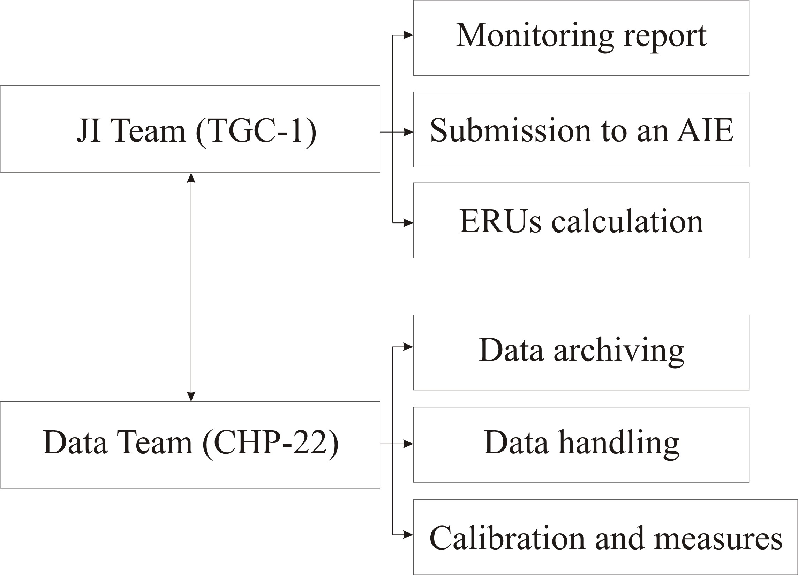
Figure 7: The management structure

The management and operational structure for monitoring of the project activity is as follows. The project owner will set up a JI Team to take charge of preparing and archiving monitoring reports, checking obtaining data, support validation process. Also TGC-1 establishes personnel (Data team) who will be responsible for data support of JI Team at CHP 22. The monitoring plan does not foresee any additional measures. All data collects from measurement equipment that will install with project implementation and standardized form of data handling are used. The personnel of CHP-22 are responsible for calibration and maintenance of measurement equipment in accordance with national rules and standards and providing measurement of parameters. The project owner will organize the training of personnel for providing monitoring plan management and support of ERUs verification procedures.

D.4. Name of person(s)/entity(ies) establishing the monitoring plan:
Name of person/entity determining the monitoring plan:
- OJSC “TGC-1”,
OJSC “TGC-1” is a project participant. The contact information is presented in Annex 1.
ECF Project Ltd.,
ECF Project Ltd. is a project participant. See Annex 1 for detailed contact information.
SECTION E. Estimation of greenhouse gas emission reductions

E.1. Estimated project emissions:
The project activity is electricity and heat generation using natural gas.
Table E.1.1 Project GHG emissions
Year | 2011 | 2012
PE_{y}, tCO₂/year | 1 486 780 | 1 486 780
Table E.1.2 Project GHG emissions after 2012
Year | 2013 | 2014 | 2015 | 2016 | 2017
PE_{y}, tCO₂/year | 1 486 780 | 1 486 780 | 1 486 780 | 1 486 780 | 1 486 780

E.2. Estimated leakage:
Not applicable
E.3. The sum of E.1. and E.2.:
Table E.3.1 The sum of project GHG emissions and leakage (taken to be zero)
Year | 2011 | 2012
PE_{y},+ LEy tCO₂/year | 1 486 780 | 1 486 780
Table E.3.2 The sum of project GHG emissions and leakage (taken to be zero) after 2012
Year | 2013 | 2014 | 2015 | 2016 | 2017
PE_{y},+ LEy tCO₂/year | 1 486 780 | 1 486 780 | 1 486 780 | 1 486 780 | 1 486 780

E.4. Estimated baseline emissions:
Table E.4.1 Baseline GHG emissions
Year | 2011 | 2012
BE_{y}, tCO₂/year | 2 288 499 | 2 288 499
Table E.4.2 Baseline GHG emissions after 2012
Year | 2013 | 2014 | 2015 | 2016 | 2017
BE_{y}, tCO₂/year | 2 288 499 | 2 288 499 | 2 288 499 | 2 288 499 | 2 288 499

E.5. Difference between E.4. and E.3. representing the emission reductions of the project:
Table E.5.1 GHG emission reductions
Year | 2011 | 2012
BE_{y}, - PE_{y},+ LEy tCO₂/year | 801 720 | 801 720

Table E.5.2 GHG emission reductions after 2012
Year | 2013 | 2014 | 2015 | 2016 | 2017
BE_{y}, - PE_{y},+ LEy tCO₂/year | 801 720 | 801 720 | 801 720 | 801 720 | 801 720

E.6. Table providing values obtained when applying formulae above:
Table E.6.1: Project, baseline, and emission reductions within the crediting period
Year | Estimated  project  emissions  (tonnes of  CO₂  equivalent) | Estimated  leakage  (tonnes of  CO₂  equivalent) | Estimated  baseline  emissions  (tonnes of  CO₂  equivalent) | Estimated  emission  reductions  (tonnes of  CO₂  equivalent)
2011 | 1 486 780 | 0 | 2 288 499 | 801 720
2012 | 1 486 780 | 0 | 2 288 499 | 801 720
Total  (tonnes of  CO₂  equivalent) | 2 973 559 | 0 | 4 576 999 | 1 603 439
Table E.6.2: Project, baseline, and emission reductions after the crediting period
Year | Estimated  project  emissions  (tonnes of  CO₂  equivalent) | Estimated  leakage  (tonnes of  CO₂  equivalent) | Estimated  baseline  emissions  (tonnes of  CO₂  equivalent) | Estimated  emission  reductions  (tonnes of  CO₂  equivalent)
2013 | 1 486 780 | 0 | 2 288 499 | 801 720
2014 | 1 486 780 | 0 | 2 288 499 | 801 720
2015 | 1 486 780 | 0 | 2 288 499 | 801 720
2016 | 1 486 780 | 0 | 2 288 499 | 801 720
2017 | 1 486 780 | 0 | 2 288 499 | 801 720
Total  (tonnes of  CO₂  equivalent) | 7 433 898 | 0 | 11 442 496 | 4 008 598

SECTION F. Environmental impacts

F.1. Documentation on the analysis of the environmental impacts of the project, including transboundary impacts, in accordance with procedures as determined by the host Party:
The necessity of an Environmental Impact Assessment (EIA) in Russia is regulated by the Federal Law “On the Environmental Expertise” and consists of two stages: EIA (OVOS —in Russian abbreviation) and state environmental expertise (SEE). Significant changes into this procedure were made by the Law in Amendments to the Construction Code which came into force on the 1st of January 2007. This Law reduced the scope of activities subject to SEE transferred them to the so called State Expertise (SE) done in line with the Article 49 of the Construction Code of the Russian Federation. In line with the Construction code the Design Document should contain the Section “Environment Protection” (Environmental Protection). Compliance with the environmental regulations (so called technical regulation in Russian on Environmental Safety) should be checked during the process of SE.
Thermal power plants with capacities of 150 MW and higher are considered to be dangerous, technical complicated and unique facilities in line with the Article 48.1 of the Construction Code RF. Design Document of such installations are subject to the state expertise at federal level. Open Joint-Stock Company «TGC-1» submitted a Design Document for this project to the Federal State Institution “The Main Agency of the State expertise” (FGU “Glavgosexpertiza” in Russian abbreviation) and received an approval (Expert Conclusion).
The main pollutants for CCGT burned natural gas are considered: nitrogen oxides and carbon oxide. The other negative effects are: the noise pollution, the water protection and the hazardous waste. All of them were considered in the section “Environmental Protection” of the Design Document.
The main conclusions of the Environmental Protection for this project and Expert Conclusion by FGU “Glavgosexpertiza” are quoted below:
Air protection:
“. the exceeding of the maximum allowable concentrations of all pollutants will not be .”.
Noise pollution:
“... will be ensured within the required noise level limits regulated by the Sanitary regulation.”.
Water protection:
“... the project technologies provide the water protection lows compliance and the exclusion of the negative impact on the region natural conditions ...”.
Hazardous waste:
All hazardous waste will be utilized by the special accredited organization.
Labour safety and welfare of inhabitants:
“... The installation of CCGT-450 at Yuzhnaia CHP -22 will not lead to the essential changes of biosphere state and population health ...”.
The main conclusions:
The proposed project “.complies with the environment protection requirements of the Russian Federation” and the project impact is considered insignificant.
Transboundary impact.
Although the project on local level will lead to increasing NO_{x} emission in country level the emission will be reduced due to increasing efficiency of fuel using. Therefore the project does not have transboundary impact.
F.2. If environmental impacts are considered significant by the project participants or the
host Party, please provide conclusions and all references to supporting documentation of an environmental impact assessment undertaken in accordance with the procedures as required by
the host Party:

On the basis on analysis of the environmental impacts for project design documents it was concluded that there is no significant negative impact on the environment.

SECTION G. Stakeholders’ comments

G.1. Information on stakeholders’ comments on the project, as appropriate:

Project information was published on the JSC “TGC-1” website: http://www.tgc-1.ru/about/invProgramma/all/. JSC “TGC-1” has publications about the project in mass media. The short list of publications is presented below.
Table G.1.1 Identity of stakeholders
Stakeholder 1
Name | Alexander Bobrov (Chairman of the Committee on Energy and Engineering Support of the Government of St. Petersburg )
Description of the effects of the project on the stakeholder | 11/09/2008  Newspaper “Energy and Industry of Russia” (http://www.eprussia.ru/news/base/2008/37577.htm)  "Subdivisions of TGC-1 to the beginning of the heating season are ready."  The Company is currently implementing the most ambitious in recent years, the investment program. In 2008, in St. Petersburg continued construction of new power Pervomayskaya CHPP-14, the construction of new reactors in Yuzhnaia CHP -22and west of the Dnieper HPP-5.
Address | St. Petersburg, Smolny, 4-th entrance  PO Box 191060
Phone | Phone: +7 (812) 576-60-94;
E-mail | press_centre@gov.spb.ru
Internet reception | http://www.gov.spb.ru/contacts
Contact person | Alexander Bobrov (Chairman of the Committee on Energy and Engineering Support of the Government of St. Petersburg )

Stakeholder 2
Name | Larisa Semenova G. (Head of the Department of Public Relations)
Description of the effects of the project on the stakeholder | 20/07/2007  Press Agency REGNUM (http://www.regnum.ru/news/866819.html)  "Moscow companies will be the reconstruction of Pervomayskaya CHPP-14 and the expansion of Yuzhnaia CHP -22."  The results of the open competitions of TGK-1 "to select a contractor for work on a" turnkey "for the reconstruction Pervomaiskaya TEC-14 and the expansion of Yuzhnaia CHP -22. Told a news agency REGNUM was informed at the press-service of JSC "TGC-1".
Address | St. Petersburg, Marsovo Pole, 1  PO Box 191186
Phone/fax | Phone: +7 (812) 901- 30-30;  Fax: +7 (812) 710- 60-70.
E-mail | Semenova.LG@tgc1.ru
Internet reception | http://www.tgc1.ru/press/contakt3/
Contact person | Larisa Semenova G. (Head of the Department of Public Relations)

Stakeholder 3
Name | Valentina Matvienko (Governor of St. Petersburg)
Description of the effects of the project on the stakeholder | 07/09/2007  Broadcasting Channel 5, "Show and tell Petersburg"  "Today, the south-west of St. Petersburg marked the beginning of a new energy era."  Valentina Matvienko, Governor of St. Petersburg: - Even without the naked eye specialist can see that the CHP had already exceeded their life, so well that there was a free territory and it was decided to build a new CHP…  Valentina Matvienko today recalled that in the past 2 decades in a city does not have commissioned a single electrical substation, depreciation of equipment reached 80 percent, power outages have become commonplace.  Valentina Matvienko, Governor of St. Petersburg: - We were just on the verge of collapse, every winter - this is a huge anxiety and excitement - whether we survive the winter. The city was practically no power, no longer only in the center, but in all areas has been practically no one kilowatt of electricity free.  Once the energy will be put into operation two new block Pervomaiskaya, dismantle the old station, half a century ago, the latest turbo startup assumed load of 10 megawatts, the power of the new station is 55 times more precisely as many increased demands metropolis.
Address | St. Petersburg, Smolny, 4-th entrance  PO Box 191060
Phone/fax | Phone: +7 (812) 576-60-94;
E-mail | press_centre@gov.spb.ru
Internet reception | http://www.gov.spb.ru/contacts
Contact person | Latyshev Marina Eduardovna (specialist press service of the governor of St. Petersburg)

Stakeholder 4
Name | Boris Vainzikher (General Director of OJSC "Silovie Machiny")
Description of the effects of the project on the stakeholder | 07/09/2007  Rosbalt - Petersburg. News  "The most unreliable CHP Petersburg and across Russia to Reconstruct"  We are pleased that the reconstruction of one of the most unreliable CHP not only St. Petersburg, but throughout Russia. We are pleased that "TGC-1" chose "Silovie Machiny" as a supplier of equipment
Address | St. Petersburg, Vatutina st., 3, Lit. A  PO Box 191000
Phone/fax | Phone: +7 (812) 346-70-37;  Fax: +7 (812) 346-70-35.
E-mail | mail@power-m.ru
Internet reception | www.power-m.ru
Contact person | Boris Vainzikher (General Director of OJSC "Silovie Machiny")
Annex 1

CONTACT INFORMATION ON PROJECT PARTICIPANTS

Organisation: | OJSC “TGC-1”
Street/P.O.Box: | Marsovo Pole
Building: | 1
City: | St. Petersburg
State/Region:
Postal code: | 191186
Country: | Russian Federation
Phone: | +7 (812) 901 36 06
Fax: | +7 (812) 494 3477
E-mail: | office@tgc1.ru
URL: | http://www.tgc1.ru
Represented by: | Boris Feliksovich Vainzikher
Title: | Mr.
Salutation:
Last name: | Vainzikher
Middle name: | Feliksovich
First name: | Boris
Department:
Phone (direct): | +7 (812) 901-31-22; +7 (812) 901-32-14
Fax (direct): | +7 (812) 4943477
Mobile:
Personal e-mail: | office@tgc1.ru

Organisation: | ECF Project Ltd.
Street/P.O.Box: | Alexandra Solzhenitsyna street
Building: | 18
City: | Moscow
State/Region:
Postal code: | 109004
Country: | Russia
Phone: | +7 495 748 79 60
Fax:
E-mail: | ecf@energyfund.ru
URL: | http://www.carbonfund.ru/home/
Represented by: | Gleb Anikin
Title: | Mr.
Salutation:
Last name: | Anikin
Middle name: | Vladislavovich
First name: | Gleb
Department:
Phone (direct): | +7 495 748 79 60
Fax (direct): | +7 495 748 79 60
Mobile:
Personal e-mail: | anikingv@energyfund.ru

Organisation: | Fortum Power and Heat Oy
Street/P.O.Box: | Keilaniementie / P.O. Box 100,
Building: | 1
City: | Espoo
State/Region:
Postal code: | 00048
Country: | Finland
Phone: | +358104528900
Fax: | +358104528900
E-mail: | communications@fortum.com
URL: | http://www.fortum.com/
Represented by: | Evgenia Tkachenko
Title: | Environmental manager
Salutation: | Mrs.
Last name: | Tkachenko
Middle name:
First name: | Evgenia
Department: | Fortum Service
Phone (direct): | +7 922 639 41 73
Fax (direct):
Mobile: | +7 922 639 41 73
Personal e-mail: | Evgenia.tkachenko@fortum.com
Annex 2
BASELINE INFORMATION
CO₂ baseline emission factor
This baseline emission factor was defined in accordance with approved CDM “Tool to calculate the emission factor for an electricity system” (version 02) with some deviations, further referred as “The Tool”. The full version of the Tool is published on the UFCCC website at the following address: http://cdm.unfccc.int/methodologies/PAmethodologies/approved.html.
Scope and applicability
This Tool “...may be applied to estimate the OM, BM and/or CM when calculating baseline emissions for a project activity that substitutes grid electricity, i.e. where a project activity supplies electricity to a grid…”.
The combined cycle gas turbine unit with electricity capacity of 450 MW each will be constructed at Yuzhnaia CHP – 22 and commissioned in 2010. After project implementation the new electricity energy unit will supply electricity to grid of United Regional Energy System (URES) “North-West”. It will substitute electricity that would have been otherwise generated by the other power plants of URES “North-West”. Therefore, this Tool can be used for determination of CO₂ baseline emission factor.
Parameters
The Tool provides procedures to determine the following parameters:
Parameter | SI Unit | Description
EFgrid,CM,y | tCO2/MWh | Combined margin CO₂ emission factor for grid connected power generation in year y
EFgrid,BM,y | tCO2/MWh | Build margin CO₂ emission factor for grid connected power generation in year y
EFgrid,OM,y | tCO2/MWh | Operating margin CO₂ emission factor for grid connected power generation in year y
Data source
The following sources of information were used for the OM development:
- Federal Service of State Statistics (RosStat RF). This is aggregated data provided by energy companies using the official statistical form 6-TP;
- JSC “Unified Energy System of Russia” (UES);
- OJSC <System Operator of Unified Energy System> (JSC “SO of UES”);
- CJSC “Agency of Energy Balances in the power industry”.
The combined heat and power plants (CHP) can operate as cogeneration and as simple (only electricity generation) cycles and some TPPs have cogeneration energy units. Each power plant submits the electricity and heat generation and fuel consumption data in RosStat RF according to the annually statistic report (6-TP).
CHPs produce electricity predominantly in the prescribed heat supply mode. Therefore they can be excluded from OM and BM calculation. However the reports (according to form 6-TP) do not contain any information about fired fuel amount for cogeneration or simple cycles and it is impossible to exclude from calculation the fired fuel amount and electricity generation with cogeneration cycle. Therefore, the parameters of cogeneration energy units were taken into account in the OM and BM calculation. It is a deviation from the Tool but it is conservative because cogeneration cycles are more efficient than simple (or combined) cycles.
The reports contain information about the total fired fuel amount (for each fuel type), fired amount fuel for electricity and heat generation (separately). The part of the fired amount fuel for electricity generation was used in the OM and BM emission factors calculation.
BM calculation is based on the data from:
- Official annual reports of JSC UES;
- Official annual reports of energy companies;
- Energy companies investment programs;
- Technical manual “Territorial Generating Companies”, CJSC “IT energy analyst”, 2007;
- Reports containing information on new power capacities put in operation in recent years, “General Scheme of Allocation of Energy Objects up to 2020” approved by the Government of the Russian Federation (Order of February 22 2008 # 2l5p).
The “General Scheme” is not a legislative act but a research work which was implemented by a commission of the Government of the Russian Federation. OJSC “RAO UES of Russia” (and some research institutes) prepared the draft of “General Scheme” in 2007. It was based on the electricity consumption forecast and the inquiry of energy companies about their investment plans. The “General Scheme” is compilation of such information and doesn’t contain any recommendations and is not responsible for where, when, what and who will construct energy units etc. The main aim of “General Scheme” is definition of the sufficiency of consumers power supply. In case of insufficiency of consumers power supply the Government of RF will prepare the arrangements on stimulation of new energy project implementation. The Government of RF approved this document in 2008 (Order of February 22 2008 # 2l5p). It means that this work was done according to the commission of the Government of the Russian Federation.
Also according to the Order the Ministry of Energy organizes the monitoring of the GS implementation. Currently CJSC “Agency of Energy Balances in the power industry” is preparing a revised version of the “General Scheme”. The new power consumption forecast and the revised investment plans of energy companies are taken into account. In comparison with the previous version of the “General Scheme” some supposed power projects are delayed and some supposed power projects are stopped.
As stated above the “General Scheme” is not an obligatory document especially for private energy companies but data from the “General Scheme” can be used for emission factors calculation in accordance with the Tool.
Methodology procedure
The Tool determines the CO₂ emission factor for an electricity, generated by power plants, displacement in an electricity system, by calculating the “operating margin” (OM) and “build margin” (BM) as well as the “combined margin” (CM). Operating margin is the emission factor that refers to the group of existing power plants whose electricity generation would be affected by the proposed project activity. Build margin is the emission factor that refers to the group of prospective power units whose construction would be affected by the proposed project activity.
In line with the Tool the following steps presented in detail below should be followed. Possible deviations should be identified and justified.
STEP 1: Identify the relevant electric power systems
A project electricity system is the system defined by the spatial extent of the power plants that are physically connected through transmission and distribution lines to the project activity and that can be dispatched without significant transmission constraints.
Similarly, a connected electricity system is defined as a system that is connected by transmission lines to the project electricity system. Power plants within connected system can be dispatched without significant transmission constraints but transmission to the project electricity system has significant transmission constraint.
If the Designated National Authority of the host country (in Russia it is the Ministry of Economic Development RF) has published a delineation of the project electricity system and connected power systems, these delineations should be used. The Designated Focal Point (DFP) of the Russian Federation didn’t publish a delineation of the project electricity system and connected electricity systems. In this case the Tool recommends: “. to use a regional grid definition in case of large countries with layered dispatch systems (e.g. provincial I regional I national)”.
Electric power industry in Russian Federation comprises nearly 400 power plants: thermal power plants (about 70% of total installed capacity), hydro power stations (20% of total installed capacity) and nuclear power stations (10% of total installed capacity). Power stations and consumers are connected by transmission lines. Power stations, consumers and regulatory organizations (JSC “SO of UES” for instance) constitute the national energy system (hereinafter referred to as UES of Russia). The UES of Russia is functioning centralized. JSC “SO of UES” contributes a great value to the operative-dispatching management. Power stations are unified by transmission lines in 60 area electricity systems (AESs), while these systems have in its turn the electric connections with the neighboring ones (excluding some isolated area systems). AESs are unified in seven united regional electricity systems (URESs), that are connected between each other through backbone and interconnection networks: “North-West”, “Centre”, “The South”, “Volga”, “Ural”, “Siberia” and “The East”.
The scheme of UES of Russia is presented in Figure Anx.2.1.
Figure Anx.2.1: Scheme of UES of Russia
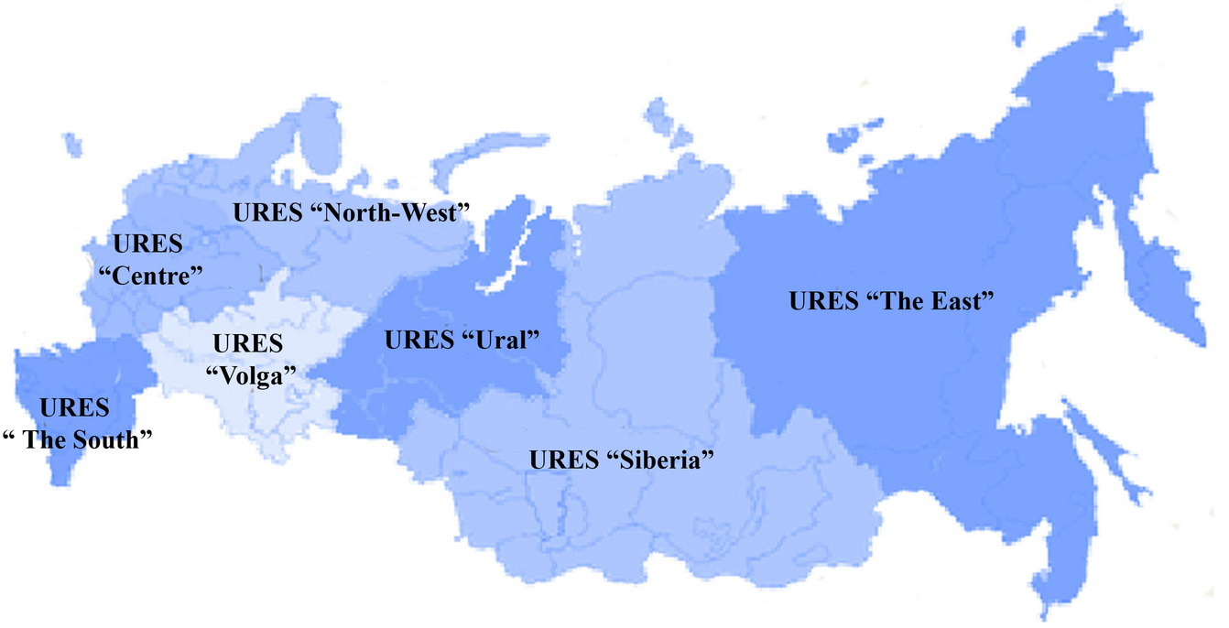
Source: JSC “SO of UES”(http://www.so-ups.ru/)
The status of these URESs is defined in State Standard (GOST) 21027-75 “Power systems. Terms and definitions” as: “the group of some area energy systems with common operating conditions and dispatching management”.
Yuzhnaia CHP – 22 is located in URES “North-West”. Installed capacity of this URES is 21 038 MW (status 2009). Project capacity (450 MW) is only 2.1% of the URES “North-West” total electric capacity, therefore project capacity ‘”.can be dispatched without significant transmission constraints”.
As a result URES “North-West” is selected as a project electricity system.
URES “North-West” is located in 10 regions of the Russian Federation North-West Federal District: Saint-Petersburg, Murmansk, Kaliningrad, Leningrad, Novgorod, Pskov and Arkhangelsk regions, the republics of Karelia and Komi, Nenets autonomous district.
The structure of installed capacity of URES “North-West” (status 2009) is as follows:
- 48.4.4% — TPPs (including combined heat and power plants and units);
- 14.3% — Hydro power stations (HPSs);
- 37.3% — Nuclear power stations (NPSs);
NPSs operate as “must-run” resources and HPSs and WPSs — as “low-cost”.
URES “North-West” is bordered by the URES “Centre” and URES “Ural”, which have no effect on her. The most recently available date of annual URES “North-West” electricity import is presented in Table Anx.2.1.
Table Anx.2.1: The recently date of annual URES “North-West” electricity generation, consumption and import
Indicator | Unit | 2007 | 2008 | 2009 | Average
Generation | mln. MWh | 94.7 | 100.7 | 97.6 | 97.7
Consumption | mln. MWh | 89.3 | 91.3 | 88.3 | 89.6
Electricity import | mln. MWh | -5.4 | -9.4 | -9.3 | -8.0
Electricity import | % | -5.7% | -9.3% | -9.5% | -8.2%
STEP 2: Choose whether to include off-grid power plants in the project electricity system (optional)
Some power plants can be considered as off-grid power plants. For North-West region they can be power plants of oil and gas companies (located on the remote oil and gas deposits) and power plants of villages located within sparsely populated area. Usually these power plants are based on the gas turbine and diesel-engine technologies with a small electric and heat capacity.
As shown above in the Russian Federation the individual plant data is considered strictly confidential and only aggregate data on the regional basis are available. The off-grid power plants report according to statistic form also. Therefore Rosstat RF data includes off-grid power plants data.
Part of off-grid power plants electricity generation can be estimated using the “ODU “North-West” (branch of “SO UES” is superior body of operating-dispatching management in URES “North-West”) operative data. The comparison of Rosstat RF and “ODU“North-West” data by 2007 are presented in Table Anx.2.2.
Table Anx.2.2: The comparison of Rosstat RF and “ODU “North-West” data by 2007
 | Installed capacity. kW |  | Diff | Electricity generation.  thous. kWh |  | Diff
Area (Republic) | Rosstat RF | ODU  “North-West” | % | Rosstat RF | ODU  “North-West” | %
The Arkhangelsk area | 1 946 | 1 908 | 1,9% | 7 719 | 7 086 | 8,2%
The Kaliningrad area | 647 | 639 | 1,2% | 2 764 | 2 761 | 0,1%
The Republic of Karelia | 1 101 | 1 094 | 0,7% | 4 952 | 4 926 | 0,5%
The Murmansk area | 3 743 | 3 737 | 0,2% | 17 551 | 17 540 | 0,1%
The Komi Republic | 2 322 | 2 215 | 4,6% | 9 063 | 8 897 | 1,8%
Novgorod Region | 216 | 216 | 0,4% | 926 | 921 | 0,6%
Pskov Region | 434 | 432 | 0,4% | 1 751 | 1 736 | 0,8%
St. Petersburg and Leningrad Region | 10 841 | 10 931 | 0,8% | 51 019 | 50 743 | 0,5%
Total | 21 250 | 21 173 | 0,36% | 95 745 | 94 610 | 1,19%

The off-grid power electricity generation of URES “North-West” is only 1.19 percent of total electricity generation.
According to the Tool project participants may choose between the following two options:
- Option I: Only grid power plants are included in the calculation.
- Option II: Both grid power plants and off-grid power plants are included in the calculation.
In accordance with the Tool, “Option II aims to reflect that in some countries off-grid power generation is significant and can partially be displaced by CDM project activities, e.g. if off-grid power plants are operated due to an unreliable and unstable electricity grid.”. As the off-grid power generation is not significant, Option I was chosen.
STEP 3: Select an operating margin (OM) method
The Tool recommends calculating the EF _{grid. OM. y} based on one of the following methods:
(a) Simple OM. or
(b) Simple adjusted OM. or
(c) Dispatch data analysis. or
(d) Average OM.
Any of these listed methods can be used; however. the simple OM method (a) can only be used if low- cost/must run resources constitute less than 50% of total grid generation calculated:
1) As average of the five most recent years or.
2) Based on long-term averages for hydroelectricity production.
Low-cost/must run resources are defined as power plants with low marginal generation costs or that are dispatched independently of the daily or seasonal load of the grid. Typically they include hydro. geothermal. wind. low-cost biomass. nuclear and solar generation. In URES “North-West” geothermal. low-cost biomass. and solar generation are negligible for the power balance. Therefore nuclear stations (as “must-run”) and wind (1 MW) and hydro plants (as “low-cost”) are defined as low-cost/must run resources. Table Anx.2.3 represents” total electricity generation during the five last years and the five year average share of low-cost/must run resources in URES “North-West” (2003-2007).
Table Anx.2.3: Total electricity generation during the last five years and share of RES‘s low-cost/must run net electricity generation (MWh)
URES  “North-West” | 2005 | 2006 | 2007 | 2008 | 2009 | Five year average %  of low-cost
All power plants | 94 911 879 | 99 168 490 | 103 352 040 | 100 664 000 | 97 597 600 | 49.11
Hydro (with wind) | 12 953 642 | 11 980 721 | 13 340 302 | 13 553 100 | 13 979 500 | 49.11
Nuclear | 34 194 021 | 33 770 747 | 34 923 872 | 38 385 800 | 36 376 700 | 49.11
Source: JSC “SO of UES” and Rosstat RF
As this indicator is lower than 50% the nuclear and hydro energy generation may not be taken into account. Therefore simple OM (method “a”) can be used and is selected for calculation of emission factor of URES “North-West”.
STEP 4: Calculate the operating margin emission factor according to the selected method
The Tool specifies how simple OM is calculated - as the generation-weighted average CO₂ emissions per unit net electricity generation (tCO₂/MWh) of all generating power plants serving the system. not including low-cost/must run plants/units (e.g. hydro and nuclear).
The Tool suggests making calculations based on:
- the net electricity generation and CO₂ emission factor of each power unit (Option A);
- total net electricity generation of all power plants serving the system and the fuel types and total fuel consumption of the project electricity system (Option B).
The Option A was chosen because the necessary data for Option A is available.
Under this option the simple OM emission factor is defined by the following formula:
(1)
Where:
EF_{grid.OMsimple.y} | = | simple operating margin CO₂ emission factor in year y (tCO₂/MWh);
FC_{i.m.y} | = | amount of fossil fuel i consumed in the project electricity system in year y (mass or volume unit);
NCV_{i.y} | = | net calorific value (energy content) of fossil fuel type i in year y (GJ / mass or volume unit);
EF_{CO2.i.y} | = | CO₂ emission factor of fossil fuel type _{i} in year y (tCO₂/GJ);
EG_{m.y} | = | net electricity generated and delivered to the grid by all power sources serving the system. not including low-cost/must-run power plants/units. in year y (MWh);
m | = | all power plants / units serving the grid in year y except low-cost / must-run power plants / units;
i | = | all fossil fuel types combusted in power plant / unit m in year y;
y | = | three most recent years for which data is available (2006-2008).
The net electricity generation and fossil fuels consumed in the project electricity system are received from Rosstat RF. The amount of fossil fuels are expressed in tone of coal equivalent with net calorific value is equal to 7.000 kcal/kg c.e. or 29.33 GJ/t.c.e.
The net electricity generation and emission factors data at all TPPs of URES “North-West” in 2003-2007 are presented in the Annex 4..
Exclusion off-grid power plants data
The above mention data includes net electricity generation and fuel consumption of the off-grid power plants. And the individual data of off-grid power plants is not available by this source. To exclude the off- grid power plants the following conservative assumptions were taken:
- The net electricity generation of the off-grid power plants is 49.11 percent (as shown in the Table Anx.2.3) of total net electricity generation of URES “North-West” in year y;
- Efficiency factor of the off-grid power plants was defined according to the Annex 1 of the Tool.
The off-grid power plants fuel consumption is defined based on the analysis of OJSC “Zvezda Energetika” (the biggest company constructing such type of power plant in Russia). The results of the analysis are presented in Table Anx.2.4.
Table Anx.2.4: The analysis results of OJSC “Zvezda Energetika” activity and value of default efficiency factors of the energy unit types
Type of power unit  (CAP is nominal capacity in MW) | Total capacity | Percentage | Default efficiency factor
Type of power unit  (CAP is nominal capacity in MW) | MW | % | %
Diesel-engine units (10<CAP<50) | 105.4 | 49.3 | 33.0
Diesel-engine units (CAP<10) | 34.0 | 15.9 | 28.0
Gas turbine units (10<CAP<50) | 24.0 | 11.2 | 32.0
Gas turbine units (CAP<10) | 50.3 | 23.5 | 28.0
Total | 213.7 | 100.0 | -
Source: http://www.energostar.com/activity/activity_map.php
The net electricity generation and fuel consumption data at TPPs of URES “North-West” excluding off-grid power plants in 2006-2008 are presented in the Table Anx.2.6.
Table Anx.2.5: The net electricity generation and fuel consumption data excluding off-grid power plants
Indicator | Unit | 2005 | 2006 | 2007
Net electricity generation | MWh | 218 010 | 247 731 | 249 064
Natural gas | GJ | 2 871 847 | 3 195 328 | 3 766 764
Heavy fuel oil | GJ | 482 244 | 512 395 | 577 625
Coal | GJ | 0 | 0 | 47 515
Peat | GJ | 0 | 0 | 0
Other | GJ | 0 | 0 | 0
Definition of other fuel types
According to statistic form 6-TP the electricity and heat producers must indicate following fuel types: natural gas (including associated gas). heavy fuel oil. coal. peat. oil-shales (slate). firewood and other fuels are indicated as other fuel types.
In North-West region some power stations use such type of fuel as blast furnace and coke even gases (power plants at the metallurgical works) and wood waste. These types are reflected in statistic form 6-TP as other fuel types. The “other” fuel type (see table above) is third fuel of URES “North-West” power plants for last years. The most relevant areas are Murmansk, Leningrad and Arkhangelsk regions, the republics of Karelia and Komi.
The amount of other fuel type consumption on the regional basis during 2005-2007 is presented in the Table Anx.2.6.
Table Anx.2.6: The other fuel type consumption on the regional basis during 2005-2007
Area (Republic) | Unit | 2005 | 2006 | 2007
The Arkhangelsk area | GJ | 29 506 831 | 30 365 320 | 29 735 341
The Republic of Karelia | GJ | 6 533 023 | 7 040 520 | 7 599 843
The Murmansk area | GJ | 13 550 | 9 122 | 8 858
The Komi Republic | GJ | 13 093 909 | 13 245 076 | 13 072 352
Novgorod Region | GJ | 0 | 0 | 0
Pskov Region | GJ | 0 | 0 | 0
St. Petersburg and Leningrad Region | GJ | 1 837 671 | 1 530 586 | 1 309 086
Total | GJ | 50 984 984 | 52 190 623 | 51 725 479
Source: Rosstat RF
For emission calculation the following assumptions were taken: The proportion of other fuel in the fuel balance of North-West region is 5.5% and the emission factor of other fuel types in North-West region was considered as zero.
Table Anx.2.7: The data of total fuel balance and net electricity generation of URES “North-West”
Indicator | Unit | 2005 | 2006 | 2007
Net electricity generation | MWh | 47 758 867 | 53 412 399 | 55 082 048
Natural gas | GJ | 574 154 460 | 599 737 171 | 636 293 614
Heavy fuel oil | GJ | 101 004 924 | 107 701 754 | 91 278 509
Coal | GJ | 80 852 251 | 100 731 304 | 96 119 044
Peat | GJ | 74 029 | 12 113 | 4 253
Firewood | GJ | 8 861 356 | 4 563 807 | 4 490 159
Other | GJ | 43 272 455 | 48 286 800 | 48 316 541
Calculation of emission at the TPPs of URES “North-West”
The default fuel emission factors are presented in the Table Anx.2.6.
Table Anx.2.6: The default fuel emission factors
Fuel type | Default emission factor
Fuel type | tCO₂/GJ
Natural gas | 0.0561
Heavy fuel oil | 0.0774
Coal | 0.0961
Peat | 0.1060
Other fuel types | 0.0
Emission calculation of the net electricity consumption from a connected electricity system (see Annex 4).
And the results of EF _{grid, OMsimple, y} and the average electricity weighted OM emission factor calculation are presented in the Table Anx.2.7.
Table Anx.2.7: Results of calculation EF _{grid, OM, y} and the average electricity weighted OM emission factor
Indicator | Unit | 2003 | 2004 | 2005 | 2006 | 2007
OM emission factor URES “North-West” | tCO₂/MWh | 0.592 | 0.587 | 0.579 | 0.582 | 0.595
Average electricity weighted OM emission factor | tCO₂/MWh | 0.583
The OM emission factor is fixed ex-ante for the period 2008-2012.
STEP 5: Identify the cohort of power units to be included in the BM
The Tool provides the recommendations on how to form the sample groups of power units used to calculate the BM. They consist of either:
(a) The set of five power units that most recently have been built. or
(b) The set of power capacity additions in the electricity system that comprise 20% of the system generation (in MWh) and that have been built most recently.
If the recommended approach does not reasonably reflect the power plants that would likely be built in the absence of the project activity. the participants are encouraged to submit alternative proposals.
Capacity additions from retrofits of power plants should not be included in the calculations of BM.
The main principle stated by the Tool is that “the build margin is the emission factor that refers to the group of prospective power plants whose construction and future operation would be affected by the proposed” project which means that the BM capacity is counterfactual and the power plants are assembled just to determine the parameters of such capacity to calculate GHG emissions.
In the Table Anx.2.8 lists all the plants/units commissioned recently (since 1991) in URES “North-West”.
Table Anx.2.8: URES “North-West”. Power plants/units commissioned recently
N | Power plant/unit | Year of commissioning | Capacity, MW | Technology | Fuel
Commissioned in 1991-2009
1 | Severo-Zapadnaia CHPP | 2000 | 450 | CC GT | Gas
2 | Vasileostrovskaya TPP-7, #3 | 2009 | 50 | Steam cycle | Gas
3 | Severo-Zapadnaia CHPP | 2006 | 450 | CC GT | Gas
4 | Avtovskaya TPP-15 | 2007 | 30 | Steam cycle | Gas
5 | Pravoberejnaya TPP-5 | 2006 | 180 | Steam cycle | Gas
Source: Energy companies
For the first commitment period of the Kyoto Protocol projects participants can choose between one of the two options:
(1) ex-ante based on the most recent information available on units already built;
(2) ex-post based on information updated during each relevant monitoring period.
The approach presented above is based upon ex-ante option.
STEP 6: Calculate the build margin emission factor
In line with the Tool the BM emission factor is the generated-weighted average emission factor of all power units m during the year y and is calculated as follows:
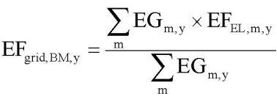 (2)
Where:
EF_{grid.BM.y} | = | Build margin CO₂ emission factor in year y (tCO₂/MWh)
EG_{m.y} | = | Net quantity of electricity generated and delivered to the grid by power unit m in year y (MWh)
EF_{EL.m.y} | = | CO₂ emission factor of power unit m in year y (tCO₂/MWh)
m | = | Power units included in the build margin
y | = | Most recent historical year for which power generation data is available
Method of EF _{EL. m. y} calculation here is the same as for EF _{grid. OMsimple. y} described under Step 4. i.e. by using specific fuel consumption per 1 kWh of energy output b_{m. y} (kg c.e./kWh).
EF _{EL. m. y}= b _{m. y x} EF _{CO2. fuel} (3)
Where:
EF _{CO2. fuel} | = | fuel emission factor (fuel type weighted) in tCO₂/MJ or tCO₂/t.c.e; the IPCC factors for main types of fuel values;
b_{m. y} | = | specific fuel consumption by the unit m (MJ/MWh or t.c.e./MWh)
In the Russian Federation individual plant based data is considered strictly confidential. Therefore the specific factors of the power units (or similar power units) from open sources were used.
The background data for EF grid. BM. y calculation is presented in the Table Anx.2.9.
Table Anx.2.9: Background data for EF _{grid. BM. y} calculation
Indicator | Unit | Severo-Zapadnaia CHPP, #1 | Severo-Zapadnaia CHPP, #2 | Vasileostrovskaya TPP-7, #3 | Avtovskaya TPP-15 | Pravoberejnaya TPP
Electric capacity | MW | 900 | 900 |  | 30 | 180
Annual net generation of electricity | MWh | 3 313 266 |  | 539 469 | 1 261 715 | 1 002 805
Specific fuel consumption | g c.e./kWh | 233 |  | 312,7 | 349,4 | 260,6
Specific fuel consumption | GJ/MWh | 6,85 |  | 9,20 | 10,28 | 7,66
Fuel | - | Natural gas
Fuel | GJ | 22 705 617 |  | 4 961 528 | 12 965 977 | 7 686 205
Fuel emission factor | tCО2/GJ | 0,0561
Source: Rosstat RF
The results of EF _{grid. BM. y} calculation are presented in the Table Anx.2.10.
EL, m, y
Table Anx.2.10: Results of EF _{grid. BM. y} calculation
Indicator | Unit | Severo-Zapadnaia CHPP, #1 | Severo-Zapadnaia CHPP, #2 | Vasileostrovskaya TPP-7, #3 | Avtovskaya TPP-15 | Pravoberejnaya TPP
Power unit CO2  emission factor | tCО2/MWh | 0,384 | 0,384 | 0,516 | 0,577 | 0,430
Average weighted BM  emission factor | tCО2/MWh | 0,443
BM emission factor is ex-ante for period 2008-2012.
STEP 7: Calculate combined margin emission factor
The combined margin emission factor (CM) is calculated as follows:
EF grid. CM. y= w 0Mx EF grid. 0M. y + w BMx EF grid. BM. y (4)
Where:
EF grid. CM. y | = | CM emission factor in year y (tCO₂/MWh);
EF grid. OM. y |  | OM emission factor in year y (tCO₂/MWh);
EF grid. BM. y | = | BM emission factor in year y (tCO₂/MWh);
w0M | = | weight of OM emission factor;
w BM | = | weight of BM emission factor.
In most cases the Tool recommends to apply w0M = w BM = 0.5. But developers may propose other weights. as long as w0M + w BM = 1.
As a starting point the weighting factor for w_{0M} is taken as 0.5.
When looking at the factor for w BM the conditions of the Russian power system have to be taken into account. The Russian power system has a big quantity of old. worn-out low efficient power plants being in operation for decades. According to the JSC “UES of Russia” average turbines operational life time is around 30 years. Most of these capacities were put in operation in 1971-1980 that corresponds to 31.4% of the whole installed capacities.
In accordance with General Scheme. dated 22 February 2008. it was planned to approximately 33 GW of old capacity has to be dismantled by 2015. To meet the growth in demand for new energy units with total capacity of 120 GW will be commissioned by 2015. This means that the JI project will not only initiate the construction of new power plants. but also accelerate the decommissioning of existing capacities. Given the impact of the financial crises on demand growth and the capability to finance new projects. the new estimation (September 2008) expects that out of the planned 120 GW only about 80 GW will be operational by 2015. Out of the 33 GW of old capacity only 10 GW will be dismantled. This means that 1 GW of any project delay leads to a delay of 0.5 GW of old capacity dismantling. So the effect of the JI project on the acceleration of decommissioning of existing capacities will only be stronger as result of the financial crisis.
The estimation. that the effect of the JI project on the decommissioning of power plants and the delays of new power plants construction is approximately 50% / 50%. For the avoidance of new power plants the emission factor of the BM is representative whereas for the accelerated decommissioning effect the emission factor of the OM is representative. And it means that 0.25 of BM refers to the group of prospective power plants and another 0.25 of BM refers to the dismantling of existing capacities and can be related to OM.
Therefore effective w_{OM} = 0.50 + 0.25 = 0.75 and w _{BM} = 0.25.
The resulting grid factor is EF grid. CM. y = 0.5481 tCO2/MWh.
CM emission factor is ex-ante for period 2008-2012. because OM and BM emission factors are ex-ante as well. This emission factor is the baseline emission factor (EF _{BL.CO2 .y}) which is used to establish the baseline emissions of the baseline scenario.
Table Anx.2.11: Key Information and Data used for Setting the Baseline.
ID number | Symbol | Data variable | Measuring unit | Value
b1 | FC_{NG,PJ,y} | Annual natural gas consumption | Thous.m³
b2 | EG_{PJ,y} | Annual electricity supply | MW• hour/year
b3 | HG_{PJ,y} | Annual heat energy supply | Gcal/year
b4 | NCV_{NG,y} | Natural gas net calorific value | GJ/m³ | 33.46
b5 | EF_{NG} | Natural gas emission factor | tCO₂/TJ | 56.1
b6 | EF_{CO2 grid,y} | Baseline emission factor | tCO₂/MWh | 0.5481
b7 | η_{boiler} | Efficiency of boilers | % | 93.3

Annex 3
MONITORING PLAN

See Section D for monitoring plan.

Annex 4
The calculation of the operating margin and
build margin emission factors
See file: table.xls

Letter from the Director of Energy Carbon Fund Gorkov A.V. No. AG-334 dated 20.06.2007
Source: Data provided by Open Joint-Stock Company «TGC-1» (file:Training of Personnel.pdf.).
http://cdm.unfccc.int/UserManagement/FileStorage/CDMWF_AM_15YH7UTNQ40J8MGMVX62CGNE0K49Y0
http://cdm.unfccc.int/UserManagement/FileStorage/9K6GRQITX27OVG3CAS2MVDN1IWXJX1
http://cdm.unfccc.int/UserManagement/FileStorage/PGZZ4XP5JIB9TSXN30YLQTRZQKO859
http://cdm.unfccc.int/UserManagement/FileStorage/CDMWF_AM_5CJO927L0ASINNC90KWHKMM9X1RMVN
http://www.e-apbe.ru/library/detail.php?ID=11106
http://www.so-ups.ru/index.php?id=oes_northwest
http://www.e-apbe.ru/library/detail.php?ID=11106
http://www.docload.ru/Basesdoc/9/9657/index.htm
http://metrologu.ru/ntd/item326.html
http://www.gazanaliz.ru/standards/iso14532-2001ru/iso14532-2001ru.html
http://www.cbr.ru/print.asp?file=/statistics/credit_statistics/refinancing_rates.htm
The discounted payback period would be outside of the project lifetime.
Net present value
See Annex 2.
Baseline Methodology for Grid Connected Electricity Generation Plants using Natural Gas, AM0029/version 03, Approved Methodology, CDM Executive board
Baseline Methodology for Grid Connected Electricity Generation Plants using Natural Gas, AM0029/version 03, Approved Methodology, CDM Executive board
Baseline Methodology for Grid Connected Electricity Generation Plants using Natural Gas, AM0029/version 03, Approved Methodology, CDM Executive board
Data unit (m3) means the volume of gas under standard conditions (temperature is 2930K, Fc = 101,325 kPa).
See Annex 2.
Baseline Methodology for Grid Connected Electricity Generation Plants using Natural Gas, AM0029/version 03, Approved Methodology, CDM Executive board
Project Design “Construction of CCGT-450 MW at Yuzhnaia CHP -22”, Volume 13: “Environment Protection”, OJSC "Zarubejtehnoproect", 2008
http://www.e-apbe.ru/scheme
Tool to calculate the emission factor for an electricity system, version 02, Methodological Tool, CDM Executive board
http://www.so-ups.ru/fileadmin/files/company/reports/disclosure/2009/pokazateli_2008.pdf
http://www.so-ups.ru/fileadmin/files/company/reports/disclosure/2009/pokazateli_2008.pdf
http://www.so-ups.ru/fileadmin/files/company/reports/disclosure/2010/ues_rep_2009.pdf
Difference
http://www.so-ups.ru/fileadmin/files/company/reports/disclosure/2010/ues_rep_2009.pdf
Guidelines for National Greenhouse Gas Inventories, Volume 2: Energy, Chapter 2: Stationary Combustion (corrected chapter as of April 2007), IPCC, 2006
Emission factor for other types of fuel is taken as zero. It is conservative
See Annex 4.
http://www.so-ups.ru/index.php?id=tech_disc
http://www.e-apbe.ru/library/detail.php?ID=11106
http://www.e-apbe.ru/library/detail.php?ID=11106

